Copilot Setup

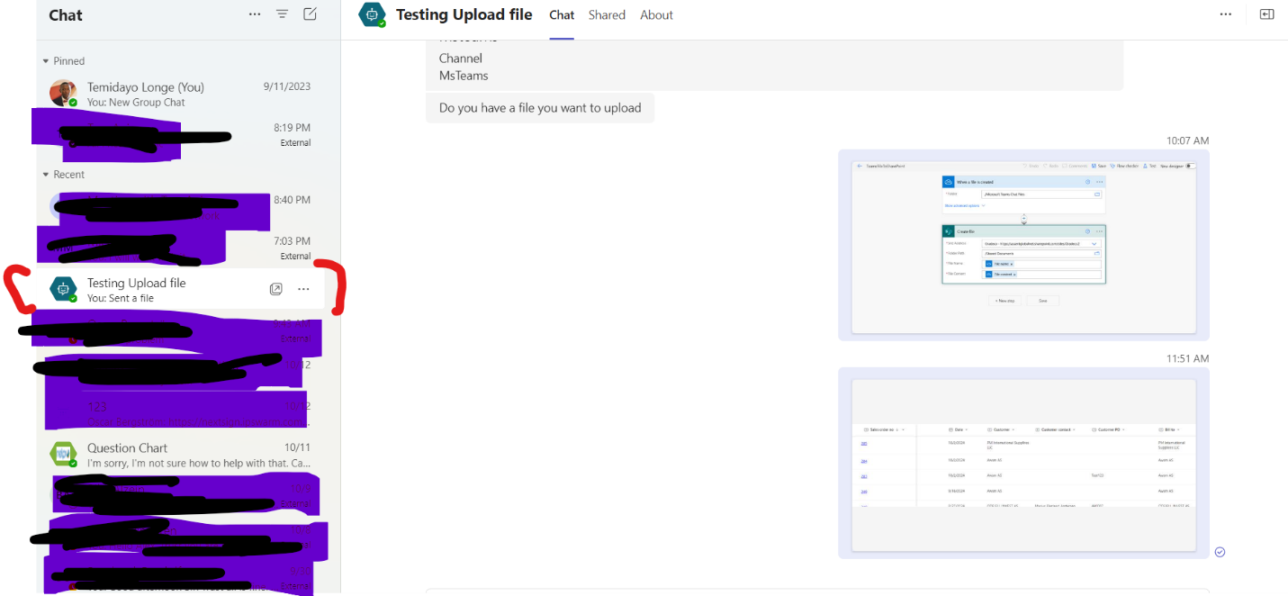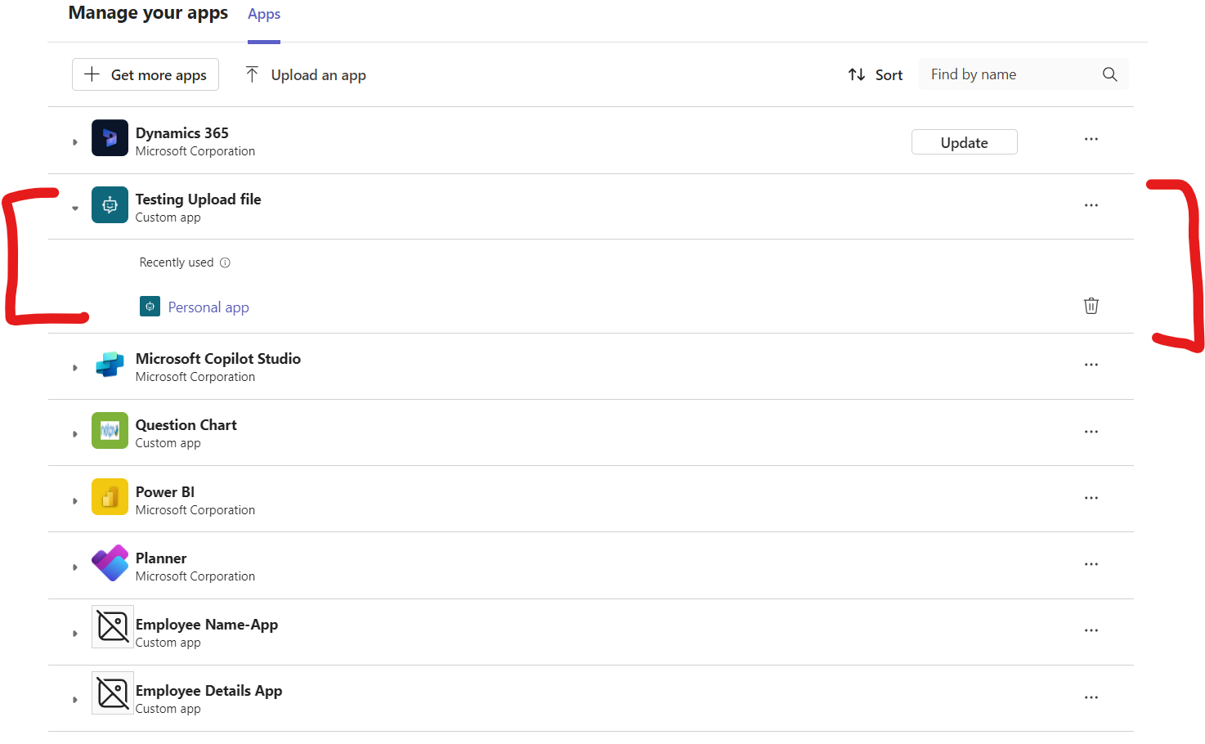

I used the UserId System variable and passed it through Power Automate in copilot

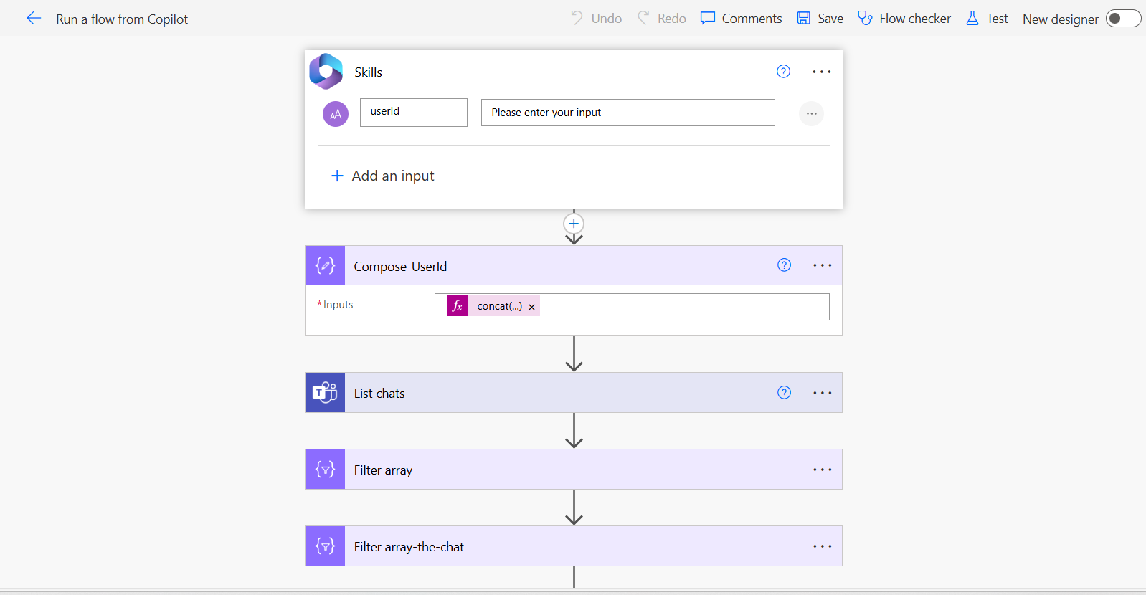

There is always a prefix, for ids in Teams that starts with “19:” I used the expression concat(’19:’,UserId gotten from the copilot chat)

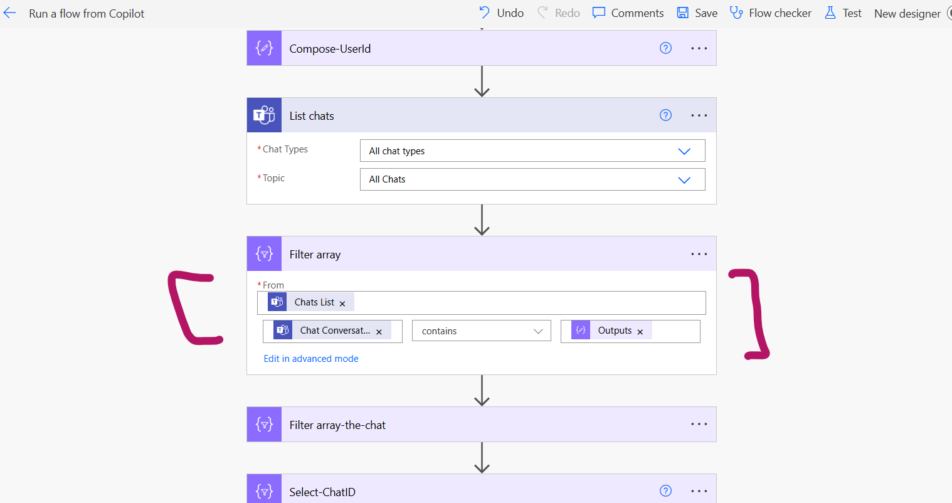

I called List chat actions to get all chats

I used the filter array action to check for chat-conversation Id to see if the UserId contains values of any of the chat’s ID.

In my case I created another filter because the UserId was in contains more than one chat since I already have a copilot chat. I filtered it my month to get the latest one.

I created a select statement to grab the value of the Chat conversationID and grad the chatID and pasted in a compose action.

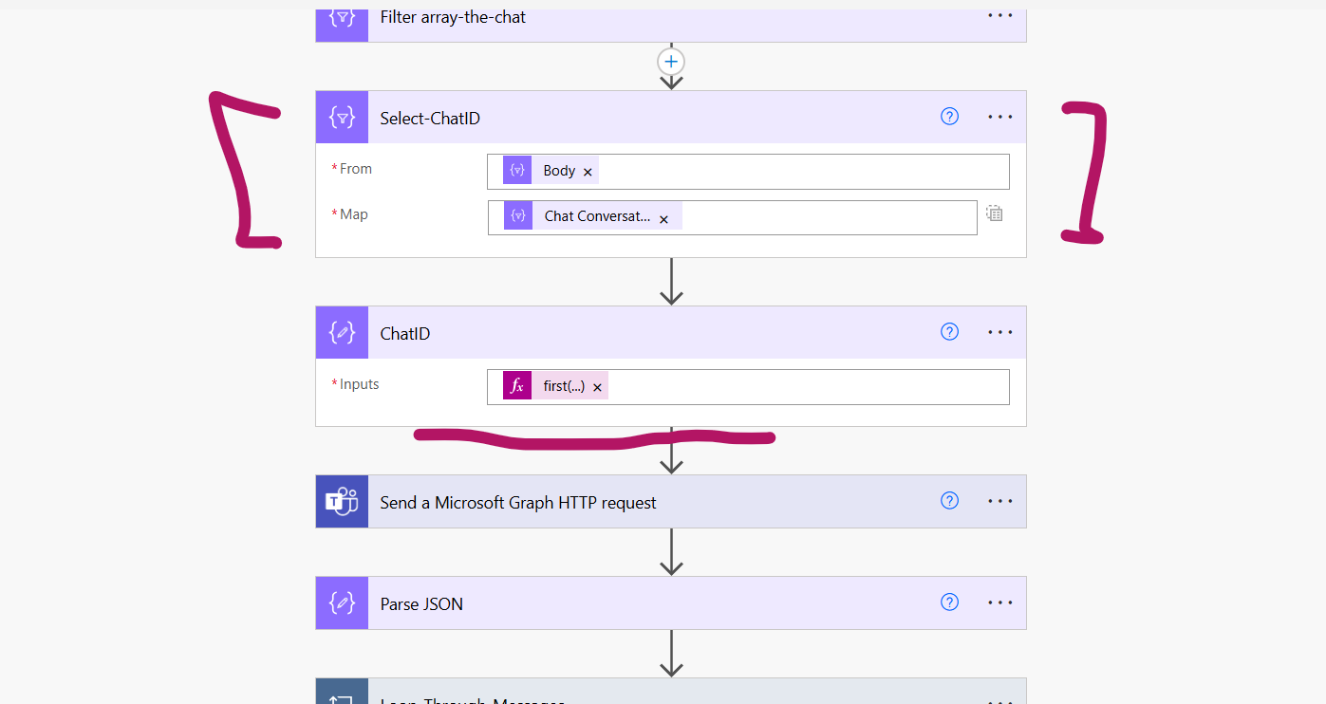

Used the Graph HTTP request action from Teams to get the chat Messages

Pasted the body in Parse JSON so that I can get the MessageID from the content.

Got the Message ID and Passed it in a loop.

Checked if attachment existed and copied the file to a SharePoint Library

More details

Get the chat ID of the Microsoft-copilot

Use the Get Message details action from Teams and add the Microsoft Copilot ID as the group chat

I used the Parse JSON action to grab the attachment contents.

I create a condition that if attachment is empty don’t do anything, but if not empty, copy the file and move to SharePoint folder.

There are some expressions I had to write, to get the Path and replace encode characters from the information got from the ParseJSON so that it meets the required information for the Get file content action.

File Uploaded in Microsoft-Co-pilot chat

File created in SharePoint Document Library/Folder



