# Artificial Intelligence (AI)-for-Good: partnering with Habitat for Canines (H4C) Dog Shelter to assist caring citizens

## Domain Background

A 2012 study by Weiss et al. estimated that about 11-16% of dogs will go missing in a five-year period in the United States1. Thankfully, they also estimated that about 86% to 97% are recovered in the US. This rate of success is due to ID tags, Animal Control, and of interest to our AI-for-good project, dog / pet shelters and people who report or try to catch loose dogs1. Such partnership, i.e., between shelters and concerned residents, exists between the Habitat for Canines (H4C) and the residents of Tacoma, Washington.

H4C is a (fictitious) dog shelter in Tacoma that cares for about 10,000 pets each year. They reunite lost pets and their owners, and they provide care for injured pets. They rely heavily on the community as a part of their process to gain leads on stray dogs, their locations, and breeds. They use this information from the community as part of their decision matrix on whether and how to capture the dog and triage it to the appropriate dog shelter (theirs or partner shelters).

## Problem Statement

The habitat is looking for an easier way to allow residents of Tacoma, Washington identify breeds of stray dogs. At the moment, they require residents to call and laboriously define the dob breed before H4C makes the decision to drive out to the neighborhood, capture the dog, and give it a nice home. The breed matters also because the habitat has limited capacity with certain exotic breeds but may have partners in Pierce County, Washington that can properly care for these breeds. H4C has surveyed the community and found that this need for calls is a significant blocker to receiving adequate leads on lost or abandoned dogs. Adding to this issue is the challenge of staffing. H4C struggles to find adequate and skilled staff who are available and able to handle incoming calls and correctly ascertain information, e.g., appropriate dog features, to properly identify the stray dog’s breed. Therefore, they are looking for AI advocates who can integrate an AI model into their website to automate this process and do so accurately. This web functionality allows Tacoma residents an online platform to upload dog pictures from their cell phones and get an identification of the dog breed. This also streamlines how H4C receives leads as they get the information about the dog breed, location, and can streamline the decision for how that stray dog will be captured and cared for. They require that the model has a minimum accuracy, i.e., better than human guessing, at or above 70%. They will settle for a little less than 70% accuracy if an end-to-end app can be deployed for this task.

## Solution Statement

We will train a PyTorch convolutional neural network (CNN) with Amazon’s SageMaker. We will leverage powerful cloud computes (GPUs) with multi-instance training given the size of the dataset and the compute power needed to train such an image classification model with many model parameters. We will deploy the model as an endpoint and integrate that endpoint into a Python-based application for dog breed identification. We will use Streamlit for the user interface (UI) that allows users to upload dog pictures and rapidly pull dog breed prediction.

Using script mode, we ensure that our work is majorly replicable to allow for further training e.g., to enhance model accuracy, continuously train on additional datasets, etc. To account for traffic, we will scale our endpoint by enabling auto-scaling for the endpoint. We might integrate it with AWS Lambda for additional auto-scaling to support concurrent requests. Our dataset will be uploaded into AWS S3.

### Simple project design depicting user interaction with dog breed prediction application

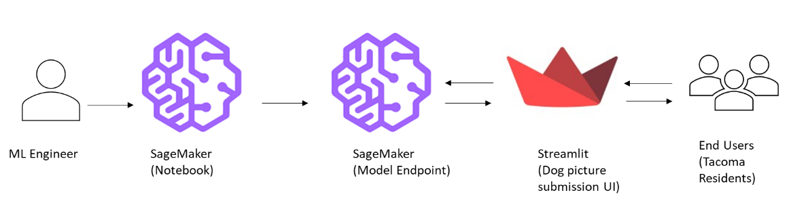

## Datasets and Inputs

Our dataset is a curated version from the original Stanford Dogs Dataset2. This dataset was originally built using images and annotation from ImageNet2. The curated version, provided by Udacity3, contains images and labels (does not include annotations for bounding boxes) and it contains 6679 training, 835 validation, and 836 test dog images. Given the task, i.e., the identification of a dog breed, this curated set is incredibly pertinent to our AI for good task with H4C.

## Benchmark Model

According to the stewards of the Standford Dataset, the authors report a baseline mean accuracy of 0.22 at 100 training images per class2.

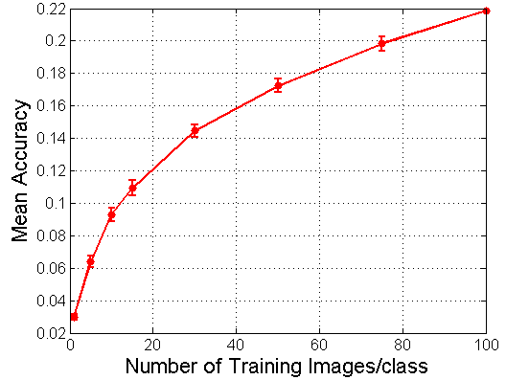

## Evaluation Metrics

To align with the original classification task metric proposed by authors, we will use mean accuracy as our primary evaluation metric instead of multi class log loss4. It will help us compare our model to the benchmark model.