Coding_Challenge4_Markdown_mer0127_kat0084

Madeline Redd and Katie Temple

2025-02-27

Table of Contents

# Data Information

Noel, Z.A., Roze, L.V., Breunig, M., Trail, F. 2022. Endophytic fungi as promising biocontrol agent to protect wheat from Fusarium graminearum head blight. Plant Disease. [DOI](https://apsjournals.apsnet.org/doi/10.1094/PDIS-06-21-1253-RE)

# Coding Challenge 3

## Question One

Explain the following: **YAML header**

A YAML header contains arguments “title”, “author”, “output”, “toc”, and “theme” within three dashes (- - -) above and below the arguments.

**Literate programming**

A mix of code and descriptive writing to explain and execute data analysis.

## Quesiton Two

* Use geom_pwc() to add t.test pairwise comparisons to the three plots made above.
* Save each plot as a new R object, and combine them again with ggarange as you did in question

library(ggplot2) #version 3.5.1  
library(ggpubr) #version 0.6.0  
library(ggrepel) #version 0.9.6

Data Set

Mycotoxin<- read.csv("MycotoxinData.csv", na.strings = "na")  
head(Mycotoxin)

## Treatment Cultivar BioRep MassperSeed_mg DON X15ADON  
## 1 Fg Wheaton 2 10.291304 107.3 3.00  
## 2 Fg Wheaton 2 12.803226 32.6 0.85  
## 3 Fg Wheaton 2 2.846667 416.0 3.50  
## 4 Fg Wheaton 2 6.500000 211.9 3.10  
## 5 Fg Wheaton 2 10.179167 124.0 4.80  
## 6 Fg Wheaton 2 12.044444 73.1 3.30

str(Mycotoxin)

## 'data.frame': 375 obs. of 6 variables:  
## $ Treatment : chr "Fg" "Fg" "Fg" "Fg" ...  
## $ Cultivar : chr "Wheaton" "Wheaton" "Wheaton" "Wheaton" ...  
## $ BioRep : int 2 2 2 2 2 2 2 2 2 3 ...  
## $ MassperSeed_mg: num 10.29 12.8 2.85 6.5 10.18 ...  
## $ DON : num 107.3 32.6 416 211.9 124 ...  
## $ X15ADON : num 3 0.85 3.5 3.1 4.8 3.3 6.9 2.9 2.1 0.71 ...

New Color Palette

cbbPalette <- c( "#E69F00", "#56B4E9", "#009E73", "#F0E442", "#0072B2",  
 "#D55E00", "#CC79A7","#000000")

### DON with pairwise comparisons

plot1 <- ggplot(Mycotoxin, aes(x=Treatment, y=DON, fill=Cultivar)) +  
   
 geom_boxplot(outlier.color=NA) +  
 geom_point(pch=21, alpha=0.6, color="black",   
 position=position_jitterdodge(dodge.width=0.9)) +  
 geom_pwc(aes(group = Treatment),  
 method = "t_test", label = "p.signif", hide.ns = TRUE)+  
   
 xlab("") +  
 ylab("DON (ppm)") +  
   
 theme_classic() +  
 scale_fill_manual(values= cbbPalette) +  
 facet_wrap(~Cultivar)  
  
plot1

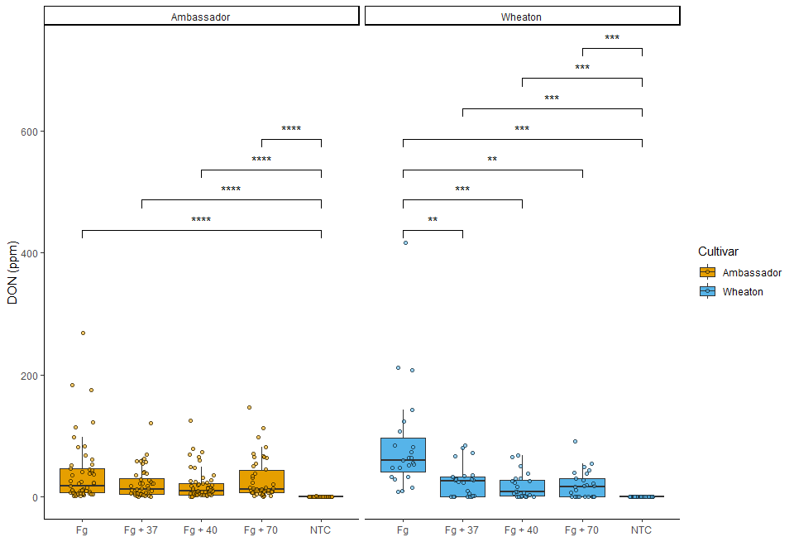

### X15ADON with pairwise comparisons

plot2 <- ggplot(Mycotoxin, aes(x=Treatment, y=X15ADON, fill=Cultivar)) +  
 geom_boxplot(outlier.color=NA) +  
 geom_point(pch=21, alpha=0.6, color="black",   
 position=position_jitterdodge(dodge.width=0.9)) +  
 geom_pwc(aes(group = Treatment),method = "t_test", label = "p.signif",   
 hide.ns = TRUE)+  
   
 xlab("") +  
 ylab("15ADON") +  
   
 theme_classic() +  
 scale_fill_manual(values=cbbPalette) +  
 facet_wrap(~Cultivar)   
   
  
plot2

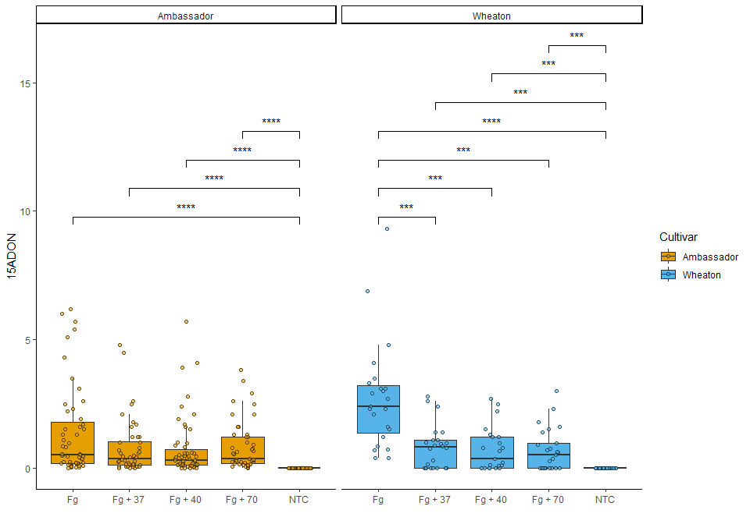

### MassperSeed_mg with pairwise comparisons

plot3 <- ggplot(Mycotoxin, aes(x=Treatment, y=MassperSeed_mg, fill=Cultivar)) +  
 geom_boxplot(outlier.color=NA) +  
 geom_point(pch=21, alpha=0.6, color="black",   
 position=position_jitterdodge(dodge.width=0.9)) +  
 geom_pwc(aes(group = Treatment), method = "t_test", label = "p.signif")+  
   
 xlab("") +  
 ylab("Seed Mass (mg)") +  
   
 theme_classic() +  
 scale_fill_manual(values=cbbPalette) +  
 facet_wrap(~Cultivar)   
   
  
plot3

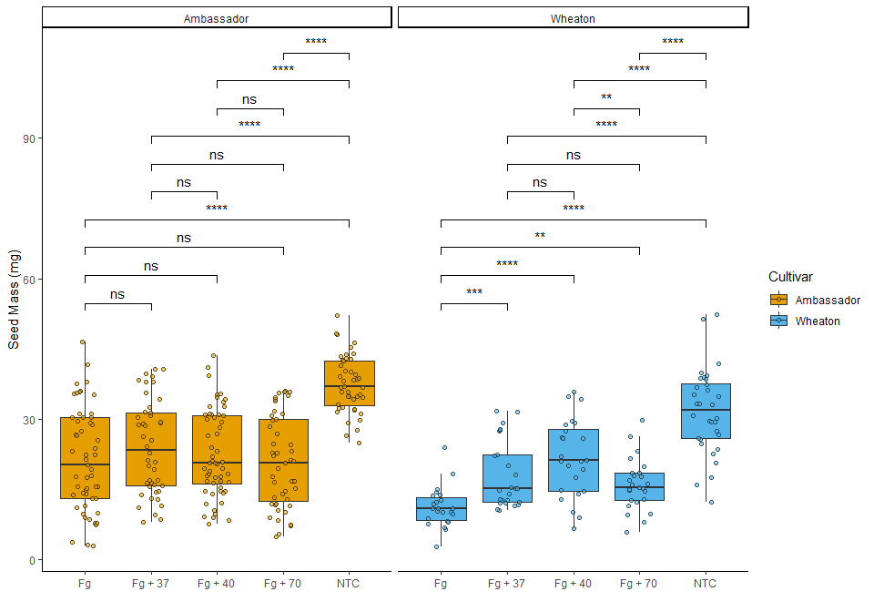

### Combining the three plots into one file

combined_plots <- ggarrange(plot1, plot2, plot3,   
 ncol = 1, nrow = 3,   
 labels = c("A", "B", "C"))  
  
combined_plots

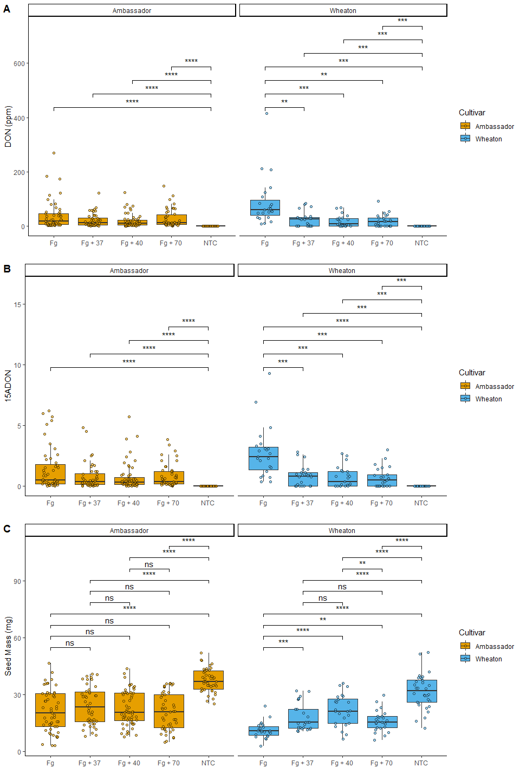

ggsave("combined_plot.jpeg", plot = combined_plots, width =15 , height = 10)   
#Saving Plot to Rproject Folder

## Question 6

[link to GitHub](https://github.com/temkat/CodingChallenge4.git)