RmarkdownTurtialNotes

Katie Temple

2025-02-21

# Notes on rednering output documents for this.

title: “RmarkdownTurtialNotes” author: “Katie Temple” date: “2025-02-21” output: md_document: variant: gfm -this is for github “Github Flavored Markdown” should me an .md file (also the way we are going to create our READMEs) html_document: toc: true -generates a clickable table of contents toc_float: true -Gerates floating table of contents like a webpage word_document: pdf_document:

#Under name, include= TRUE includes the code chunk output and FALSE foes not  
#echo=TRUE will the code chunk, FALSE won't.  
#If there are errors in the R code, the rendering of the document won't work  
#It is one way to check yourself.

# Including figures

This is how you can include figures:

library(ggplot2)  
data("mtcars")  
ggplot(mtcars, aes(x=wt, y=mpg))+  
 geom_point()

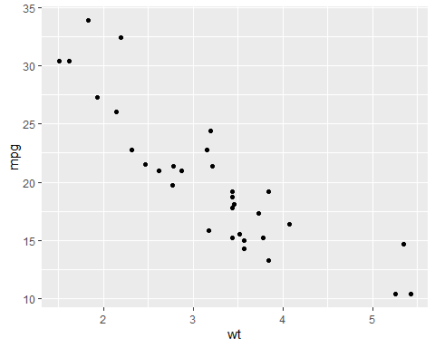 # Notes on Section Headers

You can see how it generates when looking at the outline area to the right. YOU MUST INCLUDE SPACES AFTER EACH THE NUMBER OF ### YOU WANT TO GET THE HEADING TO RENDER # First-level

## Second Level

#### subheader under the second level

### Third Level

# Style and Emphasis

use the tilde key for the “`” backquote symbol. (is symbol below tilde) to show if something is code specifically (like a function)

ggplot()

*italic* can be used for scientific names. Use single *before and after what you want italicized

*Myadestes palmeri*

**bold** uses ** on either end of what you want bolded **HELLO**

You can also insert blockquotes (for example a quopte that is clearly displayed in the final document, like at the beginning of a book chapter) Blockquotes are written after “>” example:

“I thoroughly disapprove of duels. If a man should challenge me,  
I would take him kindly and forgivingly by the hand and lead him  
to a quiet place and kill him.”

— Mark Twain

Again, be super careful of actually using spaces

# Lists

## Unordered Lists

* one item
* another item
* another one
  + a sub item
  + another subitem
  + again

## Ordered Lists

1. One
2. Two
3. Three

* subitem

# Inserting Links and Websites

### Not hyperlinked

https://abcbirds.org/bird/puaiohi

### Hyperlink

<https://abcbirds.org/bird/puaiohi/>

### Renamed Hyperlink

[Puaiohi (American Bird Conservancy)](https://abcbirds.org/bird/puaiohi/)

# Inserting Images!

#If you forgot the exclamation mark (!), it will become just a link 