**Tugas Simple Querry 2**

**By : Andi Wahyu Khusnul Malik**

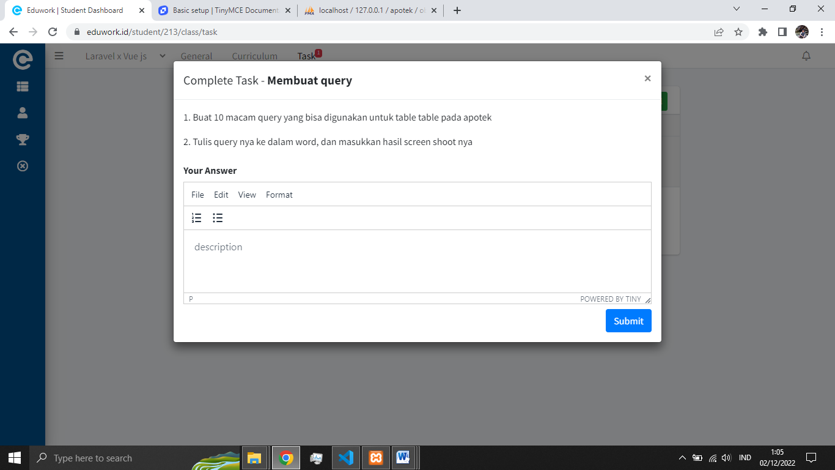 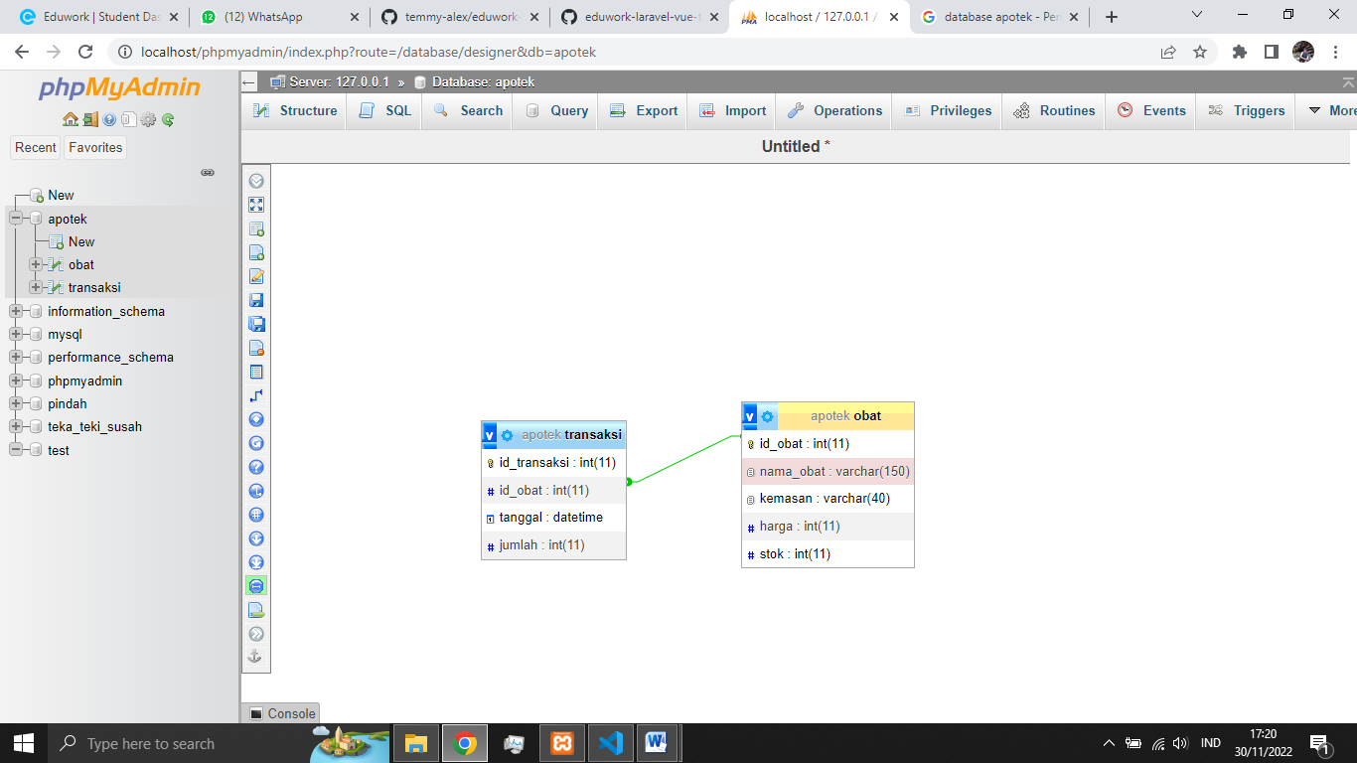

[Database](https://github.com/temmy-alex/eduwork-laravel-vue-temmy/blob/andi_wahyu-belajar_git/andi_wahyu/tugas_database/tugas_database_apotek.sql)

1. [SELECT](http://localhost/phpmyadmin/url.php?url=https://dev.mysql.com/doc/refman/8.0/en/select.html) * FROM `obat`;

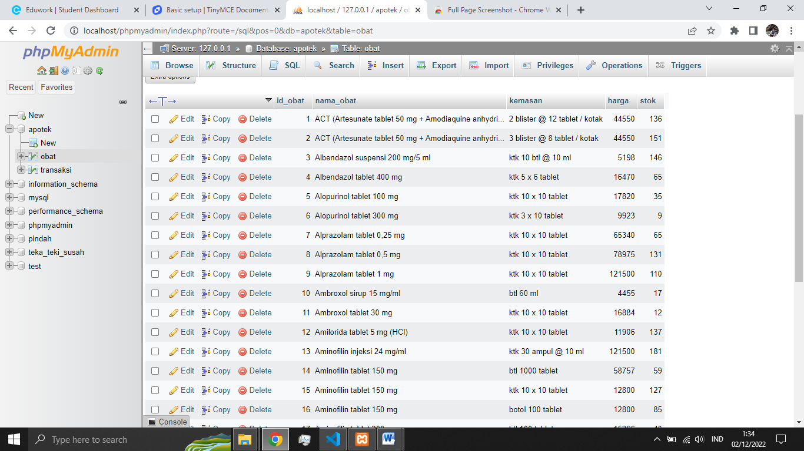

1. [SELECT](http://localhost/phpmyadmin/url.php?url=https://dev.mysql.com/doc/refman/8.0/en/select.html) * FROM `transaksi`;

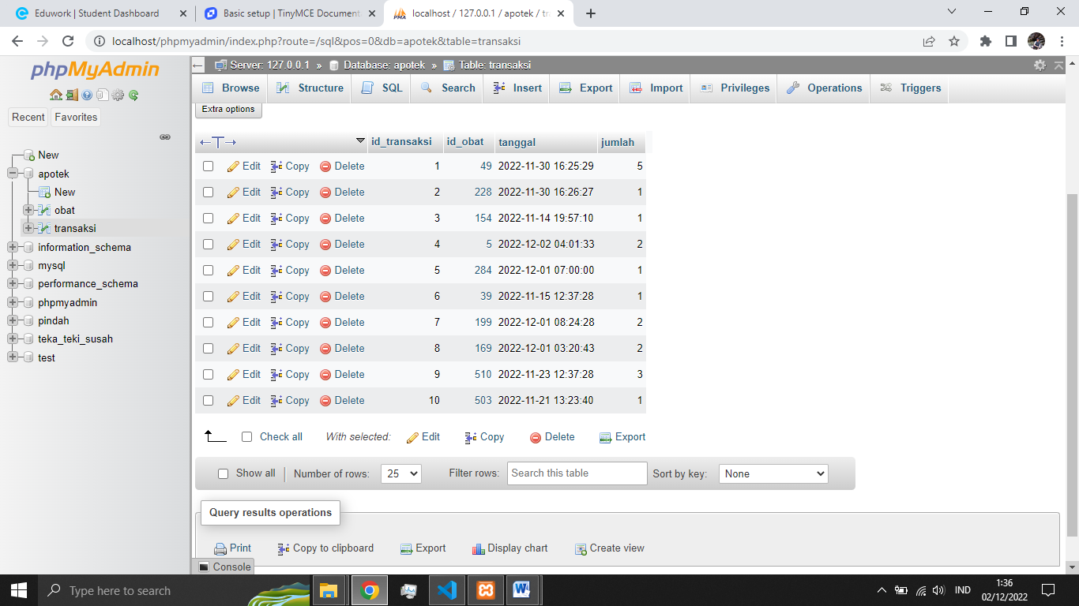

1. [SELECT](http://localhost/phpmyadmin/url.php?url=https://dev.mysql.com/doc/refman/8.0/en/select.html) * FROM `obat` WHERE nama_obat [LIKE](http://localhost/phpmyadmin/url.php?url=https://dev.mysql.com/doc/refman/8.0/en/string-comparison-functions.html%23operator_like) '%vitamin c%';

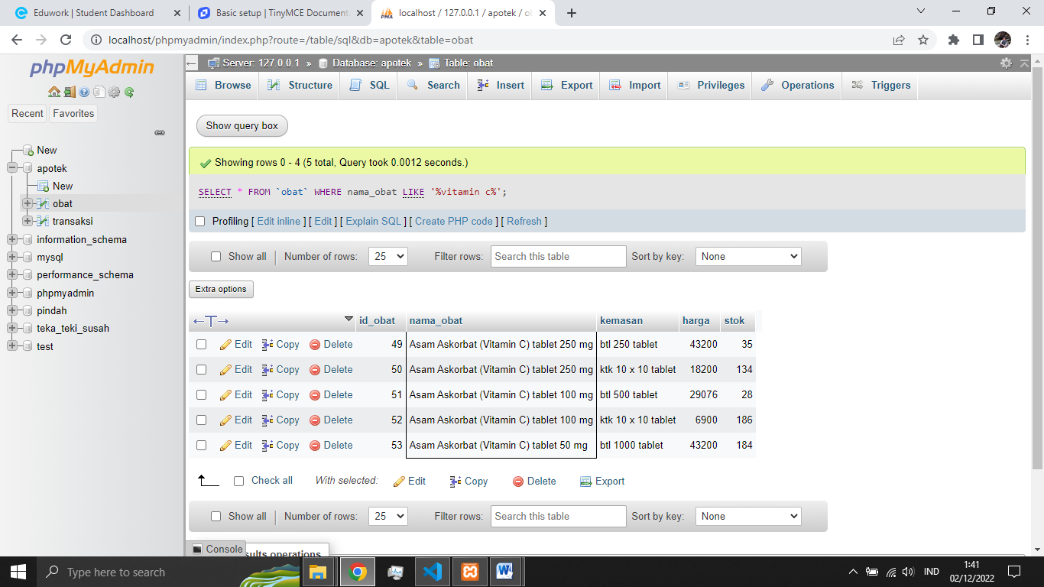

1. [SELECT](http://localhost/phpmyadmin/url.php?url=https://dev.mysql.com/doc/refman/8.0/en/select.html) id_obat, nama_obat, kemasan FROM `obat` WHERE stok = 0;

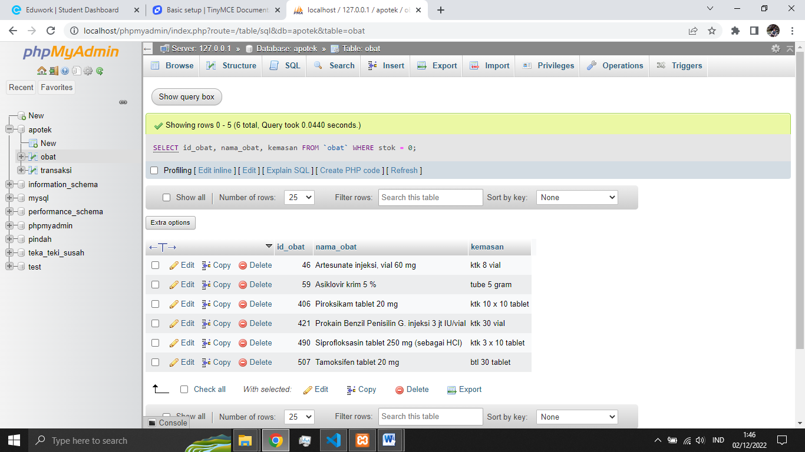

1. [SELECT](http://localhost/phpmyadmin/url.php?url=https://dev.mysql.com/doc/refman/8.0/en/select.html) * FROM `obat` WHERE stok < 6 [AND](http://localhost/phpmyadmin/url.php?url=https://dev.mysql.com/doc/refman/8.0/en/logical-operators.html%23operator_and) stok > 0;

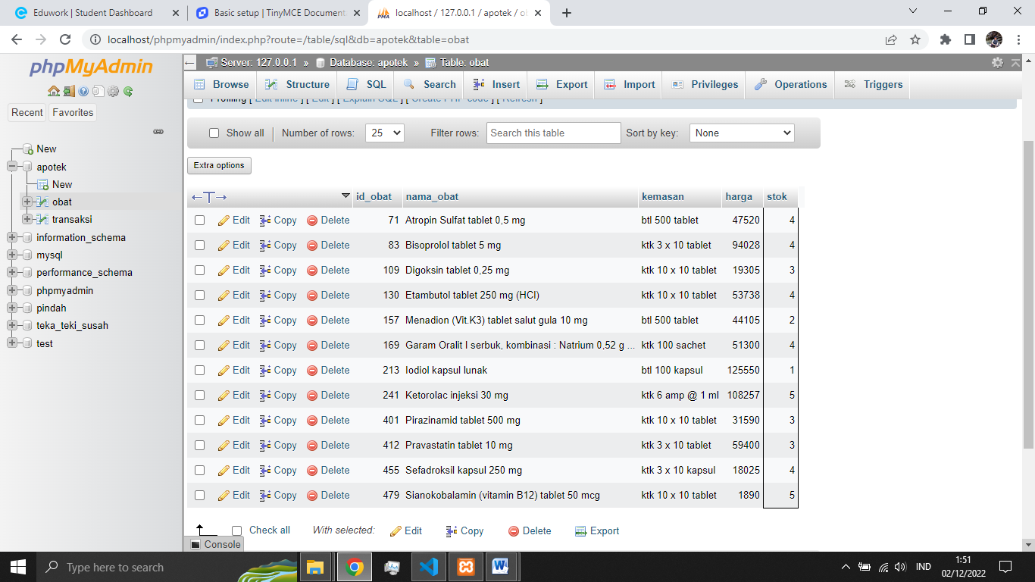

1. [SELECT](http://localhost/phpmyadmin/url.php?url=https://dev.mysql.com/doc/refman/8.0/en/select.html) * FROM `obat` WHERE kemasan = 'ktk 3 X 10 tablet' ORDER BY harga DESC;

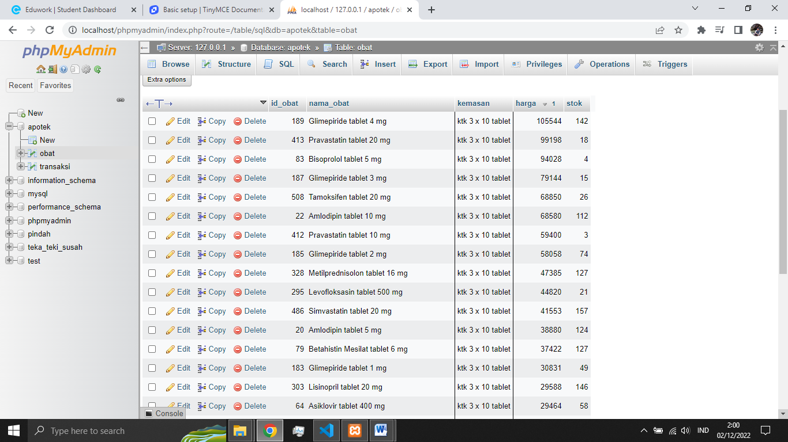

1. [SELECT](http://localhost/phpmyadmin/url.php?url=https://dev.mysql.com/doc/refman/8.0/en/select.html) `nama_obat`, `harga`, `stok` FROM `obat` WHERE nama_obat [LIKE](http://localhost/phpmyadmin/url.php?url=https://dev.mysql.com/doc/refman/8.0/en/string-comparison-functions.html%23operator_like) '%vitamin c%' [AND](http://localhost/phpmyadmin/url.php?url=https://dev.mysql.com/doc/refman/8.0/en/logical-operators.html%23operator_and) harga < 10000;

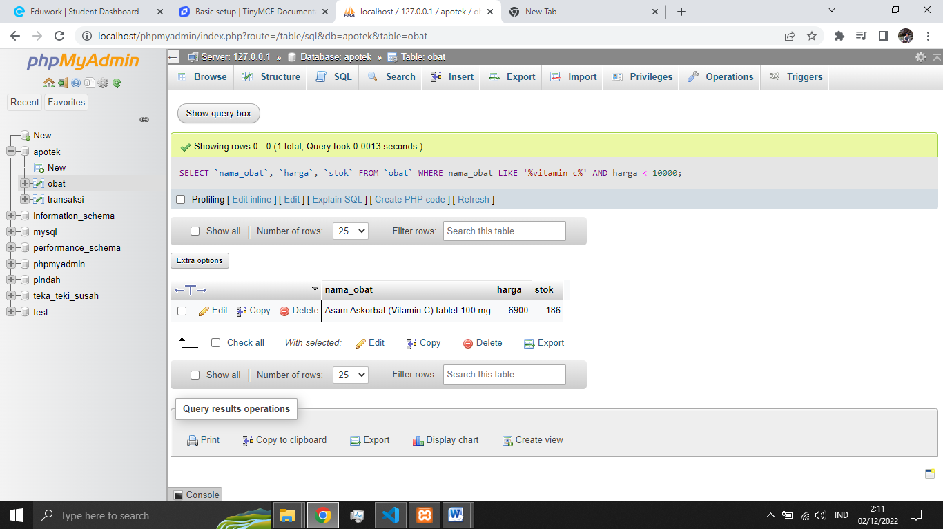

1. [SELECT](http://localhost/phpmyadmin/url.php?url=https://dev.mysql.com/doc/refman/8.0/en/select.html) * FROM `transaksi` WHERE jumlah > 1;

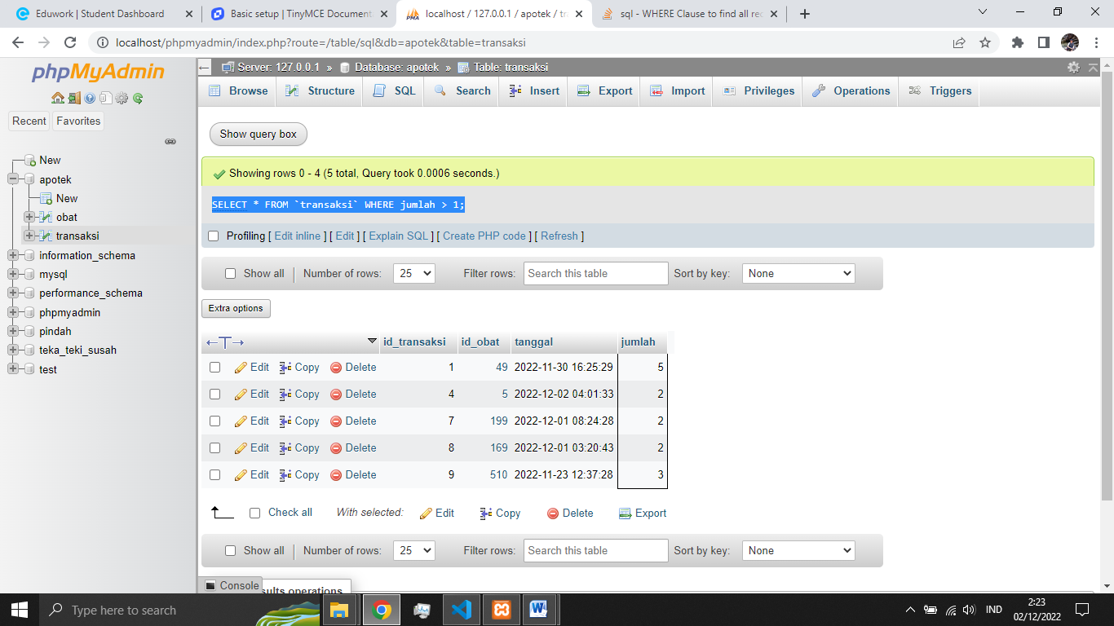

1. [SELECT](http://localhost/phpmyadmin/url.php?url=https://dev.mysql.com/doc/refman/8.0/en/select.html) transaksi.*, obat.nama_obat AS 'nama obat' FROM `transaksi` INNER JOIN obat ON transaksi.id_obat = obat.id_obat;

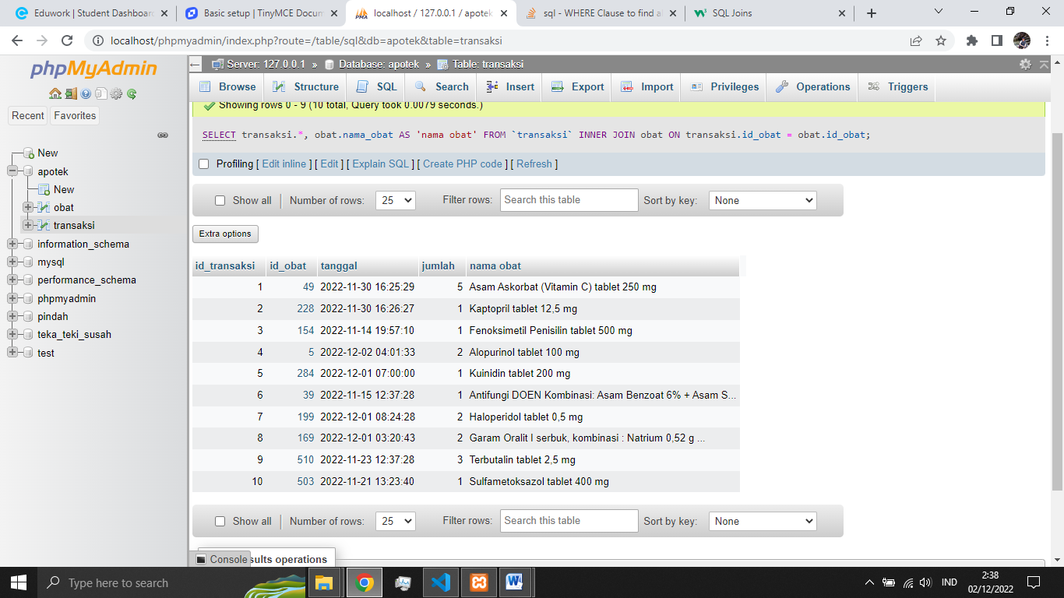

1. [SELECT](http://localhost/phpmyadmin/url.php?url=https://dev.mysql.com/doc/refman/8.0/en/select.html) transaksi.id_transaksi, obat.nama_obat AS 'nama obat', transaksi.tanggal, transaksi.jumlah FROM `transaksi` INNER JOIN obat ON transaksi.id_obat = obat.id_obat WHERE MONTH(transaksi.tanggal) = 11;

