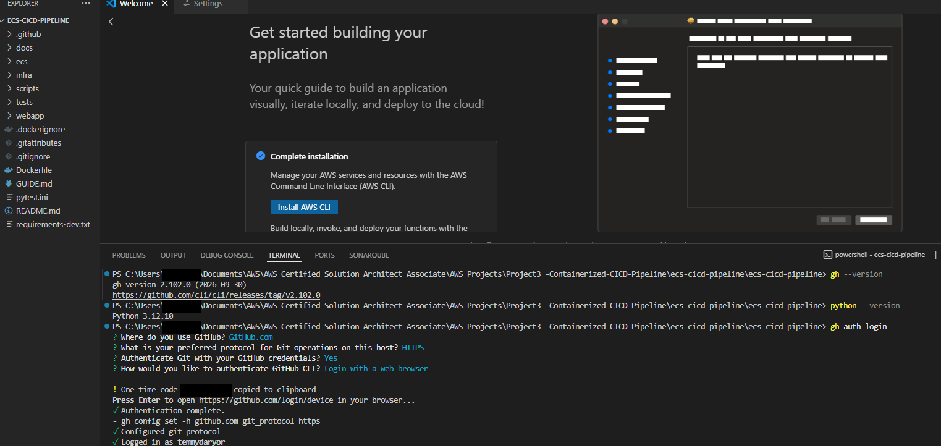

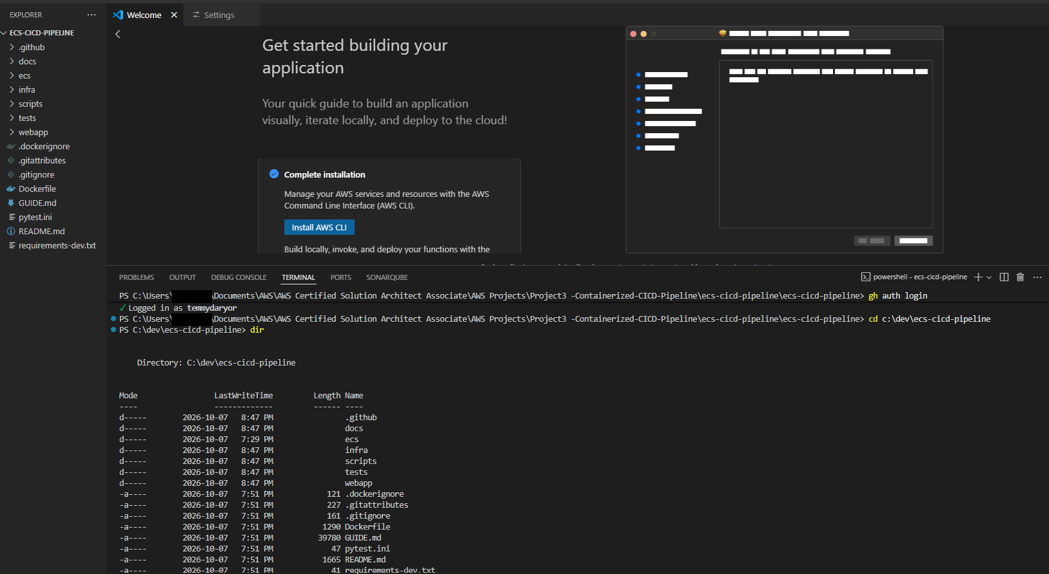

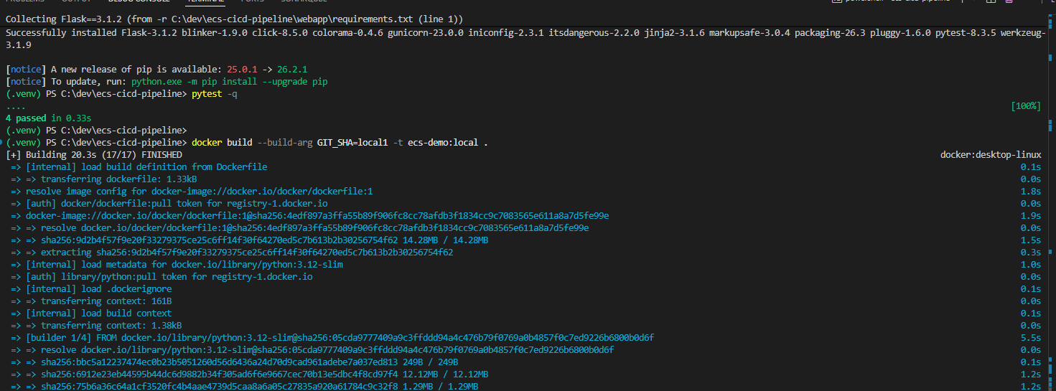

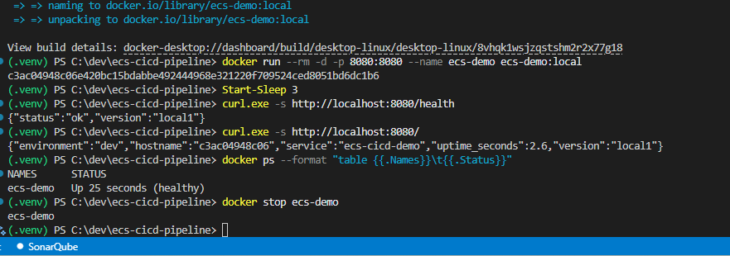

Run the unit tests
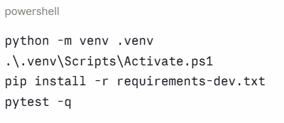

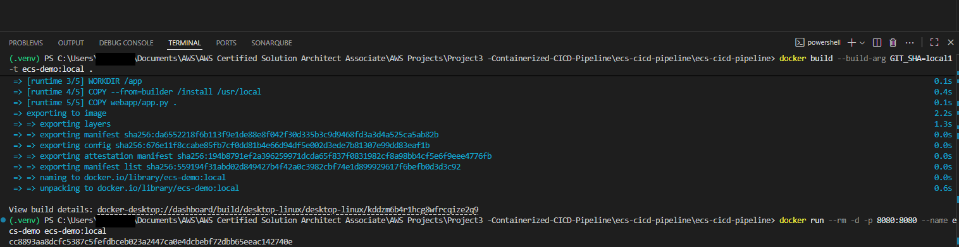

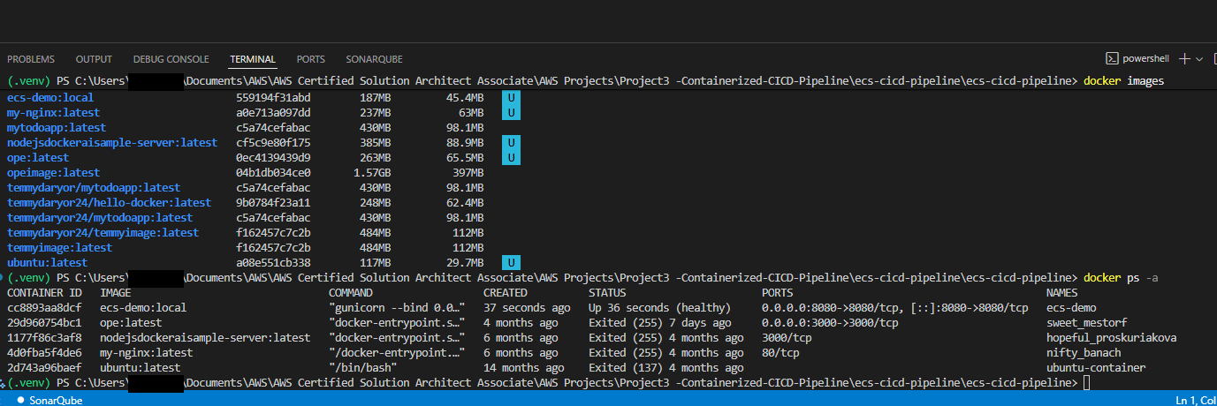

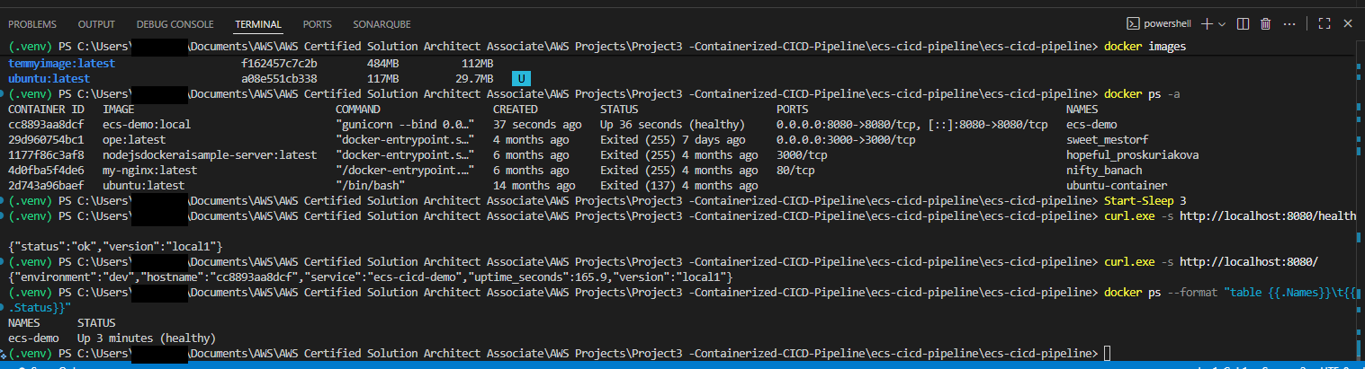

Size of the Multistage build
Single Stage build vs Multistage Build
Single Stage= 1.63Gb
Multistage image = 187MB

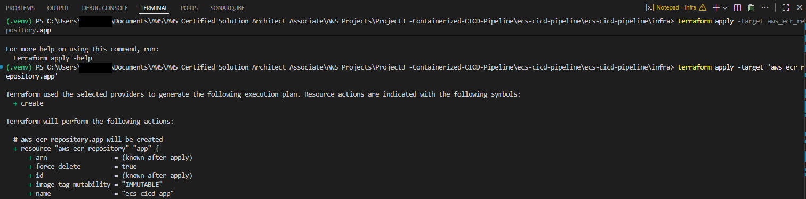

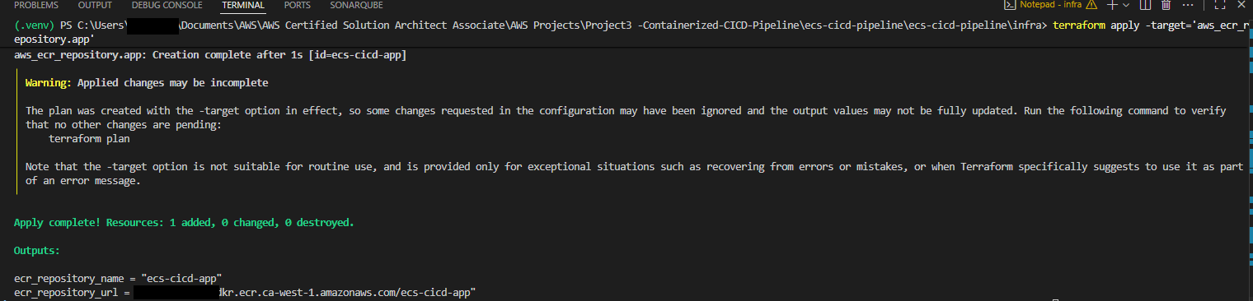

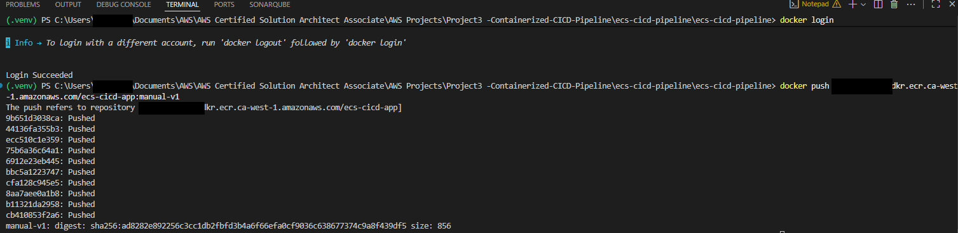

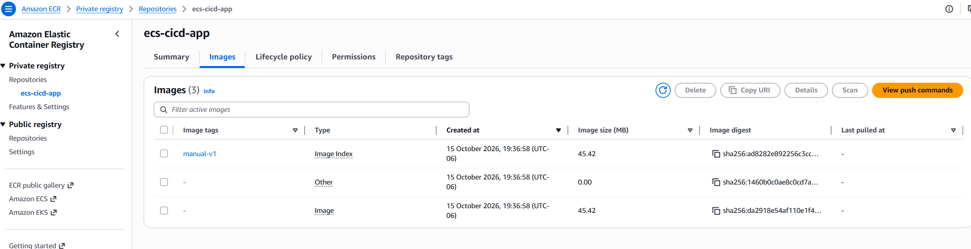

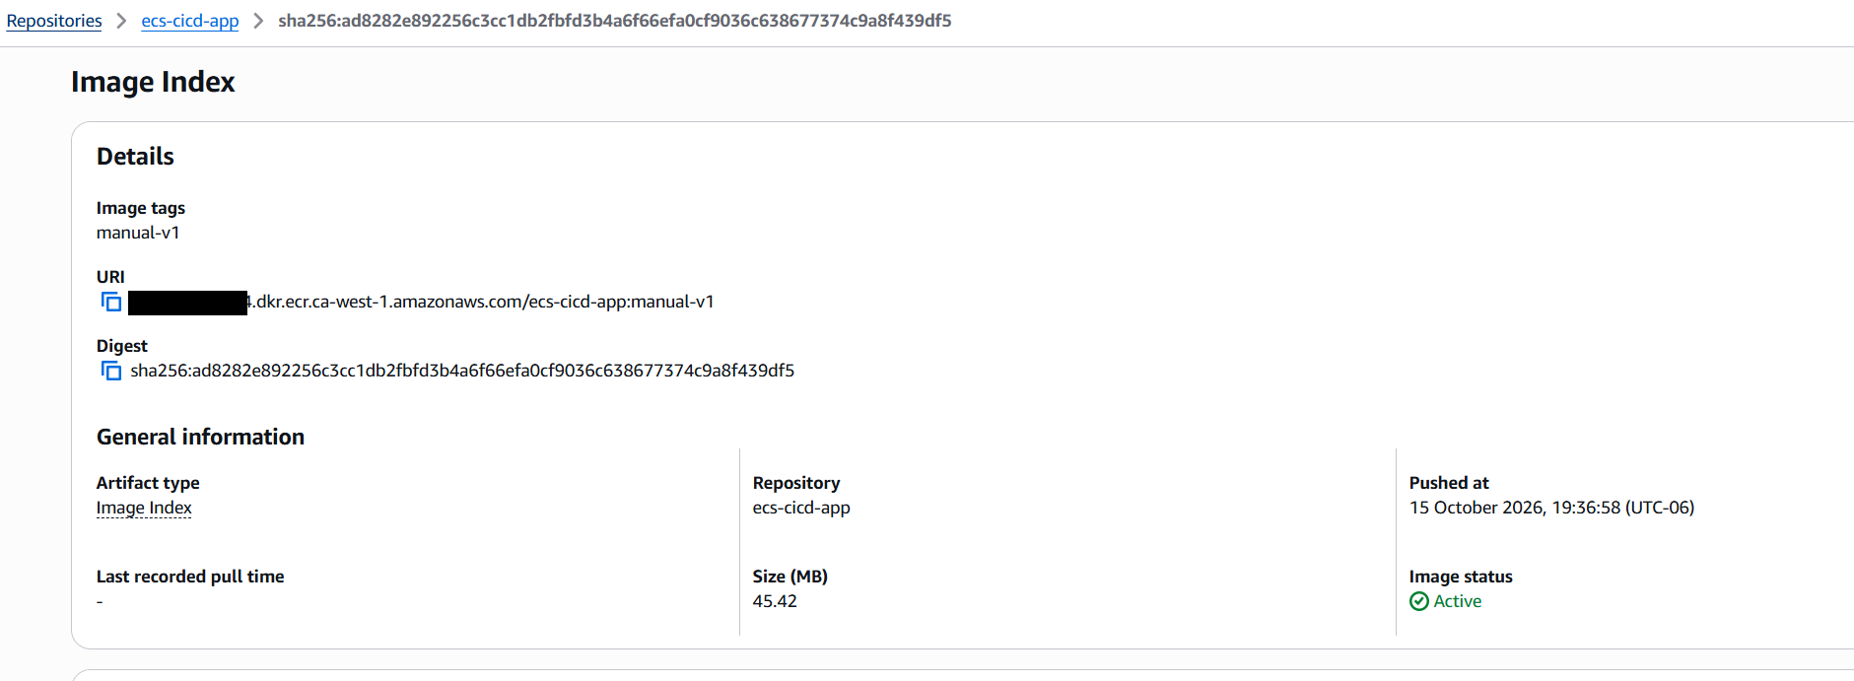
Image pushed to ECR
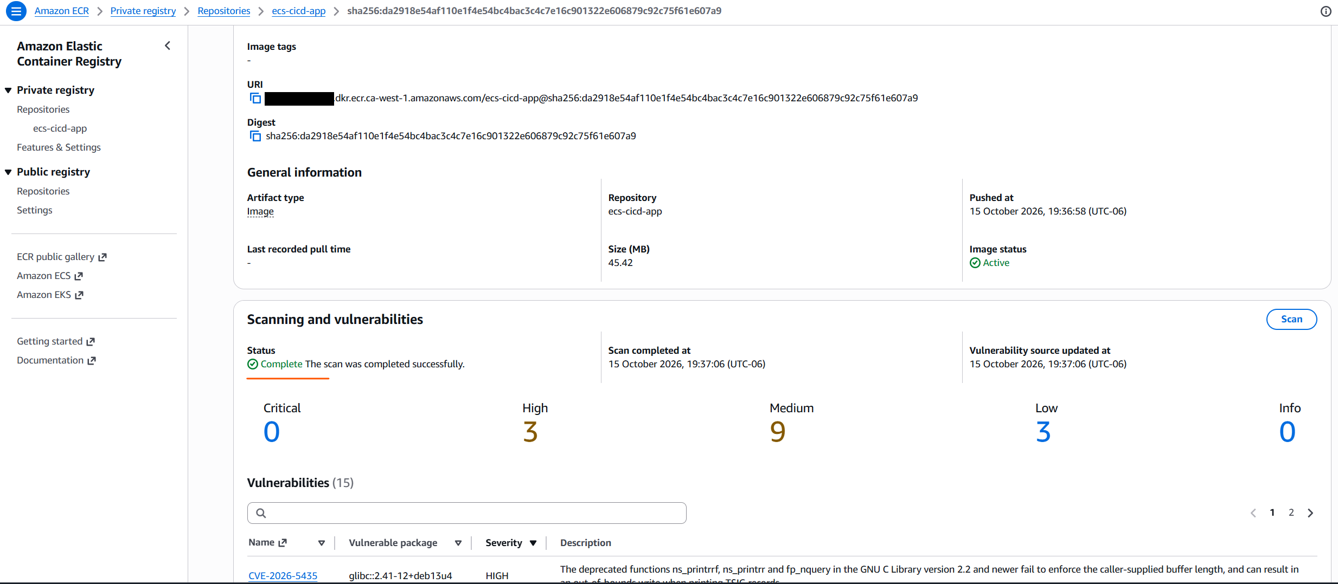
Vulnerability Scan

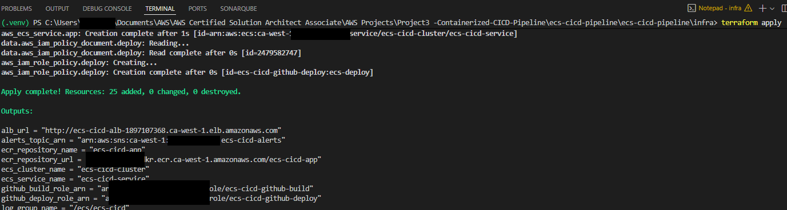
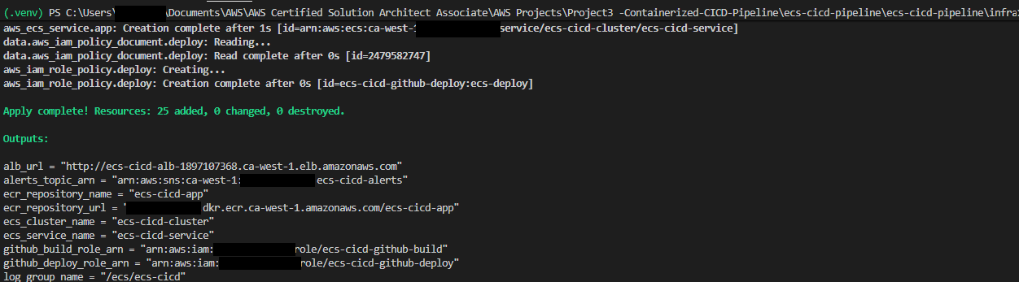

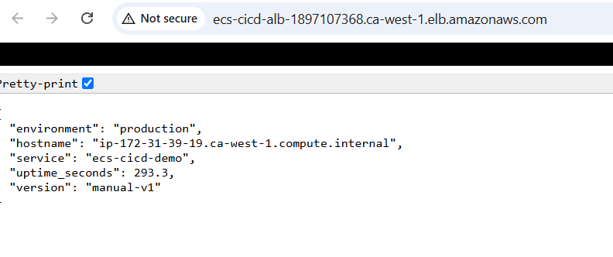
Outcome from Load Balancer
- Fargate- 1
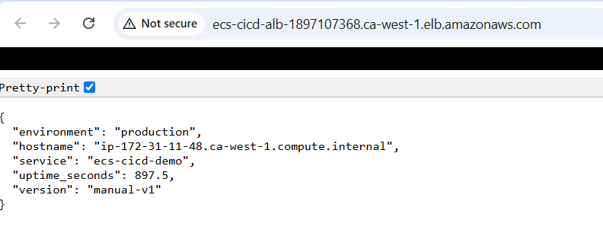
Outcome from Load Balancer – Fargate 2

Same result from the console

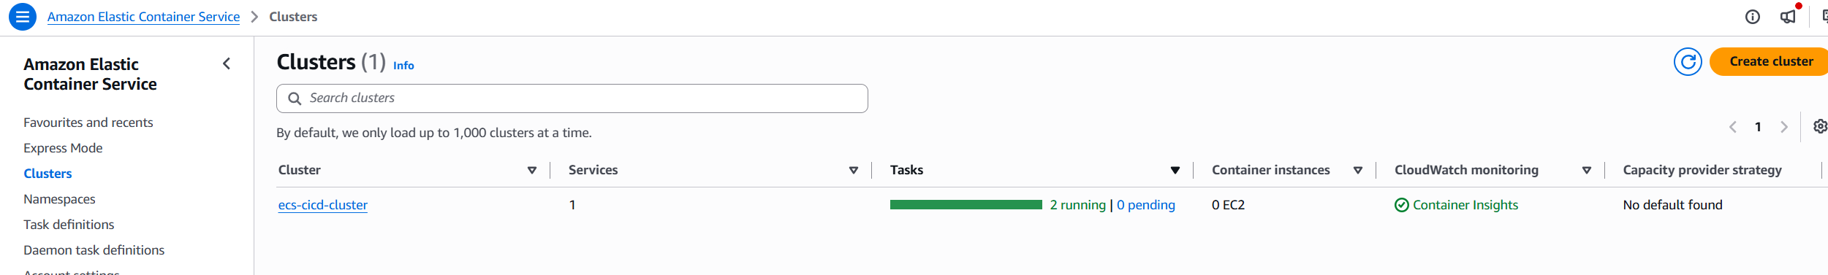

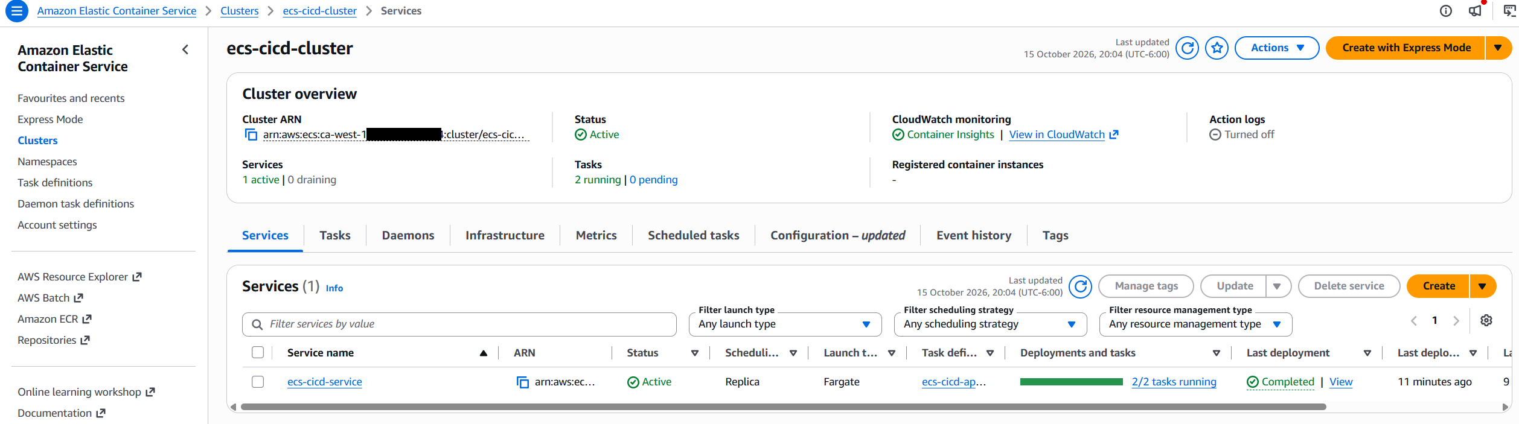

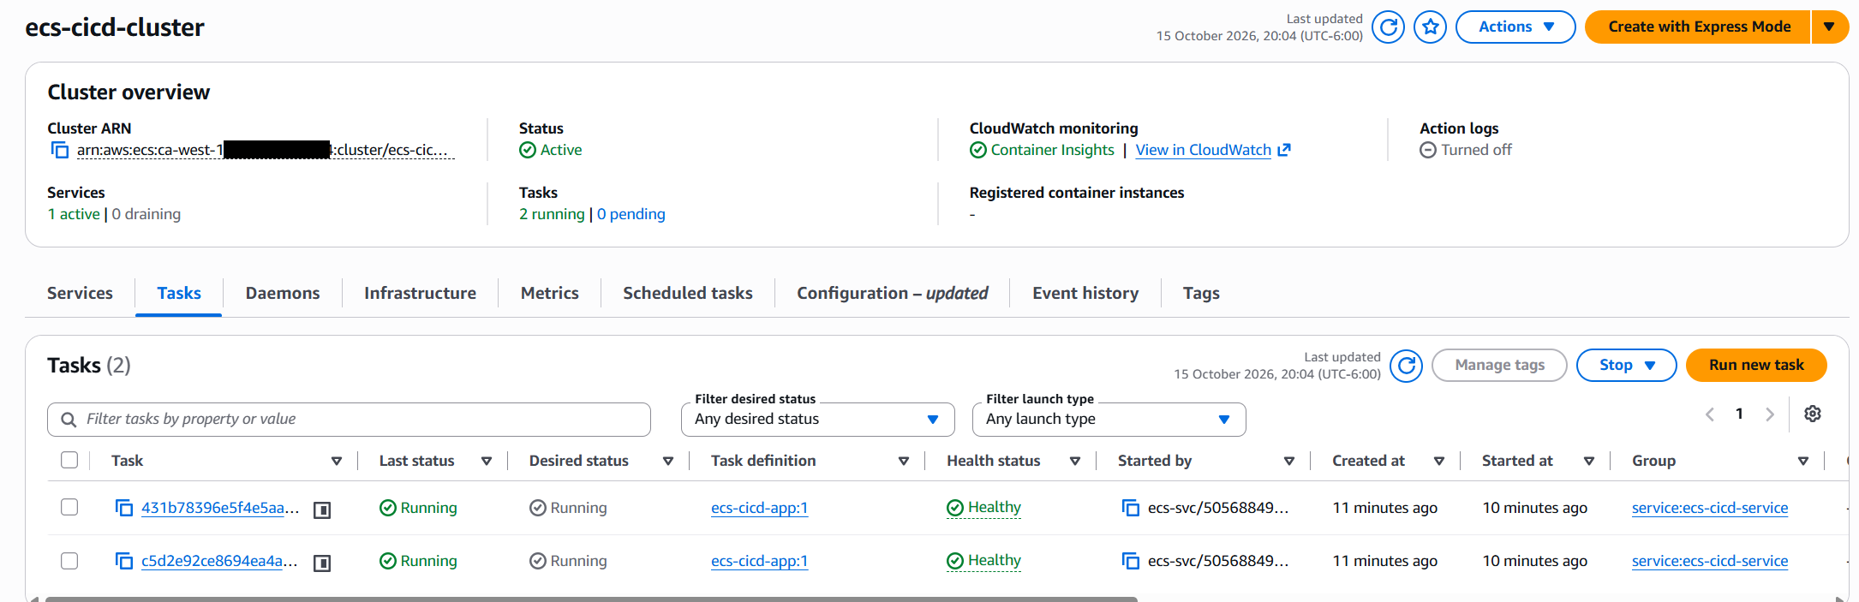

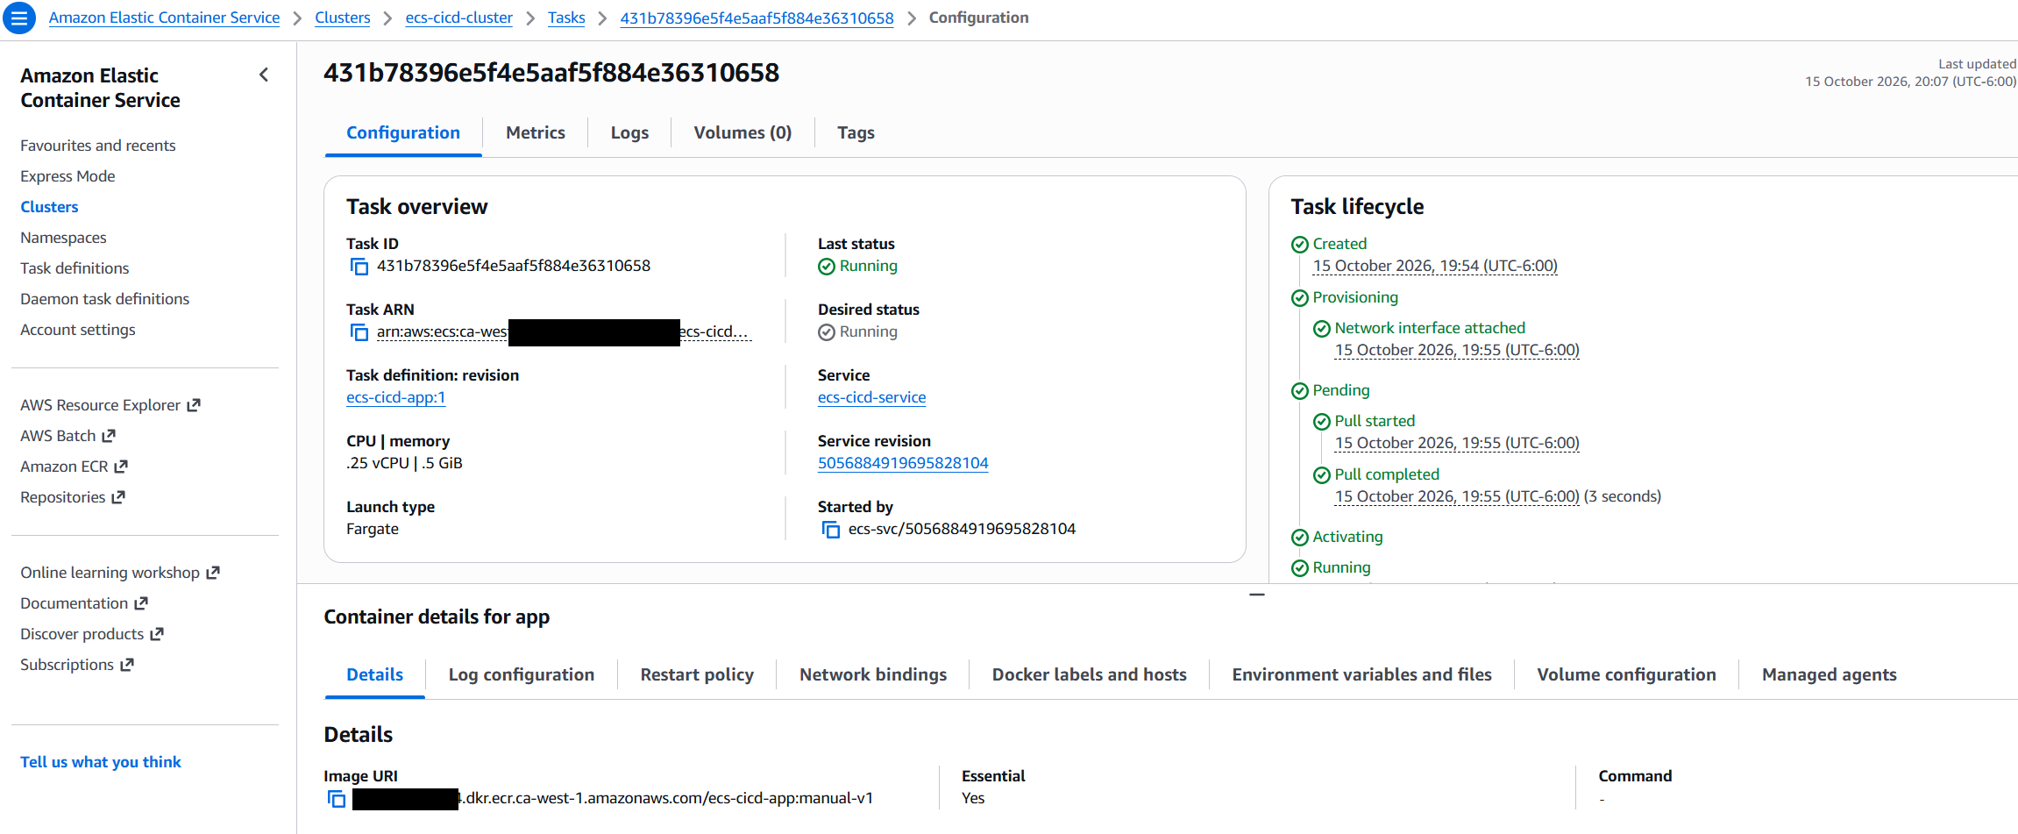

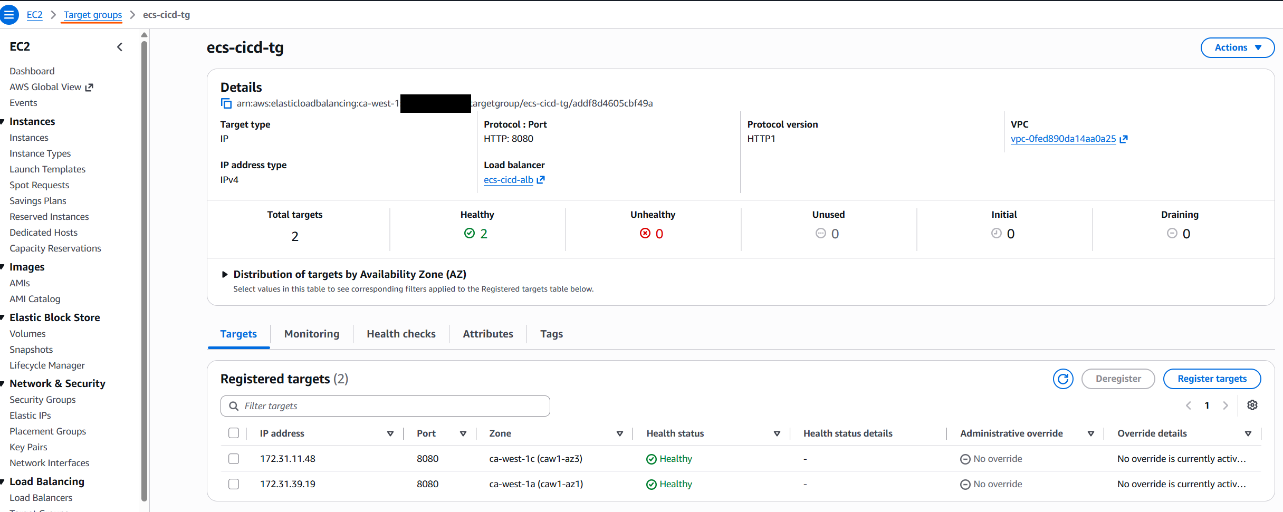Target Group

Version 2 deployed- Manual 2

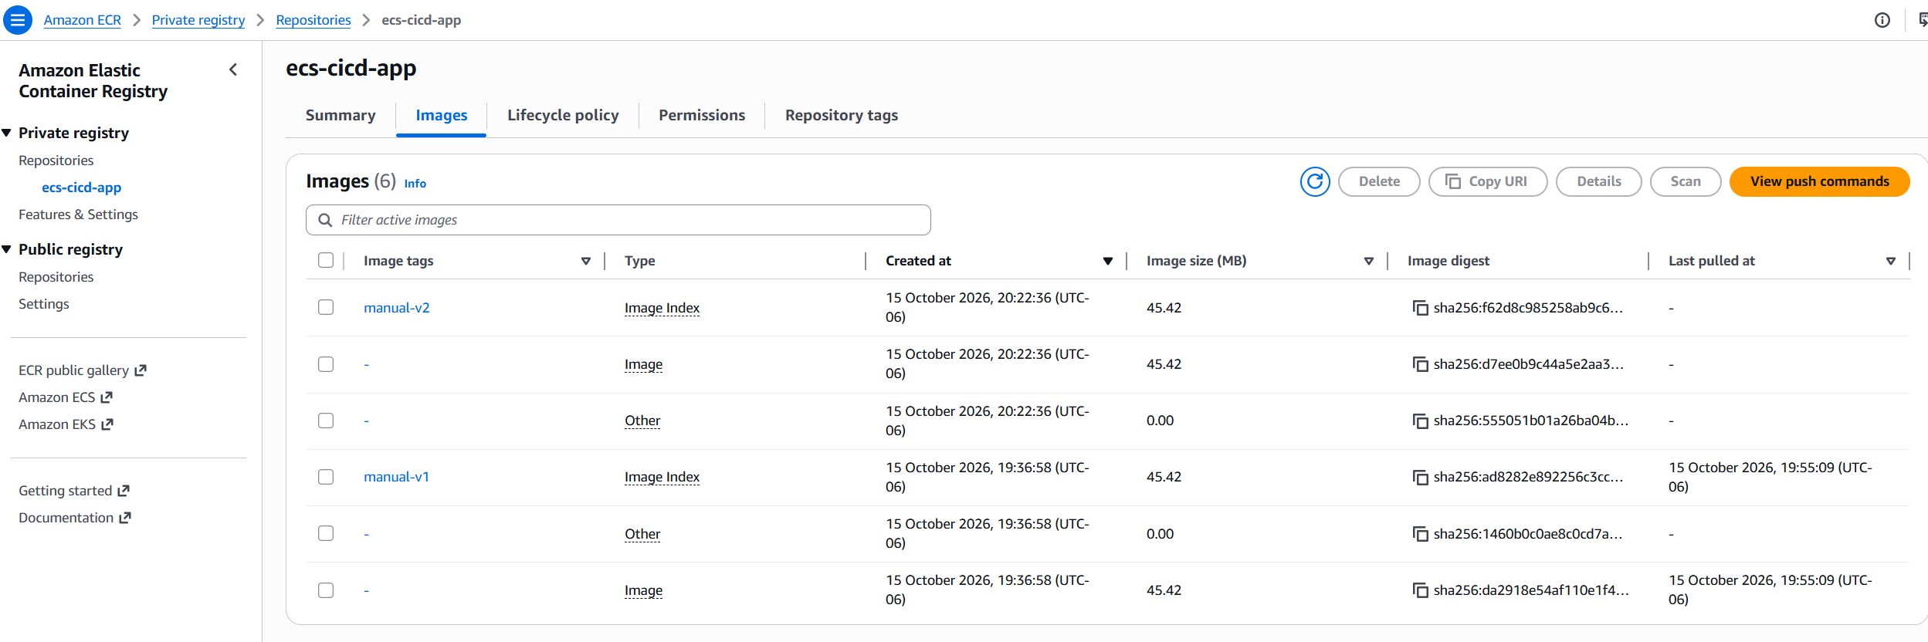
V2 has been pushed to ECR
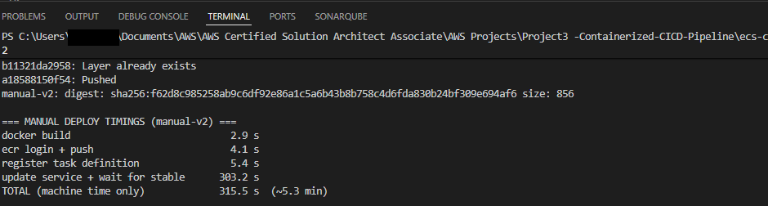
Version 2 deployed- Manual 2

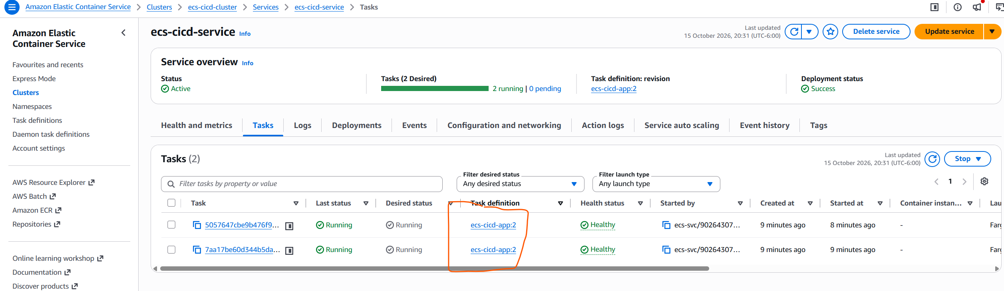
Task Definition show app2.

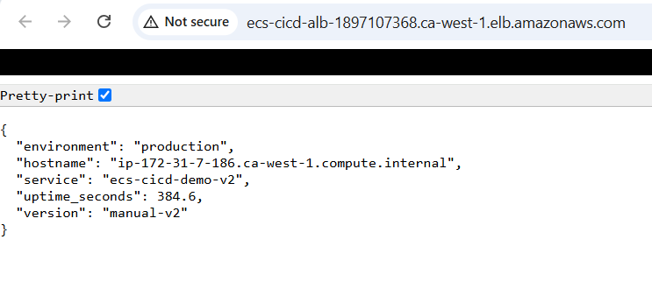

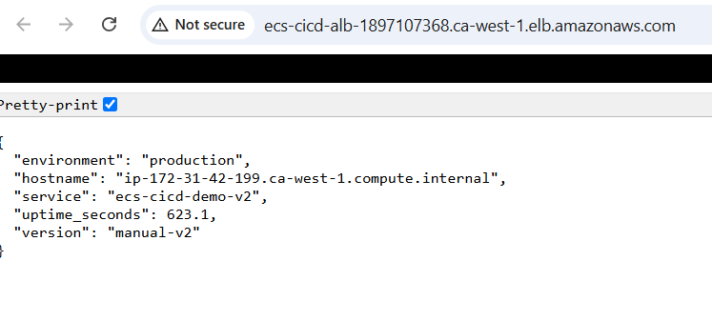
Load balance url showing the 2 tasks from the ECS cluster.

Version 3 Pushed
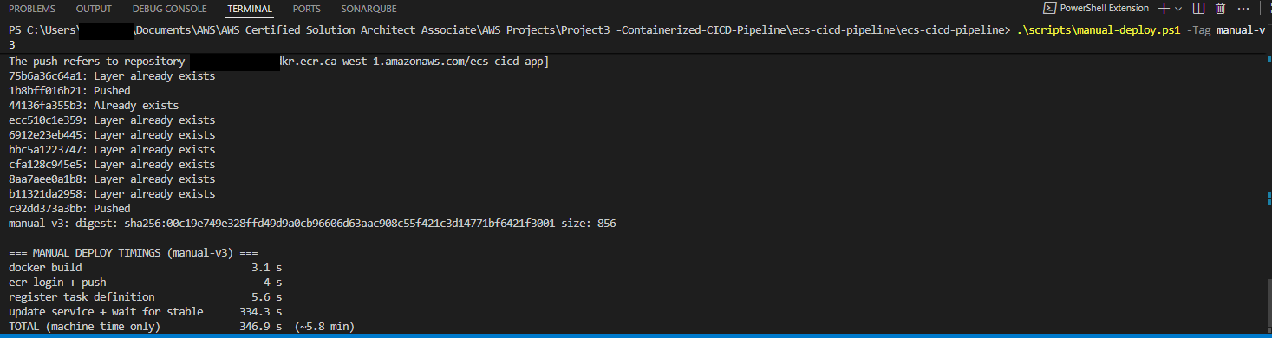

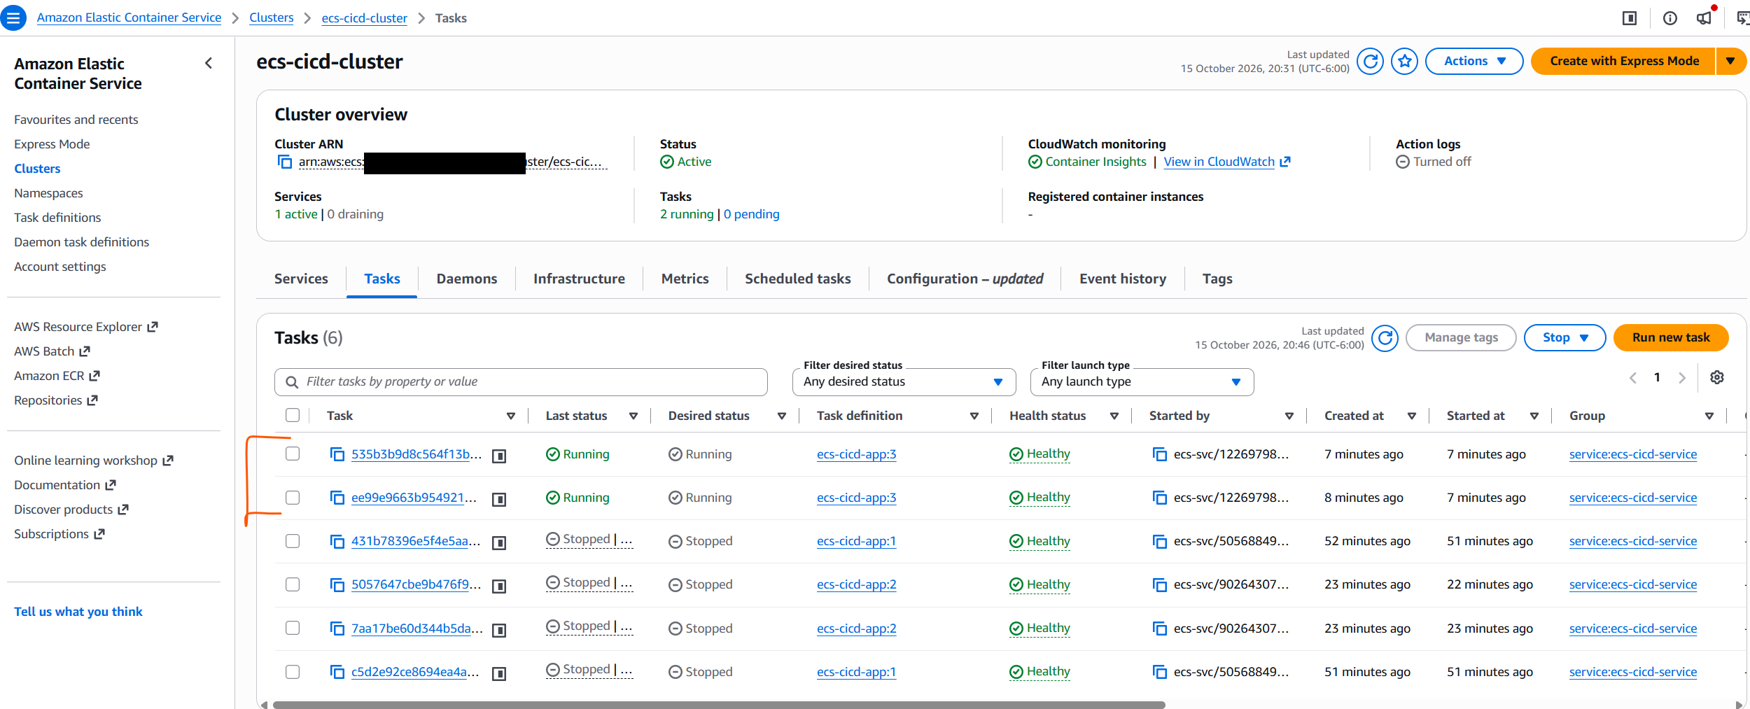

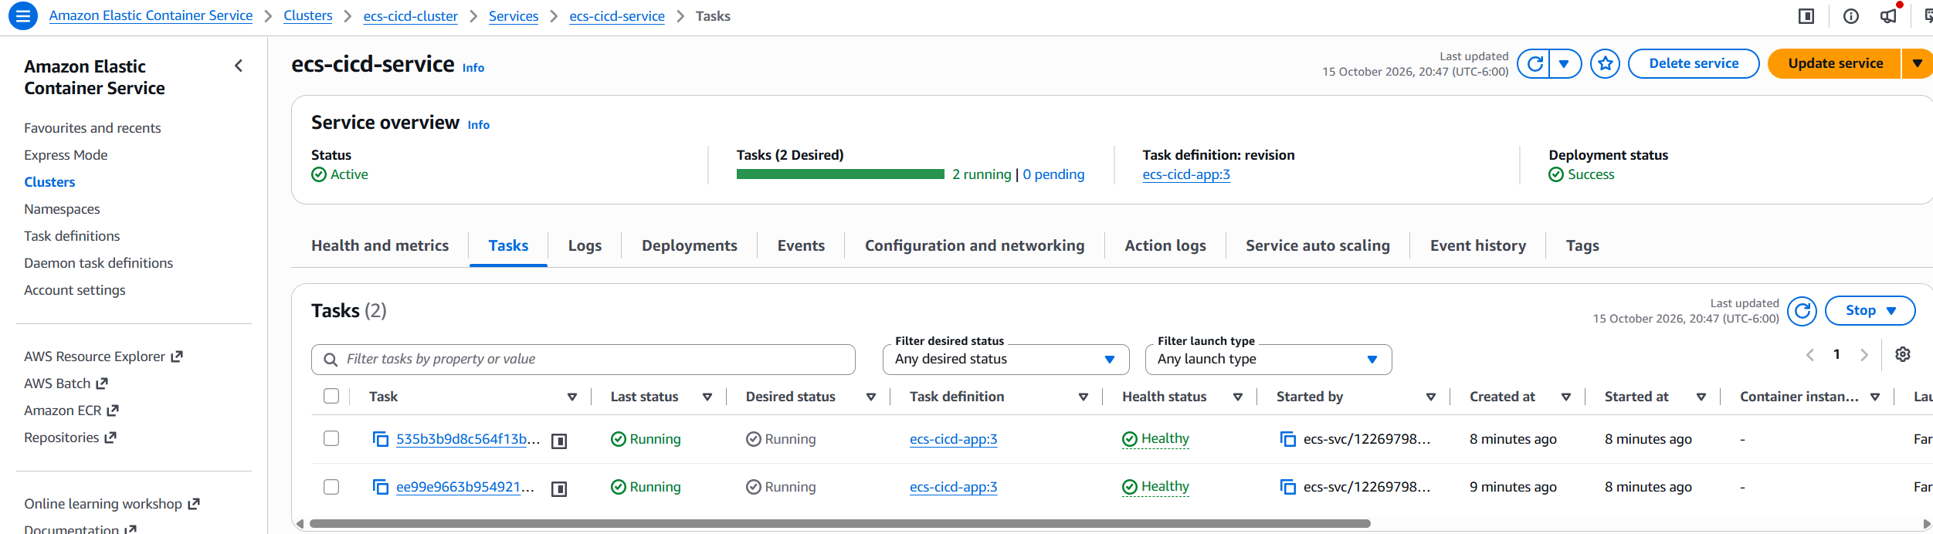

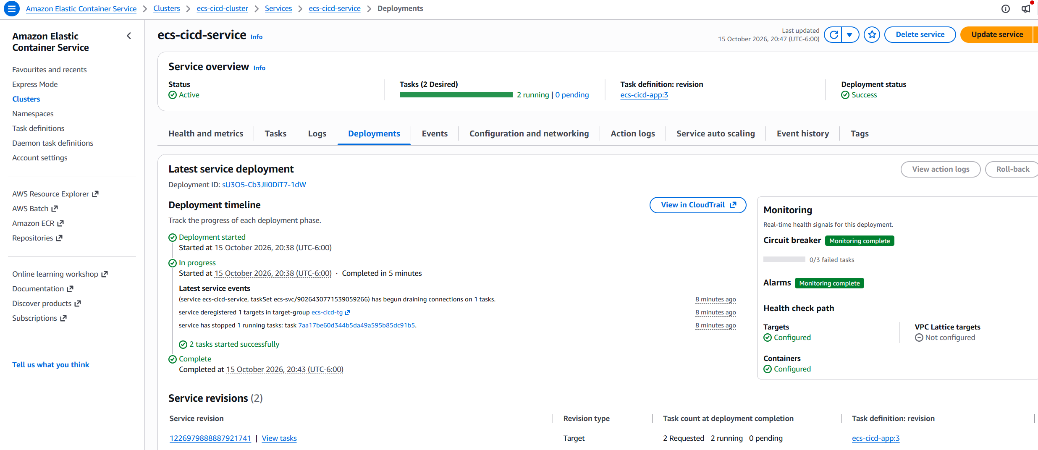

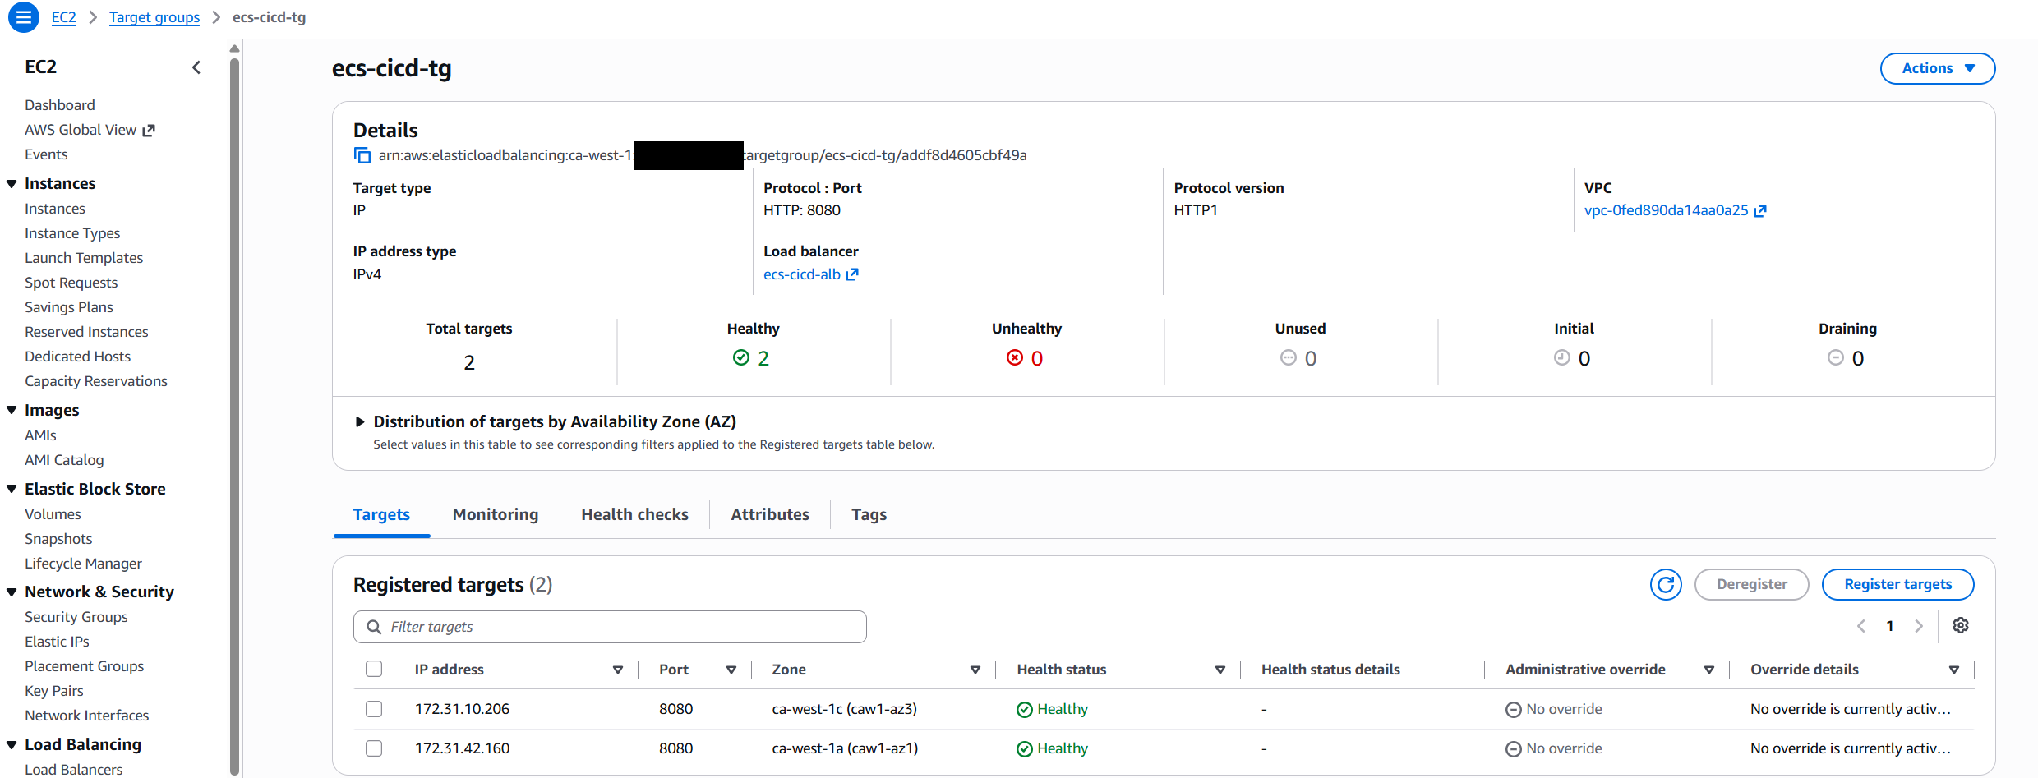
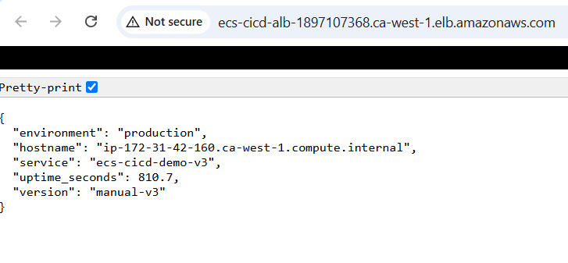

Version 4 pushed to ECR
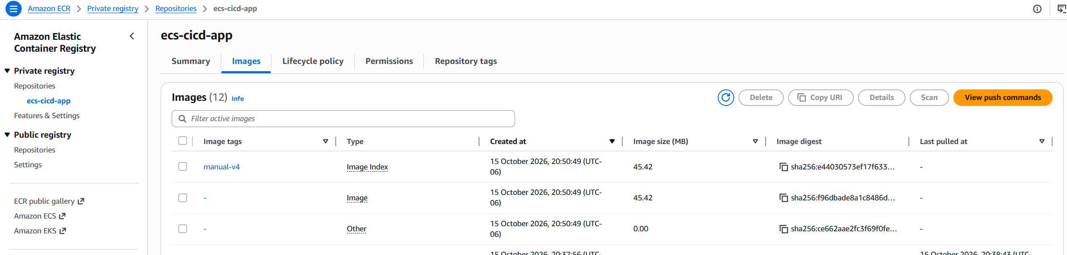

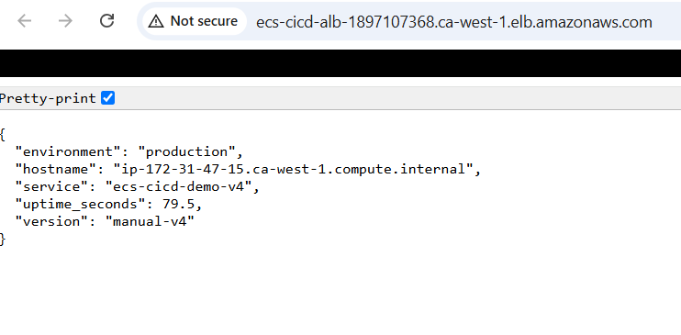
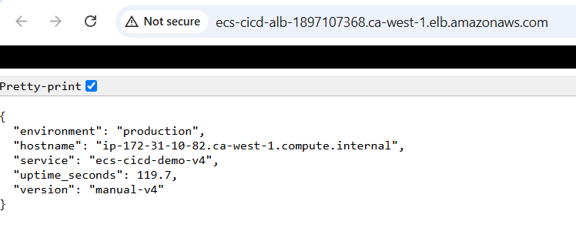

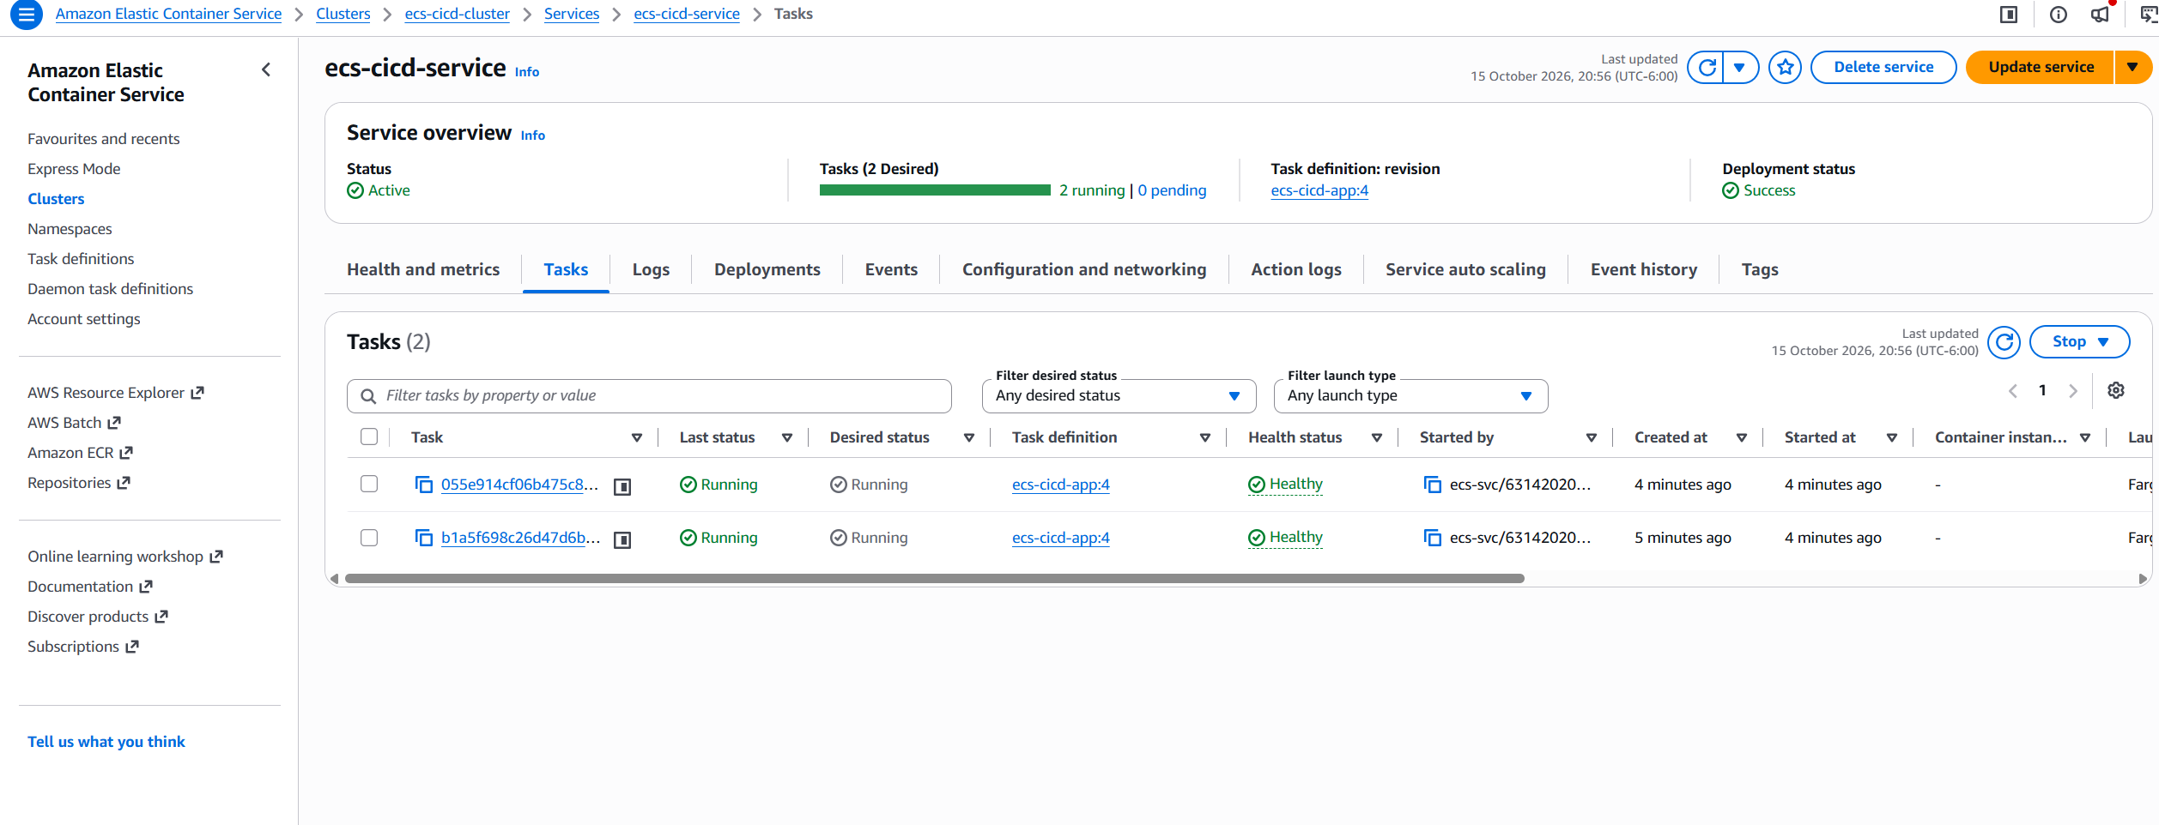

Push to GitHub
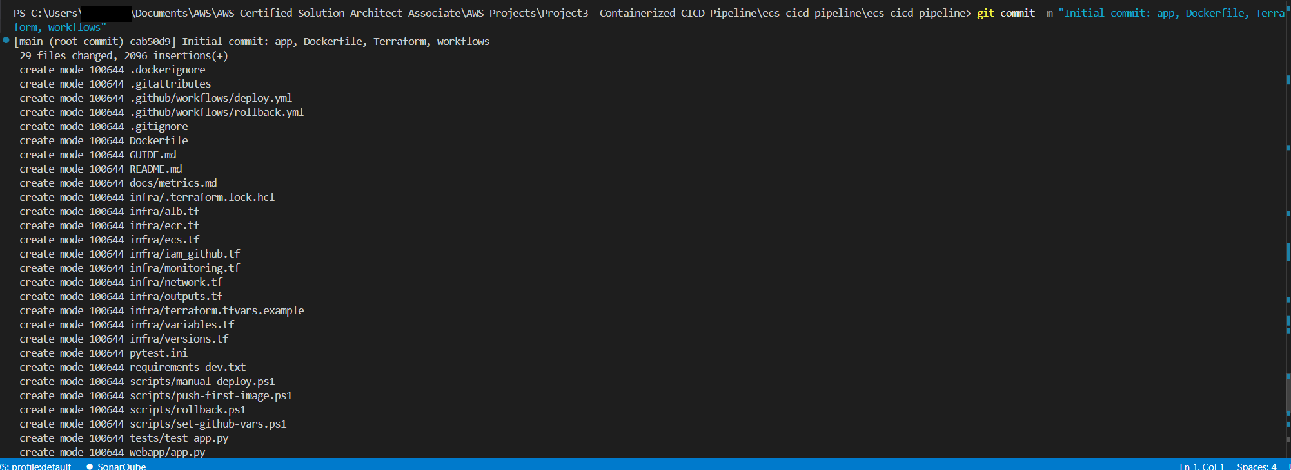

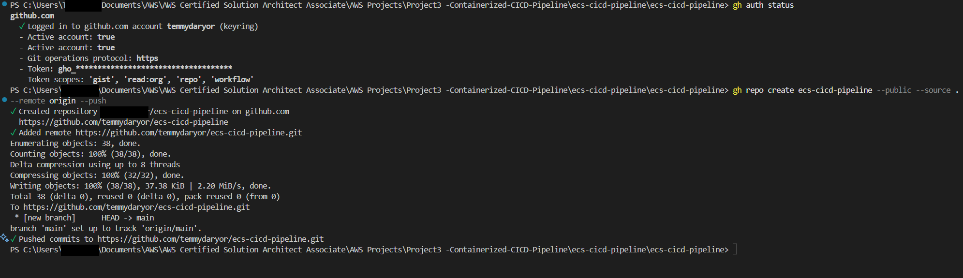

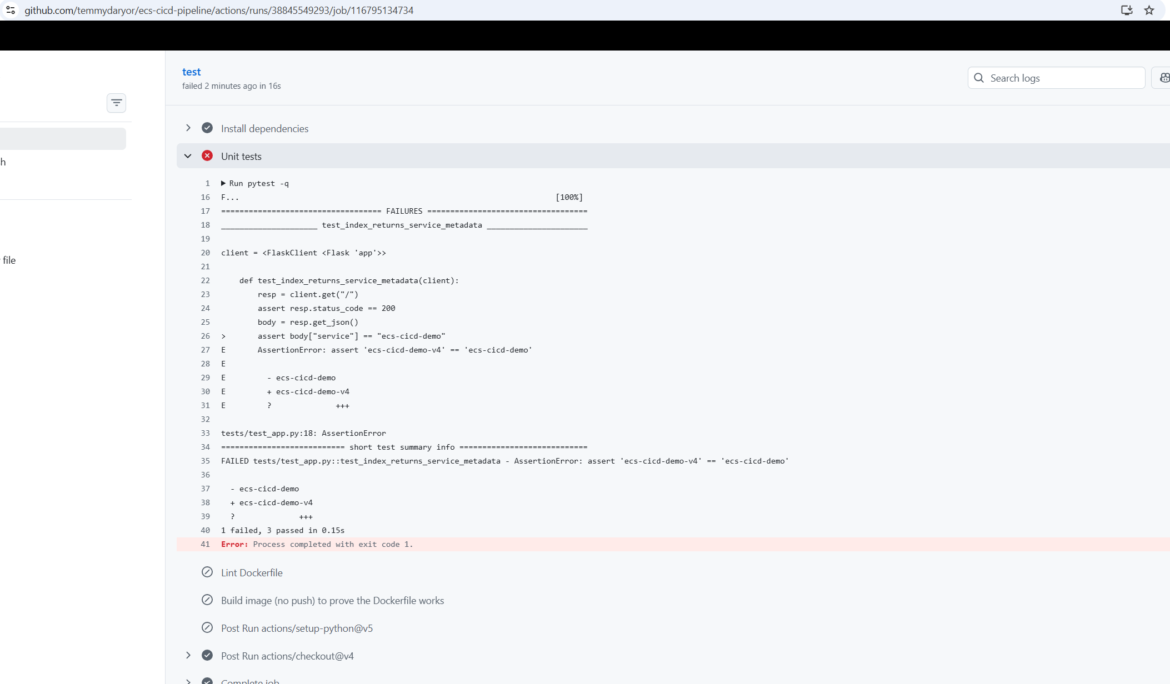

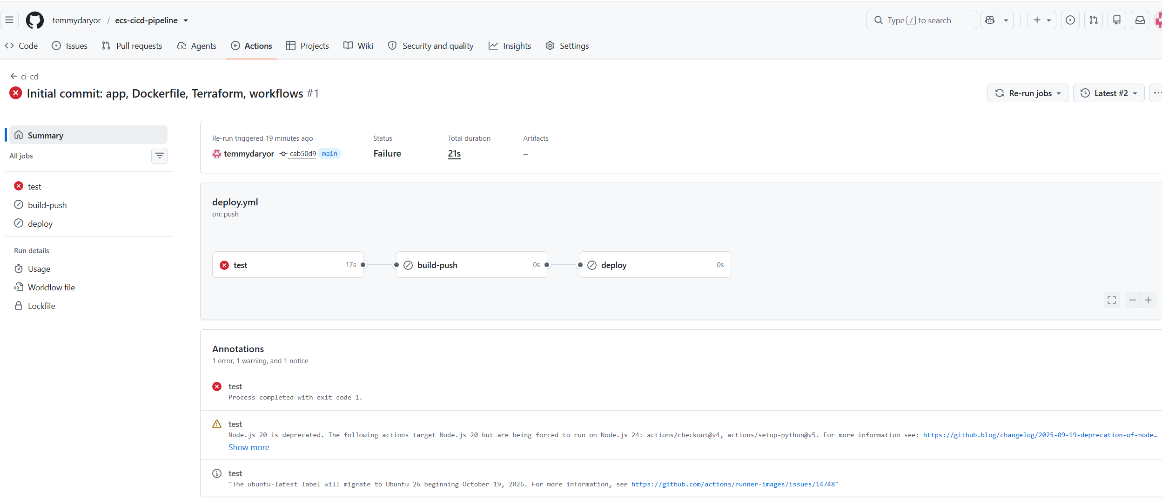

The app code now returns ecs-cicd-demo-v4 (you changed the service name for the manual deploys), but tests/test_app.py still expects ecs-cicd-demo. That mismatch fails the test and stops the pipeline before anything reaches AWS.

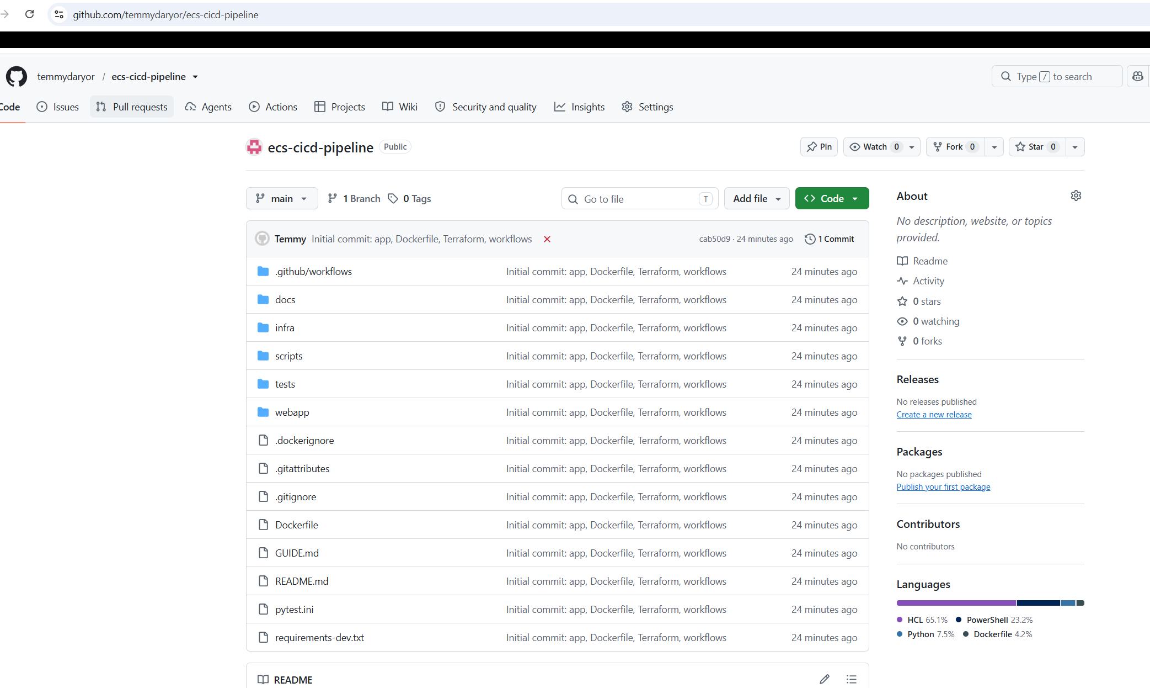

Second Error
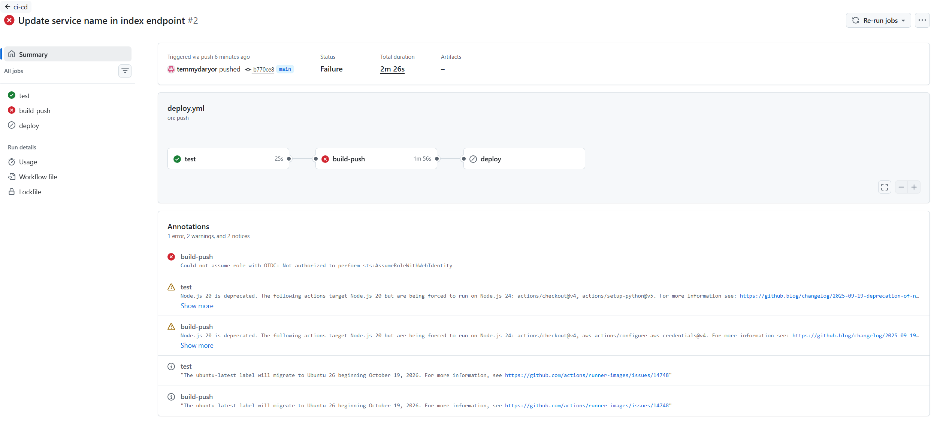
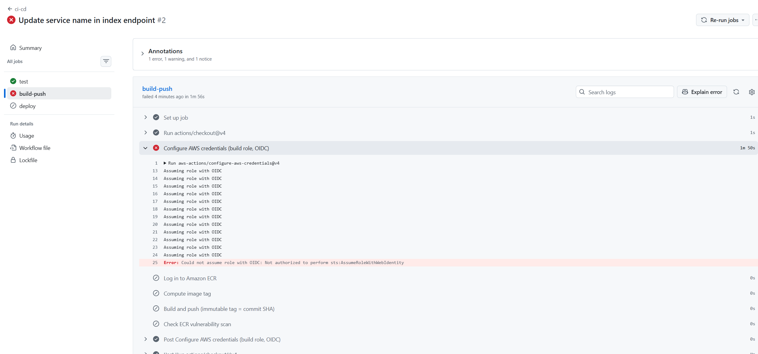

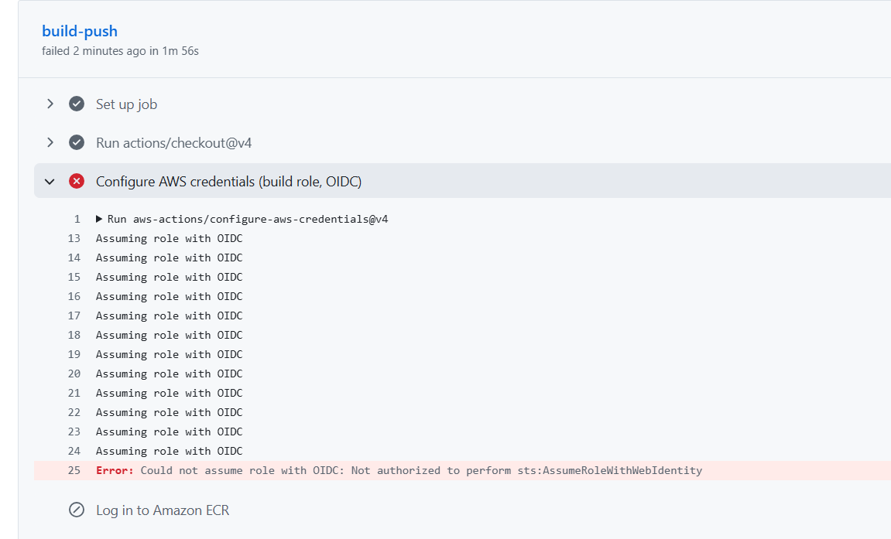

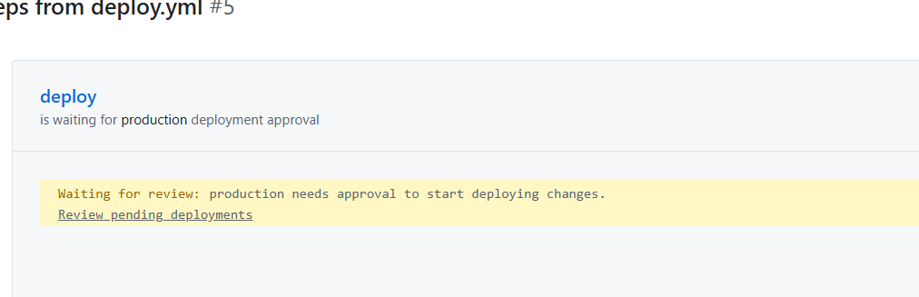

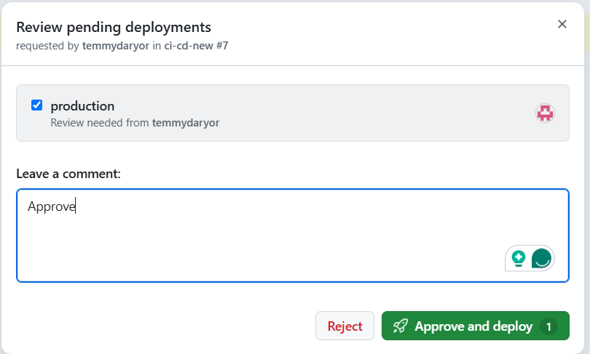

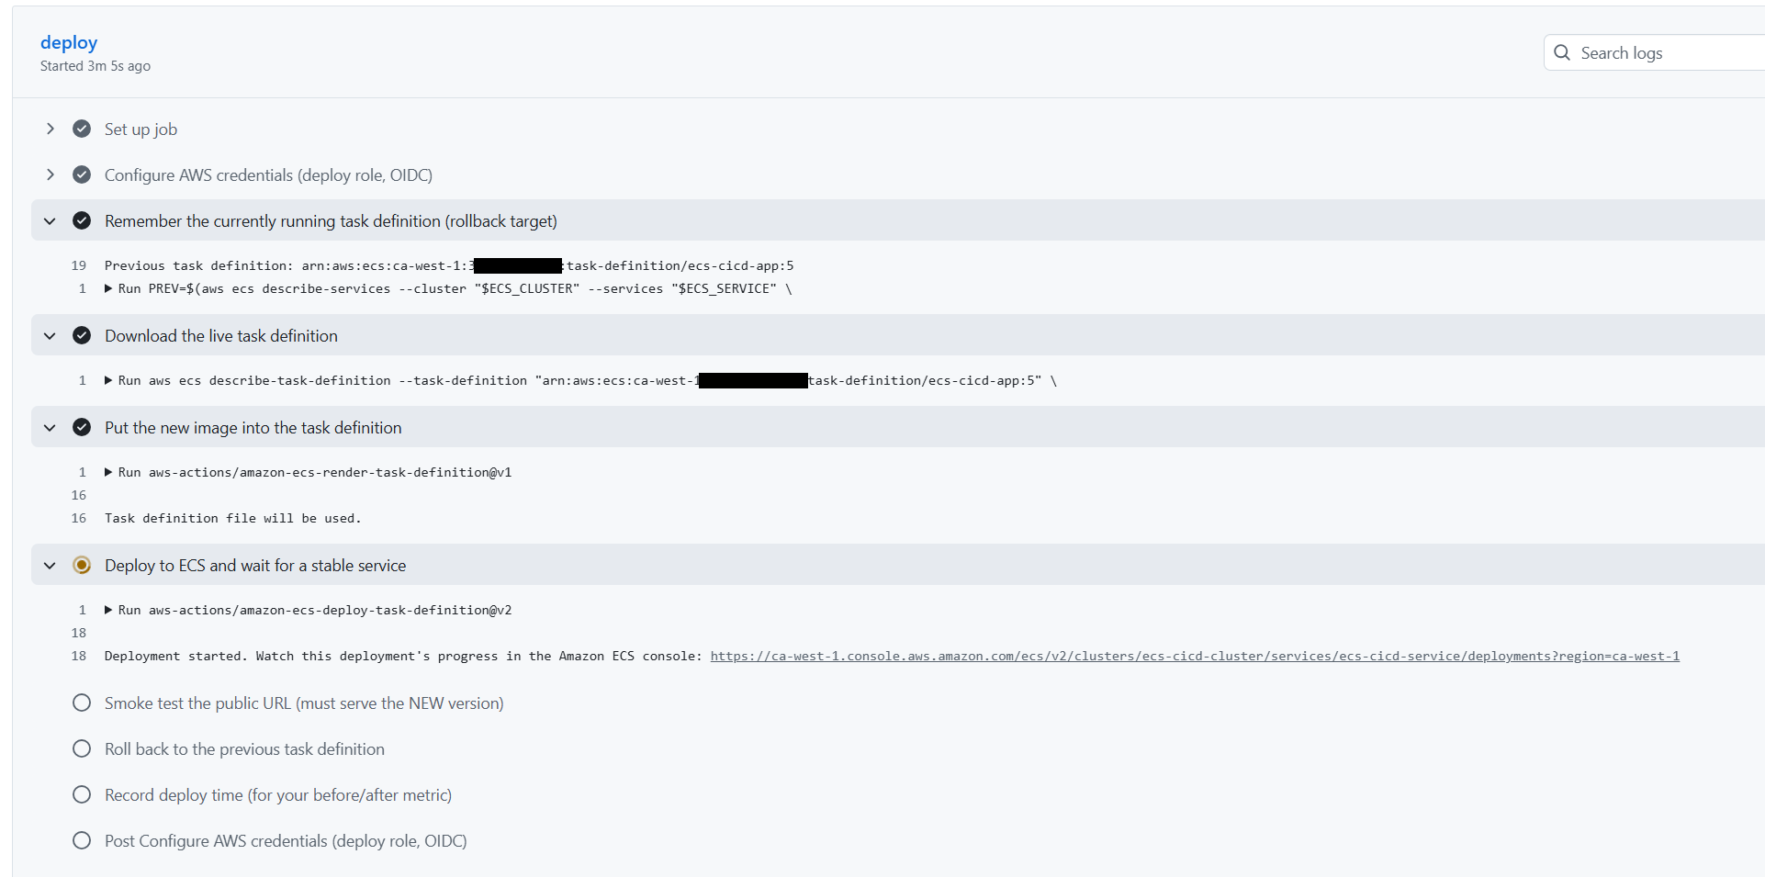

Pipeline run successfully.
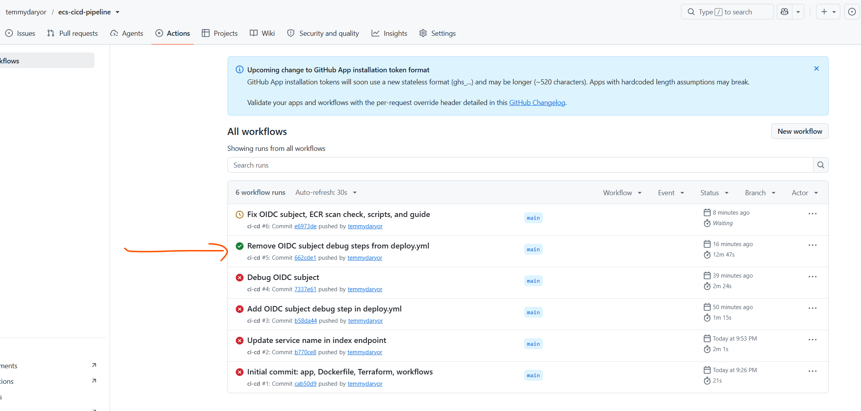

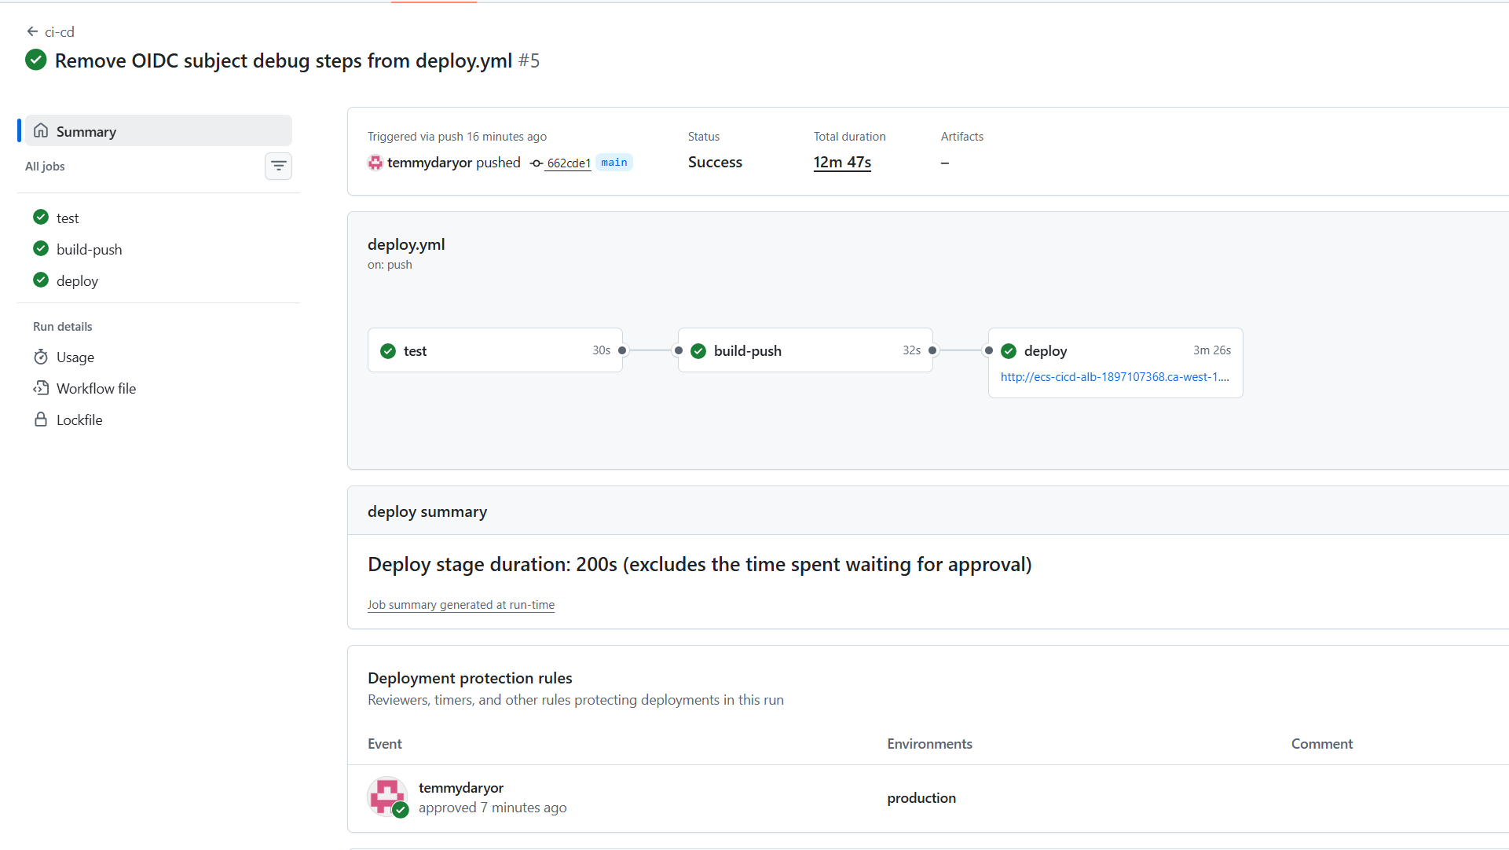

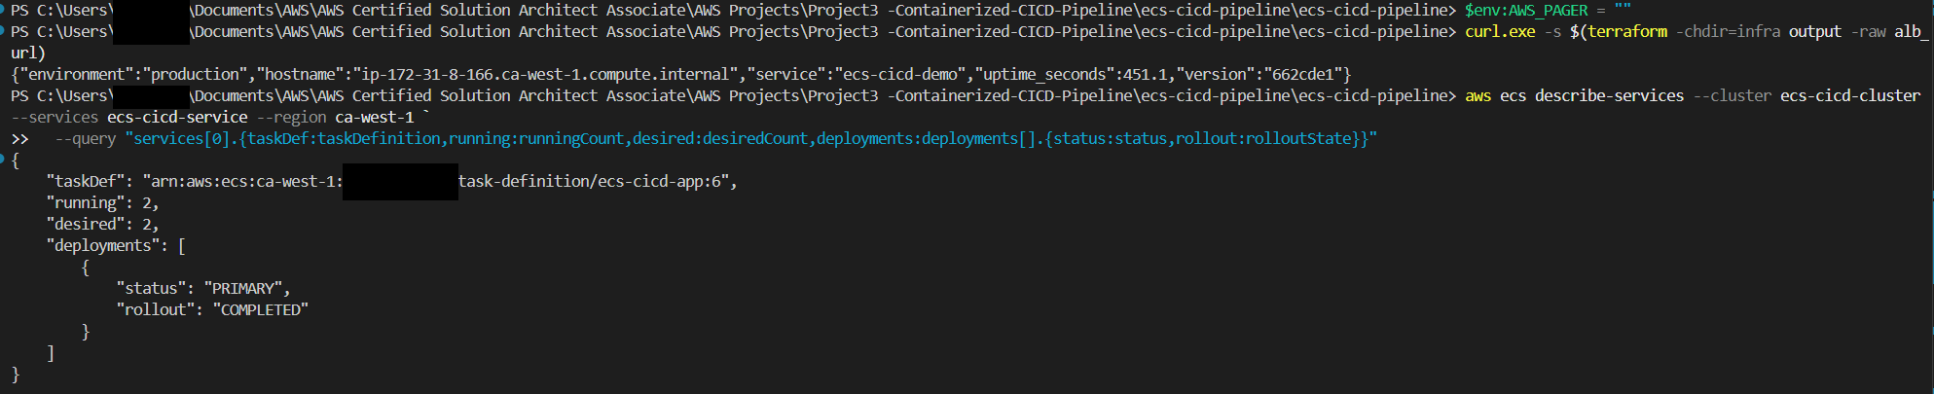

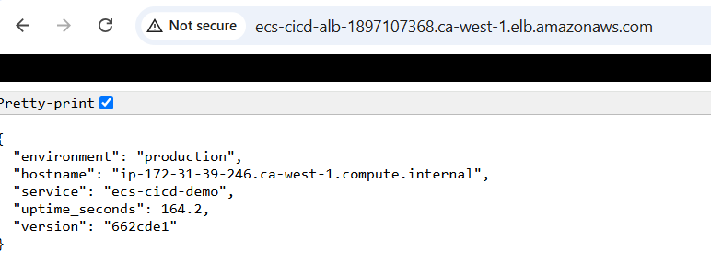

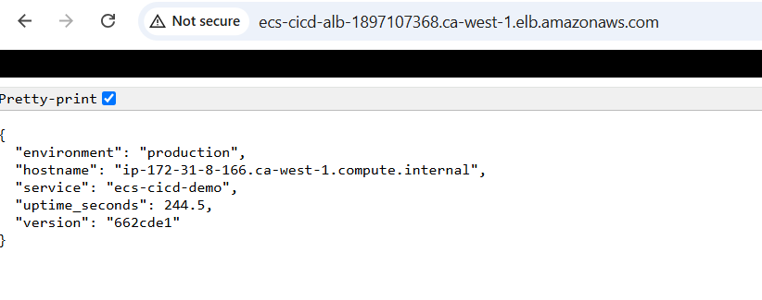
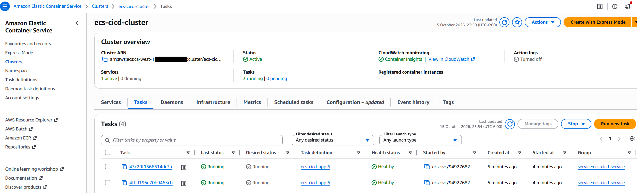

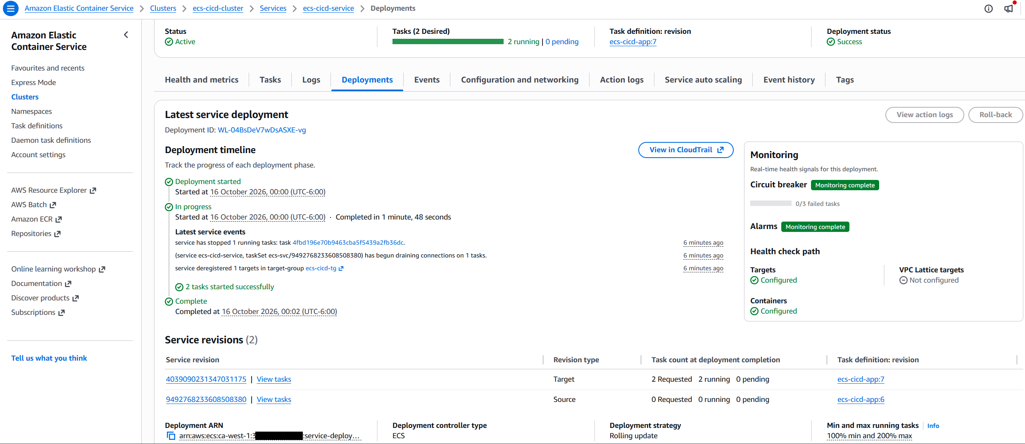

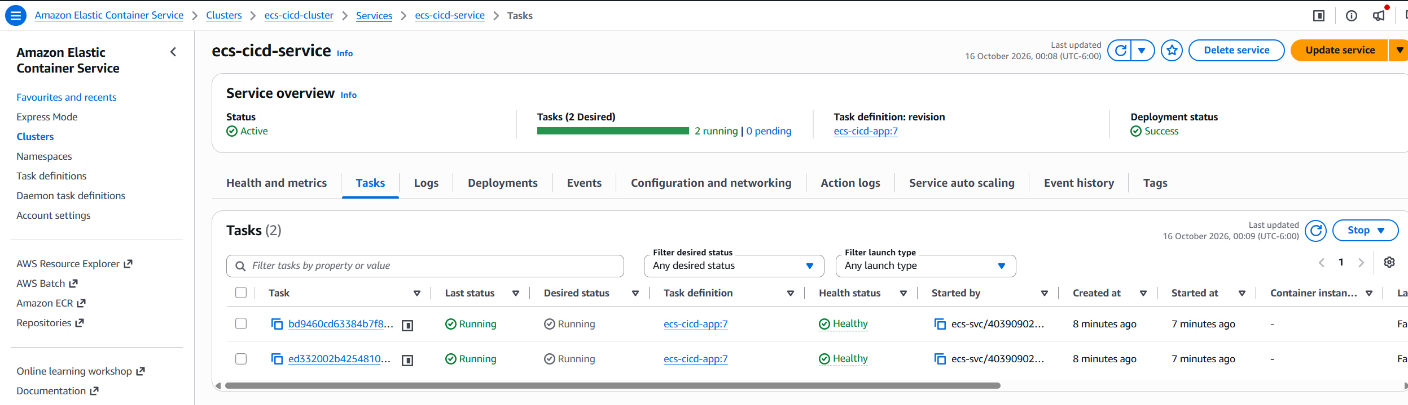

Error
Restarted docker but does not work so I updated the docker\config.json file and remove
“credsStore”: “desktop” from the file and saved it, then rerun.

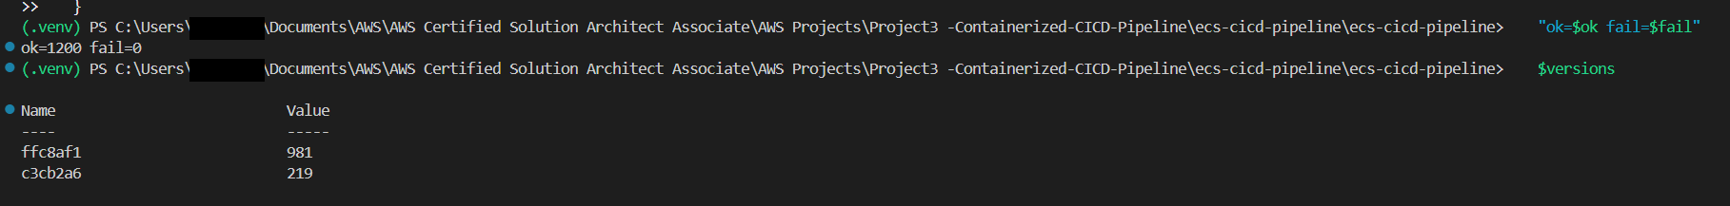
That’s a clean result. The two versions add up to 981 + 219 = 1,200 responses, which is exactly the number of requests in the loop. So every request got an answer from one of the two versions, and the rollout happened underneath live traffic.

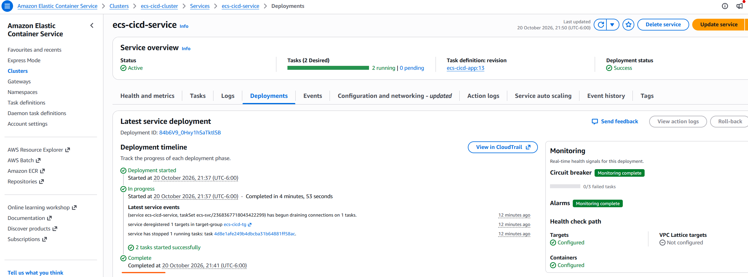

Rollback demos
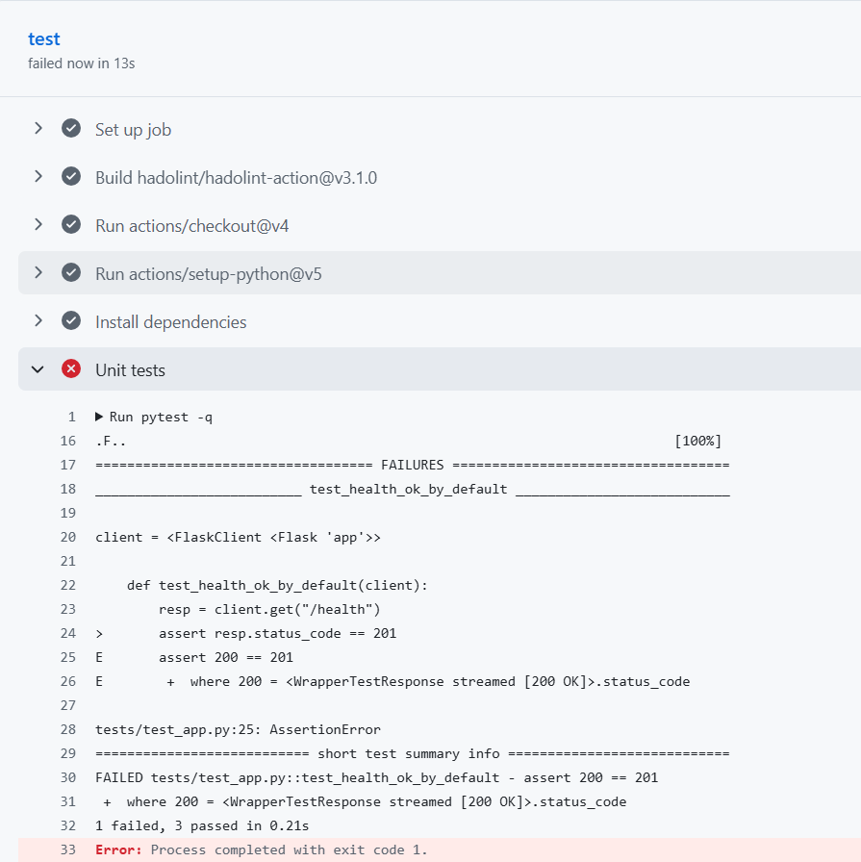
Open tests/test_app.py and change an assertion to something wrong, for example in the health test change == 200 to == 201.

In the Dockerfile, change --bind 0.0.0.0:8080 to --bind 0.0.0.0:9090. The container now listens on the wrong port.

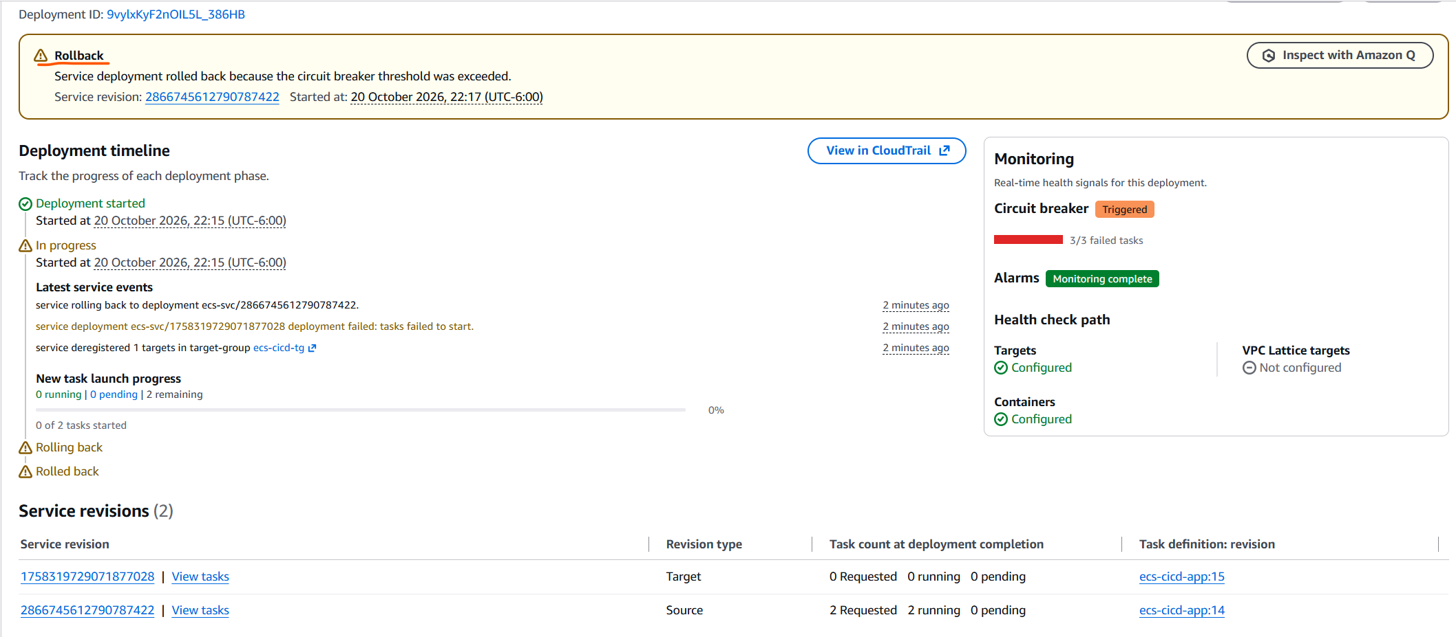

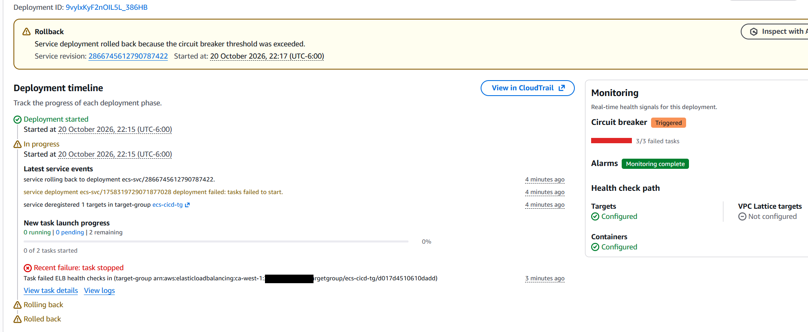

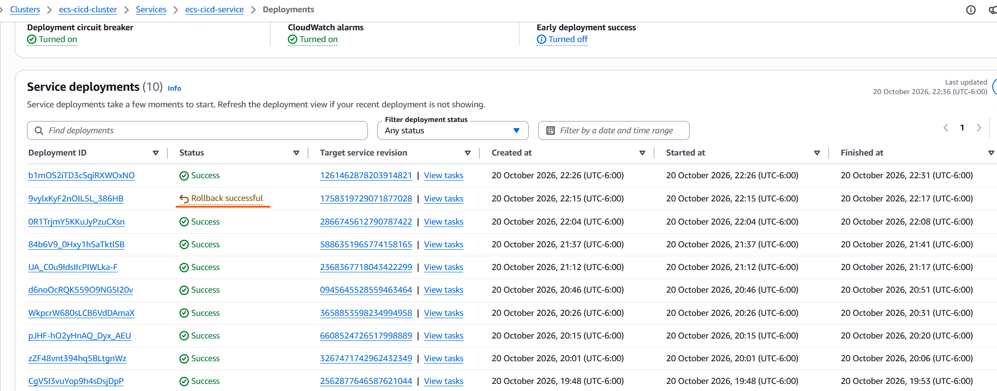
Rollback successful

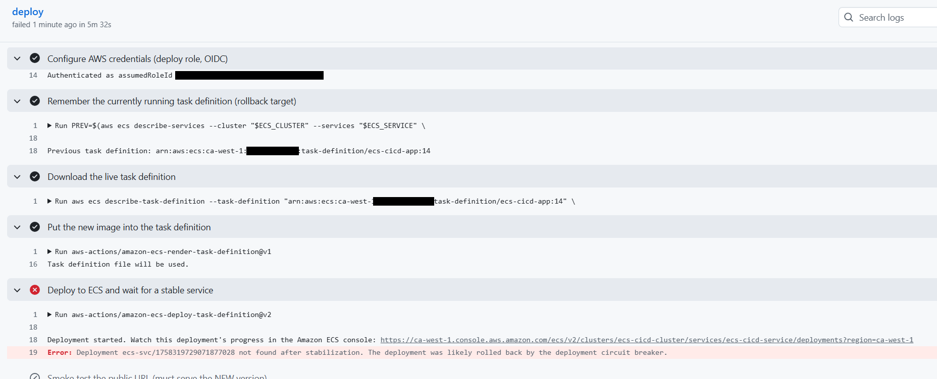

Observability: logs and alarms
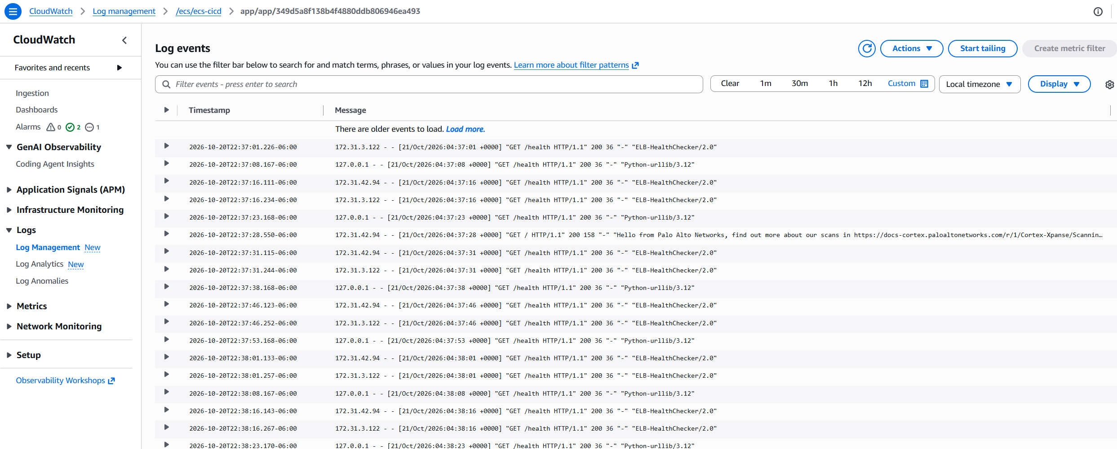

Log Insight
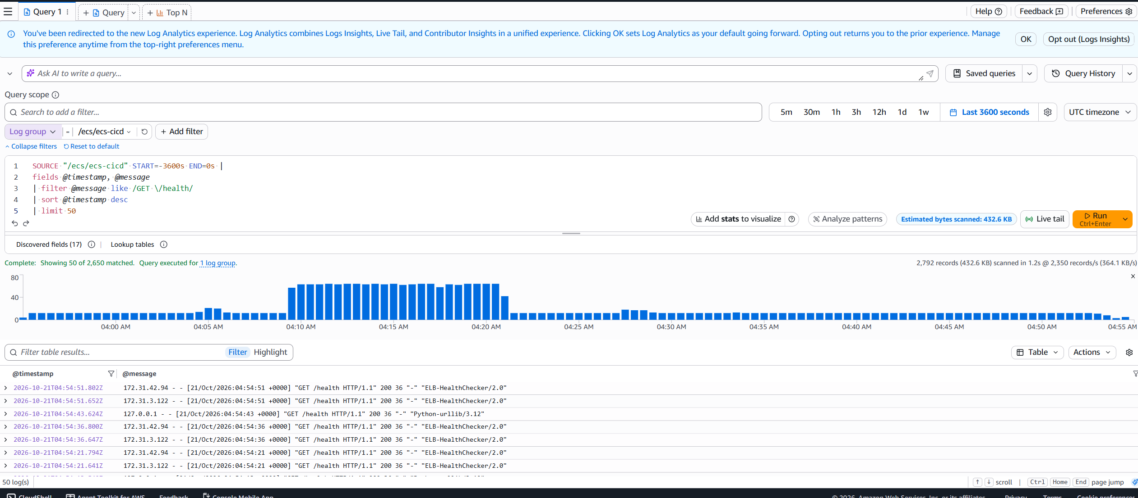

Cluster Insight- Cluster State

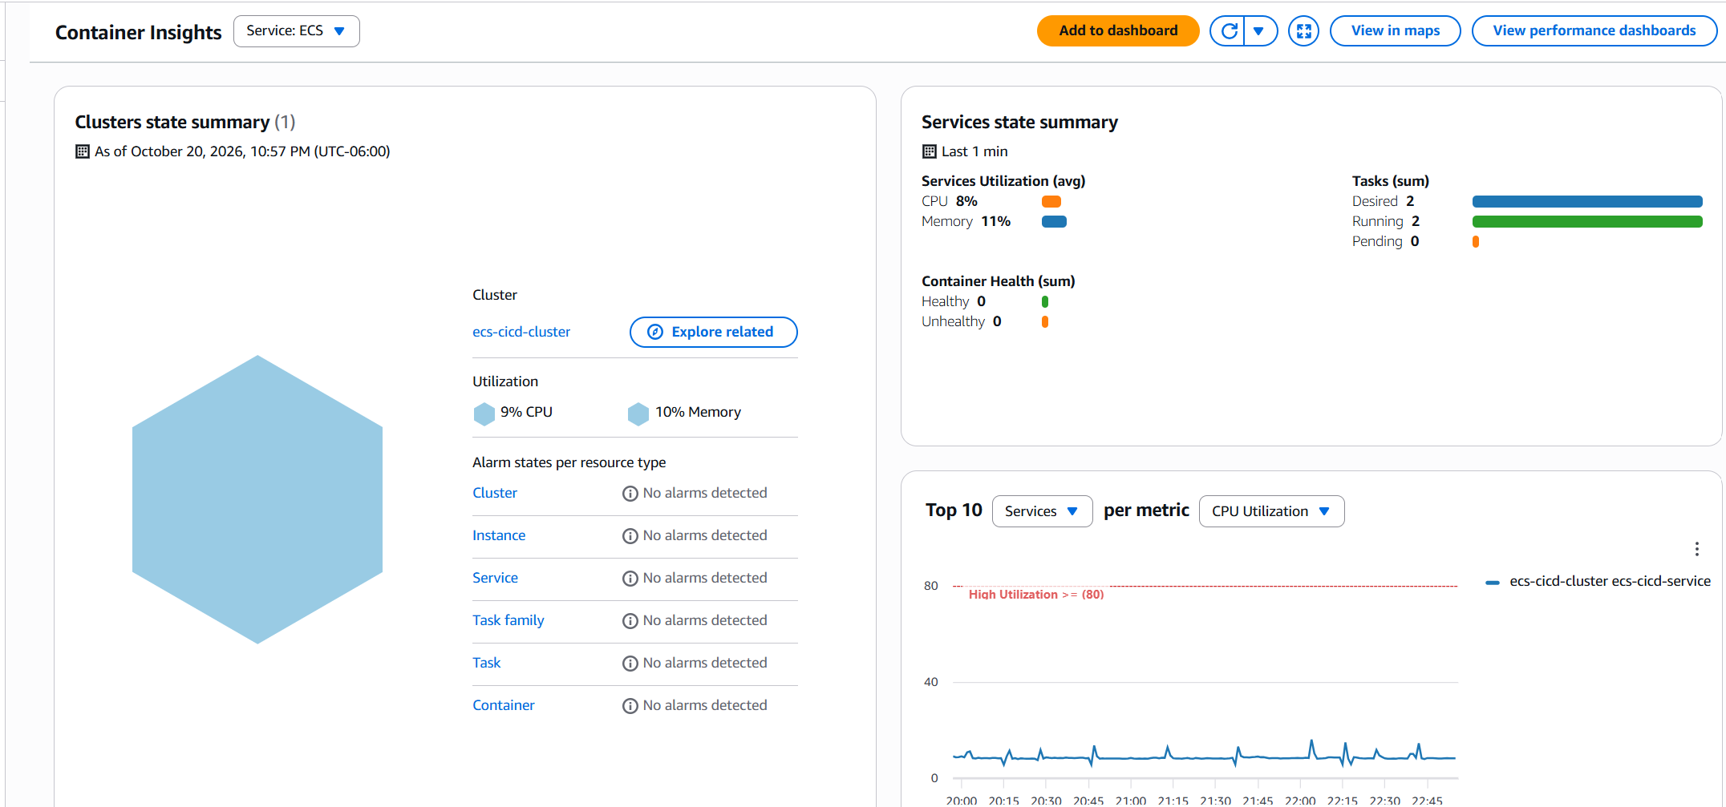

ecs-cicd-unhealthy-hosts — ALB target group has ≥1 unhealthy target
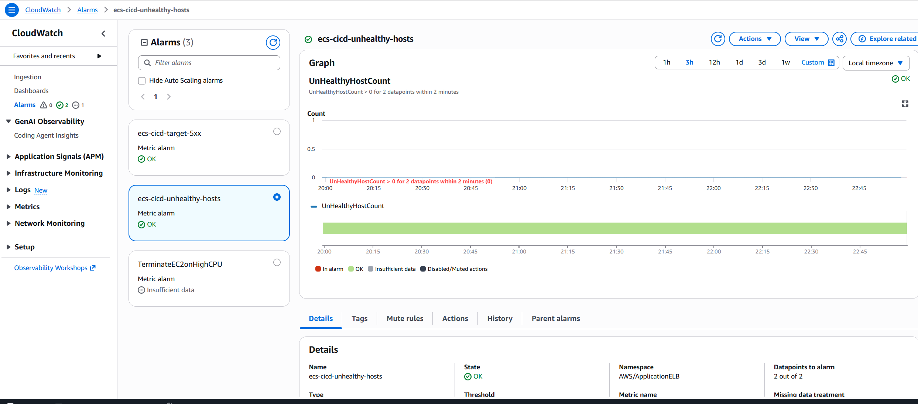

ecs-cicd-target-5xx — 5 or more 5xx responses from targets in the period
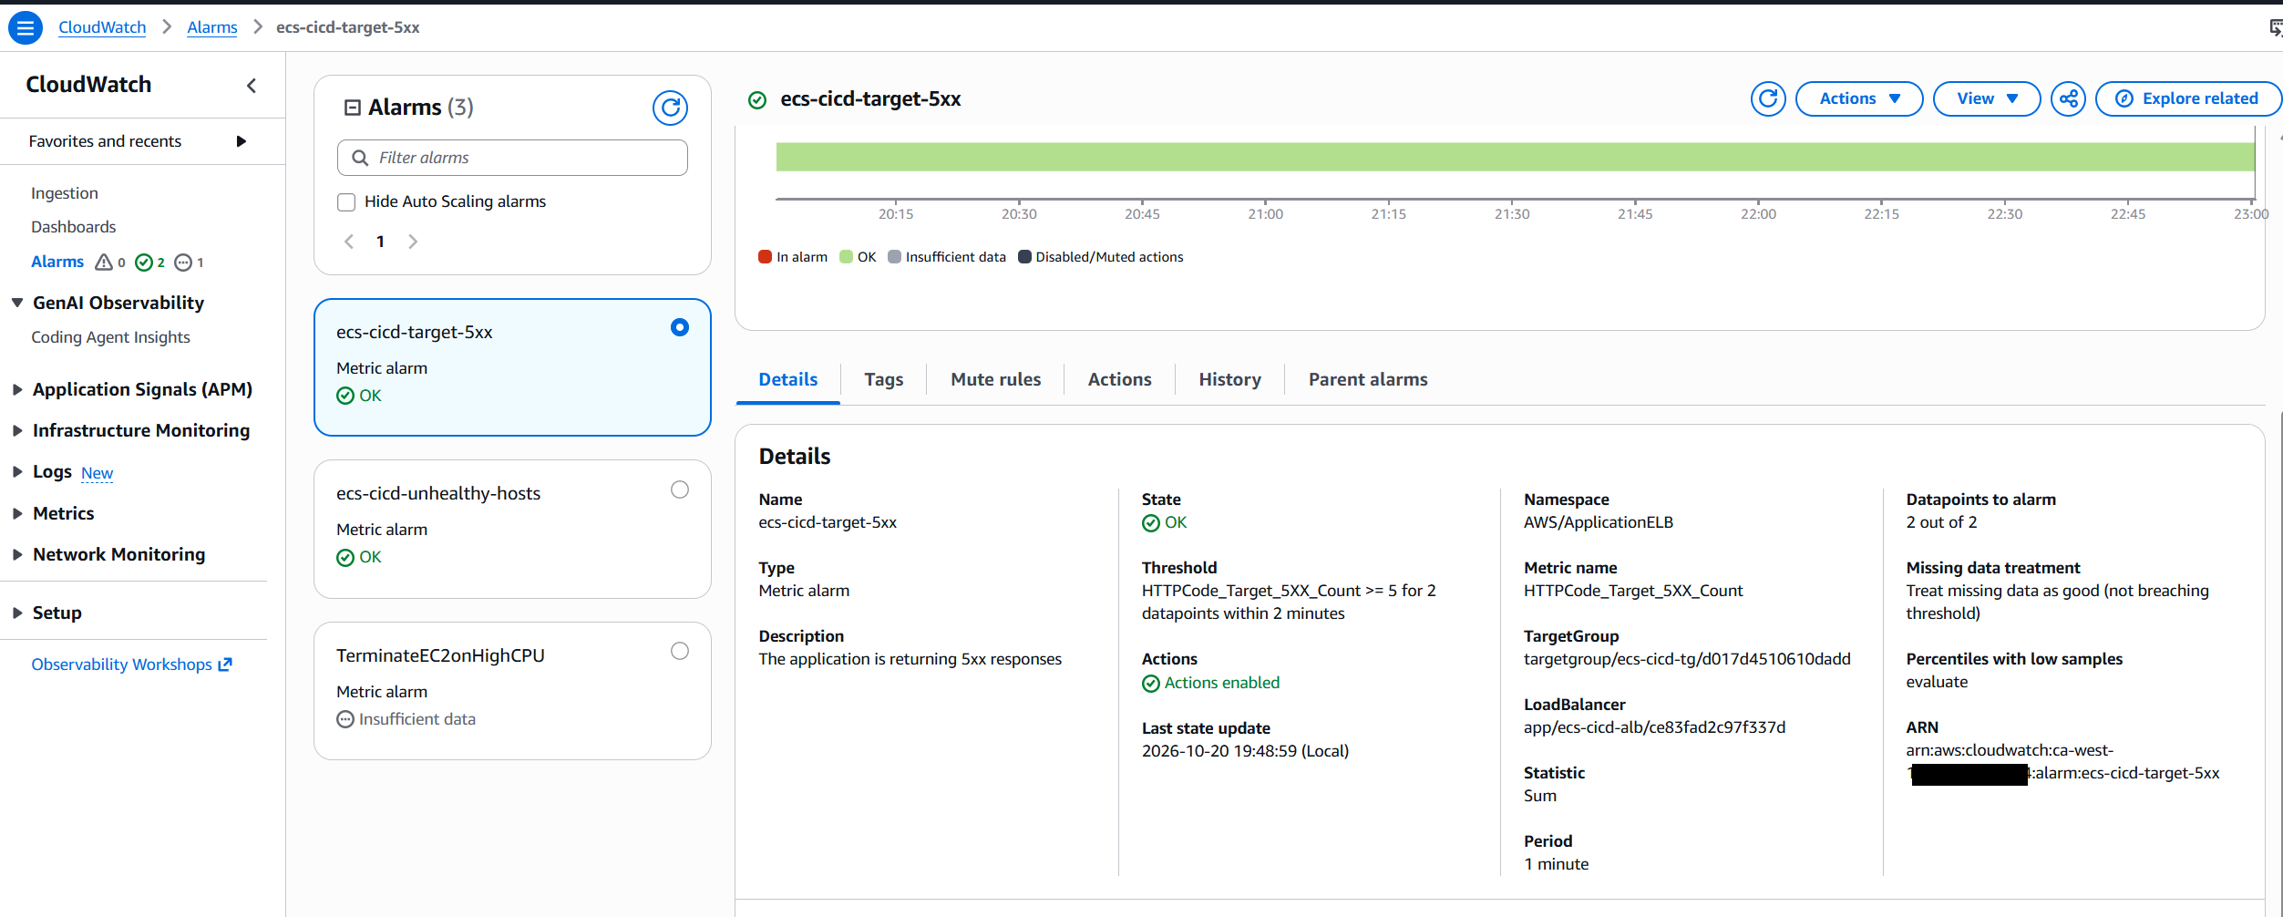

Safest test, using the CLI to force an alarm state:

aws cloudwatch set-alarm-state --alarm-name ecs-cicd-unhealthy-hosts --state-value ALARM --state-reason "manual test" --region ca-west-1

That’s the result you wanted from Demo B. The message “Service deployment rolled back because the circuit breaker threshold was exceeded” means ECS noticed the new tasks kept failing to become healthy, stopped trying, and put the previous working version back. Note that this is the circuit breaker layer. The CloudWatch alarm layer is a separate safety net that didn’t need to fire here.
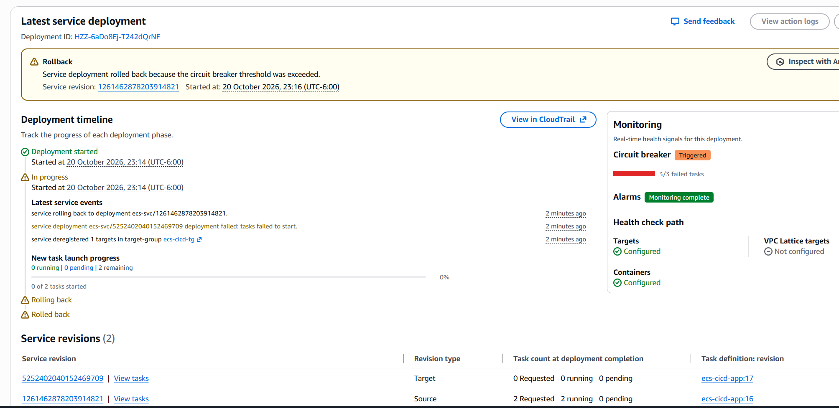
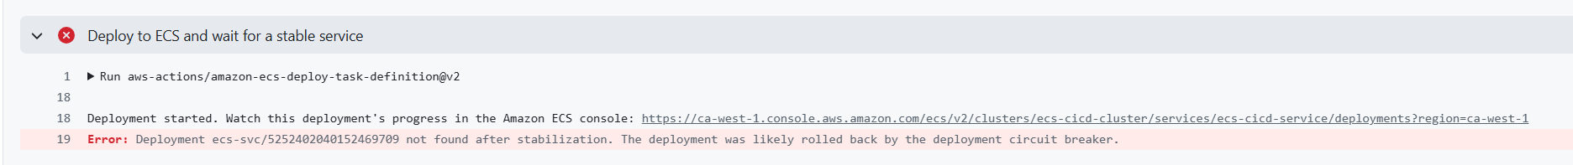
Screenshot the GitHub run: test and build-push green, deploy red.

20 October 2026, 23:14
20 October 2026, 23:17 (UTC-6:00)
Rollback is 3 mins
20 October 2026, 23:32 (UTC-6:00)
20 October 2026, 23:37 (UTC-6:00)
4 mins 53

