**Maven Archetype Plugin**

The Archetype Plugin allows the user to create a Maven project from an existing template called an **archetype**.

It also allows the user to create an archetype from an existing project.

This plugin requires Java 6.

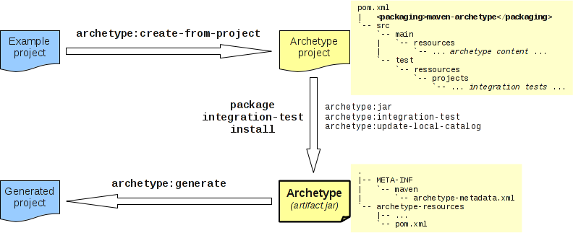

**Usage**

[Instructions on how to use the Archetype Plugin to create a project](https://maven.apache.org/archetype/maven-archetype-plugin/usage.html) can be found on the usage page.

The Archetype Plugin is embedded in IDEs (Eclipse, NetBeans, IDEA).

[Instructions on how to use the Archetype Plugin to create an archetype from an existing project](https://maven.apache.org/archetype/maven-archetype-plugin/advanced-usage.html) can be found on the advanced usage page.

**Goals Overview**

The archetype plugin has four goals for direct use:

* [archetype:generate](https://maven.apache.org/archetype/maven-archetype-plugin/generate-mojo.html) creates a Maven project from an archetype: asks the user to choose an archetype from the archetype catalog, and retrieves it from the remote repository. Once retrieved, it is processed to create a working Maven project.
* [archetype:create-from-project](https://maven.apache.org/archetype/maven-archetype-plugin/create-from-project-mojo.html) creates an archetype from an existing project.
* [archetype:crawl](https://maven.apache.org/archetype/maven-archetype-plugin/crawl-mojo.html) search a repository for archetypes and updates a catalog.

and three goals bound to default lifecycle by ['maven-archetype' packaging](https://maven.apache.org/archetype/archetype-packaging/):

* [archetype:jar](https://maven.apache.org/archetype/maven-archetype-plugin/jar-mojo.html) (bound to the package phase) is used to build the archetype jar artifact.
* [archetype:integration-test](https://maven.apache.org/archetype/maven-archetype-plugin/integration-test-mojo.html) (bound to the integration-test phase) is used to execute archetype integration tests by generating sample projects from the just built archetype.
* [archetype:update-local-catalog](https://maven.apache.org/archetype/maven-archetype-plugin/update-local-catalog-mojo.html) (bound to the install phase) is used to update the local catalog.

<https://maven.apache.org/archetype/maven-archetype-plugin/index.html>

## Maven Archetype

### What is Archetype?

In short, Archetype is a Maven project templating toolkit. An archetype is defined as *an original pattern or model from which all other things of the same kind are made*. The names fits as we are trying to provide a system that provides a consistent means of generating Maven projects. Archetype will help authors create Maven project templates for users, and provides users with the means to generate parameterized versions of those project templates.

<https://maven.apache.org/archetype/index.html>