## **Channel Factories and Channels**

Channel factories are responsible for creating channels. Channels created by channel factories are used for sending messages. These channels are responsible for getting the message from the layer above, performing whatever processing is necessary, then sending the message to the layer below. The following graphic illustrates this process.

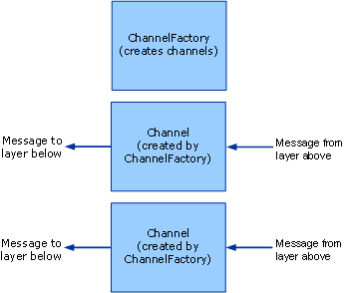  
A channel factory creates channels.

When closed, channel factories are responsible for closing any channels they created that are not yet closed. Note that the model is asymmetric here because when a channel listener is closed, it only stops accepting new channels but leaves existing channels open so that they can continue receiving messages.