## **Channel listeners and channels**

Channel listeners are responsible for creating channels and receiving messages from the layer below or from the network. Received messages are delivered to the layer above using a channel that is created by the channel listener.

The following diagram illustrates the process of receiving messages and delivering them to the layer above.

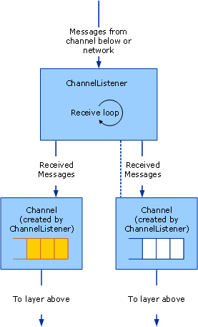

A channel listener receiving messages and delivering to the layer above through channels.

The process can be conceptually modeled as a queue inside each channel although the implementation may not actually use a queue. The channel listener is responsible for receiving messages from the layer below or the network and putting them in the queue. The channel is responsible for getting messages from the queue and handing them to the layer above when that layer asks for a message, for example by calling Receive on the channel.

WCF provides base class helpers for this process. For a diagram of the channel helper classes discussed in this article, see [Channel Model Overview](https://docs.microsoft.com/en-us/dotnet/framework/wcf/extending/channel-model-overview).

The [CommunicationObject](https://docs.microsoft.com/en-us/dotnet/api/system.servicemodel.channels.communicationobject) class implements [ICommunicationObject](https://docs.microsoft.com/en-us/dotnet/api/system.servicemodel.icommunicationobject) and enforces the state machine described in step 2 of [Developing Channels](https://docs.microsoft.com/en-us/dotnet/framework/wcf/extending/developing-channels).

The [ChannelManagerBase](https://docs.microsoft.com/en-us/dotnet/api/system.servicemodel.channels.channelmanagerbase) class implements [CommunicationObject](https://docs.microsoft.com/en-us/dotnet/api/system.servicemodel.channels.communicationobject) and provides a unified base class for [ChannelFactoryBase](https://docs.microsoft.com/en-us/dotnet/api/system.servicemodel.channels.channelfactorybase) and [ChannelListenerBase](https://docs.microsoft.com/en-us/dotnet/api/system.servicemodel.channels.channellistenerbase). The [ChannelManagerBase](https://docs.microsoft.com/en-us/dotnet/api/system.servicemodel.channels.channelmanagerbase) class works in conjunction with [ChannelBase](https://docs.microsoft.com/en-us/dotnet/api/system.servicemodel.channels.channelbase), which is a base class that implements [IChannel](https://docs.microsoft.com/en-us/dotnet/api/system.servicemodel.channels.ichannel).

The [ChannelFactoryBase](https://docs.microsoft.com/en-us/dotnet/api/system.servicemodel.channels.channelfactorybase) class implements [ChannelManagerBase](https://docs.microsoft.com/en-us/dotnet/api/system.servicemodel.channels.channelmanagerbase) and [IChannelFactory](https://docs.microsoft.com/en-us/dotnet/api/system.servicemodel.channels.ichannelfactory) and consolidates the CreateChannel overloads into one OnCreateChannel abstract method.

The [ChannelListenerBase](https://docs.microsoft.com/en-us/dotnet/api/system.servicemodel.channels.channellistenerbase) class implements [IChannelListener](https://docs.microsoft.com/en-us/dotnet/api/system.servicemodel.channels.ichannellistener). It takes care of basic state management.

The following discussion is based upon the [Transport: UDP](https://docs.microsoft.com/en-us/dotnet/framework/wcf/samples/transport-udp) sample.

<https://docs.microsoft.com/en-us/dotnet/framework/wcf/extending/service-channel-listeners-and-channels>