Far Manager keyboard shortcuts
By Zeynel Abidin Öztürk -
7 months ago
- in Shortcuts
Do you still find text based interfaces more convenient? We won't argue with it, but we can just give you what you'll surely need: Keyboard shortcuts of Far Manager.

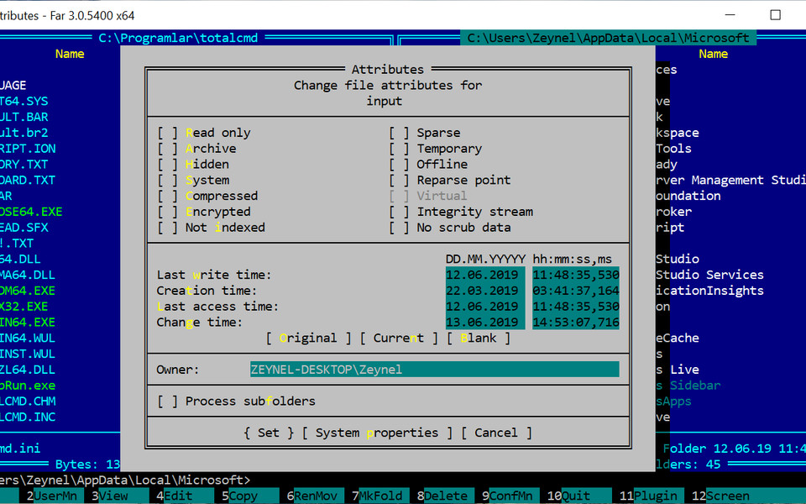

General (36 shortcuts)
Ctrl + A | Change file attributes
or F9 then F then A
Alt + Insert | Screen grabber
Alt + F9 | Maximize window
Alt + ↑ Shift + F9 | Configure plugins
Ctrl + Alt + ↑ Shift | Hide windows while the keys are held
F4 | (on a folder) Edit folders attributes (Ctrl + A)
Alt + ← → | Scroll long names
or Alt + Home
or Alt + End
Ctrl + Insert | Copy names of the selected files into clipboard (when command line empty)
Ctrl + ↑ Shift + Insert | Copy names of the selected files into clipboard (when command line is not empty)
Ctrl + Alt + Insert | Copy network (unc) names into clipboard
Alt + ↑ Shift + Insert | Copy full (with path) names into clipboard
Ctrl + F | Full file name from the active panel, Ctrl + : from passive
or Ctrl + ] then Ctrl + ⤶ Enter
Ctrl + End | Command string completion from the history (press again to go to the next matching history line)
Alt + F8 | Command history
Alt + F10 | Find folder
Alt + F11 | View and edit history
Alt + F12 | Folder history
↑ Shift + F1 | Archive management commands
or ↑ Shift + F2
or ↑ Shift + F3
↑ Shift + F10 | Show the last menu command
Ctrl + \ | Back to root
↑ Shift + ⤶ Enter | (in the drive menu) Show root directory in explorer
Ctrl + Page Down | Enter in an archive / especially SFX
Ctrl + G | Run command on selected files, like "rar32 m !.!.rar !.!" to rar each file in its own archive
Ctrl + Num . | Record a keyboard macro
Alt + Del | Wipe file, overwrite with 0, truncate, rename to a temp name and delete
Ctrl + W | Task list
F12 | Switch panes (screens) inside of Far
Ctrl + M | Restore previous selection
Ctrl + ⤶ Enter | (in quick search) Select file and move to the next
↑ Shift + ⤶ Enter | (in history) Selects an item not changing its positions

Other shortcuts (5 shortcuts)
Ctrl + . | Start recording macro. Press again to end and assign a key
Ctrl + . then Ctrl + . | then press a key you want to erase, to erase a macro
↑ Shift + Del | (in drive menu) Disconnect flash drive
Del | (in drive menu) Remove CD

https://defkey.com/far-manager-shortcuts

cd CTRL+SHIFT+[

https://www.farmanager.com/enforum/viewtopic.php?t=691

