Loan Default Risk Predictor
3MTT Capstone Project — Final Report
Author: Gbenga
Program: 3 Million Technical Talent (3MTT)
Date: September 2026

1. Introduction
Loan default is one of the most consequential risks a lending institution faces: approving a loan that later defaults costs the lender the principal and lost interest, while rejecting a creditworthy applicant costs the lender lost business and can shut a legitimate borrower out of credit. This project builds a machine learning model that predicts the probability that a loan applicant will default, using demographic, financial, and loan-specific information collected at the time of application.
The goal is not just to produce a working classifier, but to demonstrate a complete, defensible data science workflow: exploring the data, cleaning and engineering features, training and comparing multiple models, and evaluating them with metrics appropriate to an imbalanced classification problem — since only a minority of applicants in any real dataset actually default.

2. Problem Statement
Given information about a loan applicant at the time of application, predict whether they will default on the loan (binary classification: Default = 1, No Default = 0). The model should support a lender's decision-making process by flagging high-risk applicants for manual review, rather than making the approval decision outright.

3. Dataset
The dataset used is the “Loan Default Prediction Dataset”, sourced from Kaggle (kaggle.com/datasets/nikhil1e9/loan-default). It contains 255,347 loan applicant records with 18 columns, including:
- Demographic features: Age, Marital Status, Education, Employment Type, Dependents
- Financial features: Income, Credit Score, Debt-to-Income Ratio (DTIRatio), Months Employed, Number of Credit Lines
- Loan-specific features: Loan Amount, Interest Rate, Loan Term, Loan Purpose, Co-Signer and Mortgage status
- Target variable: Default (1 = defaulted, 0 = did not default)
The dataset contained no missing values. The target variable is imbalanced: 88.4% of applicants did not default, while 11.6% did. This imbalance is realistic for lending data and directly shapes the choice of evaluation metrics used later in this report (Section 6).
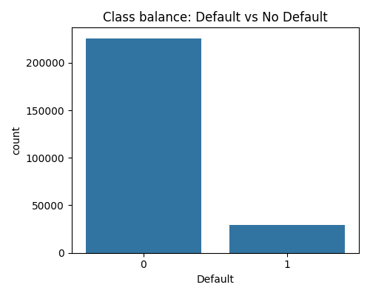
Figure 1. Class balance of the target variable (Default).

4. Methodology

4.1 Exploratory Data Analysis
Before any modeling, the data was explored to understand feature distributions, check for missing values, and examine relationships between numeric features and the target. A correlation heatmap (Figure 2) was used to identify multicollinearity and to get an early signal of which features might matter most.
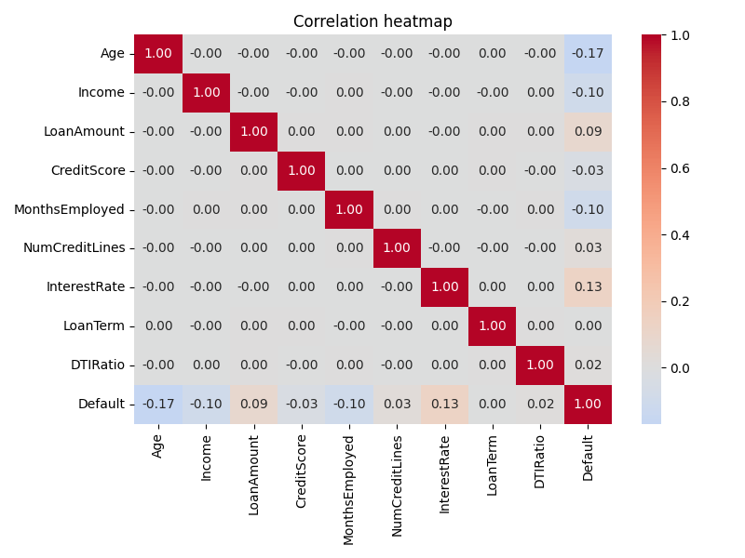
Figure 2. Correlation heatmap of numeric features.

4.2 Data Cleaning and Feature Engineering
Although the dataset had no missing values, the pipeline was built to handle them (median imputation for numeric columns, mode imputation for categorical columns) so it generalizes to messier real-world data. The identifier column (LoanID) was dropped, as it carries no predictive signal.
One engineered feature was added: loan_to_income_ratio (loan amount divided by income), which in feature importance analysis (Section 6.3) turned out to be one of the strongest predictors — a ratio can carry more signal than either raw value alone.
Categorical variables (Education, Employment Type, Marital Status, Loan Purpose, Has Mortgage, Has Dependents, Has Co-Signer) were one-hot encoded.

4.3 Train/Test Split
The data was split 80/20 into training and test sets, using stratified sampling so that both sets preserved the same 11.6% default rate. This prevents an accidental skew where the test set has a very different class balance than the training set.

4.4 Models
Two models were trained and compared:
- Logistic Regression — an interpretable linear baseline. class_weight="balanced" was used to compensate for the class imbalance by penalizing misclassification of the minority (Default) class more heavily.
- Random Forest (300 trees, max depth 10) — an ensemble model capable of capturing non-linear relationships between features, also trained with class_weight="balanced".
Numeric features were standardized (zero mean, unit variance) before training Logistic Regression, since it is sensitive to feature scale; Random Forest was trained on unscaled features, since tree-based models are scale-invariant.

5. Tools and Technologies
- Python 3 — pandas, NumPy for data manipulation
- scikit-learn — model training and evaluation
- matplotlib, seaborn — visualization
- Jupyter Notebook — exploratory analysis and presentation

6. Results
Because the target is imbalanced, accuracy alone is a misleading metric: a model that always predicted “No Default” would score roughly 88% accuracy while being completely useless to a lender. Instead, this project evaluates both models on precision, recall, F1-score, and ROC-AUC, with a particular focus on recall for the Default class — in lending, failing to catch an actual defaulter is typically more costly than a false alarm.

Model | ROC-AUC | Precision (Default) | Recall (Default) | F1 (Default)
Logistic Regression | 0.762 | 0.23 | 0.70 | 0.34
Random Forest | 0.755 | 0.25 | 0.63 | 0.35

6.1 Interpretation
Logistic Regression achieved the higher recall on the Default class (0.70 vs 0.63), meaning it correctly flagged a larger share of actual defaulters, at the cost of more false positives (lower precision). Random Forest was slightly more precise and achieved marginally higher accuracy overall, but missed more true defaulters.
For a lending use case where the cost of an undetected default is high relative to the cost of an extra manual review, Logistic Regression's higher recall makes it the more defensible choice, despite its lower precision. This is a business trade-off as much as a technical one, and would ideally be tuned against a lender's actual cost structure for false positives versus false negatives.

6.2 Confusion Matrices
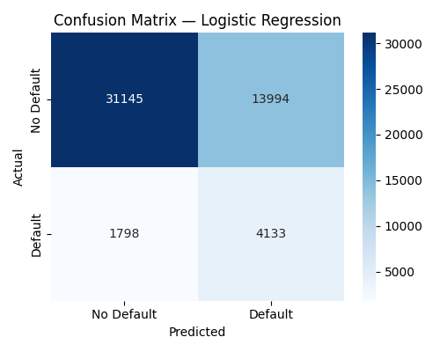
Figure 3. Confusion matrix — Logistic Regression.
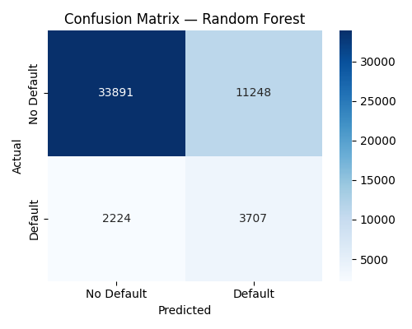
Figure 4. Confusion matrix — Random Forest.

6.3 ROC Curve Comparison
Both models achieved similar ROC-AUC scores (0.762 for Logistic Regression, 0.755 for Random Forest), indicating comparable overall discriminative ability between defaulters and non-defaulters across all classification thresholds.
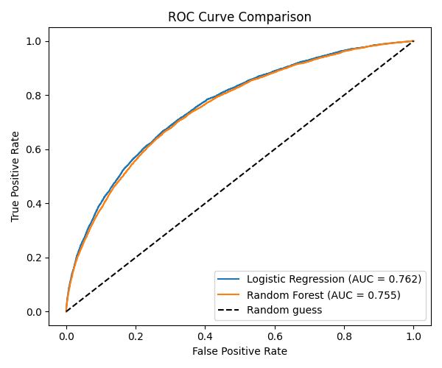
Figure 5. ROC curve comparison between both models.

6.4 Feature Importance
The Random Forest model's feature importances show which factors most influenced its predictions. The top drivers were Age, Interest Rate, loan-to-income ratio, Months Employed, and Income — broadly consistent with real-world lending intuition, where affordability (income relative to loan size), the cost of borrowing (interest rate), and job stability (months employed) are all well-established risk factors.
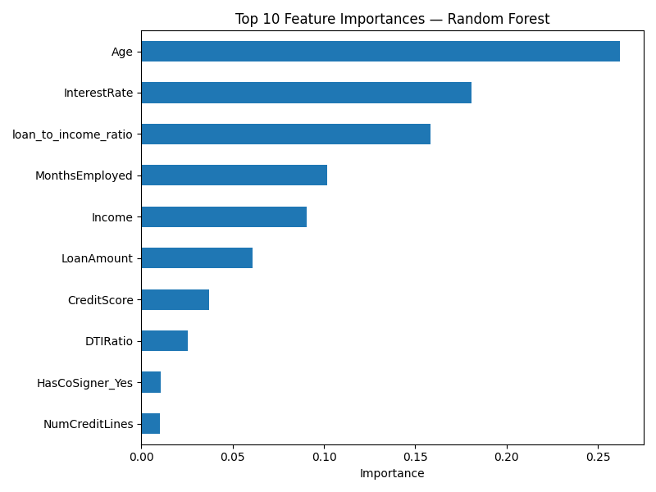
Figure 6. Top 10 feature importances — Random Forest.

7. Applying the Model: Scoring a New Applicant
Beyond evaluation on the test set, the project includes a script (05_predict_new_applicant.py) that scores a single new applicant given their details, applying the same cleaning and feature engineering used in training. This demonstrates how the model could be integrated into a real loan-decisioning workflow: an applicant's details are entered, the model returns a default probability from each model, and a recommendation (approve, review, or decline) is generated based on that probability.

8. Limitations and Future Work
- Both models plateau around 0.76 ROC-AUC; gradient-boosted models (XGBoost, LightGBM) or hyperparameter tuning could likely improve this further.
- The model was not evaluated against a specific cost matrix (dollar cost of a false negative vs. false positive), which would allow the classification threshold to be tuned to a lender's actual risk appetite rather than the default 0.5 cutoff.
- SHAP or similar interpretability tools would give per-applicant explanations, which are increasingly expected in regulated lending contexts.
- The dataset, while realistic, is a single snapshot; a production model would need to be monitored and retrained as borrower behavior and macroeconomic conditions change over time.

9. Conclusion
This project built a complete loan default risk prediction pipeline: exploratory analysis, data cleaning, feature engineering, model training, and evaluation appropriate to an imbalanced classification problem. Both Logistic Regression and Random Forest achieved comparable, reasonable performance (ROC-AUC ≈ 0.76), with Logistic Regression favoring recall on defaulters and Random Forest favoring precision. The project demonstrates not just a working model, but the reasoning behind each methodological choice — which is the core skill this capstone is meant to assess.

10. Project Repository
Full source code, the executed Jupyter notebook, trained models, and evaluation plots are available at the GitHub repository submitted alongside this report.

