Module = quote_print

depends = custom_header_footer

Below image is screenshoot of company form view.

quote_print module is depends on custom_header_footer_module.

When you check Field ‘use images for all’ report then paper formate will be chenged for all those reports which dont have paperformat’,

and when you uncheck it then paperformate will be US Letter.

Header Image = this field is for header image for all reports

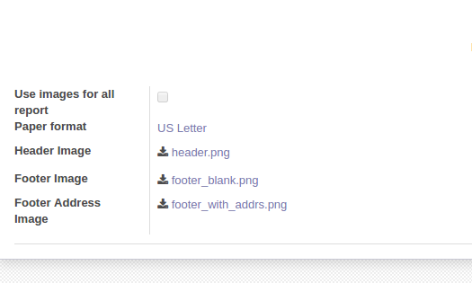Footer Image = this field is for footer image for all reports

Footer Address Image = this field for footer image with address of page online quote print report