**GSP080**



**Overview**

Google Cloud Functions is a serverless execution environment for building and connecting cloud services. With Cloud Functions you write simple, single-purpose functions that are attached to events emitted from your cloud infrastructure and services. Your Cloud Function is triggered when an event being watched is fired. Your code executes in a fully managed environment. There is no need to provision any infrastructure or worry about managing any servers.

Google Cloud Functions can be written in Node.js, Python, and Go, and are executed in language-specific runtimes as well. You can take your Cloud Function and run it in any standard Node.js runtime which makes both portability and local testing a breeze.

**Connect and Extend Cloud Services**

Cloud Functions provides a connective layer of logic that lets you write code to connect and extend cloud services. Listen and respond to a file upload to Cloud Storage, a log change, or an incoming message on a Cloud Pub/Sub topic. Cloud Functions augments existing cloud services and allows you to address an increasing number of use cases with arbitrary programming logic. Cloud Functions have access to the Google Service Account credential and are thus seamlessly authenticated with the majority of Google Cloud Platform services such as Datastore, Cloud Spanner, Cloud Translation API, Cloud Vision API, as well as many others. In addition, Cloud Functions are supported by numerous [Node.js client libraries](https://cloud.google.com/nodejs/apis), which further simplify these integrations.

**Events and Triggers**

Cloud events are *things* that happen in your cloud environment.These might be things like changes to data in a database, files added to a storage system, or a new virtual machine instance being created.

Events occur whether or not you choose to respond to them. You create a response to an event with a *trigger*. A trigger is a declaration that you are interested in a certain event or set of events. Binding a function to a trigger allows you to capture and act on events. For more information on creating triggers and associating them with your functions, see [Events and Triggers](https://cloud.google.com/functions/docs/concepts/events-triggers).

**Serverless**

Cloud Functions removes the work of managing servers, configuring software, updating frameworks, and patching operating systems. The software and infrastructure are fully managed by Google so that you just add code. Furthermore, provisioning of resources happens automatically in response to events. This means that a function can scale from a few invocations a day to many millions of invocations without any work from you.

**Use Cases**

Asynchronous workloads like lightweight ETL, or cloud automations like triggering application builds now no longer need their own server and a developer to wire it up. You simply deploy a Cloud Function bound to the event you want and you're done.

The fine-grained, on-demand nature of Cloud Functions also makes it a perfect candidate for lightweight APIs and webhooks. In addition, the automatic provisioning of HTTP endpoints when you deploy an HTTP Function means there is no complicated configuration required as there is with some other services. See the following table for additional common Cloud Functions use cases:

|  |  |
| --- | --- |
| Use Case | Description |
| Data Processing / ETL | Listen and respond to [Cloud Storage](https://cloud.google.com/storage) events such as when a file is created, changed, or removed. Process images, perform video transcoding, validate and transform data, and invoke any service on the Internet from your Cloud Function. |
| Webhooks | Via a simple [HTTP trigger](https://cloud.google.com/functions/docs/calling/http), respond to events originating from 3rd party systems like GitHub, Slack, Stripe, or from anywhere that can send HTTP requests. |
| Lightweight APIs | Compose applications from lightweight, loosely coupled bits of logic that are quick to build and that scale instantly. Your functions can be event-driven or invoked directly over HTTP/S. |
| Mobile Backend | Use Google's mobile platform for app developers, [Firebase](https://firebase.google.com/docs/functions/), and write your mobile backend in Cloud Functions. Listen and respond to events from Firebase Analytics, Realtime Database, Authentication, and Storage. |
| IoT | Imagine tens or hundreds of thousands of devices streaming data into Cloud Pub/Sub, thereby launching Cloud Functions to process, transform and store data. Cloud Functions lets you do in a way that's completely serverless. |

This hands-on lab shows you how to to create, deploy, and test a cloud function using the Google Cloud Shell command line.

**What you'll do**

* Create a simple cloud function
* Deploy and test the function
* View logs

**Setup**

**Before you click the Start Lab button**

Read these instructions. Labs are timed and you cannot pause them. The timer, which starts when you click Start Lab, shows how long Cloud resources will be made available to you.

This Qwiklabs hands-on lab lets you do the lab activities yourself in a real cloud environment, not in a simulation or demo environment. It does so by giving you new, temporary credentials that you use to sign in and access the Google Cloud Platform for the duration of the lab.

**What you need**

To complete this lab, you need:

* Access to a standard internet browser (Chrome browser recommended).
* Time to complete the lab.

**Note:** If you already have your own personal GCP account or project, do not use it for this lab.

**Note:** If you are using a Pixelbook please open an Incognito window to run this lab.

**How to start your lab and sign in to the Console**

1. Click the **Start Lab** button. If you need to pay for the lab, a pop-up opens for you to select your payment method. On the left is a panel populated with the temporary credentials that you must use for this lab.

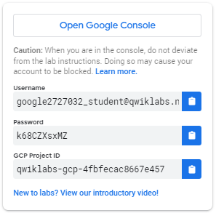

1. Copy the username, and then click **Open Google Console**. The lab spins up resources, and then opens another tab that shows the **Choose an account** page.

***Tip:*** Open the tabs in separate windows, side-by-side.

1. On the Choose an account page, click **Use Another Account**.

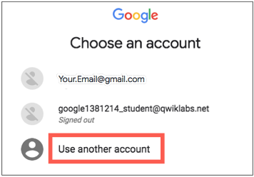

1. The Sign in page opens. Paste the username that you copied from the Connection Details panel. Then copy and paste the password.

***Important:*** You must use the credentials from the Connection Details panel. Do not use your Qwiklabs credentials. If you have your own GCP account, do not use it for this lab (avoids incurring charges).

1. Click through the subsequent pages:
   * Accept the terms and conditions.
   * Do not add recovery options or two-factor authentication (because this is a temporary account).
   * Do not sign up for free trials.

After a few moments, the GCP console opens in this tab.

**Note:** You can view the menu with a list of GCP Products and Services by clicking the **Navigation menu** at the top-left, next to “Google Cloud Platform”. 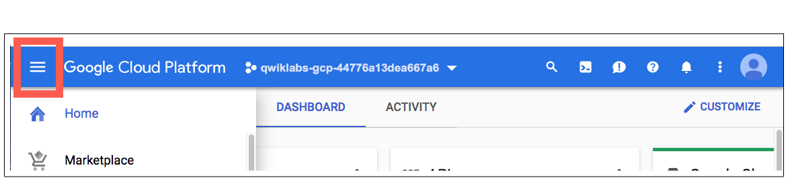

Activate Google Cloud Shell

Google Cloud Shell is a virtual machine that is loaded with development tools. It offers a persistent 5GB home directory and runs on the Google Cloud. Google Cloud Shell provides command-line access to your GCP resources.

1. In GCP console, on the top right toolbar, click the Open Cloud Shell button.

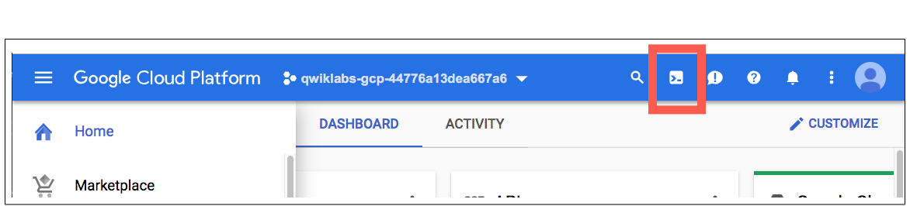

1. Click **Continue**. 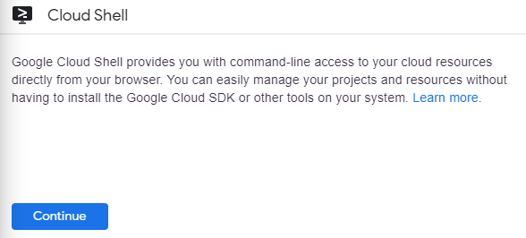

It takes a few moments to provision and connect to the environment. When you are connected, you are already authenticated, and the project is set to your *PROJECT_ID*. For example:

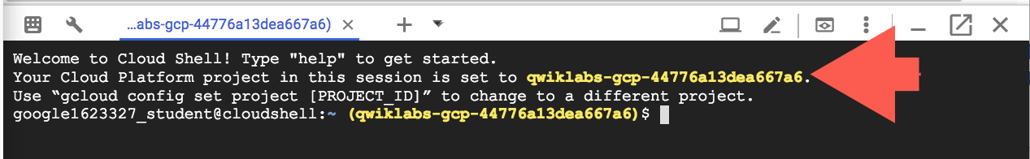

**gcloud** is the command-line tool for Google Cloud Platform. It comes pre-installed on Cloud Shell and supports tab-completion.

You can list the active account name with this command:

gcloud auth list

Output:

Credentialed accounts:

- <myaccount>@<mydomain>.com (active)

Example output:

Credentialed accounts:

- google1623327_student@qwiklabs.net

You can list the project ID with this command:

gcloud config list project

Output:

[core]

project = <project_ID>

Example output:

[core]

project = qwiklabs-gcp-44776a13dea667a6

Full documentation of **gcloud** is available on [Google Cloud gcloud Overview](https://cloud.google.com/sdk/gcloud).

**Create a function**

First, you're going to create a simple function named helloWorld. This function writes a message to the Cloud Functions logs. It is triggered by cloud function events and accepts a callback function used to signal completion of the function.

For this lab the cloud function event is a cloud pub/sub topic event. A pub/sub is a messaging service where the senders of messages are decoupled from the receivers of messages. For more information about pub/subs, see [Google Cloud Pub/Sub: A Google-Scale Messaging Service](https://cloud.google.com/pubsub/architecture).

For more information on the event parameter and the callback parameter, see [Background Functions](https://cloud.google.com/functions/docs/writing/background).

To create a cloud function:

1. In the Cloud Shell command line, create a directory for the function code.
2. mkdir gcf_hello_world
3. Move to the gcf_hello_world directory.
4. cd gcf_hello_world
5. Create and open index.js to edit.
6. nano index.js
7. Copy the following into the index.js file
8. /**
9. * Cloud Function.
10. *
11. * @param {object} event The Cloud Functions event.
12. * @param {function} callback The callback function.
13. */
14. exports.helloWorld = function helloWorld (event, callback) {
15. console.log(`My Cloud Function: ${JSON.stringify(event.data.message)}`);
16. callback();
17. };
18. Exit nano (Ctrl+x) and save (Y) the file.

**Create a cloud storage bucket**

Use the following command to create a new cloud storage bucket for your function:

gsutil mb -p [PROJECT_ID] gs://[BUCKET_NAME]

* **PROJECT_ID** is the GCP Project ID in the connection details of this lab

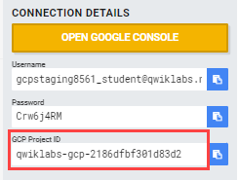

* **BUCKET_NAME** is the name you give to the bucket. It must be a globally unique name.

Test Completed Task

Click **Check my progress** to verify your performed task. If you have completed the task successfully you will granted with an assessment score.

Create a cloud storage bucket.

Check my progress

**Deploy your function**

When deploying a new function, you must specify --trigger-topic, --trigger-bucket, or --trigger-http. When deploying an update to an existing function, the function keeps the existing trigger unless otherwise specified.

For this lab, you'll set the --trigger-topic as hello_world.

1. Deploy the function to a pub/sub topic named **hello_world**, replacing [BUCKET_NAME] with the name of your bucket:
2. gcloud functions deploy helloWorld \
3. --stage-bucket [BUCKET_NAME] \
4. --trigger-topic hello_world \
5. --runtime nodejs6
6. Verify the status of the function.
7. gcloud functions describe helloWorld

An ACTIVE status indicates that the function has been deployed.

entryPoint: helloWorld

eventTrigger:

eventType: providers/cloud.pubsub/eventTypes/topic.publish

failurePolicy: {}

resource:

...

status: ACTIVE

...

Every message published in the topic triggers function execution, the message contents are passed as input data.

Test Completed Task

Click **Check my progress** to verify your performed task. If you have completed the task successfully you will receive an assessment score.

Deploy the function.

Check my progress

**Test the function**

After you deploy the function and know that it's active, test that the function writes a message to the cloud log after detecting an event.

Enter this command to create a message test of the function.

gcloud functions call helloWorld --data '{"message":"Hello World!"}'

The cloud tool returns the execution ID for the function, which means a message has been written in the log.

Example output:

executionId: 3zmhpf7l6j5b

View logs to confirm that there are log messages with that execution ID.

**View logs**

Check the logs to see your messages in the log history.

gcloud functions logs read helloWorld

If the function executed successfully, messages in the log appear as follows:

LEVEL NAME EXECUTION_ID TIME_UTC LOG

D helloWorld 3zmhpf7l6j5b 2017-12-05 22:17:42.585 Function execution started

I helloWorld 3zmhpf7l6j5b 2017-12-05 22:17:42.650 My Cloud Function: Hello World!

D helloWorld 3zmhpf7l6j5b 2017-12-05 22:17:42.666 Function execution took 81 ms, finished with status: 'ok'

Your application is deployed, tested, and you can view the logs.

**Test your Understanding**

Below are multiple-choice questions to reinforce your understanding of this lab's concepts. Answer them to the best of your abilities.

Serverless lets you write and deploy code without the hassle of managing the underlying infrastructure.

True

False

**Congratulations!**

 

Finish Your Quest

Continue your Quest with [Baseline: Deploy & Develop](https://google.qwiklabs.com/quests/37) and [Baseline: Infrastructure](https://google.qwiklabs.com/quests/33) Quests. A Quest is a series of related labs that form a learning path. Completing this Quest earns you the badge above, to recognize your achievement. You can make your badges public and link to them in your online resume or social media account. Enroll in this Quest and get immediate completion credit if you've taken this lab. [See other available Qwiklabs Quests here](http://google.qwiklabs.com/catalog).

Take Your Next Lab

This lab is also part of a series of labs called Qwik Starts. These labs are designed to give you a little taste of the many features available with Google Cloud. Search for "Qwik Starts" in the [lab catalog](https://google.qwiklabs.com/catalog) to find the next lab you'd like to take!

Next Steps /Learn More

* Now that you used the console to start a Google Cloud Function, try and compare starting a Cloud Function using the command line. See [Cloud Functions: Qwik Start - Using the Console](https://google.qwiklabs.com/focuses/10399).
* Check out our [quests](https://google.qwiklabs.com/catalog)to for a series of labs on one topic.
* Learn more about an App Engine with [An Overview Of App Engine](https://cloud.google.com/appengine/docs/standard/python/an-overview-of-app-engine).
* Try something else with an App Engine with [Getting Started with Flask on App Engine Standard Environment](https://cloud.google.com/appengine/docs/standard/python/getting-started/python-standard-env).

Google Cloud Training & Certification

...helps you make the most of Google Cloud technologies. [Our classes](https://cloud.google.com/training/courses) include technical skills and best practices to help you get up to speed quickly and continue your learning journey. We offer fundamental to advanced level training, with on-demand, live, and virtual options to suit your busy schedule. [Certifications](https://cloud.google.com/certification/) help you validate and prove your skill and expertise in Google Cloud technologies.

Manual Last Updated June 17, 2019

Lab Last Tested April 8, 2019

Copyright 2020 Google LLC All rights reserved. Google and the Google logo are trademarks of Google LLC. All other company and product names may be trademarks of the respective companies with which they are associated.