Deployment Manager: Full Production + (Stackdriver)

1 hour 30 minutes1 Credit

Rate Lab

**Overview**

In this lab you will...

1. Install an advanced deployment using Deployment Manager sample templates.
2. Enable Cloud Monitoring.
3. Configure Monitoring Uptime Checks and Notifications.
4. Configure a Monitoring Dashboard with two charts, showing CPU and Received packets.
5. Perform a load test and simulate a service outage.

**Objectives**

In this lab, you will learn to:

* Launch a cloud service from a collection of templates.
* Configure basic **black box** monitoring of an application.
* Create an uptime check to recognize a loss of service.
* Establish an alerting policy to trigger incident response procedures.
* Create and configure a dashboard with dynamically update charts.
* Test the monitoring and alerting regimen by applying a load to the service.
* Test the monitoring and alerting regimen by simulating a service outage.

**Full Production**

Mechanically, the actions you will perform in this lab are almost identical to the previous lab, with a few differences. But look at the deployment you are launching:

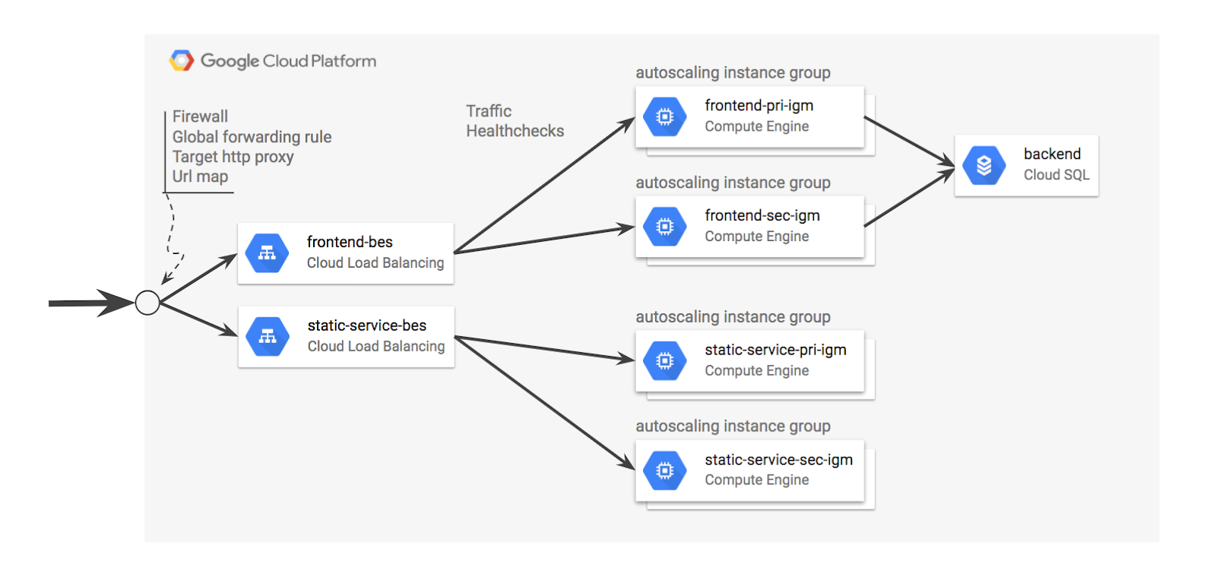

This deployment and the sample templates employ many of the best practices you have learned about throughout this class. It doesn't build just a single load balancer, but two of them. One for static content and another for dynamic content. Separating the workloads in this way allows the static and dynamic content to scale independently, making for a more cost optimized solution.

Both the dynamic and the static content are served by TWO managed instance groups so that if one group is lost, the other can resume. So this is a highly reliable and resilient design.

Finally, the system state information is pushed into a back-end Cloud SQL server. Do you know why there isn't a separate Cloud SQL server in a different zone performing replication?

Because the number of servers you are starting will reach the 8-server quota limit established in the Qwiklabs lab accounts!

Oh -- and this is a Logbook application.

**Clone the Deployment Manager sample templates**

Google provides a robust set of sample Deployment Manager templates that you can learn from and build upon.

**Clone the repo.**

In the GCP Console, to open Cloud Shell, click **Activate Cloud Shell** ( 54fc287f71fa86e5.png). If prompted, click **Start Cloud Shell**.



Open the **Cloud Shell Code Editor**. You will be using it to create and edit the template file, and the other tab to interrogate the environment for values you'll need to specify in the template. The controls you need to open the editor may be off screen to the right. You will need to close the Navigation menu to see the controls.

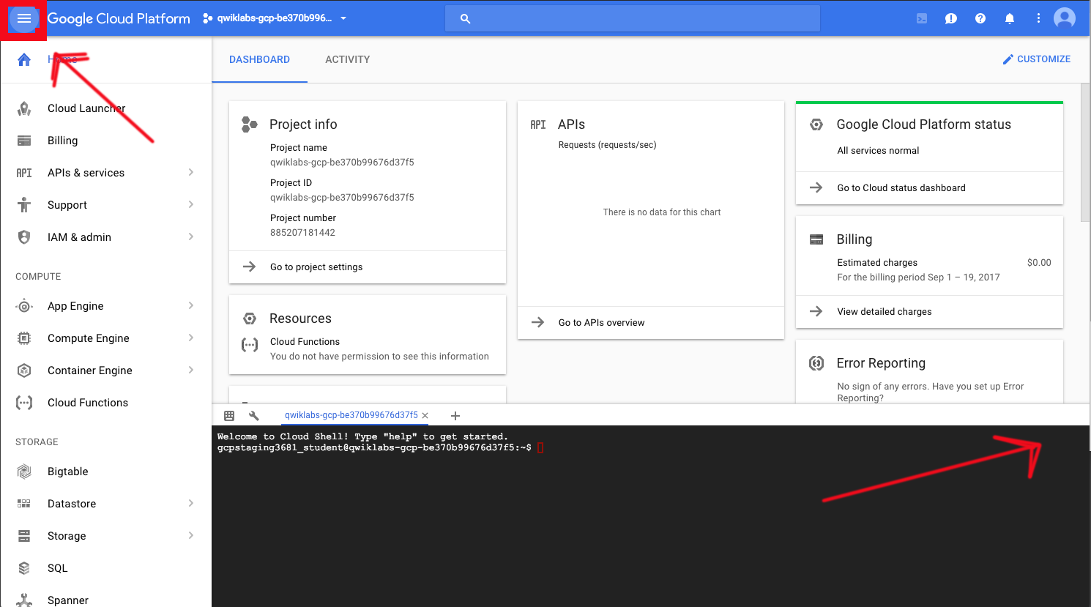

The control looks like a pencil. This is how you launch the Cloud Shell Code Editor.

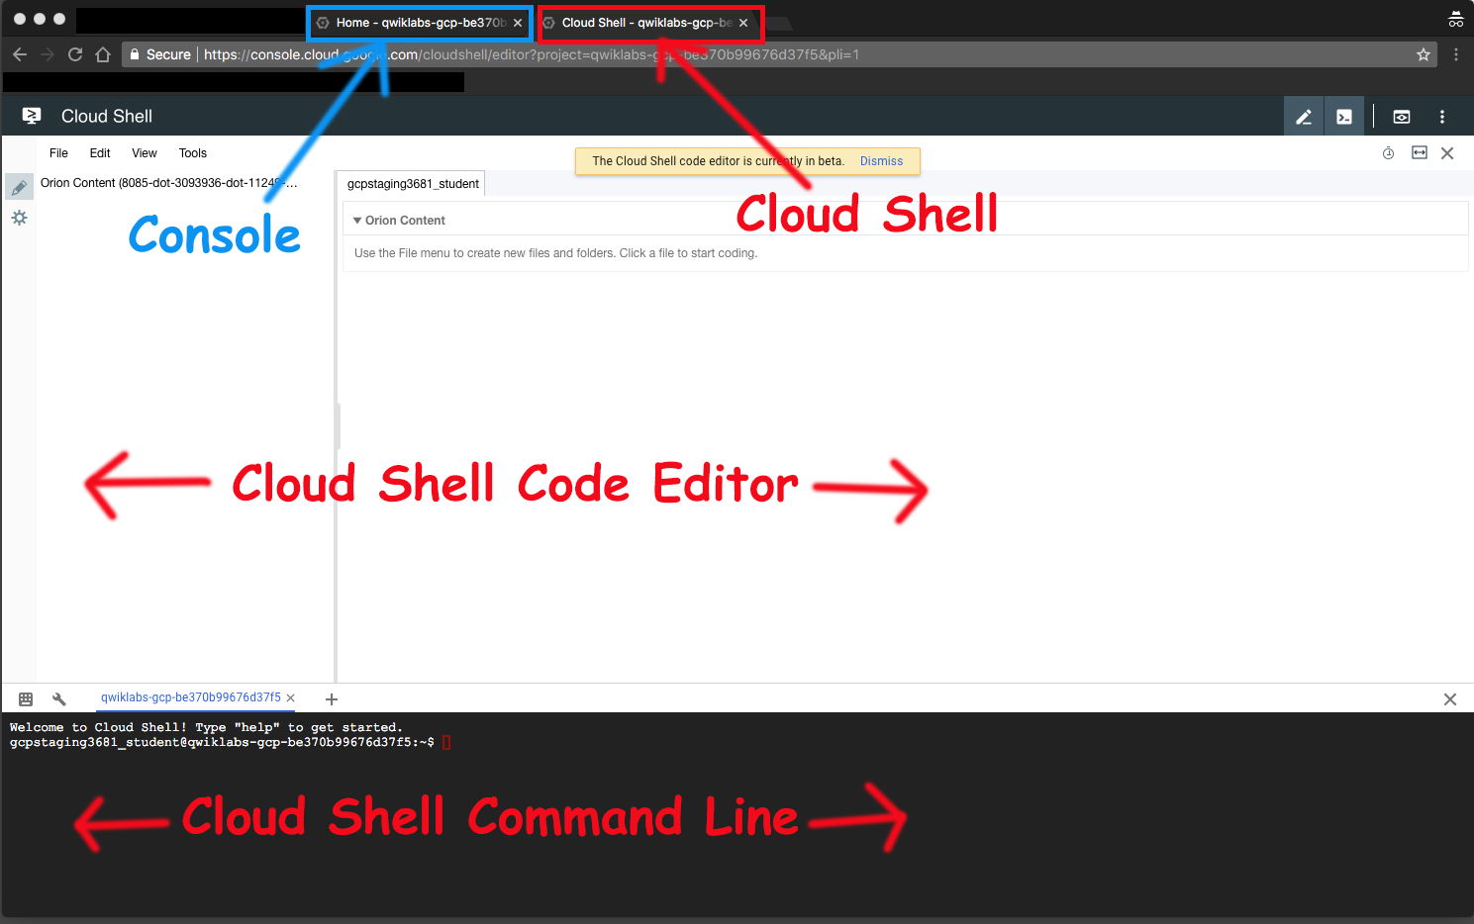

In Cloud Shell Command Line, create a directory to hold the Deployment Manager sample templates and change into that directory.

mkdir ~/dmsamples

cd ~/dmsamples

Clone the repository.

git clone https://github.com/GoogleCloudPlatform/deploymentmanager-samples.git

**About the tutorials**

There are several step-by-step tutorials in the documentation. They are located here:

<https://cloud.google.com/deployment-manager/docs/tutorials>

This lab is based on one of those tutorials, but includes additional content. The Deployment Manager template you will use generates an advanced HTTP(S) Load Balanced deployment for a Logbook sample application. The samples are available in both Jinja and Python. This lab uses the Python version of the templates.

<https://cloud.google.com/deployment-manager/docs/create-advanced-http-load-balanced-deployment>

**Explore the sample files**

There are many sample templates in the directory.

**List the example templates.**

Locate the version 2 examples and list them.

cd ~/dmsamples/deploymentmanager-samples/examples/v2

ls

You should see something like this:

**Example (don't copy)**

bigtable cloud_router container_vm htcondor image_based_igm internal_lb_haproxy nodejs_l7 regional_igm ssl vm_startup_script waiter build_configuration common gke iam instance_pool metadata_from_file project_creation saltstack step_by_step_guide vm_with_disks cloud_functions container_igm ha-service igm-updater internal_lb nodejs quick_start single_vm template_modules vpn_auto_subnet

Not all of the subdirectories are independent projects. For example, the directory named **common** contains templates that are used by several of the other projects. If you are studying independently later, use the README files as a guide.

The application you will build in this lab is contained in the **nodejs_l7** directory. Note that there is a **nodejs** directory and a **nodejs_l7** directory, you will use the one *with* L7.

L7 means network layer 7 load balancing.

<https://cloud.google.com/deployment-manager/docs/create-advanced-http-load-balanced-deployment>

<https://cloud.google.com/deployment-manager/images/http-load-balanced-diagram.svg>

**List and examine the NodeJS_l7 deployment.**

Locate the version 2 examples and list them.

cd nodejs_l7/python

ls

You should see something like this:

**Example (don't copy)**

application.py application.py.schema application.yaml autoscaled_group.py autoscaled_group.py.schema service.py service.py.schema

* application.py
* application.py.schema
* Unifies the frontend and backend and defines additional resources.
* A static service with primary and secondary managed instance groups that serves a static webpage.
* A URL Map resource that maps different URLs to their correct paths, default or static.
* A global forwarding rule that provides a single external IP address.
* A firewall rule that allows traffic through port 8080.
* service.py
* service.py.schema
* Creates the application frontend.
* Creates two managed instance groups, one primary and one secondary, using the autoscaled_group.py template
* Creates the backend service including health checker.
* autoscaled_group.py
* autoscaled_group.py.schema
* Creates an autoscaled managed instance group using the common container_instance_template.py

The above application-specific templates make use of several common templates that are used with other deployments.

* /common/python/container_instance_template.py
* /common/python/container_vm.py
* /common/python/container_helper.py

**Customize the deployment**

Google provides a robust set of sample Deployment Manager templates that you can learn from and build upon.

**Specify the zone and secondary zone.**

The application.yaml file requires a primary zone and a secondary zone.

You can find the list of zones in Cloud Shell Command Line by entering:

gcloud compute zones list

Use Cloud Shell Code Editor to edit **application.yaml** in ~/dmsamples/deploymentmanager-samples/examples/v2/nodejs_l7/python

and replace ZONE_TO_RUN and SECOND_ZONE_TO_RUN with zones of your choosing.

**application.yaml**

resources:

- name: nodejs

type: application.py

properties:

primaryZone: ZONE_TO_RUN

secondaryZone: SECOND_ZONE_TO_RUN

backendImage: gcr.io/deployment-manager-examples/mysql

frontendImage: gcr.io/deployment-manager-examples/nodejsservice

staticImage: gcr.io/deployment-manager-examples/nodejsservicestatic

**Run the application**

The application will not be operational until several steps are completed. First, you will use Deployment Manager to deploy the application. That will build the infrastructure but it won't initially allow traffic to begin. After the infrastructure is setup, you will apply service labels.

**Deploy the application**

1. Name the application and pass Deployment Manager the configuration file.

gcloud deployment-manager deployments create advanced-configuration --config application.yaml

Verify that the application is open for traffic

* On the **Navigation menu**, click **VPC Network** > **Firewall rules**.
* The Deployment Manager template should have already created a firewall rule to allow traffic from TCP 8080.

**If you don't have already created firewall rule to allow traffic from tcp:8080 then create a firewall rule by using following instructions:**

* Create a firewall rule that opens tcp:8080 for the service.
* On the **Navigation menu**, click **VPC Network** > **Firewall rules**
* Click on **Create Firewall Rule** and specify the following:

|  |  |
| --- | --- |
| **Property** | **Value (type value or select option as specified)** |
| Name | **allow-8080** |
| Description |  |
| Network | **default** |
| Priority | **1000** |
| Direction of traffic | **Ingress** |
| Action on match | **Allow** |
| Targets | **All instances in the network** |
| Source filter | **IP ranges** |
| Source IP ranges | **0.0.0.0/0** |
| Protocols and ports | **Specified protocols and ports** **Check tcp and enter 8080** |

Click **Create**.

**Verify that the application is operational**

The application takes a few minutes to start. You can view it in the Deployment Manager part of Console or you can see the instances in the Compute Engine part of Console. The application is accessible on port 8080 at a global IP address. Unfortunately, The IP address was established dynamically when the global forwarding rule was implemented by the Deployment Manager templates, so you don't know the application's IP address. And you will need that address to test the application.

**Find the global load balancer forwarding rule IP address**

Find the Forwarding IP address.

gcloud compute forwarding-rules list

Open a browser and view port 8080

http://<your forwarding IP>:8080

It may take several minutes for the service to become operational. If you get an error, such as a 404, wait about two minutes and try again. When you get a blank page, you may proceed to enter log information and view it.

Create several log entries by calling this repeatedly with different messages.

http://<your forwarding IP>:8080/?msg=enter-a-message

View the log entries:

http://<your forwarding IP>:8080/

**Enable monitoring for the project**

Now that the application is running, you will setup Monitoring Alerts and some Monitoring dashboards.

Create a Monitoring workspace

You will now setup a Monitoring workspace that's tied to your Qwiklabs GCP Project. The following steps create a new account that has a free trial of Monitoring.

1. In the Google Cloud Platform Console, click on **Navigation menu** > **Monitoring**.
2. Wait for your workspace to be provisioned.

When the Monitoring dashboard opens, your workspace is ready.

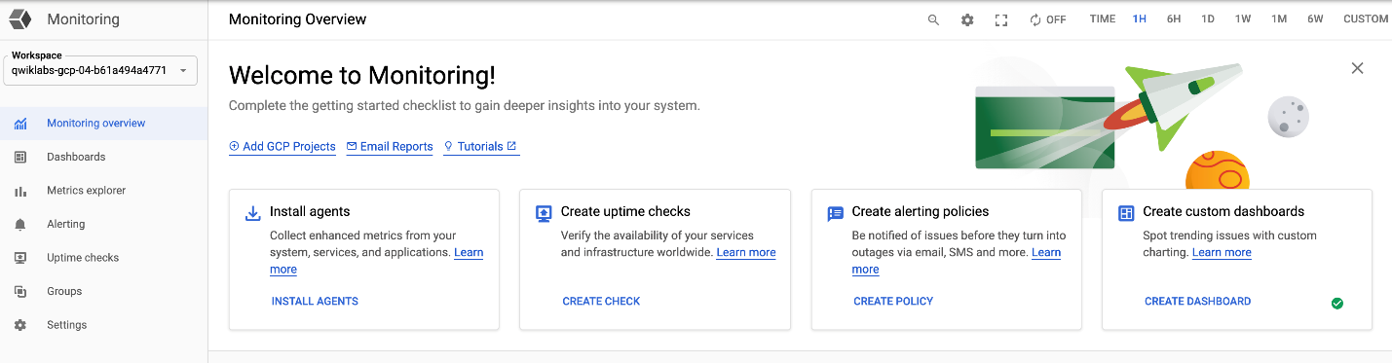

**Configure an uptime check and alert policy for the application**

Now that the application is running, you will setup Monitoring Alerts and some Monitoring dashboards.

**Configure an Uptime Check**

1. On the Monitoring window or tab, click on **Uptime Checks** menu, click **CREATE UPTIME CHECK**.
2. Specify the following:

|  |  |
| --- | --- |
| **Property** | **Value (type value or select option as specified)** |
| Title | < give the suitable name of Uptime Check > |
| Check Type | **HTTP** |
| Resource Type | **URL** |
| Hostname | < your forwarding IP > |
| Path | < leave blank > |
| Check every | **1 minute** |

1. Click **Advanced Options** and specify the following, leaving the remaining settings at the default values.

|  |  |
| --- | --- |
| **Property** | **Value (type value or select option as specified)** |
| Port | 8080 |
| **Locations** | **Global** |

1. Click **Test**. If the test fails, make sure that the service is still working. Also check to see that the firewall rule exists and is correct. If the test succeeds, click **Save**.
2. After the Uptime Check is saved, Monitoring will offer to create an alerting policy.

**Configure an Alerting Policy and Notification**

1. Click **Create Alert Policy**.

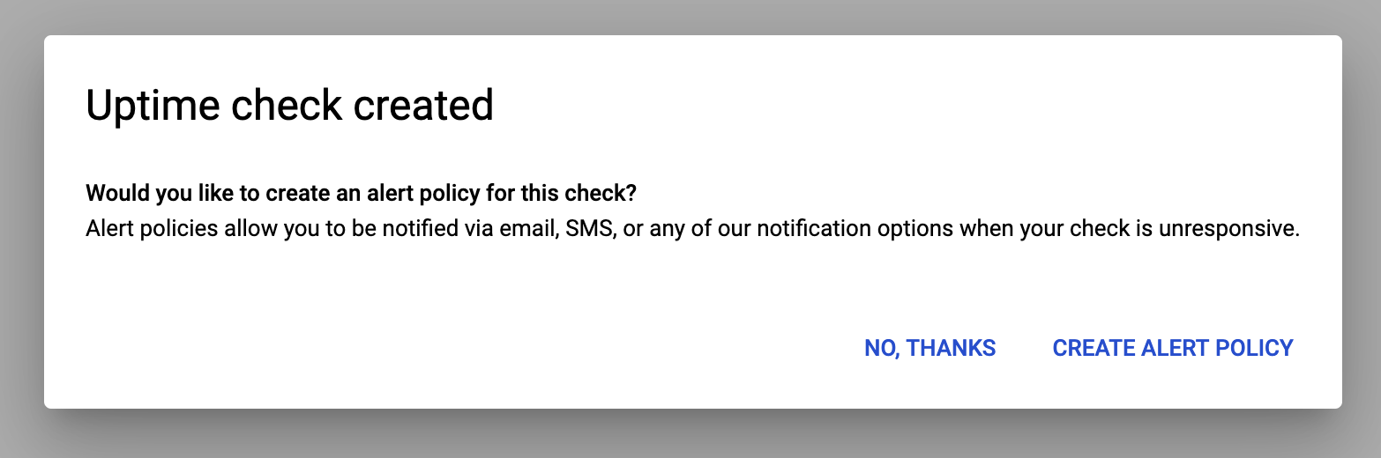

1. Go to **Metric** tab, give a display name in the **Untitled Condition**.
2. Click **Save**.

**Configure notifications and finish the alerting policy**

1. Type a name for the policy.

**Note**: Policy names are used as subjects in notification emails, so use that to your advantage.

1. In **Notifications** section, click **Add Notification Channel**.
2. Select **Email** for **Notification Channel Type**.
3. Enter the Qwiklabs username as the email address.

If you enter your own email address, you might get alerts until all the resources in the project have been deleted.

1. Click **Add**.
2. Skip the Documentation step.
3. Click **Save**.

**Configure a dashboard with a couple of useful charts.**

**Configure a Dashboard**

1. In the left pane, click **Dashboards** > **Create Dashboard**.
2. For **New Dashboard Name**, type **ArchDP Dash**, and press **Confirm**.
3. Click **Add Chart**.

|  |  |
| --- | --- |
| **Property** | **Value (type value or select option as specified)** |
| Title | < leave blank to allow the default name > |
| Resource Type | **GCE VM Instance** |
| Metric Type | **CPU usage** |

1. Click **Save.**
2. Click **Add Chart** and add another chart to the dashboard with the following properties:

|  |  |
| --- | --- |
| **Property** | **Value (type value or select option as specified)** |
| Title | < allow the default name > |
| Resource Type | **GCE VM Instance** |
| Metric Type | **Received packets** |

1. Click **Save.**

**Place a test load on the application.**

**Create a test application in Cloud Shell.**

In Console, return to Cloud shell or open Cloud Shell if necessary.

Using the Cloud Shell Code Editor, create the **test-monitor1.sh** file in ~/dmsamples/deploymentmanager-samples/examples/v2/nodejs_l7/python

Replace <your forwarding IP> with the forwarding IP address of the application and save the file.

**test-monitor1.sh**

#!/bin/bash

for ((c=1; c<=250; c++))

do

echo "$c"

curl -s "http://<your forwarding IP>:8080/"

done

Using the Cloud Shell, make the script executable.

chmod +x test-monitor1.sh

Using the Cloud Shell, run the script several times.

./test-monitor1.sh

View the results on the Dashboard in Monitoring.

The minimum dashboard timeline is 1 hour. You should see the Received packets graph trend upwards after a few minutes.

This bash script running on Cloud Shell is not sufficient to drive autoscaling. A load testing application will be required.

**Create a test VM with Apache Bench**

With the number of VMs launched, you have probably reached the Qwiklabs quota limit. Instead of installing Apache Bench on a VM, as you would normally do in a production environment, just install and use it from the Cloud Shell Command Line

**Install Apache Bench on Cloud Shell**

1. Open Cloud Shell

cd

sudo apt-get update

sudo apt-get -y install apache2-utils

1. Use Apache Bench to apply load to the service.

ab -n 10000 -c 100 http://<your forwarding IP>:8080/

**Note:**You must include the trailing slash after your forwarding IP address. Otherwise you will get an error such as: "ab: invalid URL" when you run the above command.

1. Run the above command two or three times.
2. View the results on the Dashboard in Monitoring.
3. You can also view the instance groups in Console to see if autoscaling has been triggered. On the **Navigation menu**, click **Compute Engine** > **Instance groups**. Your results may look similar to the image below:

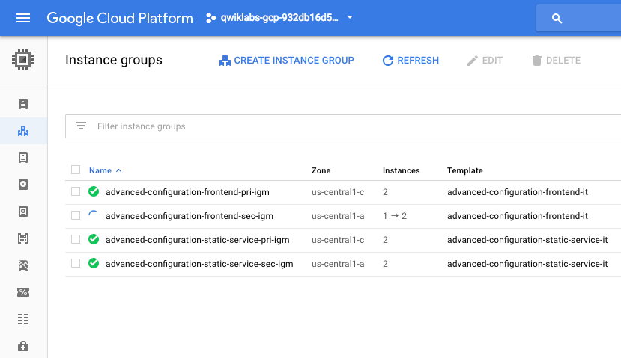

**Simulate a service outage.**

Remove the firewall to simulate an outage.

1. On the **Navigation menu**, click **VPC Network** > **Firewall rules**.
2. As shown in the image below, select the firewall rule that is allowing TCP **8080** traffic, and click **Delete**.

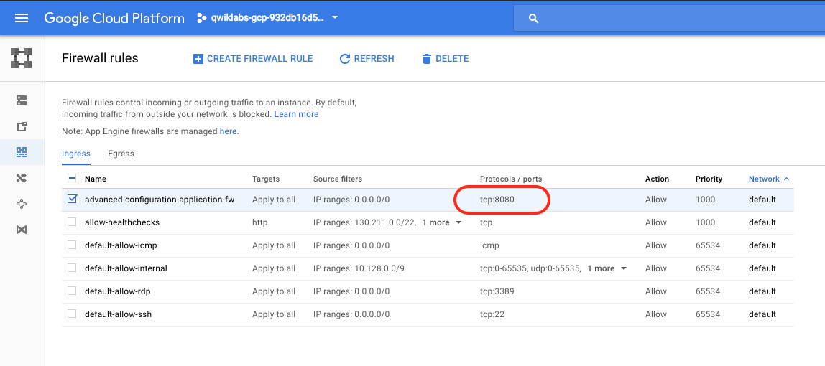

1. After some time, you should receive a notification email. The notification latency setting determines how long after a policy is triggered before a notification is sent.

After you receive the notification you can proceed.

**Full Production**

You just built a full-featured full-size highly available, reliable, scalable, and resilient service. And it probably didn't feel significantly different from the much smaller services you built in the previous two labs. That's the magic of Deployment Manager!!