Assignment 1 : Linux Basic Commands

1. Display current working directory.

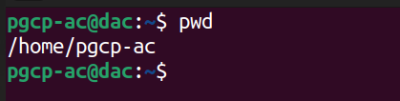

2. List all files and hidden files in current directory.

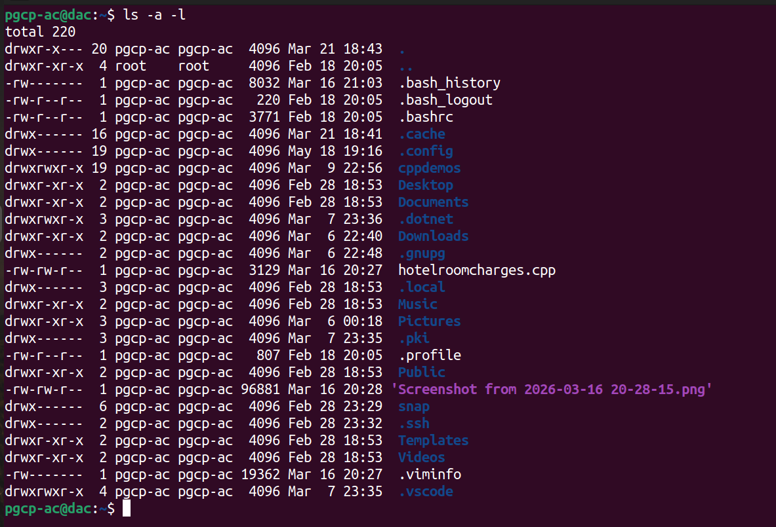

3. Create a directory named documents .

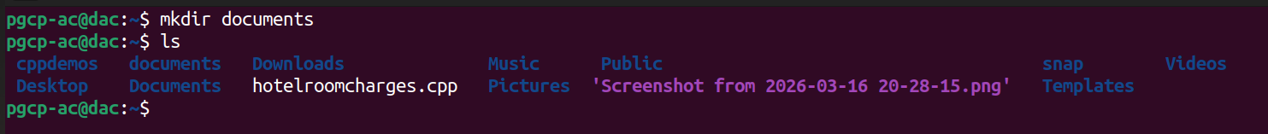

4. Create subdirectories docs , backup , and scripts .

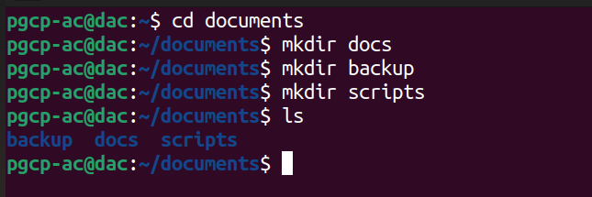

5. Create files:
file1.txt
file2.txt
notes.txt

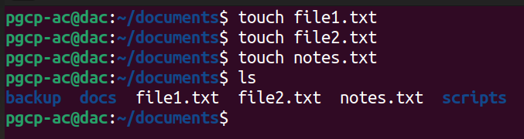

6. Copy file1.txt into backup .

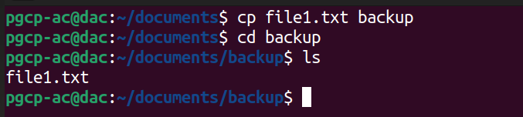

7. Move notes.txt into docs .

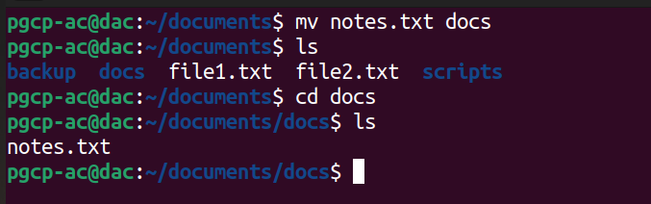

8. Rename file2.txt to data.txt .

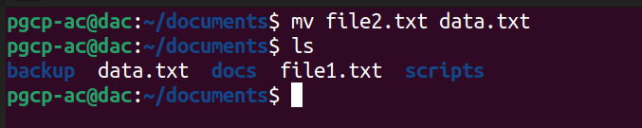

9. Delete data.txt .

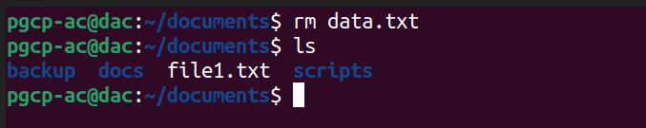
10. Remove backup directory recursively.
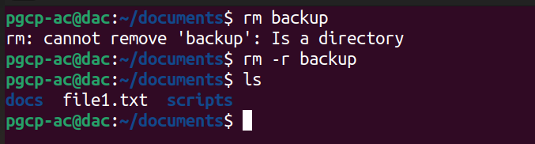

11. Display contents of example.txt .

12. Display first 10 lines of /etc/passwd .

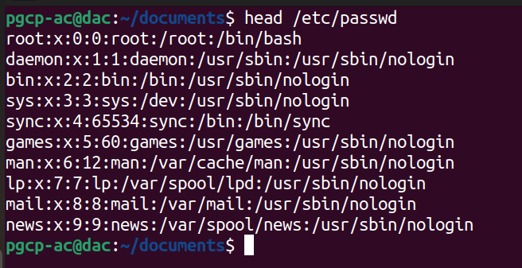

13. Display last 10 lines of /etc/passwd .

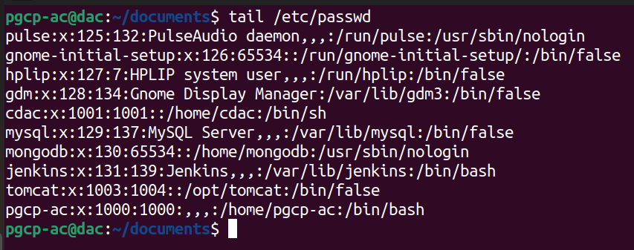

14. Count lines, words, and characters in file.

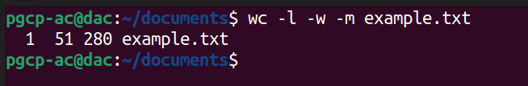
15. Search word Linux inside file.

16. Search recursively for word error inside /var/log .

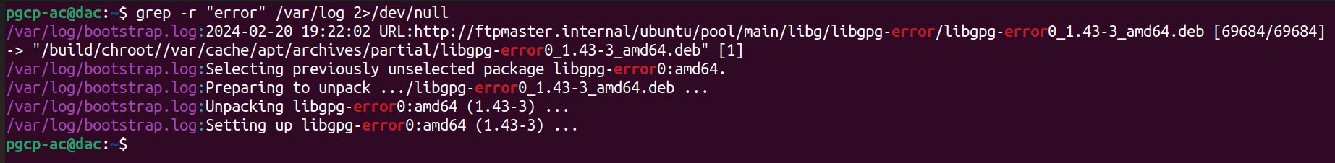
17. Find all .txt files in home directory.

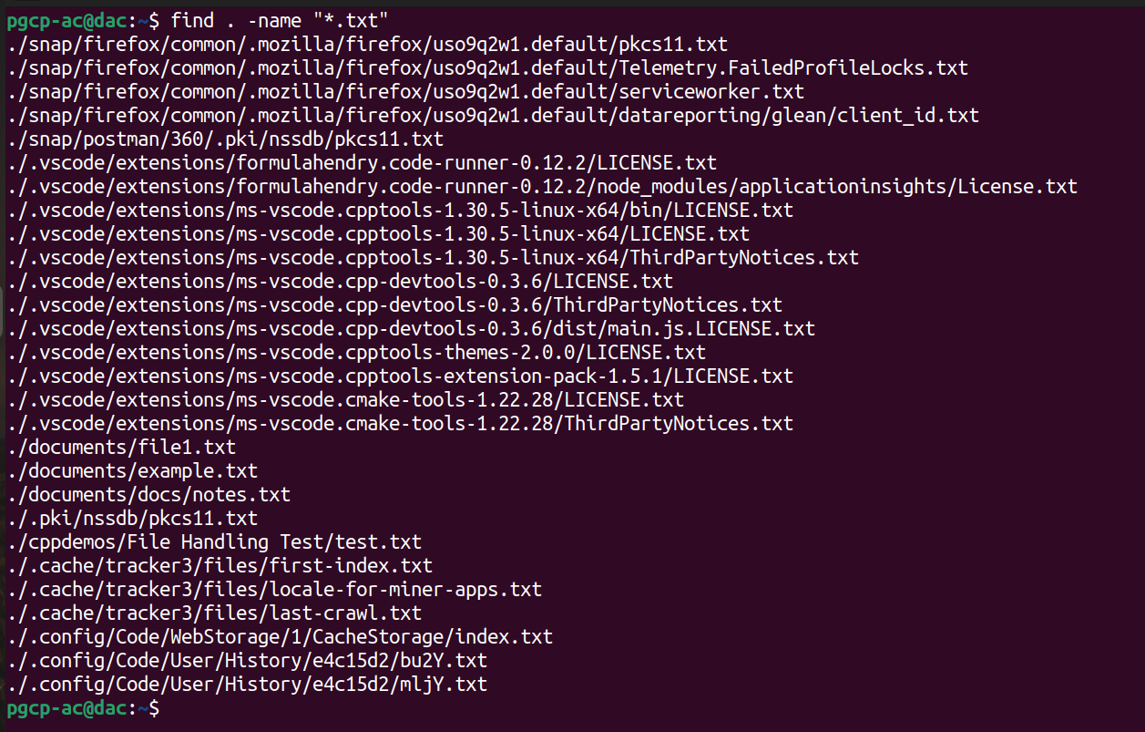

18. Find empty files inside /tmp .

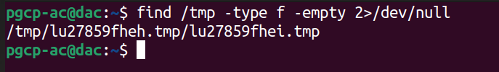
19. Find files modified within last 2 days.

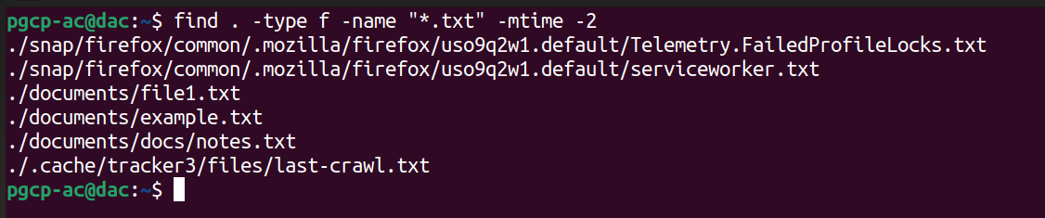
20. Display size of report.pdf in KB.

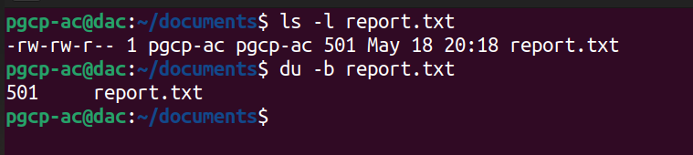
21. Display file permissions using long listing format.

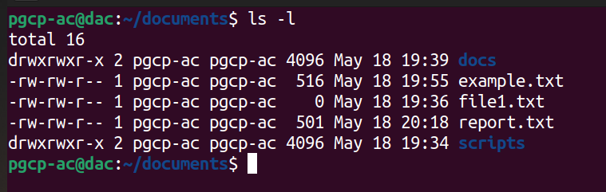

22. Give execute permission to script.sh .

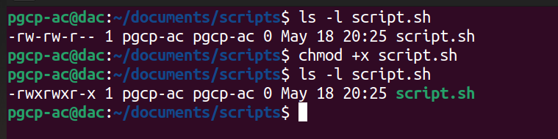
23. Remove write permission from others for data.txt .

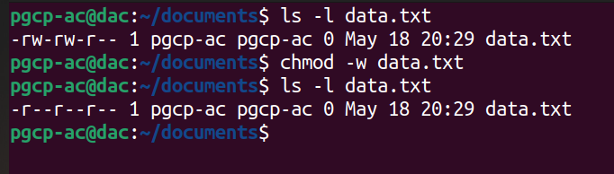
24. Set permission 754 on project.sh .

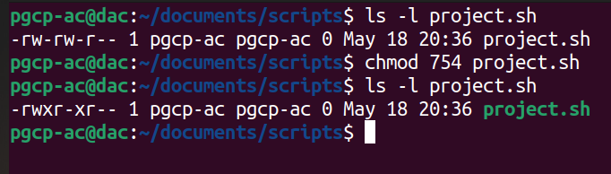
25. Change owner of file to another user.
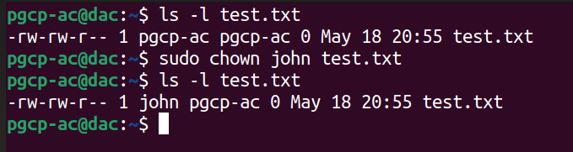
26. Change group ownership of file.

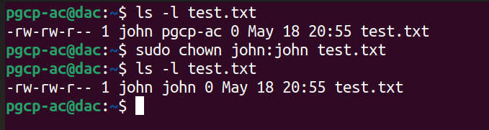
27. Create new user john .
28. Set password for john .

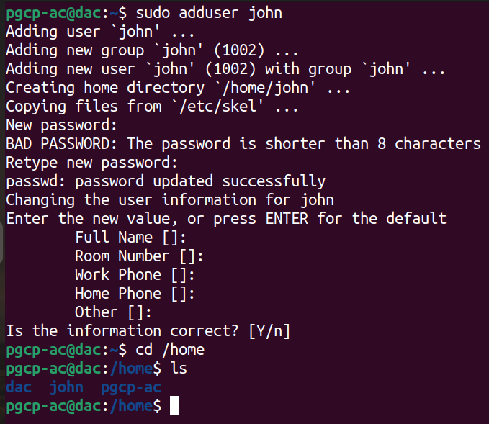

29. Delete user alice with home directory.

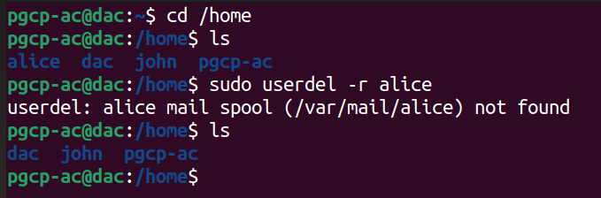
30. Display currently logged in users.

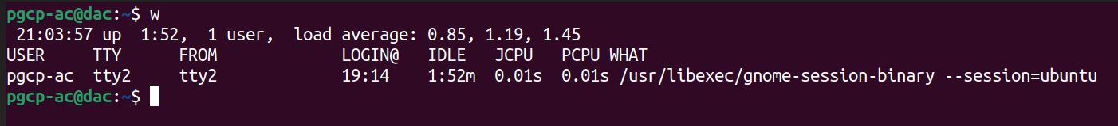
31. Display all environment variables.

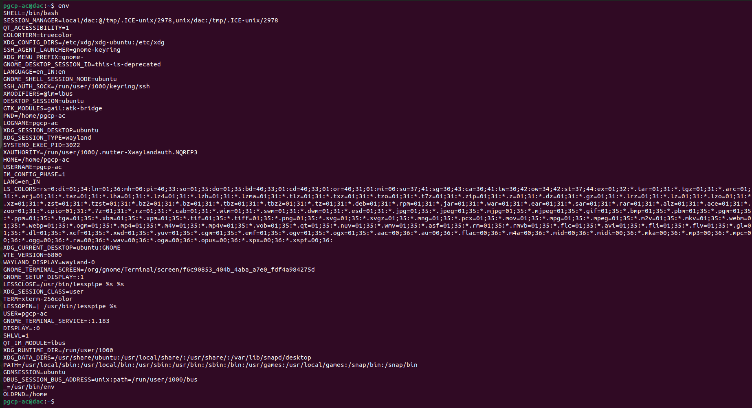

32. Create custom shell variable and print it.

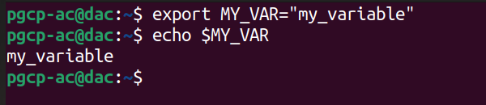
33. Change PS1 prompt temporarily.

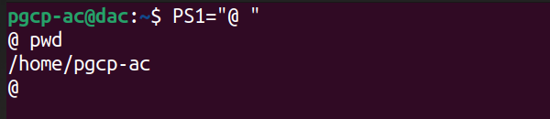
34. Redirect output of ls -l into list.txt .

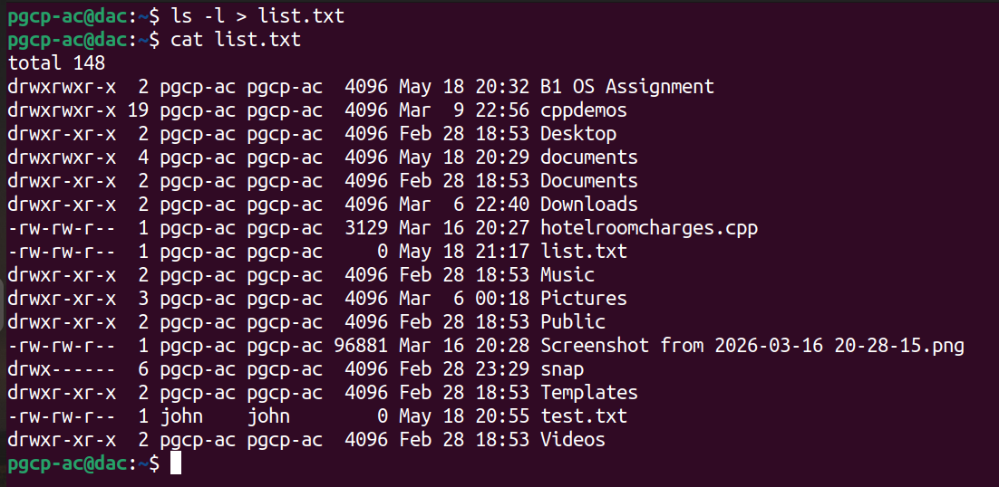
35. Append current date into log.txt .

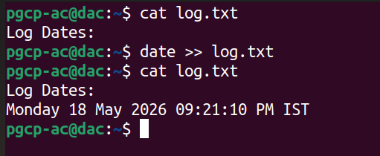

36.Redirect standard error into error.txt .

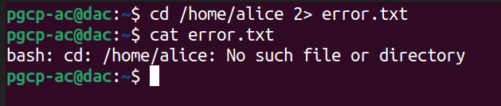
37. Redirect both standard output and standard error into same file.

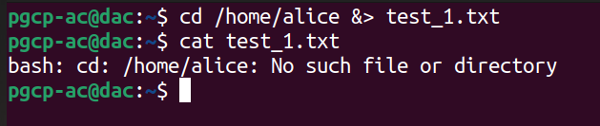
38. Use pipe to count number of running processes.

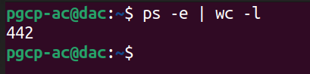

39. Display only .txt files using grep .

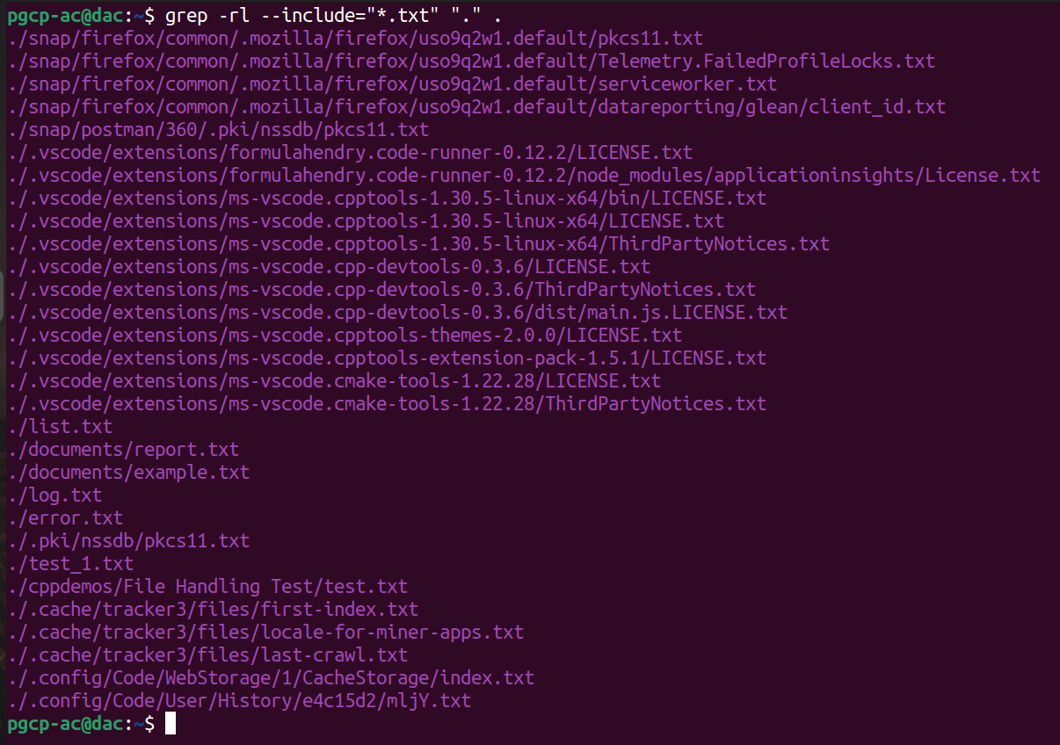

40. Sort contents of a text file.

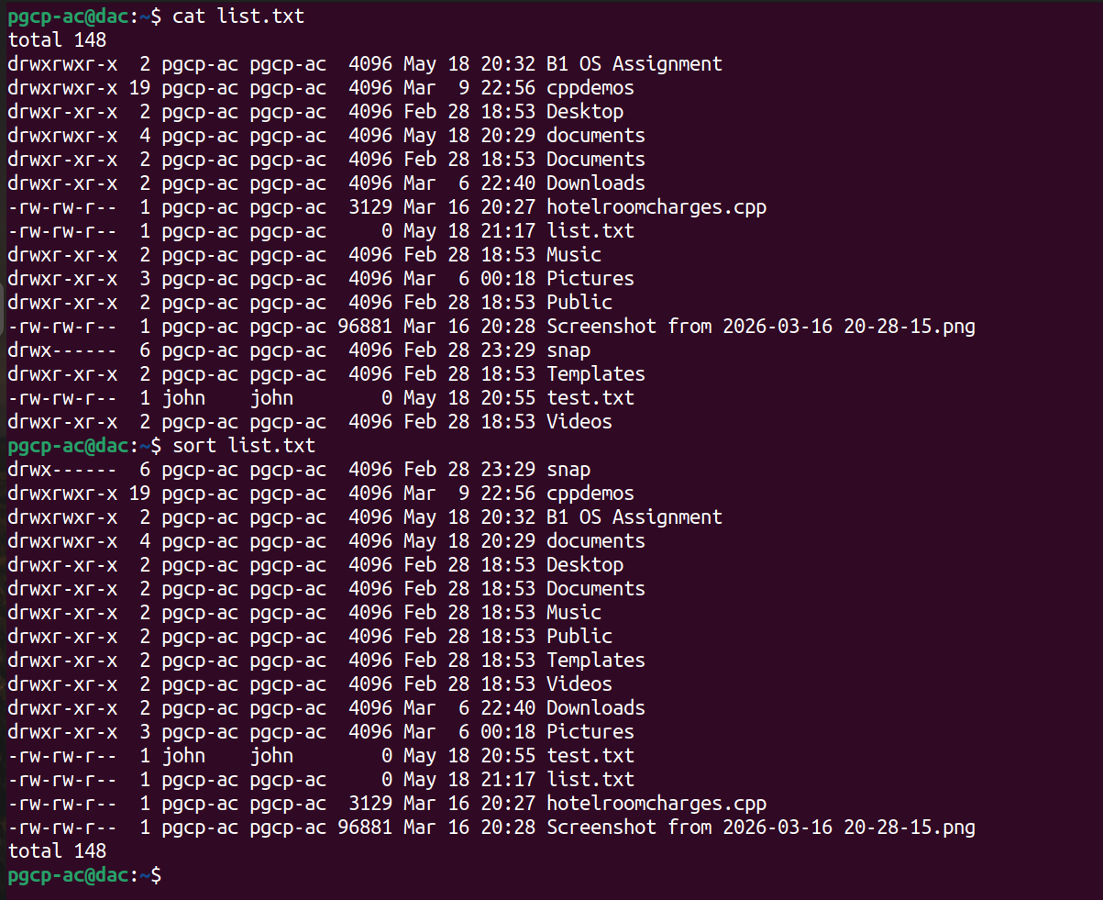

41. Remove duplicate lines from file.

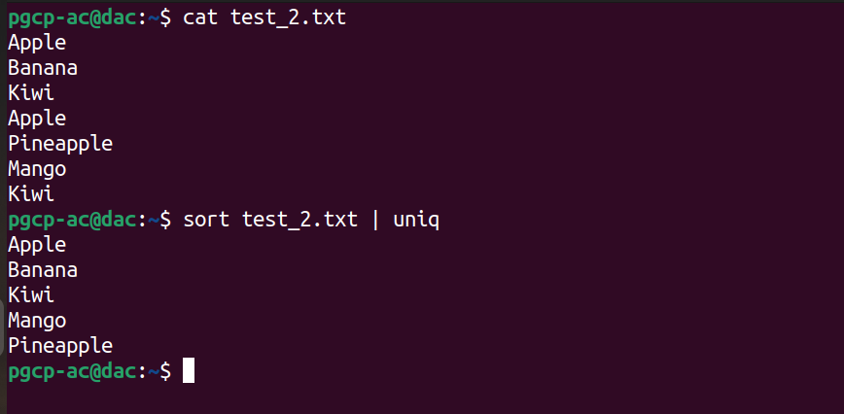

42. Compare two files using diff .

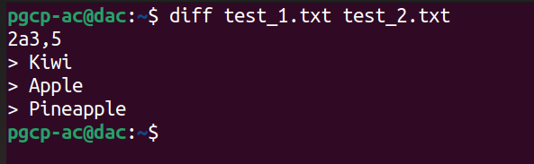

43. Merge two text files into one file.

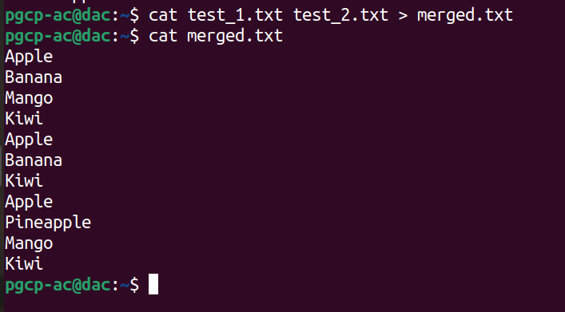

44. Reverse contents of file.

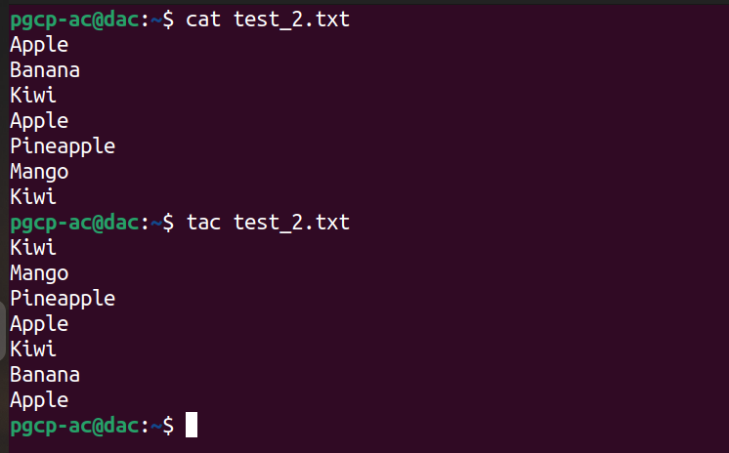

45. Compress directory using tar .

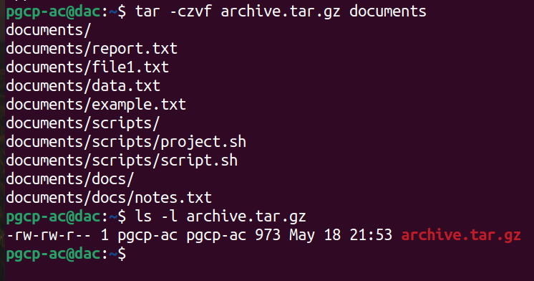

46. Extract .tar.gz archive.

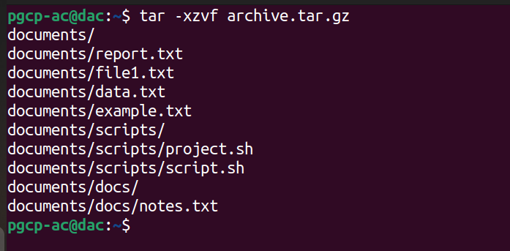
47. Display line numbers while viewing file.

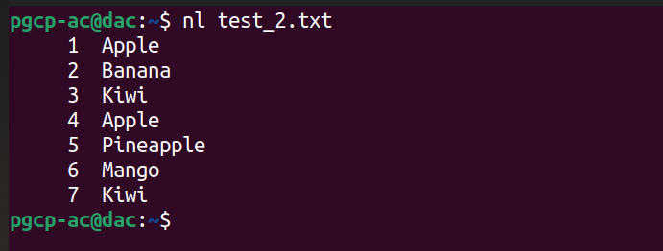

48. Append text into file using echo .

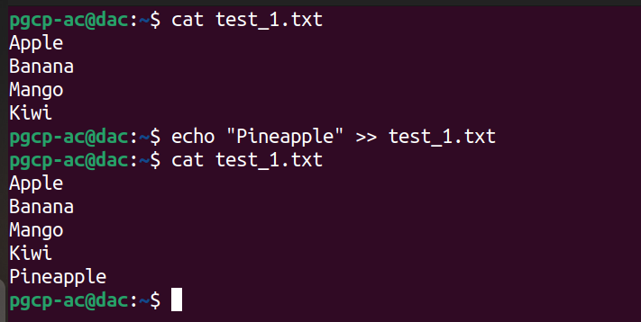

49. Display contents of multiple files together.

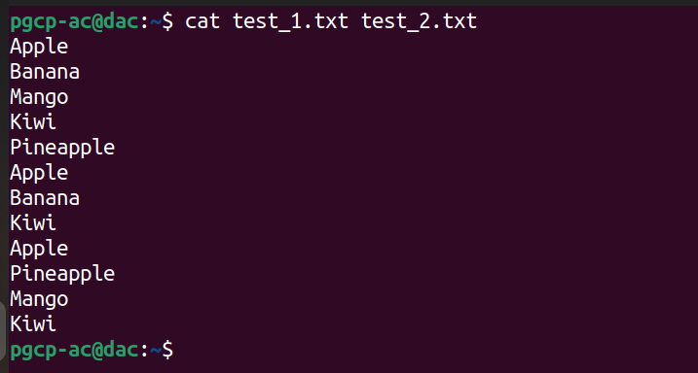

50. Display current date and time in custom format.

