Assignment : (Git & GitHub)

Q1. Create and Initialize Git Repository
Create a new repository named git_lab on your local system.
Initialize it using Git.
Create a file info.txt and add your name and date.
Check the repository status.
Add the file to staging and commit with message "Initial commit" .
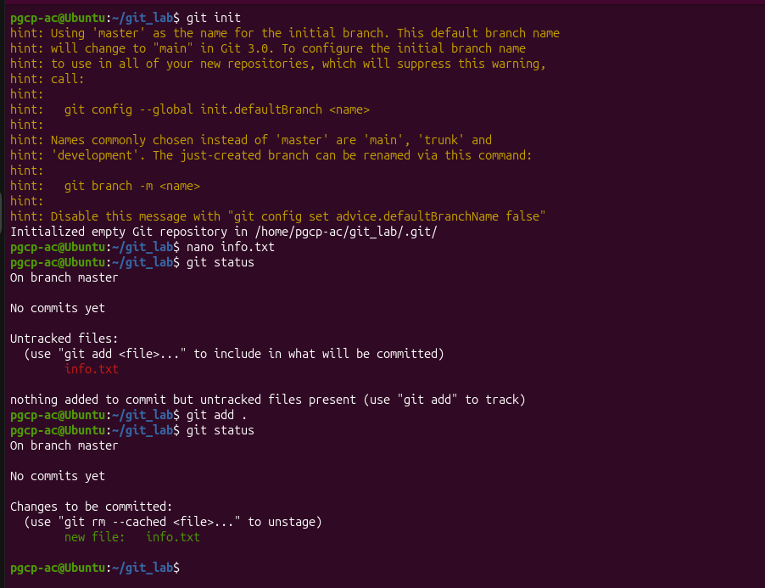
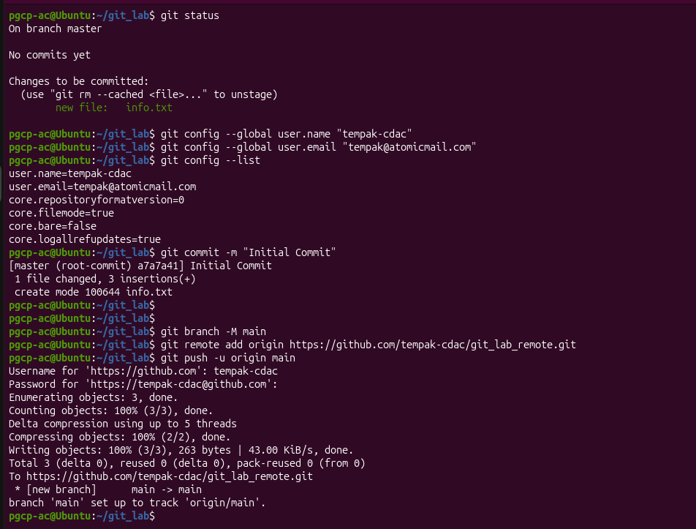

Q2. Connect to GitHub and Push Code
Create a repository named git_lab_remote on GitHub.
Link your local repository ( git_lab ) to the remote repository.
Push your committed file to the remote repository.
Verify the file is uploaded on GitHub.
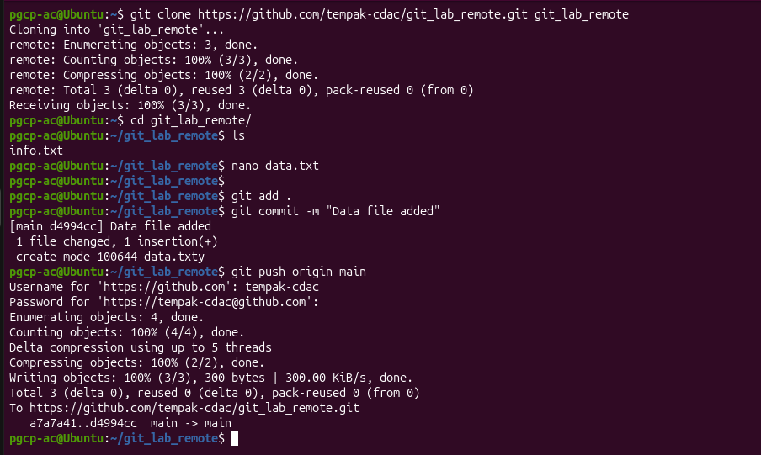

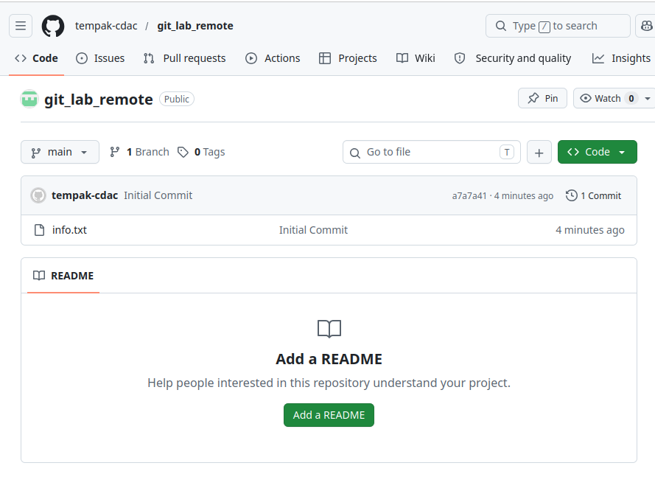

Q3. Clone Repository and Make Changes
Clone the repository git_lab_remote to a new directory.
Create a new file data.txt and add some sample content.
Add and commit the file with message "Added data file" .
Push the changes back to GitHub.


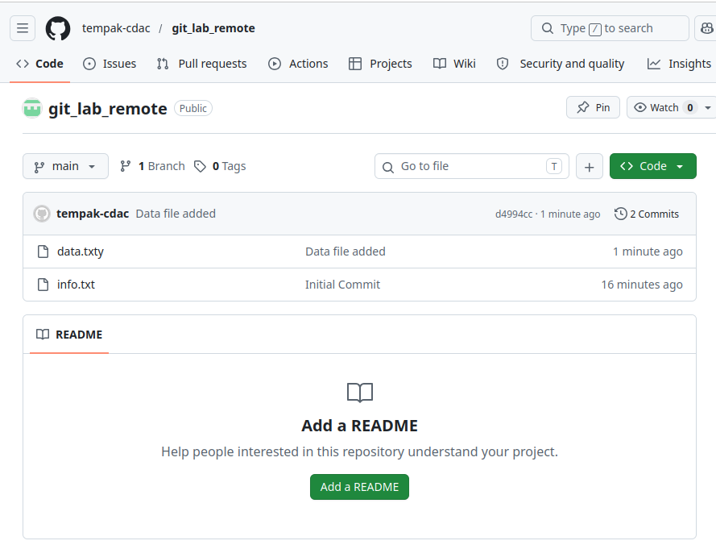

Q4. Branching and Merging
Create a new branch named feature .
Switch to the feature branch.
Modify info.txt (add new line: “Feature branch update”).
Commit the changes.
Switch back to main branch.
Merge the feature branch into main .
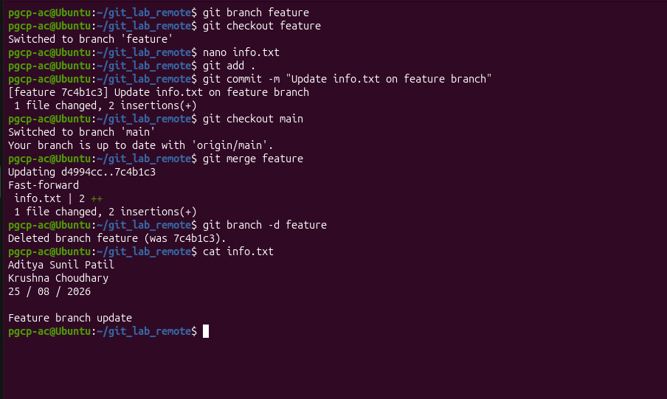
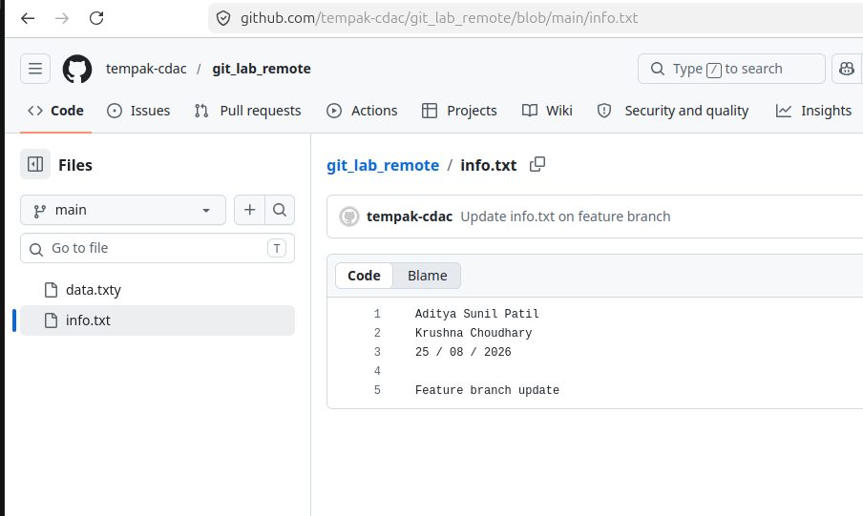
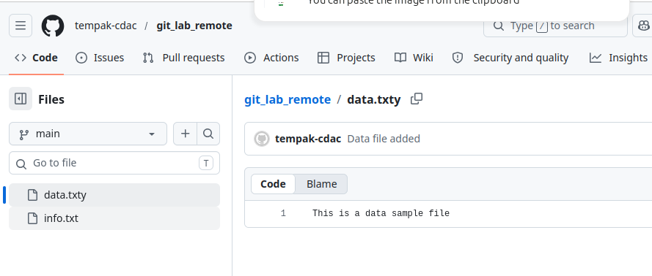

Assignment : (Git & GitHub) 1

Delete the feature branch after merge.

