Inhalt
Installation 2
Conditions 2
Database login credentials 3
Creating the first user 3
Basecamp import 3
Administration 4
Project administration 4
Add project 5
User administration 6
Add user 6
Assign user 7
System administration 7
Basecamp import 8

Installation
Unpack the Collabtive archive in a directory of your choice.
Next, upload all the files to your webserver.
Make the following files/folders writable:
- /files
- /templates_c
- config.php
Then open the installer in your browser.
Point your browser to http://yourdomain.com/collabtive_dir/install.php to do that.

Conditions
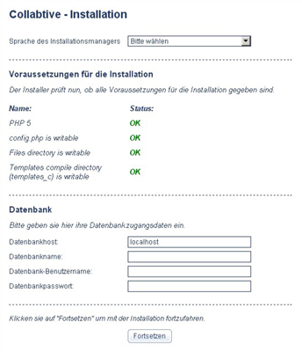
In this first step the installer checks if all conditions for the installation are given.
If everything is all right a green OK appears next to each requirement.

Database login credentials
Next you need to provide the login credentials to your MySQL database.

- Database host: The host were your MySQL server runs.
Usually you can leave this set to „localhost“.
- Database name: The database name
- Database user: The database username
- Database password: The corresponding password

Creating the first user
Now it's time to create the first user.
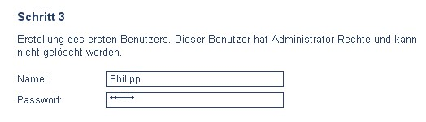
This user automatically receives admin privileges and can not be deleted.
Other users can be created later.

Basecamp import
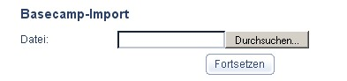
Basecamp allows you to export your data to XML files. Here you can import them into Collabtive. Just select the exported XML file, hit „Continue“ and you're ready to go.
The following data is imported:
- User
- Projects
- Milestones
- Tasklists and tasks
User assignments to tasks and projects are maintained, too.

Administration
Ein Klick auf Administration öffnet den Adminbereich.

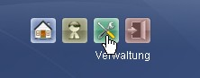
Project administration
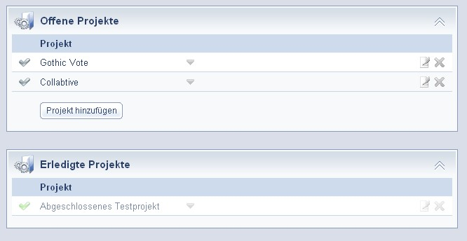
In this are all open and finished projects are displayed.
Projects can be opened, closed, edited and deleted by clicking the appropriate icons.
Projects can also be added by clicking „Add project“

Add project
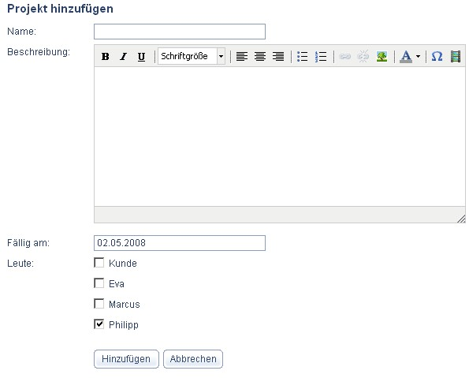
Name: Name of the project
Description: Description of the project
Due: Deadline for the project
People: People that are assigned to this project.
By default you'll get assigned to each project you create.

User administration
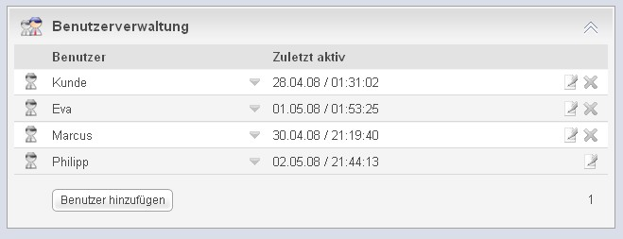
Hier können

Add user
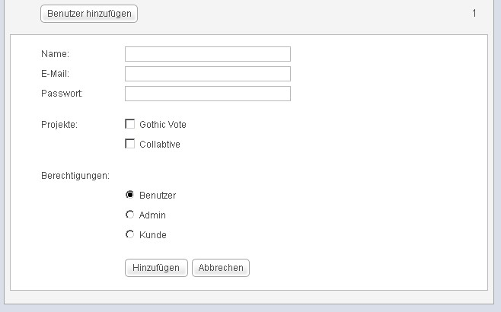
Name: Name of the user
E-Mail: Email Address of the user
Password: Password of the user
Projects: Projects the user is assigned to.
Permissions: Role of the user

Assign user
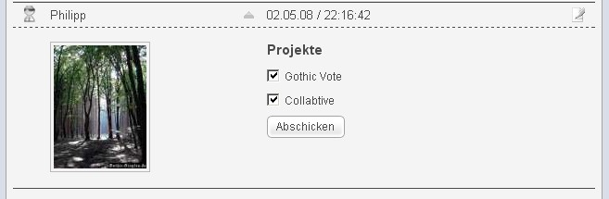
Zunächst öffnet man die Detailansicht des Benutzers indem man den blauen Pfeil anklickt. Hier sieht man die Projekte denen der Benutzer zugewiesen ist.
Um ihn zusätzlichen Projekten zuzuweisen klickt man einfach das entsprechende Häckchen an und klickt „Abschicken“.

System administration
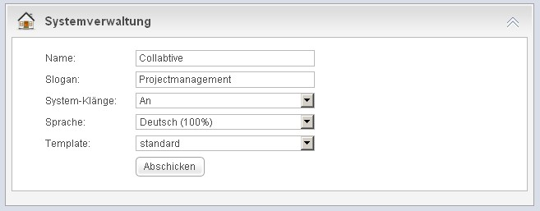
Here you can change all system wide settings.
Name: The name of the system.
Slogan: Subtitle for the system.
System-Klänge: Systemsounds on login, logout and error on/off.
Locale: The locale for the system. This setting is only effective for non logged in users and users that have „default“ as their locale setting. This is the default setting for each user.
Template: The theme for the GUI.

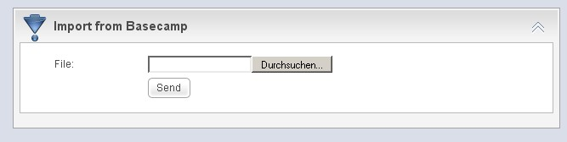
Basecamp import
Basecamp allows you to export your data to XML files. Here you can import them into Collabtive.
Just select the exported XML file, hit „Continue“ and you're ready to go.
The following data is imported:
- User
- Projects
- Milestones
- Tasklists and tasks
User assignments to tasks and projects are maintained, too.
Last update: 03.05.08

