Requirements Specification

|  |  |
| --- | --- |
| **Client Details** |  |
| **Name** | Sam Cogan |
| **Company** | TinyPages Web Design |
| **Contact** | info@tinypages.ie |

# Site description: (100-200 words)

TinyPages is an Irish (Dublin-based) web design company, which focuses on providing websites to the SME market, particularly small companies.

The designed site itself consists of four pages of HTML5, with additional styling (CSS) and scripting (Javascript/jQuery); the content is pulled from the two existing versions of this site. The first of the four pages is a home/index page which provides a basic overview of TinyPages, and the services it offers. The second of the four pages provides a more detailed description of the services that TinyPages can provide to potential clients, while the third page is a portfolio page, which gives an overview of work done previously for four other clients, along with links to their new websites for potential clients to view. Lastly, there is a contact page, which provides email and social media links, as well as a contact form, all of which can be used to contact TinyPages Web Design.

# Site map: (Diagram of pages laid out in their hierarchy)

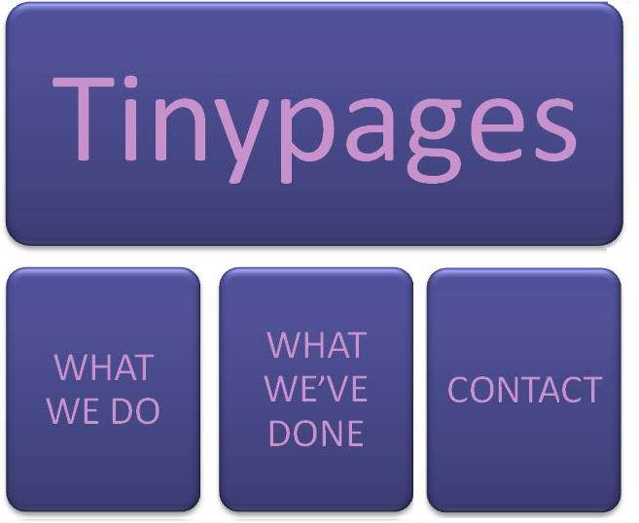

# Technical Details (No of pages, languages used, doctype etc)

|  |  |
| --- | --- |
| **Domain name** | Tinypages.ie |
| **Extensions required (.ie,.com etc)** | .ie, .net |
| **Contact form required?** | Yes |
| **Email address(es) needed** | No |
| **Doctype** | HTML |
| **Languages used** | HTML5, CSS3, Javascript (jQuery 1.10.2) |
| **No. of pages** | 4 |
| **Responsive design needed** | No |
| **Cross-browser testing** | Yes; Firefox (v24), Chrome (v30), Opera (v12), Internet Explorer (v8, 9, 10) |

# Site Details (Written interpretation of client needs)

Upon initial contact with the client, we were provided with a basic design spec, which specified the following:

* four pages (home/index, work, portfolio, and contact);
* a minimalist design, pulling content from the other two sites;
* to not use white in the design;
* to use the shade of purple from Sam’s logo, and;
* to set the horizontal width to 960px to eliminate horizontal scrolling.

Several days later, five prototype wireframes were constructed, and emailed to the client, along with a couple of further questions, including specific fonts, and font sizes to be used. Images of the five initial wireframes (Initial_01 to Initial_05) are included in this folder for viewing. The client subsequently replied with the answers to these questions, as well as the wireframe that most interested him, a design which included a fixed, vertical menu on the right-hand side of each page (Initial_04).

Once a site corresponding to this basic design had been created, three different sample colour schemes, along with two minor variations on the menu (Revision_04a and Revision_04b) were shown to the client for consultation and feedback. The differences between the two menu variations were the size of the text, and the placement of the social media icons. Of the prototypes related to the social media icons, one (Revision_04a) positioned them just under the menu links, while the other (Revision_04b) positioned them near the bottom of the page; the client preferred the latter. Once this feedback had been received, work commenced on tweaking and altering the website to its final form, with the client being consulted on one or two additional occassions for final pieces of feedback.