
System Requirements Specification Document
PLI Integration with IVR
25/Feb/2015 14:00
Ver 1.11
© 2013 Infosys Limited. Strictly private and confidential. No part of this document should be reproduced or distributed without the prior permission of Infosys Limited.

Review List
Sign Off Required: | Role:
Review Required: | Role:
Information Only: | Role:

Version History

Document Version | Date | Author | Reviewed By | Change Description
0.3 | 24-01-2015 | Base document | Shubangi | Initial draft document
0.6 | 25-01-2015 | Formatted Document | Vivek Jain | Major Changes and service wise description.
0.7 | 29-01-2015 | Updated document based on the review comments | Shubangi,  Davnit and Vivek | Additional attributed added and updated with datatypes.s
0.71
0.8 | 02-02-2015 | Shiv, Hulin | Shiv, Hulin | Updated the document with review comments and changes in track mode.  Marked the Futuristic items as being scoped out of This Document.  Added the table with only in-scope line items.
0.9 | 03-02-2015 | Shiv, Hulin | Shiv, Hulin | - Modifications as per Vivek’s responses.  - Moved Integration Flow diagram up one section.  - Moved table for in-scope requirements to Section 4, Business Process Flow.  - Added section numbers for each line item of in-scope requirements table.  - Removed sections on futuristic functionalities.  - Removed section on Claim Intimation, since it is applicable for Manual, not IVR.  - Promoted section on Revival Document to Level 1  - Promoted section on WSDL to Level 1.  - Renamed section on Approach to Web Service Specification
1.0 | 04-02-2015 | Vivek | Vivek | Addressed the comments raised.
1.1 | 04-02-2015 | Vivek, Shiv | Vivek, Shiv | Addressed the comments raised. WSDL attachment removed.  Pg 15, 5.1.1, Request Message  N-13 : For Policy Number only.  N-9 : For Proposal Number and service request number, only the numeric- 9 digit would be entered.  Changed to :  N-13 : For Policy Number only.  N-9 : For Proposal Number and Claim request number, only the numeric- 9 digit would be entered.  In section 8. WSDL, restored the following sentence :  The WSDL provided herein will meet the functionality as per the table and entire content of Section 4, Business Process Flow. Any shortcoming in the functionality will be attended to within the prevailing timeframes of the activities dependent on This Document.
1.11 | 25/Feb/15 | Hulin, Shiv, Nalin | Dinesh | Comments from NISG. TCS response to comments from NISG.
2.0 | 9/Mar/15 | Vivek Jain | Vivek Jain | Updated the comment in the Open Section.

Table of Contents
1. Overview 5
2. Scope and Assumptions 6
3. Intergration Flow Diagram 8
4. Business Process Flow 9
4.1 Policy Servicing: 9
4.2 Proposal Status 10
4.3 Policy Status 10
4.4 Premium Due Date. 10
4.5 Premium Amount Check 11
4.6 Sum Assured Check 11
4.7 Surrender Value Check 11
4.8 Loan Amount Check 12
4.9 Rate of Interest of Loan 12
4.10 Premium Updated Status 13
4.11 Policy Maturity Date Info 13
4.12 Maturity Amount Info 13
4.13 Claim Status 14
4.14 Agent License Expiry 14
5. Web Service Specifications 15
5.1 pliSearchRequest – WSDL service signature 15
5.1.1 Request Message 15
5.1.2 Response Message 16
5.1.3 Error Description: 17
5.2 PliAgentRequest: Agent Search Service 17
5.2.1 Request Message 18
5.2.2 Response Message 18
6. Error Handling 19
7. Revival Document 20
8. WSDL 21
9. Open Items 22

Overview

Interactive voice response (IVR) is a technology that allows a computer to interact with humans through the use of voice and DTMF tones input via keypad.
In Insurance Industry IVR systems can respond with prerecorded or dynamically generated audio to further direct users on how to proceed. IVR applications can be used to control almost any function where the interface can be broken down into a series of simple interactions.
This document provides an overview of the Services, which will be invoked once the customer is authenticated, IVR presents all the self service options to the customer, from which customer can choose a specific request for PLI System to respond to.

Scope and Assumptions

- IVR will interact with PLI Solution via Biztalk using Web Service Route.
- IVR System will be integrated with PLI solution’s APIs using XML over HTTP mechanism.
- The authentication of customer requesting a specific Service will be handled by IVR System. PLI system will share the date of birth of customer in response to policy number given as request. The validation of date of Birth will be done by IVR system.
- In case of the technical/business error, IVR system is expected to send the same request again.
- The table afore, gives a snapshot of IVR requirements and a column indicating whether they are in scope for this phase of the implementation.

Refer to the following table for scope of IVR processes:
No. | Process | Nature of Transaction | Transaction Description | Manual / IVR | In Scope of This Document
1 | Postal Insurance | Inquiry | Policy servicing | Both | Yes
2 | Postal Insurance | Inquiry | Proposal status | Both | Yes
3 | Postal Insurance | Inquiry | Medical Test Appointment status | Both | Futuristic  As per DoP, this item is futuristic, hence it has been scoped out.
4 | Postal Insurance | Inquiry | Policy status | Both | Yes
5 | Postal Insurance | Inquiry | Premium due date | Both | Yes
6 | Postal Insurance | Inquiry | Premium amount check | Both | Yes
7 | Postal Insurance | Inquiry | Sum assured check | Both | Yes
8 | Postal Insurance | Inquiry | Fund value check | Both | Futuristic  As per DoP, this item is futuristic, hence it has been scoped out.
9 | Postal Insurance | Inquiry | Surrender value check | Both | Yes
10 | Postal Insurance | Inquiry | Partial Withdrawal amount | Both | Futuristic  As per DoP, this item is futuristic, hence it has been scoped out.
11 | Postal Insurance | Inquiry | Loan amount check | Both | Yes
12 | Postal Insurance | Inquiry | EMI for Loan taken | Both | Futuristic  As per DoP, this item is futuristic, hence it has been scoped out.
13 | Postal Insurance | Inquiry | Tenure of loan | Both | Futuristic  As per DoP, this item is futuristic, hence it has been scoped out.
14 | Postal Insurance | Inquiry | Rate of Interest of Loan | Both | Yes
15 | Postal Insurance | Inquiry | Premium updated status | Both | Yes
16 | Postal Insurance | Inquiry | Policy maturity date info | Both | Yes
17 | Postal Insurance | Inquiry | Maturity amount info | Both | Yes
18 | Postal Insurance | Inquiry | Information about documents required to be submitted for policy renewal | Both | Yes
19 | Postal Insurance | Inquiry | Claim status | Both | Yes
20 | Postal Insurance | Inquiry | Agent License expiry date | Both | Yes
21 | Postal Insurance | Inquiry | Provide product related information | Both | No*
22 | Postal Insurance | Transaction | Claim intimation | Manual | No

* : The Product Information related text will be provided by DoP. CSI will record this text and make it available on the IVR.

Intergration Flow Diagram

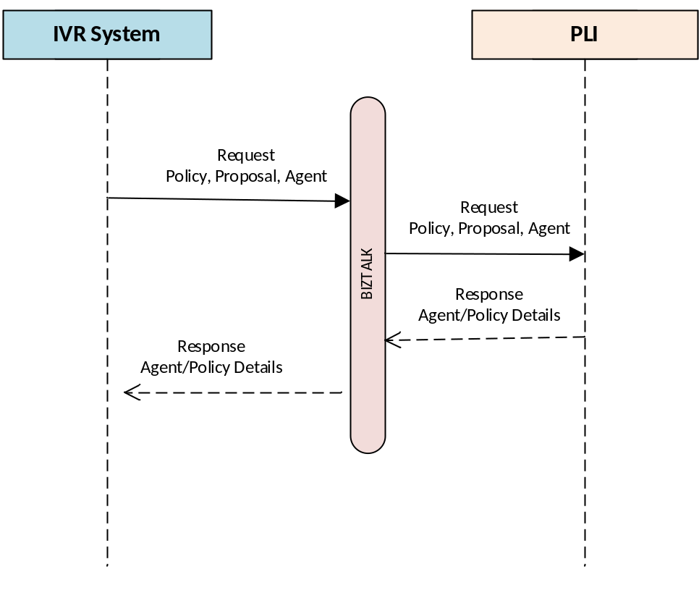

Business Process Flow

PLI system and the IVR System will interwork to provide the in-scope functionalities as per the following table. This table has been derived by removing the Manual and Futuristic line items from the table in section 2 Scope and Assumptions.
No. | Process | Nature of Transaction | Transaction Description | Manual / IVR | Section Number of This Document
1 | Postal Insurance | Inquiry | Policy servicing | Both | 4.1
2 | Postal Insurance | Inquiry | Proposal status | Both | 4.2
4 | Postal Insurance | Inquiry | Policy status | Both | 4.3
5 | Postal Insurance | Inquiry | Premium due date | Both | 4.4
6 | Postal Insurance | Inquiry | Premium amount check | Both | 4.5
7 | Postal Insurance | Inquiry | Sum assured check | Both | 4.6
9 | Postal Insurance | Inquiry | Surrender value check | Both | 4.7
11 | Postal Insurance | Inquiry | Loan amount check | Both | 4.8
14 | Postal Insurance | Inquiry | Rate of Interest of Loan | Both | 4.8, 4.9
15 | Postal Insurance | Inquiry | Premium updated status | Both | 4.10
16 | Postal Insurance | Inquiry | Policy maturity date info | Both | 4.11
17 | Postal Insurance | Inquiry | Maturity amount info | Both | 4.12
18 | Postal Insurance | Inquiry | Information about documents required to be submitted for policy renewal | Both | 7
19 | Postal Insurance | Inquiry | Claim status | Both | 4.13
20 | Postal Insurance | Inquiry | Agent License expiry date | Both | 4.14

Policy Servicing:
Customer can use IVR Systems to send a Request to get their Servicing details .
The IVR system will take policy number and the API that will return with the servicing details for that API. Refer to Section 5.1 for API details
Request Payload | Search Parameter: <Policy Number>  Search Type: policyRequest
Response: | validateParameter  dob  policyStatus (Service_request_status)

Proposal Status
Customer can use IVR System to request for proposal status.
The IVR system will take in the Proposal Number, in response to inputs the Proposal related information would be sent back. Refer to Section 5.1 for API details

Request Payload | Search Parameter: <proposal Number>  Search Type: serviceRequestNumber
Response: | validateParameter  dob  statusRequest : any one of the values defined in the WSDL.

Policy Status
Customer can use IVR system to inquire for Policy Status, The IVR system will take the Policy number and return with the Policy details. Refer to Section 5.1 for API details
Request Payload | Search Parameter: <Policy Number>  Search Type: policyRequest
Response: | validateParameter  dob  policyStatus

Premium Due Date.
Customer can use IVR system to inquire for premium due date
The IVR system will take the Policy number and return with the premium details. Refer to Section 5.1 for API details
Request Payload | Search Parameter: <Policy Number>  Search Type: policyRequest
Response: | validateParameter  dob  premiumdueDate

Premium Amount Check
Customer can use IVR system to inquire for premium amount check, The IVR system will take the Policy number and return with the premium details. Refer to Section 5.1 for API details.
Request Payload | Search Parameter: <Policy Number>  Search Type: policyRequest
Respnse: | validateParameter  dob  premiumAmount

Sum Assured Check
Customer can use IVR system to inquire for sum assured check, The IVR system will take the Policy number and return with the sum assured details. Refer to Section 5.1 for API details.
Request Payload | Search Parameter: <Policy Number>  Search Type: policyRequest
Response: | validateParameter  dob  sumAssured

Surrender Value Check
Customer can use IVR system to inquire for Surrender value check, The IVR system will take the Policy number and return with the surrender value details. Refer to Section 5.1 for API details.
Request Payload | Search Parameter: <Policy Number>  Search Type: policyRequest
Response: | validateParameter  dob  surrenderEligibility  surrenderValue

Loan Amount Check
Customer can use IVR system to inquire for loan amount check, The IVR system will take the Policy number and return with the loan details. Refer to Section 5.1 for API details.
Request Payload | Search Parameter: <Policy Number>  Search Type: policyRequest
Response: | validateParameter  dob  loanOutstandingAmount  interestRateOnLoan  loanEligibility  loanAvailed

Rate of Interest of Loan
Customer can use IVR system to inquire for ROI for loan, The IVR system will take the Policy number and return with the ROI details. Refer to Section 5.1 for API details.
Request Payload | Search Parameter: <Policy Number>  Search Type: policyRequest
Response: | validateParameter  dob  interestRateOnLoan

Premium Updated Status
Customer can use IVR system to inquire for premium updated status, The IVR system will take the Policy number and return with the premium details. Refer to Section 5.1 for API details.
Request Payload | Search Parameter: <Policy Number>  Search Type: policyRequest
Response: | validateParameter  dob  premiumAmount  premiumDueDate  lastPremiumPaidDate  lasPremiumPaidAmount

Policy Maturity Date Info
Customer can use IVR system to inquire for policy maturity date, The IVR system will take the Policy number and return with the policy details. Refer to Section 5.1 for API details.
Request Payload | Search Parameter: <Policy Number>  Search Type: policyRequest
Response: | validateParameter  dob  maturityDate

Maturity Amount Info
Customer can use IVR system to inquire for maturity amount, The IVR system will take the Policy number and return with the maturity details. Refer to Section 5.1 for API details.
Request Payload | Search Parameter: <Policy Number>  Search Type: policyRequest
Response: | validateParameter  dob  maturityAmount  maturityDate

Claim Status
Customer can use IVR system to inquire for claim status, The IVR system will take the claim service Request Number and return with the claim details. Refer to Section 5.1 for API details.
Request Payload | Search Parameter: <claim Status Request Number>  Search Type: serviceClaimRequest
Response: | validateParameter  dob  statusRequest  ( enumerated values as per the WSDL )

Agent License Expiry
Customer can use IVR system to inquire for agent license details, The IVR system will take the Agent ID and return with the license details. Refer to Section 5.2 for API details.
Request Payload | Search Parameter: <agentID>
Response: | validateParameter  dob  licenseExpiryDate  agentStatus  ( enumerated values as per the WSDL )

Web Service Specifications

This section refers to the PLI-IVR Call Flow as per the file PLI- IVR v1.8b.xlsx.
The call flow is evolving, however, the touch points with Finacle will be as per This Document.
IVR will interact with BizTalk server and will be using webservices of BizTalk to interact with PLI Solution. The online integration touch points using PLI WS are mentioned below
The specifications provided herein will meet the functionality as per the table in Section 4, Business Process Flow. Any shortcoming in the functionality will be attended to within the prevailing timeframes of the activities dependent on This Document.

pliSearchRequest – WSDL service signature

This is a service signature for invoking a remote web service for PLI based IVR services.

Request Message
Please enter the length against the type for each request and response parameter:

Tag | Type | IVR Data Type | Usage | Description
searchParameter | Integer : Size 13 | N-13  For Policy Number only.  N-9  For Proposal Number and service request number, only the numeric- 9 digit would be entered. | Required | - Policy Number:  For polcies with non-numeric characters, the IVR will not be able to solicit the input, hence, such callers will be transferred to the CC Agent.  For policies with all numeric characters in the policy number, the IV Rwill be able to take the policy number and service the caller.  It so happense that all new policies will have numeric characters from the policy number, and there will be 13 numeric characters. For legacy policies, migrated or non-migrated, since the policy numbers have non-numeric characters, the call will be transferred to the agent. The agent will be able to service only the policies that have been migrated to the new PLI system.  - Proposal Number:  Only the numeric part would be entered: 9 digit.  c) Claim Request: Only the numeric part of the service request number: 9 digit.
requestSearchType | String :  Size 25 | C-25 | Required | Following are the values that the IVR may populate for this parameter :  - “policyRequest”  This would be used for policy search  - “serviceRequest”  This would be used for proposal search and other non-financial service request.  - “serviceClaimRequest”  This attribute is primarily for financial requests.

Response Message

Tag | Type | IVR Data Type | Usage | Description
pliSearchResponse |  |  |  | Response payload
validateParameter | Boolean | C-1 | Required | Validation field, indicating that the inquired field is available in the system. It is Boolean, indicating Y as the valid and N being invalid.
dob | String: Size 8  ddmmyyyyy | N-8 | Required | Data Of birth of the insurer in ddmmyyyy format.
Status request | String: Size 15 | C-15 | NA | Following are enumerated values  In case of policy search, this field will be nill. ( Policy Status is listed in a separate parameter further below ).  For requestSerarchType = “serviceRequest”, or “serviceClaimRequest”, this tag will be populated with one of the following enumerated values : .  - Withdrawn  - Terminated  - Approved  - Completed  - Rejected  - Pending  - Approved-pending Disbursement
premiumAmount | Integer: Size10 | N-10 | Required | Premium Amount with interest if applicable.
sumAssured | Integer:size10 | N-10 | Required | Sum Assured amount.
loanEligibility | String: size 10 | C-10 | Required | Enumerated values :  Availed,  Eligible,  Not Eligible.
premiumDueDate | Integer:size 8  Ddmmyyyy | N-8 | Required | Premium Due Date: It is the next premium due date.  Eight numeric characters, date format is ddmmyyyy
surrenderValue | Integer:size10 | N-10 | Required | Surrender value would be 0, if Surrender is not eligible for the policy  Else it will be the amount in Rupees.
loanOutstandingAmount | Integer:size 10 | N-10 | Required | Loan Outstanding amount, this value would be defaulted to 0.
interestRateLoan | decimal : size 2,2 | N-2.2 | Required | Interest Rate on Loan
lastPremiumPaidDate | Integer:Size 8  Ddmmyyyy | N-8  ddmmyyyy | Required | Last Premium Paid date
lastPremiumPaidAmount | Integer: Size 10 | N-10 | Required | Last Premium Paid Amount Details
maturityAmount | Integer: Size 10 | N-10 | Required | Maturity Amount, this amount is 0 in case of WLA and CWLA.
maturityDate | String: Size 10 | N-8  ddmmyyyy | Required | Maturity Date.
premiumPaidTillMaturity | Boolean | C-1 | Required | This amount would be marked as y, if the payment is paid till maturity.  It will be marked as n if the payment is not paid till maturity.
nextPremiumAmount | Integer: Size 10 | N-10 | Required | Next Premium amount: Consolidated amount.
interestOnPremium | Integer: Size 10 | N-10 | Required | Interest on Premium, this value will be marked NA if not applicable.
firstUnPaidDate | Integer: Size 8  Format: ddmmyyyy | N-8  ddmmyyyy | Required | First UnPaid Date.
surrenderEligiblity | Boolean | C-1 | Required | Surrender Eligibility: True in case when there is an eligibility to surrender.  y = Yes  n= No
policyStatus | String: Size 20 | C-20 | Require | Expected values, as per the WSDL accompanying This Document, are :  Pending Surrender  Active Conversion  Terminated Death  Active No Premium  Death Claim Rejected  Void  Inactive  Terminated Maturity  Lapse  Terminated Conversion  Active  Pending Maturity  Pending Death  Terminated Surrender  Pending Premium
bounsAmount | Integer: Size 10 | N-10 | Required | The amount will be defaulted to 0, wherever it is not applicable.
loanAvailed | Integer: Size 10 | N-10 | Required | The actual loan amount availed.

Error Description:
Tag | Type | Usage | Description
pliSearchRequestFault |  | Required | Fault Node.
pliSearchRequestFaultDescription | String | Required | Following are the values expected:  - Policy_not_found  - Servicerequest_not_found  - Claimrequest_not_found
pliSearchRequestFaultCode | String | Required | Following are the corresponding mapped error codes:  100: Policy_not_found  200: ServiceRequest_not_found  300: Claimrequest_not_found

PliAgentRequest: Agent Search Service

This service call would fetch Agent Details from the PLI application.

Request Message

Tag | Type | IVR Data Type | Usage | Description
agentID | Integer: Size 10 | N-4 | Required | Agent Id of the Agent : Last 4 digits

Response Message

Tag | Type | IVR Data Type | Usage | Description
pliAgentSearchResponse |  |  |  | Response payload
Dob | Integer: size 8: ddmmyyyy | N-8  ddmmyyyy | Required | Data Of birth of the Agent.
validationParameter | boolean | C-1 | Required | Validation field, indicating that the inquired field is available in the system. It is Boolean, indicating y as the valid and n being invalid.
licenseExpiryDate | String: Size 10 | N-8  ddmmyyyy | Required | License expiry date
agentStatus | String: Size 10 | C-10 | Required | Agent Status = one of { Active, Pending, Suspended, Terminated }  (as per the WSDL accompanying This Document)

Error Handling

Every service signature, has a corresponding soap fault associated.
The SOAP fault comprises of Code and Description correspondingly.
Refer the WSDL for more information.

Error Code | Error Description | Value
100 | Policy Not found | policy_not_found
200 | Service Request Not found | servicerequest_not_found
300 | Claim Request not found | claimerequest_not_found
400 | Agent Not found | agent_not_found
404 : Technical Error | Service Not Available / Service timing out. : This would not be part of the SOAP fault.

Revival Document
Revival Document list has been provided, however the documents needs to be voiced based on the following table:
Renewal Type | Policy Status | Documents
Reinstatement | IL or VL  (Inactive or Void) | Good Health Declaration Certificate
Revival |  | Revival Application Form,
Revival | AL  (Lapse) | Employer Certificate ( Mandatory if the Billing Method is Pay recovery ),
Revival |  | Medical Certificate for Renewal

The above is valid only for the policy statuses listed herein. For rest of the policy statuses, the revival document advice is not to be provided.

WSDL

WSDL version: 1.1.

This has been packaged as a zip along with the SRS.

The WSDL provided herein will meet the functionality as per the table and entire content of Section 4, Business Process Flow. Any shortcoming in the functionality will be attended to within the prevailing timeframes of the activities dependent on This Document.

Open Items

S. No | Open Item Description | Owner | Resolution
1 | Policy Number of policies with non-numeric characters (migrated policies) :  During meeting at PLI directorate it was suggested that numeric characters of such policy number in combination with the DoB should identify the policy. FSI indicated that such combination will not be unique. This point is yet to be vetted and closed. Hence as of now the IVR flow caters to only the new (13 digit numeric) policy numbers. | DOP / FSI | Open

--- end of document : ‘SRS - PLI Integration with IVR’ ---

