Cartoon-O-Matic help file

Main window

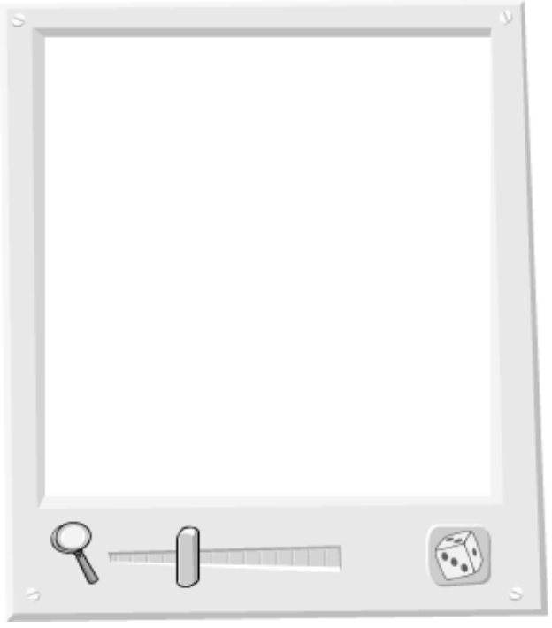

Moving the face
To change the position of the cartoon face within the main window simply click and drag. The face will move as you move your mouse.

Zooming
To enlarge or shrink the cartoon face, pull the magnifying slider back and forth. Note that when you export the face to PrintMaster that the zooming is ignored. Please refer to [PrintMaster scaling command] for information about resizing the cartoon face from within PrintMaster.

Randomize button
If you would like the computer to create a new face for you just click on this button. A new, random face will appear.

Feature buttons
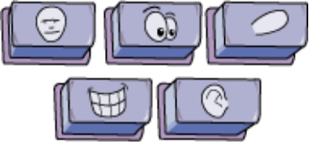
Each cartoon face is made up of several different facial features. To view the properties of each feature, click on the appropriate feature button. Most faces share the same five features: face, eyes, nose, mouth and ears. Occasionally a face may have special features (for example, the Witch can have a bat, cat and spider join her).

Sliders
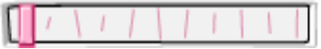
Each facial feature has a set of associated slider controls. For instance, selecting the eyes feature button will display sliders for changing the character’s gaze direction. To operate a slider simply click anywhere on the slider and drag. As you drag the face updates automatically.

Exit buttons


OK
When you have finished your cartoon masterpiece and would like to include it in your PrintMaster document click the OK button. The Cartoon-O-Matic will close and your newly created face will appear as a graphic within your document.

Cancel
If you decide that you do not want to export your cartoon face to your PrintMaster document click the Cancel button. This will close the Cartoon-O-Matic and your cartoon face will not appear within PrintMaster.

New Face button
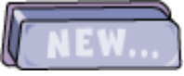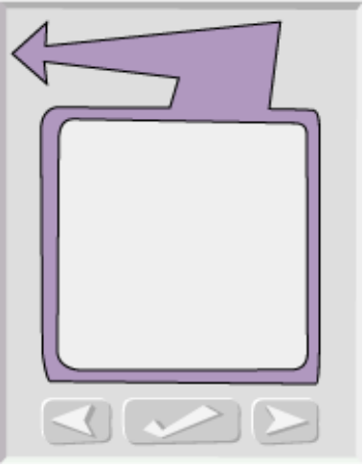

New…
The New… button lets you select a new face to manipulate. Clicking the New… button brings up a face picker with three new buttons. Use the left and right arrows to page through the available faces. When you see one you like click on the OK check mark. The selected face will appear in the Main Window.

Be sure to visit the nFX website at http://www.nfx.com to download new faces for the Cartoon-O-Matic.

File Menu

New…
Select this command to make the Face Picker appear.
This is the same as clicking the New… button.

Random Face
Choosing this menu command will randomly distort the cartoon face.
This is the same as clicking the Randomize button.

Save and Exit
Export the current cartoon face to PrintMaster and close the Cartoon-O-Matic.
This menu command is identical to clicking the OK button.

Cancel and Exit
Close the Cartoon-O-Matic. The current cartoon face will not be exported to PrintMaster.
This can also be accomplished by clicking on the Cancel button.

