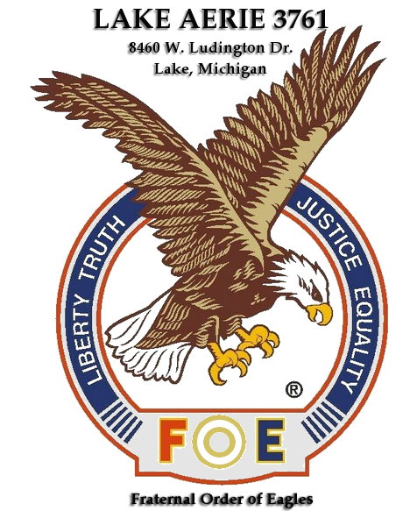
Lake Eagles
Weekly Specials

Monday | Burger Night. 50 off all burgers.
Tuesday | Salisbury steak, mashed potatoes, and cole slaw or cottage cheese. $7.50
Wednesday | Mexican Night
Thursday | Chili dog special. $3.00 each.
Friday | Fish Fry
Saturday | Soup and Sandwiches. $3.00

