Don Bosco Technical College

City of Mandaluyong

Mechanical Engineering Program

Basic Electronics (BELECS)

2nd Semester, AY 2022-2023

Fire Alarm System

Final Project Proposal

2ME

Wednesday, 1:00-4:00pm

**Templo**, Joshua Adrian L. ____________________

**Jaramillo**, RJ Warren G. ____________________

**Romano**, Daniel S. ___________________

**Juancho**, Cayanan S. _________________

Date submitted: March 29, 2023

R. Stephen L. Ruiz

Instructor

___________________________________________________________________________

1. Project Description

Today's buildings and architecture, particularly gas stations, data centers, and banks, all need fire alarms. When they detect smoke or heat, they sound an alarm, which notifies others of the fire and gives them time to take preventative measures. They quickly spot the fire in the atmosphere. It occasionally saves lives in addition to preventing significant losses caused by deadly fire. We are constructing a straightforward fire alarm system with the assistance of Transistor BC547 that will sound an alarm when the fire's surrounding temperature rises.

There are two primary ways that the fire alarm system is intended to detect fire: by heat and smoke. In the event that the fire is discovered before the smoke or heat reaches the system's sensors, the system should also be able to pull manually. Other systems are triggered when movement in the sprinkler system is detected, indicating that the sprinklers are responding to a fire. As well as making you aware of possible risks, the alarm framework in your home or office can execute control measures to safeguard you. When an alarm goes off, some systems start doing things to keep people safe and stop smoke and fire from spreading. For instance, robotized entryways are closed in various zones, the cooling and ventilation are switched off, or lifts are rerouted to the perfect locations.

The term "circuit problems" refers to malfunctioning or missing wires in a circuit. That will cause an issue with the panel and an open circuit. On conventional circuits with IDC, device circuits are indicated by an end-of-line resistor. The flow of current is typically controlled by devices of this kind. Battery failures are a different topic. The system's batteries act as a backup power source in the event that the main power goes out, and they can occasionally fail. Additionally, you can disapprove of the charging circuits that keep those energized. Examine it, determine what's wrong, check the voltage, and then perform a straightforward fix if necessary is the fundamental solution. I only have to change the batteries.

We are developing a straightforward Heat or Temperature Sensor Circuit. Since this circuit only requires a few basic components that are readily available, it can be constructed immediately by anyone. This Intensity Sensor isn't just basic yet additionally viable.

Heat is detected by means of the Transistor BC547. The transistor begins to conduct to some extent as the temperature of the PN junction rises. In this application, the transistor's "temperature" property is utilized to serve as a heat sensor.

In this case, a variable resistor of 1k ohm and the diode 1N4148 are utilized to establish a threshold or reference level for the heat sensitivity. Additionally, the circuit's sensitivity can be altered by turning the knob.

1. Block Diagram & Circuit Schematic

**Block Diagram**

START

SET THE VARIABLE RESISTOR

COLLECTOR CURRENT INCREASE AND LED STARTS ILLUMINATING SLOWLY

ROTATE IT COMPLETELY IN ONE DIRECTION

LED WILL BE OFF

IF YOU ROTATE IT IN ONE DIRECTION

LED WILL GLOW WITH FULL ILLUMINATION

ROTATE IT COMPLETELY IN ONE DIRECTION

**Circuit Diagram**

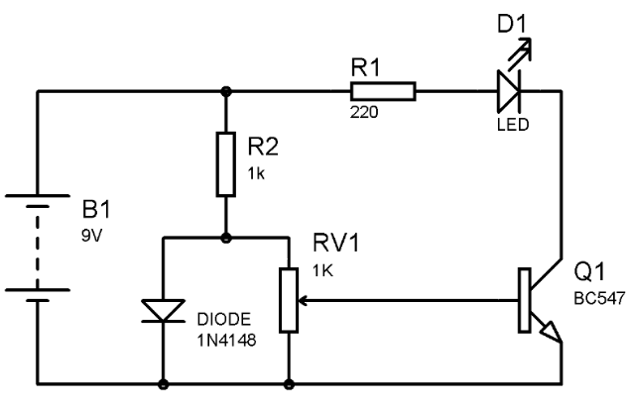

1. Methodology

The circuit operates in a straightforward manner: when temperature rises above the Pot's threshold, the collector current increases, and the LED slowly begins to illuminate. In place of the LED, we can also use a buzzer. You also mention that the Variable Resistor must be set first before the circuit can be tested. At the point when you turn it totally in one heading, Drove will be Off, and when you pivot it totally in other course, Drove will gleam with full enlightenment. Therefore, position the Pot so that a slight rotation will initiate a dim LED illumination.

* BC547 Transistor
* Photo Diode
* Red led 5mm
* 12v Buzzer
* 1 Kilo ohms Resistor
* 1 Kilo ohms Resistor
* 10 Kilo ohms Resistor
* 9v battery

A thermistor is utilized in this circuit to quantify temperature. When it detects that the temperature of the environment is rising above a predetermined threshold, it issues a signal. Utilizing the potentiometer arrangement, the temperature at which the circuit recognizes fire might be changed.

When the temperature rises above a predetermined level, the meter setup generates a high voltage. This voltage is then supplied to the BC547 transistor in common emitter mode. It is a NPN transistor with many uses. When a high input is applied, the base starts working. When the transistor is turned on, the voltage from the collector to the emitter falls to a low level. The first transistor's collector output voltage serves as an input to the second BC 547 NPN transistor's base. The output at the collector will rise significantly because the input is low when the temperature threshold for this transistor, which is also in common emitter mode, is reached.

A thermistor is used to measure the temperature in this circuit. It emits a signal whenever it detects that the temperature of the surrounding area is rising above a predetermined threshold. The potentiometer configuration permits adjusting the temperature at which the circuit detects fire. When turned on, the BC107 transistor allows current to flow through the collector from the power source to the ground, acting as an electrical switch. When current is flowing, the siren circuit, which was constructed as the circuit's load, is turned ON. The siren is then heard by the buzzer. The capacitors are the essential components of the circuit that produce the siren sound.

1. Schedule of Activities

IV. Schedule of Activities

Present a Gantt chart of your deliverables. Indicate who does what and when the

deliverables will be accomplished.

|  |  |  |  |  |  |
| --- | --- | --- | --- | --- | --- |
| Tasks | 1ST Wednesday | 2nd Wednesday | 3rd Wednesday | 4th Wednesday | 5th Wednesday |
| Fire Alarm Circuit Block Diagram Estimation. | **TEMPLO** |  |  |  |  |
| Gathering Required Components for Fire Alarm Circuit. |  | **JARAMILLO**  **CAYANAN** |  |  |  |
| Estimating the Fire Alarm Circuit Diagram |  |  | **EVERYONE** |  |  |
| Connecting & Soldering Circuit. |  |  |  | **JARAMILLO**  **ROMANO** |  |
| Fire Alarm Working Principle. |  |  |  |  | **EVERYONE** |