DYONICS POWER II EIP MDU Tester
20601785

Purpose
The DYONICIS Power II EIP MDU Tester (20601785) with DYONICIS Power II EIP MDU Tester Software (73000138) provides a means to test the functionality of stand alone MDU control boards, MDU motors and assembled MDUs.

Description
The software for the MDU Tester is based upon the DYONICS POWER II EIP Control System software (73000126) version 1.00.00 which includes support for the DYONICS Power Mini MDU. The MDU Test software supports the following features not found in the DII software:

- Blade Sense reporting for all 9 blade magnet codes supported by the Power Mini MDUs and the 4 blade magnet codes supported by other MDUs.
- Button press reporting, 2 button reporting for Power Mini MDUs with hand controls and 3 button for all other MDUs with hand controls
- Reporting of state of the 3 TAC sensors.
- Reporting of the motor current draw in mA.
- Reporting of the actual motor velocity in RPMs.
- Reporting the minimum velocity in RPMs.
- The ability to upgrade the software in a Power Mini MDU.
- The ability to upgrade the software in a Dyonics II Footswitch.
- Display a Device Family based upon the detected device Id for supported handpieces and powered Instruments.

The following required features of the MDU Tester software were inherited through the use of the DYONICS POWER II EIP Control System software version 1.00.00

- Reporting the software version contained within a Power Mini MDU.
- The ability to Start/Stop a motor.
- Ability to operate the MDU in Forward, Reverse, and Oscillate modes
- The ability to set the target motor speed.

Features

Control Screen
The Control screen for the MDU Tester software provides support for 2 MDUs at a time.

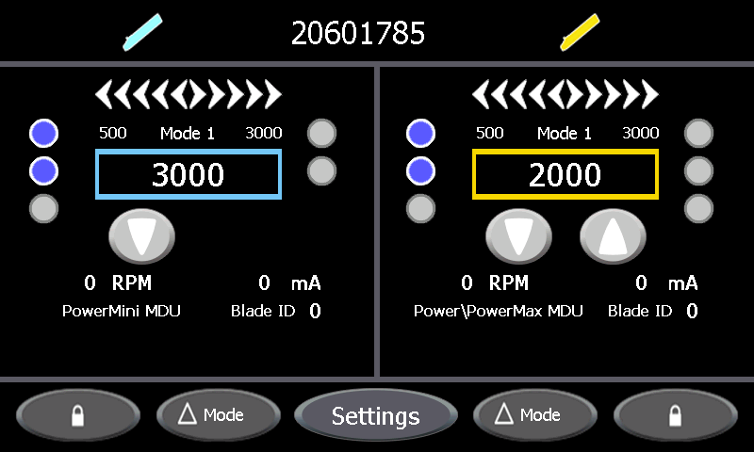
Figure 1: Control Screen Power Mini MDU and Power Max Elite

The items on the Control Screen that were added for the MDU Tester are indicated in Figure 2.

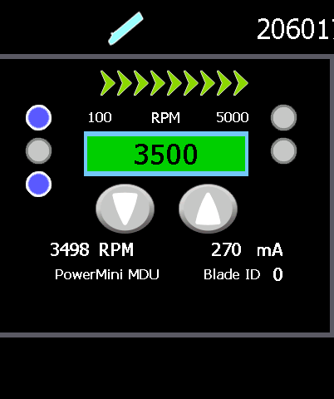
TAC Sensor Status
MDU Button Status
Actual Velocity
Motor Current
Blade ID value
Minimum Set Speed
Device Family
Figure 2: Single Channel with PowerMini MDU

TAC Sensor Status
The TAC Sensor Status reports the prior state of the 3 Motor Hall Sensors, The icons are ordered Top to Bottom A, B, and C. When an MDU is first inserted all 3 icons are blue, and when the MDU is unplugged all 3 icons turn grey before being erased. These are the only 2 times that all 3 icons should be the same color. As the motor shaft is spun the icons change state with no more than 2 icons being blue or 2 icons being grey. Any icon that remains grey through out the sequence is an indication of an open connection while an icon that remains blue is an indication of a short. For the PowerMini the sequence is as follows when the shaft is rotated clockwise.

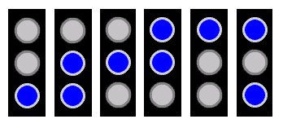
Figure 3: PowerMini Clockwise TAC Pattern

The PowerMax Elite generates the same pattern by rotating the shaft counter clockwise. The difference is due to the gearbox on the motor.

MDU Button State
The Button State indicates when the software detects if one or more buttons on the MDU are pressed. An Orange icon indicates that the button is pressed. The display shows a 2 Button Status for the PowerMini MDU and a 3 Button Status for all other MDUs with hand controls.

Figure 4: MDU 2 Button Status

Forward / Reverse
Oscillate / Window Lock

Figure 5: MDU 3 Button Status

Forward
Oscillate / Window Lock
Reverse

In order to support stand alone testing of MDU processor controller boards the motor stall detection period was increased from 3 seconds to 10 seconds and the motor stall shut off delay was increased from 6 seconds to 20 seconds if the motor current is less than 100mA.

Motor Current
The motor current is the average current in mA delivered to the handpiece since the last update. When the handpiece is not running the system automatically readjusts the zero offset.

Actual Velocity
The actual velocity is the average velocity of the motor in RPM since the last update.

Blade ID
The Blade ID is the numerical value assigned to each of the blade families as a function of the blade’s Magnet Code. The range of Blade ID values for the DYONIC Power, PowerMax, and PowerMax Elite MDUs is as follows:

PowerMax Elite MDU Blade IDs
Blade ID | Magnet Code
0 | None
1 | Left
2 | Right
3 | Both

Reporting of any other Blade ID by a DYONIC Power, POWERMAX, and POWERMAX ELITE is an indication of a failure.

Blade sensing for the Power Mini MDU incorporates magnet orientation as well as presence. The range of Blade ID values for the Power Mini MDU is as follows:

Power Mini MDU Blade IDs
Blade ID | Magnet Code
0 | 00
1 | 0S
2 | 0N
4 | S0
5 | SS
6 | SN
8 | N0
9 | NS
10 | NN

Reporting of any other Blade ID by the PowerMini MDU is an indication of a failure.

The Mini and Ultralight MDUs and any other handpieces which do not support blade sensing report a Blade ID of 25.

Device Family
The Device Family is a label based upon the device id reported to the MDU Tester while the handpiece or powered Instrument is connected.

Device Family
Label | Handpiece / Powered Instrument
Power\PowerMax MDU | DYONICS POWER (REF 7205354, 7205355)  DYONICS POWERMAX (REF 7210542, 7210586, 7209891) DYONICS POWERMAX ELITE (REF 72200616, 72200617)
High Torque MDU | MTO
Development | Future Development
PowerMini MDU | DYONICS POWERMINI (REF 72201500, 72201503)
Ultralight MDU | DYONICS POWER Ultralight (REF 7205971)
Mini-Motor MDU | DYONICS Mini Motor Drive (REF 7205357)
Drill | Pistol Grip Drill (REF 7205785)
Saw | Sagittal Saw Module (REF 7205791)  Inline Sagittal Saw (REF 7205786)  High Speed Drill (REF 7209391)  Reciprocating Saw (REF 7209392)  Oscillating Saw (REF 7209394)  Heavy Duty Oscillating Saw (REF 7209395)

Procedures

Software Installation
- Turn off power to the DYONICS Power II EIP Control System.
- Insert the USB key with the MDU Tester Software (20601785) into a USB port on back of the DYONICS Power II EIP Control System.
- Turn on power to the DYONICS Power II EIP Control System.
- Press the Start key to initiate installation of the MDU Tester software.
- When prompted to remove the USB Drive, unplug the USB key from the back of the DYONICS Power II EIP Control System.
- Cycle Power to the DYONICS Power II EIP Control System.
- Verify that the Control screen displays the 20601785 tool number on the top of the display.
- Bring up the System Information screen. The display should have the following information:
DYONICS POWER II EIP MDU Tester
20601785
Software Version 1.00.00
Application Version 1.00.00
Motor Controller 1.02.11

MDU Software Upgrade
Using the following procedure, the MDU Tester provides the ability to update the software installed in a functioning PowerMini MDU. The PowerMini MDU must have been previously programmed with software version 0.00.04 or greater.

- Turn off power to the MDU Tester.
- Connect a PowerMini MDU to Port A of the front panel of the MDU Tester.
- Connect the USB Software key containing the PowerMini Software to the rear of the MDU Tester.
- Turn on power to the MDU Tester.

If the system detects the PowerMini and the USB software key the display will show the Software Upgrade screen.

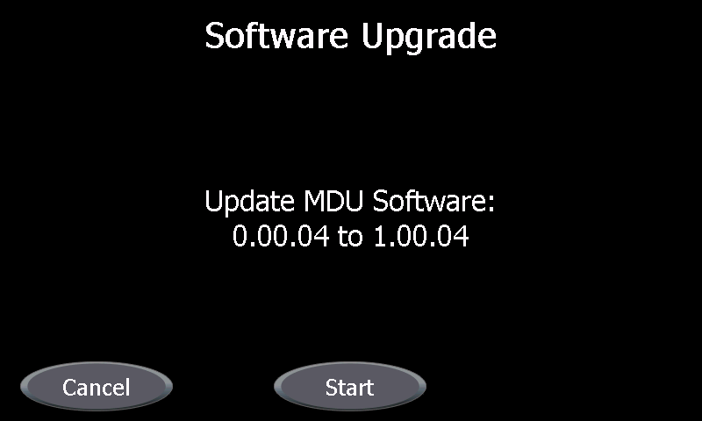
Figure 4: Software Upgrade Start screen

- Press the Start key to initiate the software upgrade.
The display will transition through the following screens:

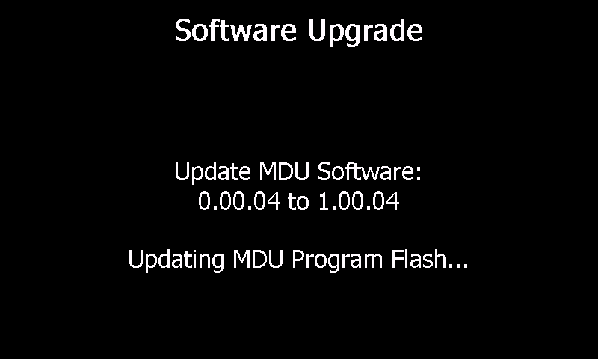
Figure 5: Software Upgrade Programming Flash

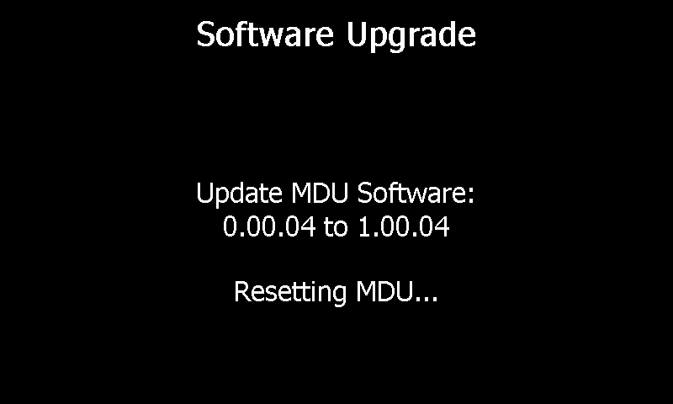
Figure 6: Software Upgrade Resetting MDU....

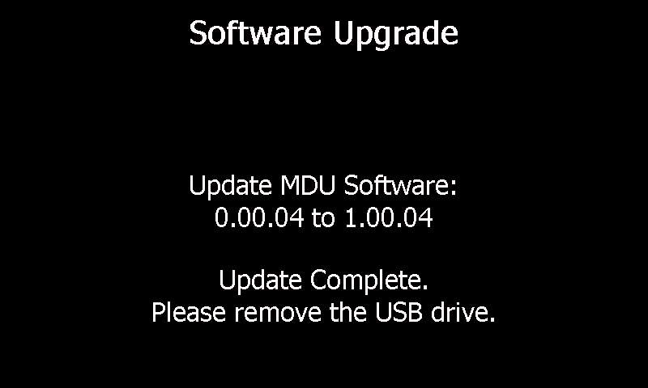

- Unplug the USB key from the MDU Tester.
The display will update with the Update Complete.
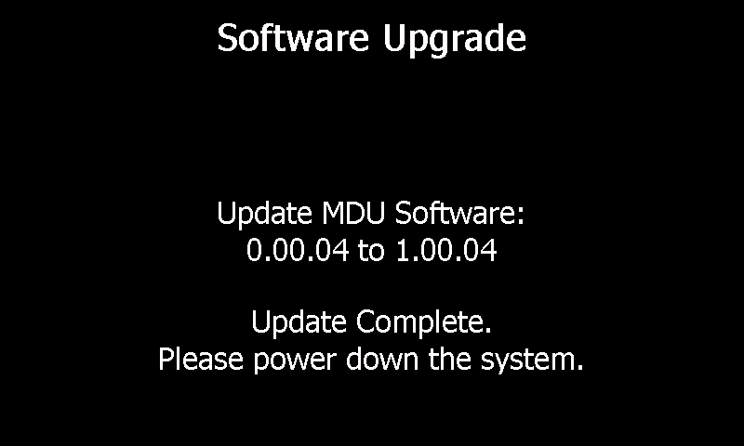

- Power off the MDU Tester and unplug the programmed PowerMini MDU.

Repeat the above procedure for each PowerMini MDU to receive the software upgrade.

Note: If the display does not show the “Updating Program Flash...” screen and the “Resetting MDU…” screen then the programming may not have completed properly. Re-execute the MDU programming procedure.

