IBOH (Stage1) Write-Up Competition: The Whistle Blower (OSINT)
Challenge: The Whistle Blower
Challenge Category: OSINT
Solved By: Emily Koh Poh Yee (katsud0n)
Team: 0x3 (local category)
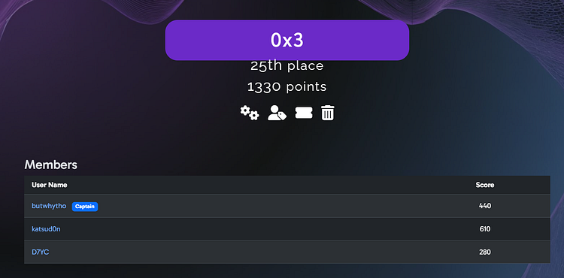
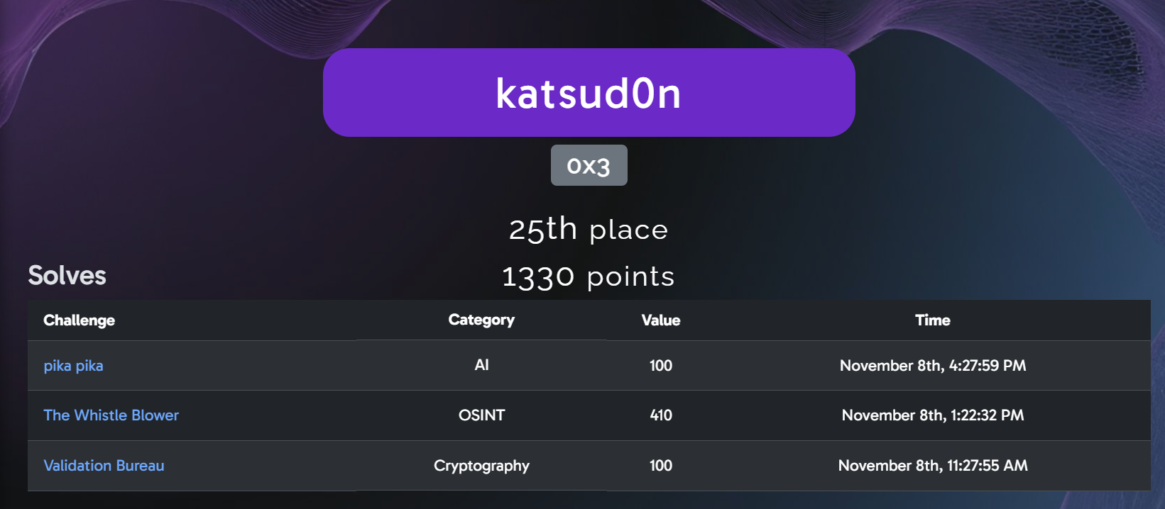

The challenge question:
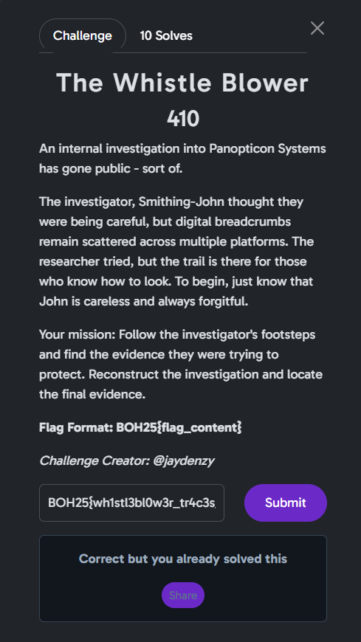
Challenge Description:
An internal investigation into Panopticon Systems has gone public — sort of.
The investigator, Smithing-John thought they were being careful, but digital breadcrumbs remain scattered across multiple platforms. The researcher tried, but the trail is there for those who know how to look. To begin, just know that John is careless and always forgitful.
Your mission: Follow the investigator’s footsteps and find the evidence they were trying to protect. Reconstruct the investigation and locate the final evidence.
Flag Format: BOH25{flag_content}
Challenge Creator: JaydenZy

Initial Analysis & Reconnaissance
From the description, I identified several key hints that set the direction for the investigation:
- Panopticon Systems → likely the company under investigation.
- Smithing-John → the investigator and main character.
- Digital breadcrumbs across multiple platforms → information could be found on several online sites.
- Careless and always “forgitful” → intentional misspelling of forgetful → for-git-ful → GitHub 💡

Step 1: Tracking Smithing-John on GitHub
Starting with GitHub, I searched for the user “Smithing-John” — and found only one account. That was a good sign.
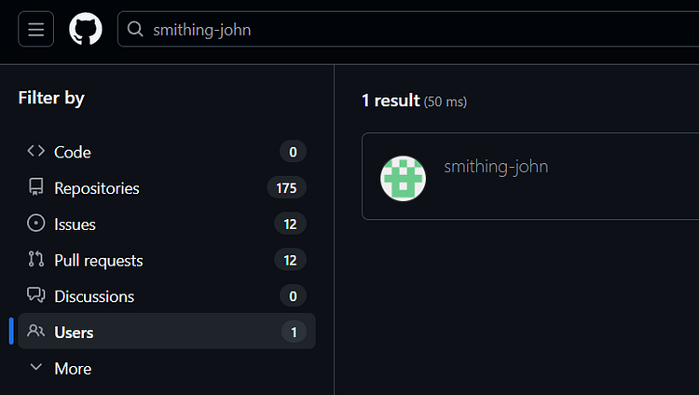
The account profile had two days of activity:
- Day 1 → account creation.
- Day 2 → 13 contributions to a single repository.
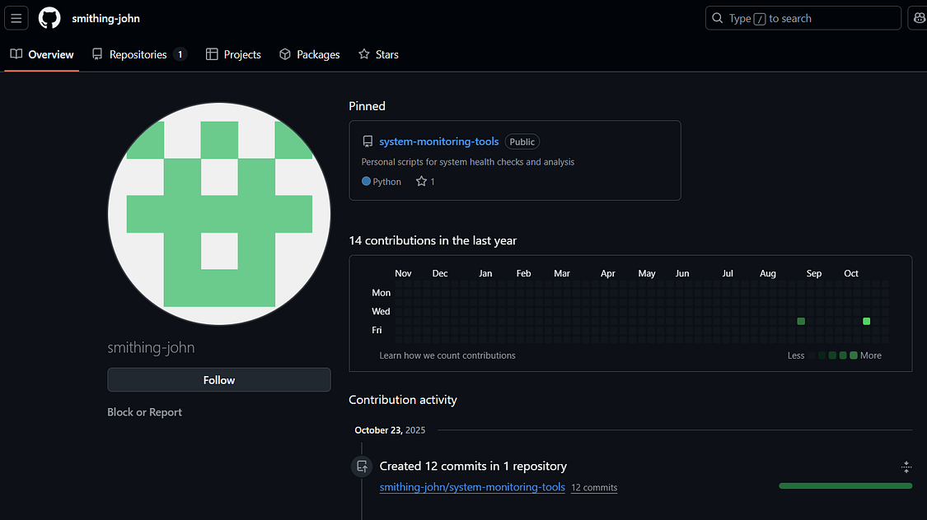

Inside that repo, there were multiple files, but since the challenge said he’s careless and forgetful, I suspected something might still be visible in the commit history.
Using Insights → Network, I explored all commits (yes, even got rickrolled in one of them 😂). The most suspicious commit was titled “adding investigation notes and evidence tracking.”
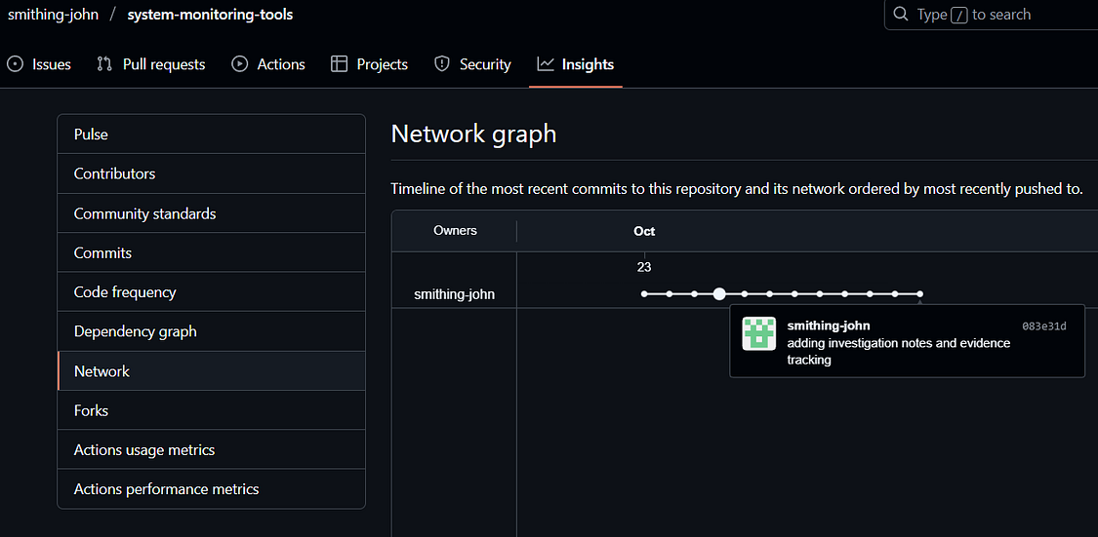

Step 2: Investigation Notes
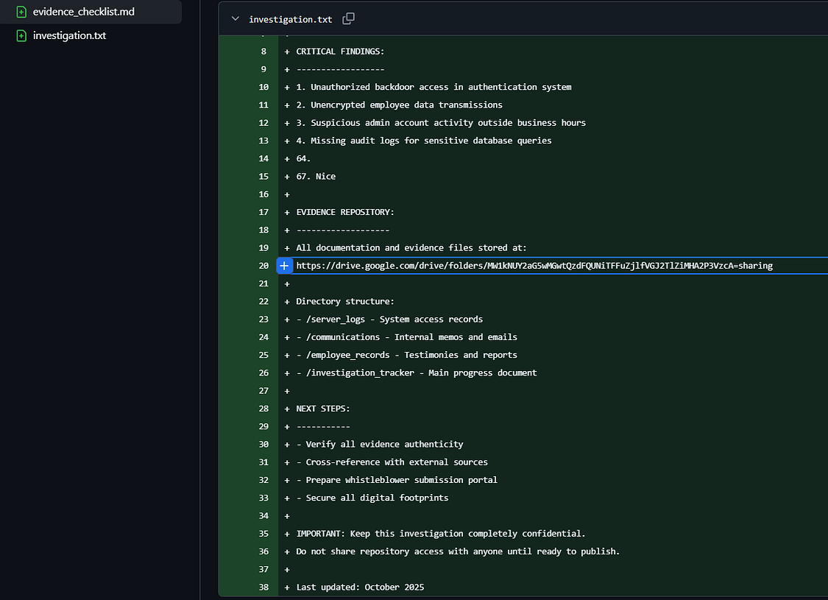
Inside that commit were two files:
- evidence_checklist.md
- investigation.txt — immediately suspicious because of the header: PERSONAL INVESTIGATION NOTES — CONFIDENTIAL
In investigation.txt, I found a supposed Google Drive link, but there was a section that was Base64 encoded (because of the = padding):
https://drive.google.com/drive/folders/MW1kNUY2aG5wMGwtQzdFQUNiTFFuZjlfVGJ2TlZiMHA2P3VzcA=sharing

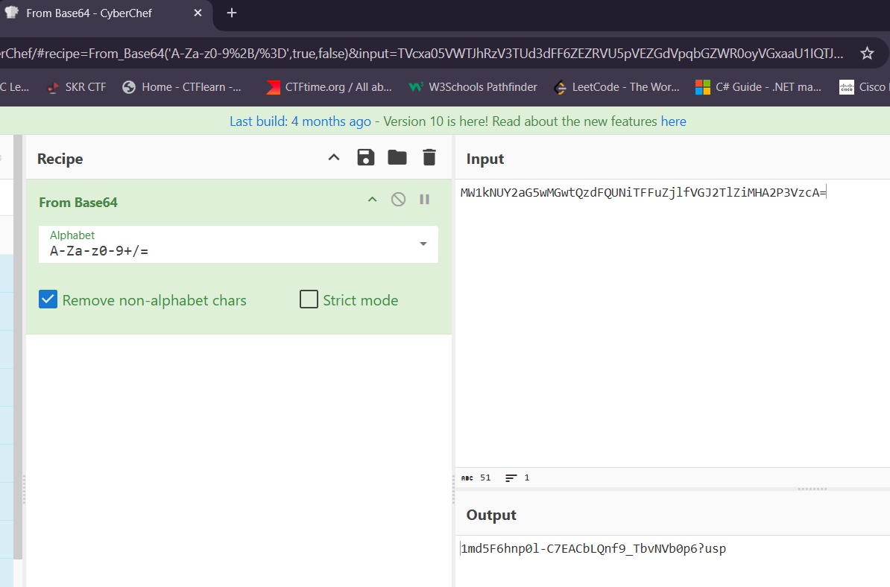
So, I put it in CyberChef to decode it, and it gave me:
1md5F6hnp0l-C7EACbLQnf9_TbvNVb0p6?usp
So, the real link was:
https://drive.google.com/drive/folders/1md5F6hnp0l-C7EACbLQnf9_TbvNVb0p6?usp=sharing

Step 3: The Google Drive Rabbit Hole
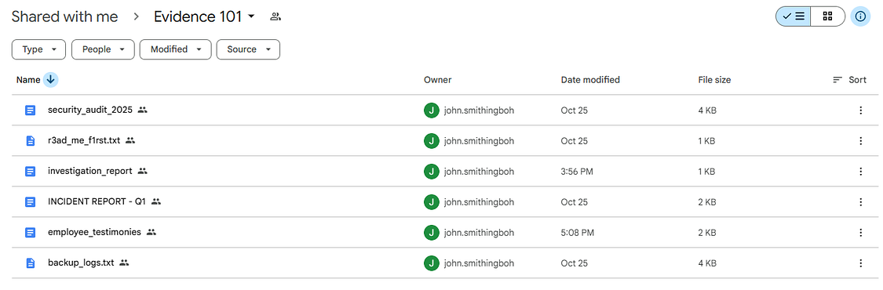
The Drive folder had six files — all filled with fake flags 😩:
- r3ad_me_f1rst.txt
- backup_logs.txt → fake flag
- employee_testimonies → fake flag
- INCIDENT REPORT - Q1 → fake flag + hint → “check_all_documents_thoroughly”
- security_audit_2025 → fake flag
- investigation_report → said the document was moved to a “more secure location.”
That “check_all_documents_thoroughly” hint made me think of checking previous versions of the file — since our “careless” investigator might’ve left something behind.

Step 4: Digging Into File Versions
Looking at earlier versions of the investigation_report file, I found two major clues:
- All detailed findings documented and password protected on Pastebin.
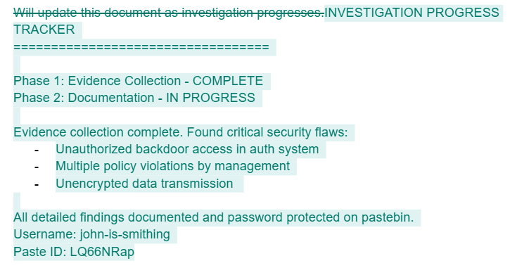
Username: john-is-smithing
Paste ID: LQ66NRap

2. Moving documentation to a more secure hosting solution on Vercel.
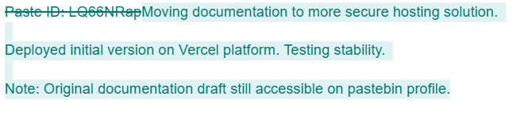

Step 5: Pastebin
The direct Paste link (pastebin.com/LQ66NRap) was locked.
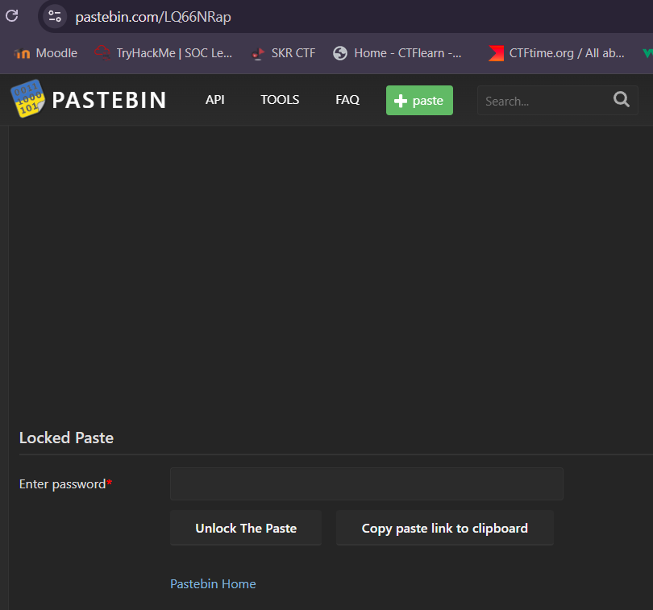

However, the username profile (pastebin.com/u/john-is-smithing) had another paste titled “WHISTLEBLOWER INVESTIGATION STEPS – DRAFT”.
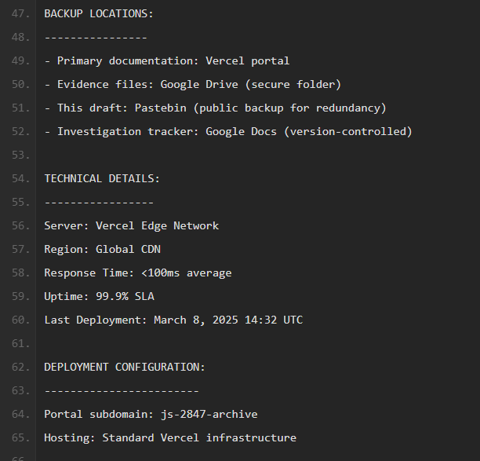
That file contained:
- Mentions of Form A–D (different submission forms).
- Backup locations: Vercel portal, Google Drive, Pastebin, Google Docs.
- Deployment configuration: Portal subdomain: js-2847-archive Hosting: Vercel
So now I knew where to go:
👉 https://js-2847-archive.vercel.app/

Step 6: The Vercel Portal
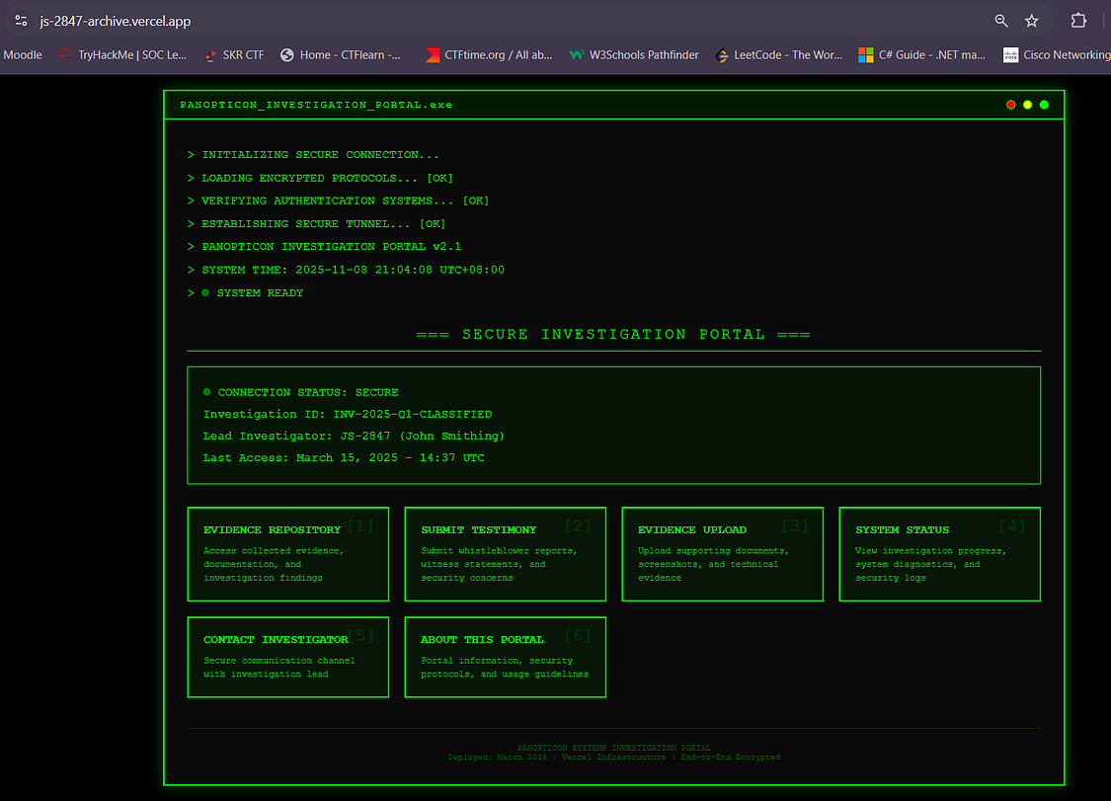
On the Vercel site, I found an interface titled “Panopticon Investigation Portal” with several buttons. Some were temporary disabled, but a few gave big hints:
- About This Portal → warned that Google Form responses might be visible to others.
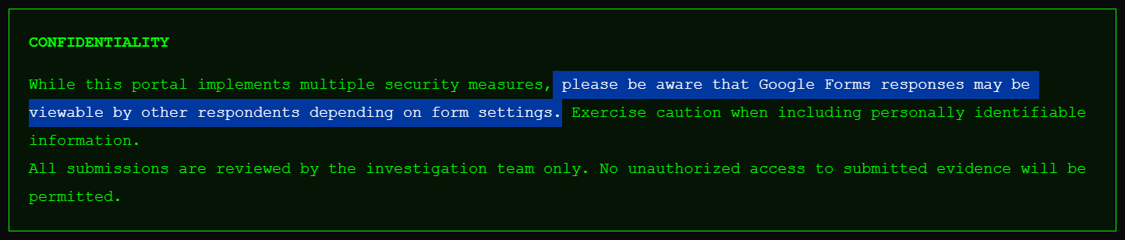
- System Status → showed Testimony Collection [IN PROGRESS].
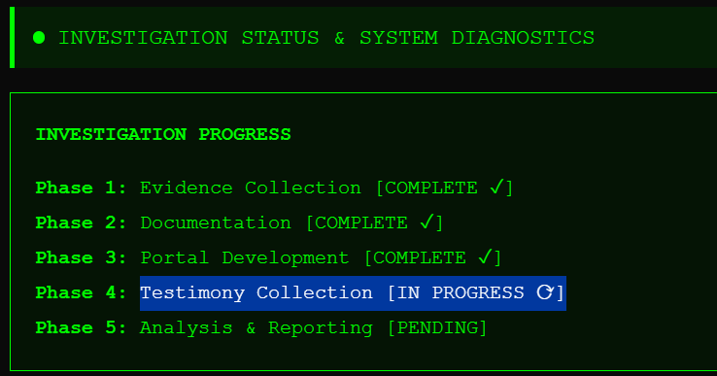
- Contact Investigator → said to reach them via Form C (Employee Testimonies) and mark it as “URGENT”.
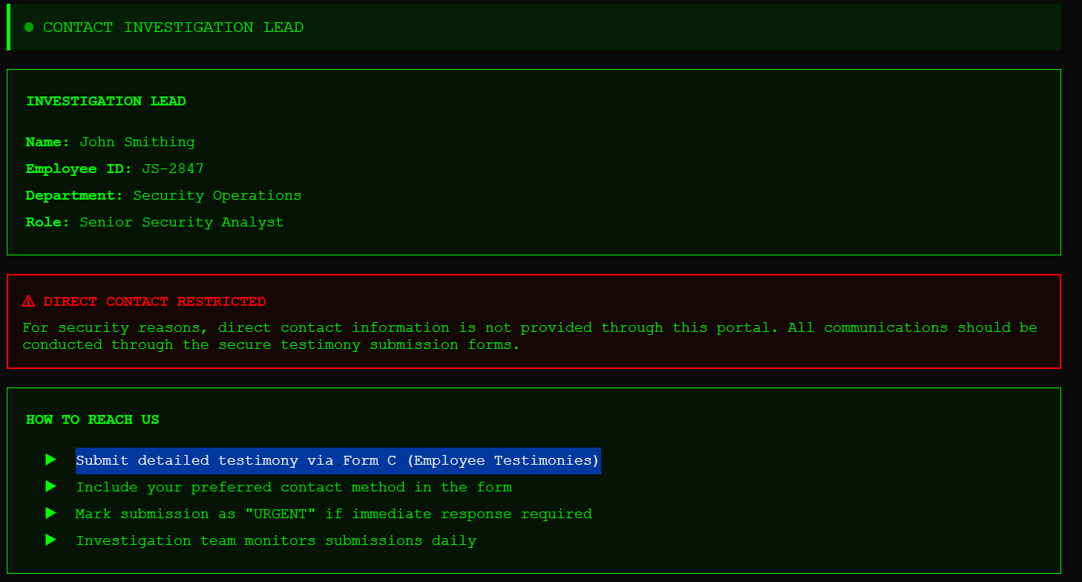

The Submit Testimony button led to a Google Form, which matched everything from the draft file.

Step 7: Submitting the Testimony
Following the hints, I submitted a response through Form C, marked it as URGENT.
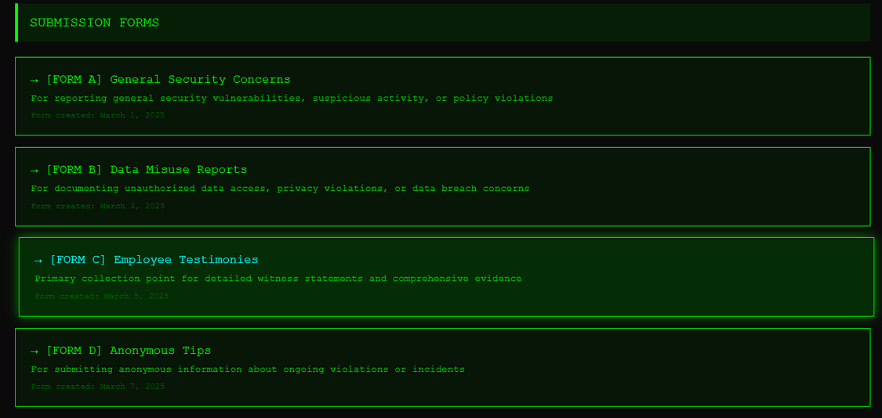
After filling up the form with information, I submitted it and realized that it was indeed a public form. Hence, I viewed all previous responses hoping for more clues or possibly the flag.
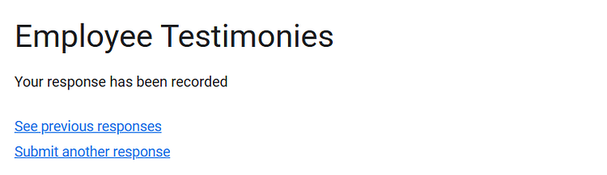

After some investigation through all the responses, I found the final flag!!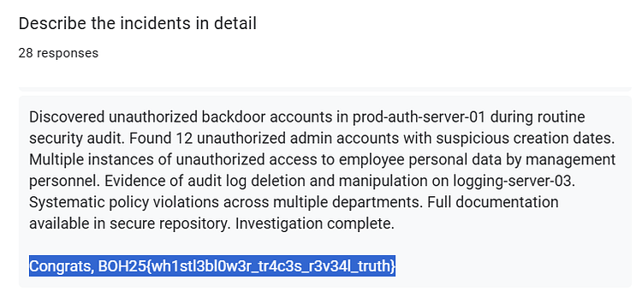
🎉Final Flag: BOH25{wh1stl3bl0w3r_tr4c3s_r3v34l_truth}

Conclusion
This challenge was an excellent exercise in tracking a target through multiple pivots. It required moving from one location to another.
By systematically exploiting the "carelessness" of the investigator (Smithing-John), I was able to reconstruct the deleted evidence and recover the flag. Thank you challenge creators for such an amazing and fun challenge!

