User Manual
Slope Stability RL Framework (v7)
How to run slope_rl_framework_v7.py and test the trained agent on new data

1. Overview
This instruction explains how to (A) reproduce the full training and evaluation pipeline, and (B) use the trained agent to assess new slope monitoring data through a simple graphical interface (GUI).
A single execution of slope_rl_framework_v7.py performs three experiments (Approaches 1–3) plus the rainfall ablation study in one run. The trained, safety-tuned agent produced by this run can then be applied to new data using slope_agent_gui.py | no coding required.

2. Package Contents (GM.zip)
Download and extract GM.zip. After extraction, the GM folder contains the following items:
Item | Description
slope_rl_framework_v7.py | Main implementation script — runs all three approaches (Approaches 1–3) and the rainfall ablation in one execution
ML_working_Data | Sliding-window transformed working dataset (model input)
I_PS_NS_V | Original vertical displacement data (The merged NS and ES PS points)
rl_outputs_v7\ | Pre-computed output folder generated on my machine (results already available, for reference and review)
rl_outputs_v7\approach3_improved\slope_agent_gui.py | GUI application for testing the trained agent on new data
outputs to be examined.
Output | Content
working_data_with_levels.csv | 74,880 windows with raw stages, time gaps, rainfall variables, past-only kinematic features and proxy stability labels
experiments_summary.csv | Aggregate test-set metrics of the three configurations
classification_report.csv (×3) | Per-class precision, recall and F1-score for each configuration
confusion_matrix.csv / .png (×3) | 5×5 confusion matrices on the 14,960 held-out windows
sb3_log/progress.csv (×3) | PPO training diagnostics (episode reward, episode length, losses)
engineering_recommendations.csv | Per-window recommended engineering action for the test set (Approach 3)
ppo_slope_agent.zip, scaler.pkl, inference_config.json (×3) | Trained agents with the fitted standardisation scalers and feature configuration for inference on new data

3. Prerequisites
- Python (Anaconda distribution recommended) — the GUI uses Tkinter, which is included with Anaconda Python by default.
- Required packages for the main script: numpy, pandas, scikit-learn, stable-baselines3, gymnasium, matplotlib, openpyxl.

4. Part A — Running the Full Framework (slope_rl_framework_v7.py)
- Extract GM.zip to a location of your choice (e.g., C:\Users\<your_name>\Desktop\GM).
- Confirm that the two data files ML_working_Data and I_PS_NS_V are in the same folder as slope_rl_framework_v7.py. (They are already placed correctly inside the extracted GM folder.)
- Open slope_rl_framework_v7.py and update the directory path to match your machine. In my setup the path was:
C:\Users\hp\Desktop\NR7\GM
Replace it with the full path of your extracted GM folder.
- Run the script:
python slope_rl_framework_v7.py
- When execution finishes, all results (models, metrics, and figures) are written to the output folder rl_outputs_v7.
Note: If you prefer not to re-run the full experiment (training can take considerable time), you can directly inspect the pre-computed results in the included rl_outputs_v7 folder, which was generated on my machine.
The console output of slope_rl_framework_v7.py should look like the screenshot below:

5. Part B — Testing the Trained Model on New Data (GUI)
The trained agent can be applied to any new dataset that has been transformed in the same way as the working data.
- Navigate to the GUI folder:
GM\rl_outputs_v7\approach3_improved\
This folder is self-contained — it already includes everything the GUI needs:
- slope_agent_gui.py — the GUI application
- ppo_slope_agent.zip — the safety-tuned trained agent
- scaler.pkl — the scaler fitted during training
- inference_config.json — inference settings
- I_PS_NS_V.csv — sample input data
- Launch the GUI from this folder:
python slope_agent_gui.py
the GUI is ready as soon as it opens.
- (Default run) Click Run. The GUI immediately loads the 19-feature v7 agent from the folder, applies the saved training scaler, and scores the input data, producing graded stability recommendations for each sliding window.
- (Your own new data) If your new data file is not in the same folder, click Browse, select the file, and then click Run. Any .csv or .xlsx file containing the required raw columns is accepted (e.g., new_data.xlsx, whose 18 windows are scored with graded recommendations).

6. What the GUI Does Internally
For every input file, the GUI performs the following sequence:
- Loads the trained 19-feature v7 PPO agent (ppo_slope_agent.zip) from its own folder.
- Applies the saved training scaler (scaler.pkl) so that new data is normalised identically to the training data.
- Scores each sliding window in the input file.
- Outputs a graded recommendation per window (from stable upto Reinforce/alarm intervention).
The Interface would like the following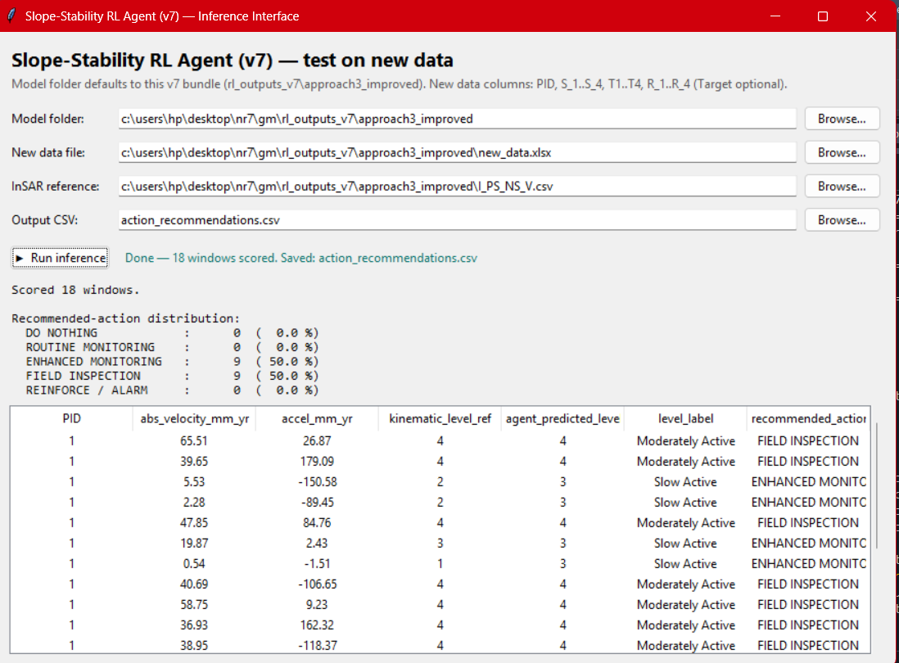
The Console result of the rl_framework_v7.py
