MCLAREN STRATEGIC SOLUTIONS
Ohio Medicaid Fiscal Intermediary — CEF Platform
cBuildCapEnrolls
End-to-End Code Analysis of the Capitation Enrollment Build
Trigger, control flow, business rules, data access and downstream dispatch, traced from the QFrame agent entry point to the final payment, voucher and adjustment writes.
Attribute | Value
Document ID | CEF-CAP-ENRL-001
Revision | rev 0.1 — DRAFT
Date | 31 August 2026
Author (Solution Architect)
Reviewer(s)
Approver
Engagement | IV&V Architecture Assessment — Contract 0A1286 / SOW 31066
Pillar | P1 — Critical Process Parallelism & CapRecon
Subject process | cBuildCapEnrolls — capitation enrollment build (QNXT Advanced Capitation)
Primary repository | mms-cms-cef
Analysis basis | Static source analysis of the QCSI ASC Capitation component and the Payment / Provider / ProcessLog data-service query classes
Classification | MSS / Gainwell Confidential — not for State distribution without review
Status | Issued for technical review

Contents
Generated from the document headings. Right-click and choose Update Field, or press F9, to refresh entries and page numbers.

0. Document control and conventions

0.1 Purpose and scope
This document is a current-state trace of a single process: the construction of capitation enrollment batches for capitated providers, performed by the cBuildCapEnrolls class in the QNXT Advanced Capitation component. It records what the process does today — its trigger, its control flow, the branch conditions that steer it, every database interaction it makes, and the records it leaves behind.
The scope begins at the QFrame agent that consumes the scheduler message and ends at the two dispatch outcomes: synchronous in-process batch handling, or asynchronous hand-off to the QFrame message queue. Downstream capitation calculation — affiliation selection, amount allocation, fund allocation and voucher storage — is performed by CapitationBatchProcessAgent and is named here only where it is the destination of a dispatch.
Current state only
This document describes what exists. Target-state options, remediation designs and recommendations belong in the SOW and decision instruments. Statements about defects, gaps and risk are recorded as observations of the code as built, not as proposals.

0.2 Evidence and confidence tags
Every substantive claim resolves to one of the following. Claims carrying no tag are structural narration and assert nothing about the code.
Tag | Meaning | Basis
VERIFIED | Read directly from source in the repository | File and line citation given; the statement restates what the line does
INFERRED | Concluded from surrounding structure, not stated in one place | Reasoning given inline; the conclusion is defeasible
NOT FOUND | The artefact was searched for and is absent from the available workspace | Recorded in §17 with the search performed

0.3 Source basis
The analysis reads the following, all within mms-cms-cef:
- components/QNXT/ASCs/Capitation/Src/QCSI ASC Capitation/ — the VB.NET capitation service component, including cBuildCapEnrolls.vb (2,079 lines), aCapitationAgents.vb, CapitationService.vb, CapitationActivity.vb, cBatchProcessEnrolls.vb and XMLAdvCap.vb.
- components/QNXT/Agents/Capitation/Src/BuildCapEnrolls/BuildCapEnrolls.cs — the C# QFrame AddIn on the legacy path.
- components/QNXT/DataServices/Payment/Src/QCSI Access Payment/Queries/ — the generated query classes that carry the SQL text and QUERYID values reproduced in §10.
Query classes referenced from the Provider and ProcessLog data services are read from their own service directories. Stored-procedure bodies, agent registration configuration and connection-string resolution are outside the available workspace; each is recorded in §17.

0.4 Conventions
- Code identifiers are set in monospace. Database objects are lower-case, matching the schema.
- Citations take the form file.vb:line. Line numbers are those of the revision analysed.
- QUERYID values are the data-services framework identifiers and are stable across environments; they are the most reliable handle on a query, because several classes share similar names.
- SQL in §10 is reproduced as it appears in the query class. Where the source builds SQL by string concatenation, this is stated and the parameter placeholders shown are notional.

0.5 Related instruments
Instrument | Relationship
CEF-CAP-TAD-001 — End-to-End Capitation, Current State | Parent architecture and engineering document. This analysis supplies §2.2 stage detail for the enrollment-build stage; the parent owns the stage catalogue and the wider pipeline.
CEF-CAP-VOID-002 — Flexi & Vue 360 Payment Void Analysis | Covers the downstream fate of the payment rows created here, including the void window and the Flexi invoice states. The payment row this process inserts at status INCOMPLETE is the same row that analysis tracks.

1. Executive summary
cBuildCapEnrolls is the enrollment-build stage of the QNXT advanced capitation pipeline. It determines which member enrollments qualify for capitation in a given cap period, stages them into a queue table, opens a payment record to receive the resulting vouchers, settles any pending monetary adjustments, and hands the work on for calculation.

1.1 Process identity
Attribute | Value
What the process does | Processes capitation enrollments for capitated providers — determines valid enrollments, builds cap messages per enrollment batch, creates payment records, settles cap adjustments, and dispatches batches for downstream calculation
True process entry point | CapitationCreateAgent.ProcessMessage() — a QFrame agent dispatched by the QEnterprise message queue
Trigger type | Message-queue consumer, invoked by the QEnterprise scheduler / dispatcher
Main repository | mms-cms-cef
Main component | QCSI ASC Capitation (VB.NET, under components/QNXT/ASCs/Capitation/Src/)
Primary database | PlanData alias (SQL Server), with secondary aliases qenterprise and planintegration
Final process output | payment (INSERT), capvoucher (INSERT), capadjustment (UPDATE), capmessagequeue (INSERT via stored procedure), and dispatched batch messages to CapitationBatchProcessProxy
Methods on the successful path | 18 distinct methods
Methods including error and restart paths | 25 distinct methods
Distinct database calls | 17, of which 4 are stored-procedure executions
Business rules identified | 12

1.2 Key findings
- Two implementations share the name `cBuildCapEnrolls`, and only one carries behaviour. A legacy C# QFrame AddIn reaches a public wrapper class of the same name; the active VB.NET agent path reaches a Friend class holding all 2,047 lines of data access and business logic. Any change made against the wrapper has no effect on production behaviour. [VERIFIED]
- The process forks early and irreversibly on `isGlobal`. Global capitation and PCP capitation share the entry point, the payment write and the dispatch, but nothing in between: different queries, different stored procedures, different validation. Global runs additionally impose a hard cardinality rule — exactly one payto affiliation, or the run throws. [VERIFIED]
- The staging table is populated entirely inside stored procedures whose bodies are not in the repository. spq_BuildPCPCapMessage and spq_BuildGlobalCapMessage, together with their advance-reconciliation variants, decide which enrollments qualify. This is the single largest blind spot in the trace: the enrollment eligibility rule itself is not readable from source. [NOT FOUND]
- Cap adjustment settlement is an unguarded two-statement sequence. For each pending monetary adjustment the process inserts a capvoucher row and then updates the capadjustment row to PROCESSED, with no wrapping transaction. A failure between the two leaves a voucher whose adjustment is still PENDING, and the adjustment is eligible to be settled again on the next run. [VERIFIED]
- Batch size determines whether the work runs in-process or on the queue. A single batch is processed synchronously by cBatchProcessEnrolls; multiple batches are dispatched asynchronously through CapitationBatchProcessProxy. The two routes have different failure and restart characteristics, and the choice is made by a configuration option, not by the caller. [VERIFIED]
- Two inline queries are assembled by string concatenation. DistinctRateIDSQL() and DistinctEligibleorgIDSQL() build SQL by concatenating values taken from the inbound XML message. The values originate inside the platform rather than from a user, but the construction is unparameterised. [VERIFIED]
- Failure is counted, not caught, at the boundary. The Finally block queries processstate for a failure count and marks the process-log detail COMPLETED or ERROR accordingly. A run that recorded errors in individual batches still completes its own method normally; the status is derived from state written elsewhere. [VERIFIED]

2. Symbol identification
The name cBuildCapEnrolls resolves to more than one symbol, and the search term IBuildCapEnrolls resolves to none. This section fixes exactly which symbol the rest of the document refers to.

2.1 Exact matches
Search term | Match | Symbol type | File | Class / interface | Lines
cBuildCapEnrolls | YES | Friend Class | cBuildCapEnrolls.vb | Capitation.cBuildCapEnrolls | 32–2079
BuildCapEnrolls (C# agent) | YES | Public Class | BuildCapEnrolls.cs | Q.QFrame.Extensibility.CapitationAgents.BuildCapEnrolls | 16–76
cBuildCapEnrolls (wrapper) | YES | Public Class | BuildCapEnrolls.vb | Q.ServiceComponents.Capitation.cBuildCapEnrolls | 20–185
IBuildCapEnrolls | NOT FOUND | — | — | — | —
ICapitationActivity | YES | Interface | ICapitationActivity.vb | Q.ServiceComponents.ICapitationActivity | 10–85
ICapitationService | YES | Interface | ICapitation.vb | Capitation.ICapitationService | 10–18
CapitationActivity | YES | Public Class | CapitationActivity.vb | Q.ServiceComponents.Capitation.CapitationActivity | 22–192
CapitationService | YES | Public Class | CapitationService.vb | Capitation.CapitationService | 18–185
CapitationCreateAgent | YES | Public Class | aCapitationAgents.vb | Agent.CapitationCreateAgent | 13–56
All files sit under components/QNXT/ASCs/Capitation/Src/QCSI ASC Capitation/ except BuildCapEnrolls.cs, which is under components/QNXT/Agents/Capitation/Src/BuildCapEnrolls/.

2.2 Two implementation paths
Both paths exist in the repository and both compile. They differ in what they contain.

2.2.1 Legacy path — C# agent to VB wrapper
The C# BuildCapEnrolls QFrame AddIn instantiates CapitationActivity, which calls its BuildCapEnrolls() method, which reaches Q.ServiceComponents.Capitation.cBuildCapEnrolls — the 165-line public wrapper in BuildCapEnrolls.vb. The wrapper delegates; it holds no query classes, no stored-procedure calls and no branch logic.

2.2.2 Active path — VB agent to Friend class
The VB.NET CapitationCreateAgent instantiates CapitationService, whose CreateCapitation() constructs Capitation.cBuildCapEnrolls — the Friend class in cBuildCapEnrolls.vb. This class contains every database interaction, every business rule and every stored-procedure execution described in this document.
Which path this document traces
The CapitationCreateAgent → CapitationService → cBuildCapEnrolls chain. That the VB path is the operative one is [INFERRED] rather than [VERIFIED]: agent-to-message-type registration is held in the QEnterprise database and is not in the repository (§17, item 3). The inference rests on the VB path being the only one that contains the behaviour — the C# path terminates in a wrapper that does nothing on its own.
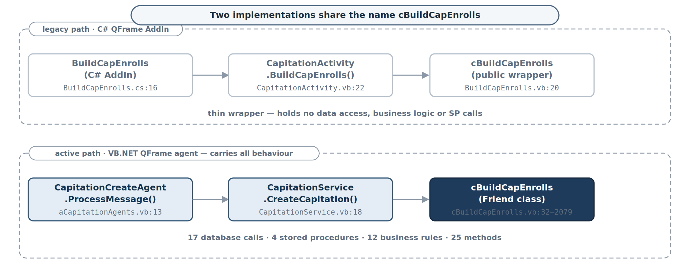
Figure 1 — The two implementations that share the name cBuildCapEnrolls. Only the lower path carries data access, business rules and stored-procedure calls.

3. Entry point

3.1 True entry point
Attribute | Value
Repository | mms-cms-cef
Solution / project | QCSI ASC Capitation
File | aCapitationAgents.vb
Namespace | Agent
Class | CapitationCreateAgent
Method | Protected Overloads Overrides Function ProcessMessage(ByVal session As IQcsiSession, ByVal msg As String) As String
Lines | 23–55
Trigger type | QFrame agent — message-queue consumer
Trigger configuration | QEnterprise agent registration, database-configured; the agent is dispatched against CapProviderRequestMessageType
Input parameters | session — an IQcsiSession carrying connection information; msg — an XML string conforming to CapProviderRequestMessageType
First downstream call | CapitationService.CreateCapitation(msg)
There is no scheduled task, no service host and no HTTP surface. The process starts when the QEnterprise dispatcher hands a message to the agent, and the agent is registered in the database rather than in configuration held with the source.

3.2 Secondary entry points on the same class
Two further agents in aCapitationAgents.vb enter the same service and reach the same component by different routes.
Agent | Lines | Service method | Purpose
CapitationRestartAgent.ProcessMessage() | 62–95 | CapitationService.RestartCapitation() | Re-enters a run that failed part-way, resuming from capmessagequeue rather than rebuilding the enrollment set
CapitationBatchProcessAgent.ProcessMessage() | 100+ | CapitationService.BatchProcessEnrollments() | Consumes the batch messages this process dispatches asynchronously; the downstream half of the pipeline

4. End-to-end control flow
The process runs as a single ordered pass with two forks — restart versus new run, and global versus PCP — and one loop, over enrollment batches. Everything else is sequential.

4.1 Stage sequence
# | Stage | Effect
1 | QEnterprise scheduler dispatches CapProviderRequestMessageType | Message placed on the queue; agent invoked
2 | CapitationCreateAgent.ProcessMessage() | Message deserialised to a typed object via CUtility.GetObject()
3 | CapitationService.CreateCapitation() | Session cloned; XMLAdvCap.LoadQFrameMessage() parses the payload
4 | cBuildCapEnrolls.New() | Three database sessions opened: PlanData, qenterprise, planintegration
5 | cBuildCapEnrolls.ProcessMessage() | XMLAdvCap.InitXML() parses the message; restarting flag read
6 | Fork — restarting = "Y" | RestartFailedCapRun(); the remainder of this table is not executed
7 | Fork — otherwise | BuildCapEnrolls() begins the normal path
8 | LoadProgramcaps() | Reads programcap for cap method, split month and true-cap flags
9 | True-cap adjustment | If usetruecap = "Y" and the effective range covers the cap date, capdate moves to the last day of the month
10 | LoadOpenPayments() | Reads existing OPEN and PAID payments with their voucher dates
11 | Fork — isGlobal | Global: select global affiliations, load affiliation and contract data, execute spq_BuildGlobalCapMessage. PCP: check pay holds, generate a queue ID, execute spq_BuildPCPCapMessage
12 | ValidateCapFactorProgramFundsForAffiliations() | Detects capfactors pointing at funds absent from programfund; logs warnings only
13 | ProcessEnrollments() | Groups the staged rows by capmessagequeueid and loops
14 | Per batch — load into XML | Program caps, open payments, contract data and affiliation folded into the message
15 | Per batch — CreatePayment() | INSERT payment at status INCOMPLETE
16 | First batch only — CalcCapAdjustments() | INSERT capvoucher (ADJUSTMENT) and UPDATE capadjustment to PROCESSED for each pending monetary adjustment
17 | Dispatch | Single batch: cBatchProcessEnrolls.ProcessMessage() synchronously. Multiple: CapitationBatchProcessProxy.ProcessMessage() per sub-batch
18 | Finally — process log finalisation | processstate failure count read; detail marked COMPLETED or ERROR

4.2 Control flow — dispatch and enrollment build
Figure 2 covers the path from the scheduler message to the point at which capmessagequeue holds the staged enrollment rows. The two lanes below isGlobal never both execute.
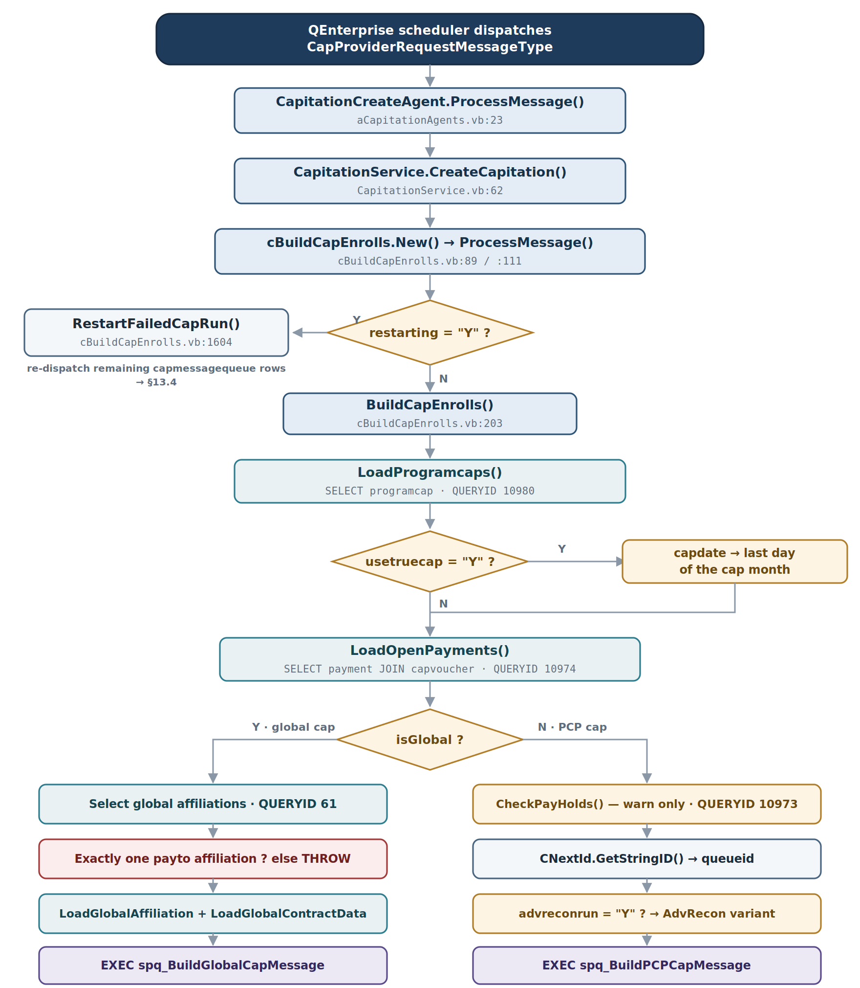
Figure 2 — Control flow from agent dispatch through to stored-procedure execution. Only the global lane contains a throwing cardinality check.

4.3 Control flow — enrollment processing and dispatch
Figure 3 resumes at the staged queue and carries through to process-log finalisation. The adjustment sequence on the left runs on the first batch only; every subsequent batch skips it.
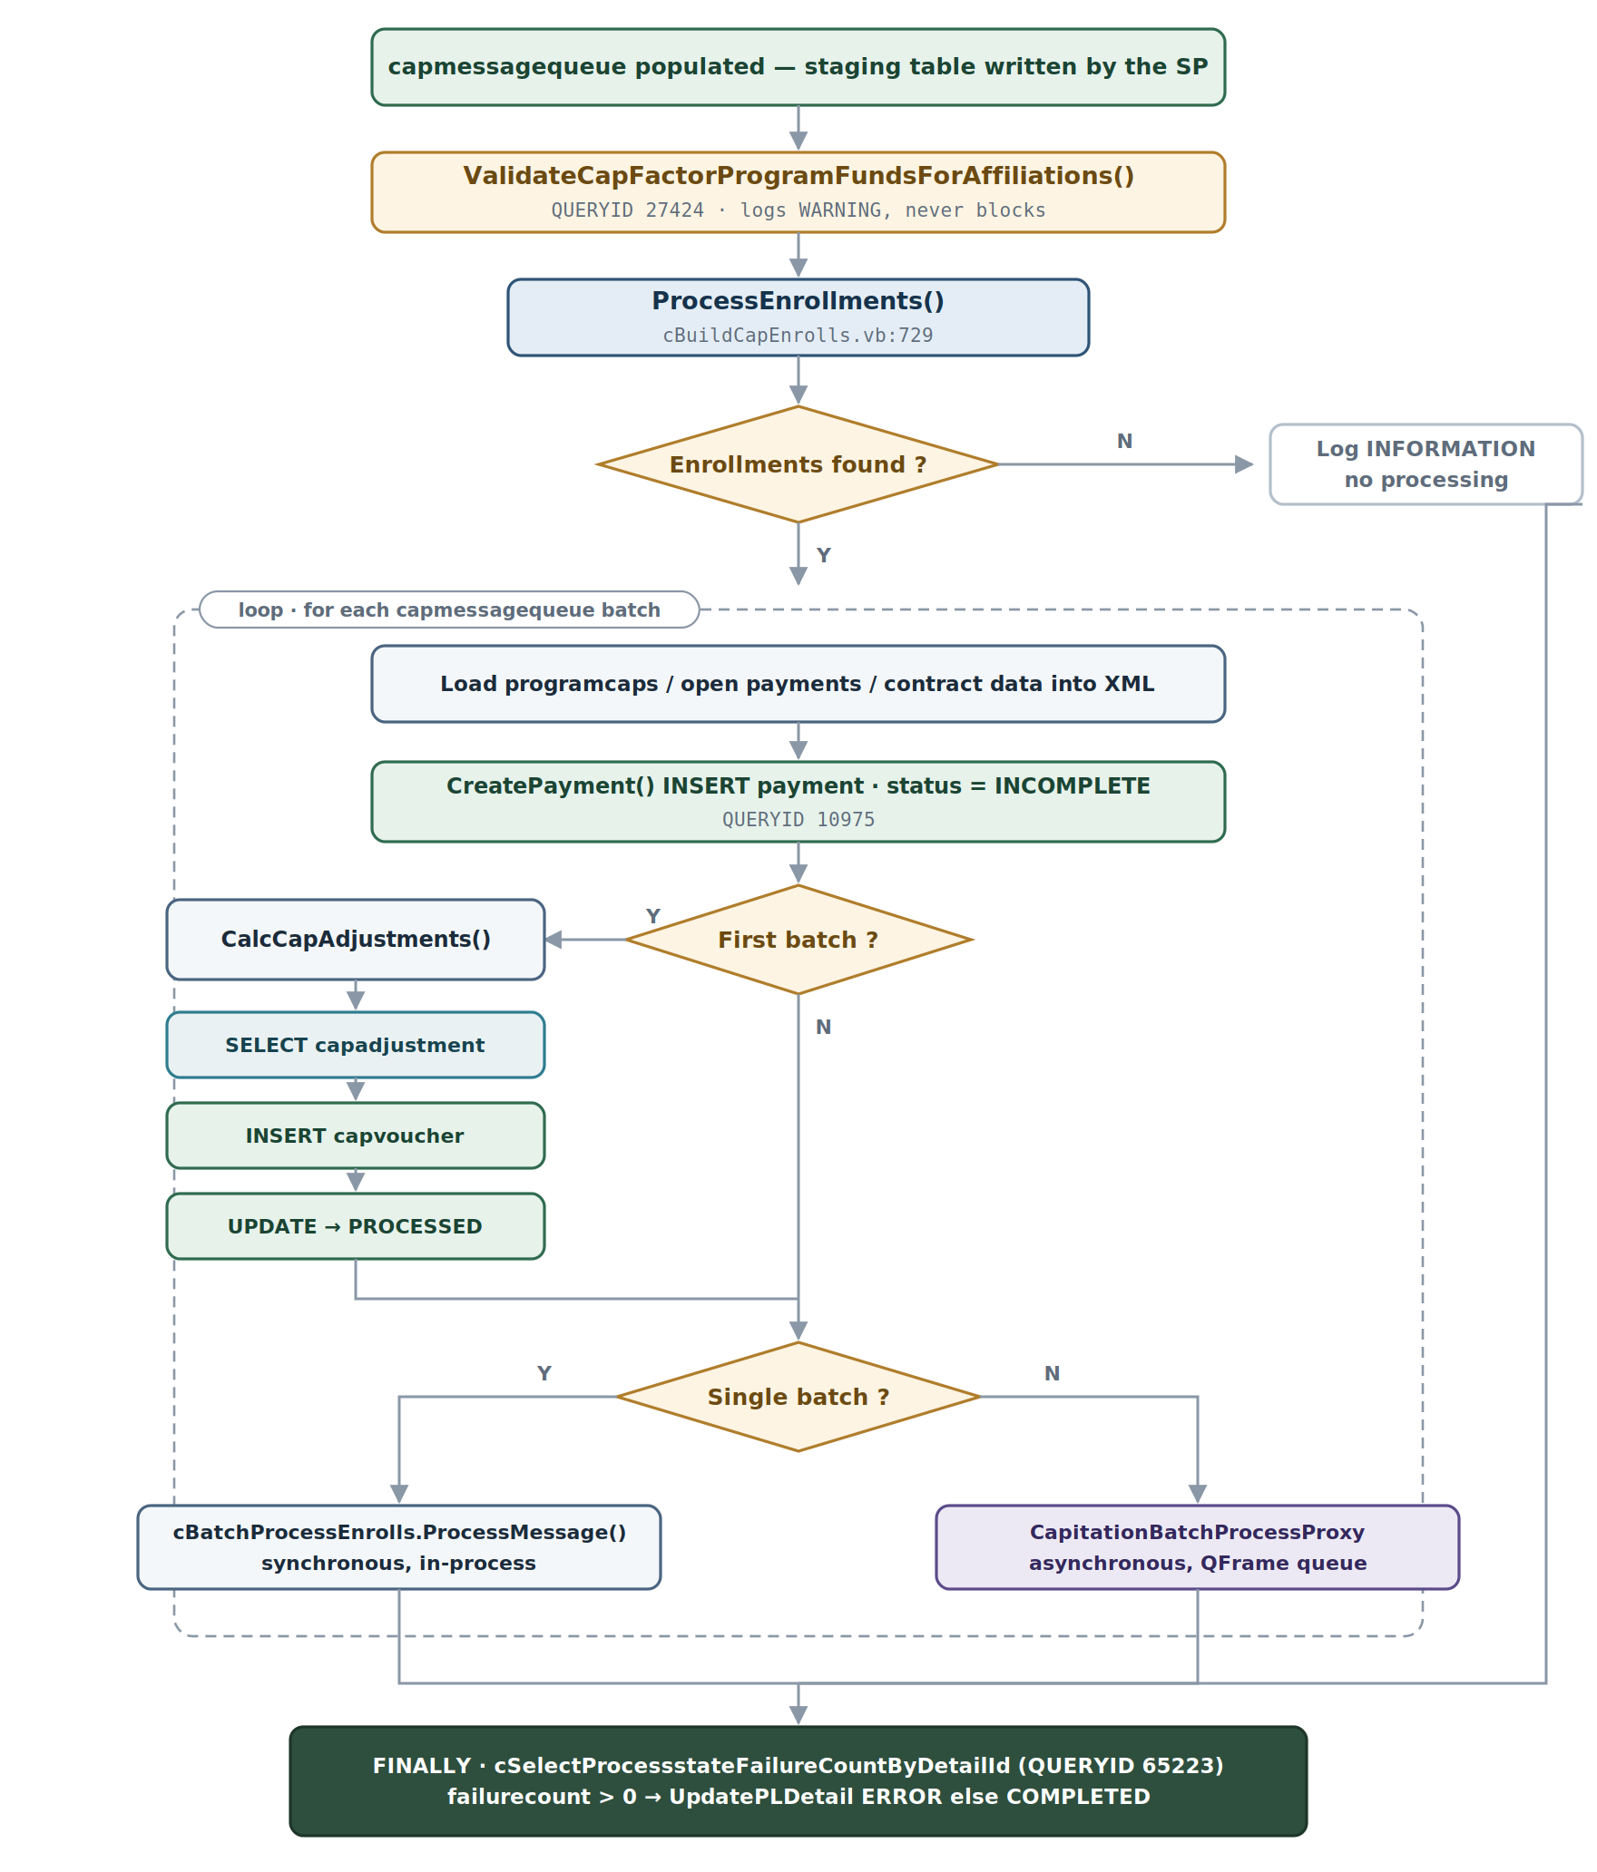
Figure 3 — Enrollment processing, adjustment settlement and the synchronous / asynchronous dispatch fork.

5. Method call hierarchy
The full static call tree of the successful path, with the file and line at which each method is defined. Query classes are shown at the point of call because they are the boundary between this component and the database.
CapitationCreateAgent.ProcessMessage() [aCapitationAgents.vb:23]
└─> CapitationService.CreateCapitation() [CapitationService.vb:62]
└─> XMLAdvCap.LoadQFrameMessage() [XMLAdvCap.vb]
└─> cBuildCapEnrolls.New() [cBuildCapEnrolls.vb:89]
└─> cBuildCapEnrolls.ProcessMessage() [cBuildCapEnrolls.vb:111]
└─> XMLAdvCap.InitXML() [XMLAdvCap.vb]
├─[restarting=Y]─> RestartFailedCapRun() [cBuildCapEnrolls.vb:1604]
│ └─> cSelectRemainingCapmessagesByMessagequeueid
│ └─> cCapPayment.ProcessMessage()
│ └─> cBatchProcessEnrolls.ProcessMessage() [cBatchProcessEnrolls.vb:68]
│ └─> CapitationBatchProcessProxy.ProcessMessage()
└─[restarting=N]─> BuildCapEnrolls() [cBuildCapEnrolls.vb:203]
└─> LoadProgramcaps() [cBuildCapEnrolls.vb:996]
│ └─> cRetrieveProgramCapsByProgidCapTypeEffdateTermdate.LoadData()
└─> LoadOpenPayments() [cBuildCapEnrolls.vb:917]
│ └─> cRetrievePaymentsByProgProvDateType.LoadData()
├─[isGlobal]─> Build_Global_Enrollments() [cBuildCapEnrolls.vb:528]
│ └─> cSelectGlobalAffiliationsByProgramidCapdateRecondateEtc.LoadData()
│ └─> LoadGlobalAffiliation() [cBuildCapEnrolls.vb:1522]
│ │ └─> cSelectAffiliationByAffiliationid.LoadData()
│ └─> LoadGlobalContractData() [cBuildCapEnrolls.vb:1422]
│ │ └─> cSelectGlobalContractData.LoadData()
│ └─> cExecuteSpq_buildglobalcapmessage.LoadData()
├─[NOT isGlobal]─> Build_PCP_Enrollments() [cBuildCapEnrolls.vb:396]
│ └─> CheckPayHolds() [cBuildCapEnrolls.vb:1327]
│ │ └─> cRetrieveCapitationPayHoldsPlusCapType.LoadData()
│ └─> CNextId.GetStringID()
│ └─> cExecuteSpq_buildpcpcapmessagewithtype.LoadData()
└─> ValidateCapFactorProgramFundsForAffiliations() [cBuildCapEnrolls.vb:302]
│ └─> cSelectContractinfoEtcByRequestidlistlistProgramidCapdateEtc.LoadData()
└─> ProcessEnrollments() [cBuildCapEnrolls.vb:729]
└─> LoadProgramcapsIntoXML() [cBuildCapEnrolls.vb:1063]
└─> LoadOpenPaymentsIntoXML() [cBuildCapEnrolls.vb:973]
└─> LoadGlobalContractDataIntoXML() [cBuildCapEnrolls.vb:1489]
└─> LoadGlobalAffiliationIntoXML() [cBuildCapEnrolls.vb:1573]
└─> CreatePayment() [cBuildCapEnrolls.vb:1264]
│ └─> CNextId.GetStringID()
│ └─> cInsertPaymentWithPaymentidProgramidProvidPaytypeEtc.ExecuteQuery()
└─> CalcCapAdjustments() [cBuildCapEnrolls.vb:1967]
│ └─> cSelectCapadjustmentEtc…PendingMonetaryReadonly.LoadData()
│ └─> cCreatecapvoucherRecord.ExecuteQuery()
│ └─> cUpdateCapadjustmentByProcessdatePaymentidStatusEtc.ExecuteQuery()
└─> [small batch] cBatchProcessEnrolls.ProcessMessage()
└─> [large batch] CapitationBatchProcessProxy.ProcessMessage()

6. Method-by-method analysis
Fourteen methods carry the process. Each entry below states where it lives, what it is for, and what it changes.

6.1 Call 01 — `CapitationCreateAgent.ProcessMessage()`
File | aCapitationAgents.vb:23
Class | Agent.CapitationCreateAgent
Signature | Protected Overloads Overrides Function ProcessMessage(ByVal session As IQcsiSession, ByVal msg As String) As String
Purpose | QFrame agent entry point. Deserialises the inbound CapProviderRequestMessageType and delegates.
Processing | Builds a CapProviderRequestMessageType from the message XML using CUtility.GetObject(), then constructs CapitationService with the session, header ID and detail ID, and calls CreateCapitation.
Exceptions | All errors are wrapped in QFrameAgentException.

6.2 Call 02 — `CapitationService.CreateCapitation()`
File | CapitationService.vb:62
Class | Capitation.CapitationService
Signature | Public Function CreateCapitation(ByVal msg As String) As Boolean
Purpose | Orchestrates a new capitation run: clones the session, parses the message, builds the worker and disposes it.
Processing | (1) clone session; (2) create XMLAdvCap and load the QFrame message; (3) construct cBuildCapEnrolls(mySession, Me.ProcessLog, Me.HeaderId, Me.DetailId, msg); (4) call ObjBuildCapEnrolls.ProcessMessage(ObjXmlMessage.XML); (5) dispose the worker.
Exceptions | Catches QServiceException and Exception, logs through LogErrorWithFallback, and rethrows as ActivityServiceComponentException.

6.3 Call 03 — `cBuildCapEnrolls.New()`
File | cBuildCapEnrolls.vb:89
Purpose | Establishes the database sessions and captures the process-log references.
Processing | Stores the session reference and calls Session.SelectAlias("PlanData"); sets QSession.SelectAlias("qenterprise"); creates a separate sessionPlanintegration bound to the planintegration alias; stores processLog, headerID, detailID and the original XML.
Note | Three aliases are held open for the lifetime of the object. PlanData carries all plan queries, planintegration carries process state, and qenterprise is held for cross-database reference.

6.4 Call 04 — `cBuildCapEnrolls.ProcessMessage()`
File | cBuildCapEnrolls.vb:111
Signature | Public Function ProcessMessage(ByRef lxml As String) As Boolean
Purpose | Top-level control. Parses the XML, decides restart versus new run, and finalises the process log.
Processing | (1) create XMLAdvCap and call InitXML(lxml); (2) store the original XML; (3) read the loginfo flag; (4) if restarting = "Y" call RestartFailedCapRun(), otherwise call BuildCapEnrolls().
Finally block | Queries cSelectProcessstateFailureCountByDetailId for the error count, then calls UpdatePLDetailNoXml with ERROR or COMPLETED.

6.5 Call 05 — `BuildCapEnrolls()`
File | cBuildCapEnrolls.vb:203 (private)
Purpose | Main orchestration for the enrollment build.
Processing | (1) read optCAPBatchSize from session options; (2) if the run is both summary and global, set recondate and reviewdate equal to capdate; (3) LoadProgramcaps(); (4) walk the program caps and, where usetruecap = "Y" and the effective range covers the cap date, move capdate to the last day of the month; (5) LoadOpenPayments(); (6) branch to Build_Global_Enrollments() or Build_PCP_Enrollments(); (7) ValidateCapFactorProgramFundsForAffiliations(); (8) ProcessEnrollments().

6.6 Call 06 — `LoadProgramcaps()`
File | cBuildCapEnrolls.vb:996
Purpose | Loads programcap rows for the program and cap date to establish cap method, split-month behaviour and the true-cap setting.
Database | cRetrieveProgramCapsByProgidCapTypeEffdateTermdate — QUERYID 10980. SELECT from programcap filtered on programid, captype (M or S), effdate <= capdate and termdate >= recondate.

6.7 Call 07 — `LoadOpenPayments()`
File | cBuildCapEnrolls.vb:917
Purpose | Retrieves existing OPEN and PAID capitation payments together with their voucher dates, for reconciliation.
Database | cRetrievePaymentsByProgProvDateType — QUERYID 10974. payment joined to capvoucher, filtered on program, provider, eligible organisation, pay type and the pay-date window.

6.8 Call 08 — `Build_PCP_Enrollments()`
File | cBuildCapEnrolls.vb:396
Purpose | Builds enrollment messages for PCP-based, non-global capitation.
Processing | (1) calculate the first day of the cap month; (2) CheckPayHolds() — warns about providers on hold but does not exclude them; (3) generate a queueid via CNextId.GetStringID(); (4) determine the management-cap flag; (5) if this is an advance reconciliation run, read the recon date from cSelectcapadjustmentReconDateforAdvanceReconRun and execute the AdvRecon variant; (6) otherwise execute cExecuteSpq_buildpcpcapmessagewithtype.
Key stored procedure | spq_BuildPCPCapMessage — populates capmessagequeue.

6.9 Call 09 — `Build_Global_Enrollments()`
File |  | cBuildCapEnrolls.vb:528
Purpose |  | Builds enrollment messages for global, non-PCP capitation.
Processing |  | (1) query cSelectGlobalAffiliationsByProgramidCapdateRecondateEtc for global affiliations; (2) require exactly one global payto affiliation, else throw; (3) LoadGlobalAffiliation() via cSelectAffiliationByAffiliationid, which must also return exactly one row; (4) LoadGlobalContractData() via cSelectGlobalContractData, which must find capitated contracts; (5) generate a queueid; (6) execute cExecuteSpq_buildglobalcapmessage.
Key stored procedure |  | spq_BuildGlobalCapMessage — populates capmessagequeue.
Cardinality is enforced twice on the global path
Both the affiliation search and the affiliation load require a single row. Neither condition is degraded to a warning: a program configured with two global payto affiliations for the same cap period stops the run rather than picking one. [VERIFIED — cBuildCapEnrolls.vb:608, :612]

6.10 Call 10 — `ValidateCapFactorProgramFundsForAffiliations()`
File | cBuildCapEnrolls.vb:302
Purpose | Detects capfactor rows that reference funds not present in programfund for the program.
Database | cSelectContractinfoEtcByRequestidlistlistProgramidCapdateEtc — QUERYID 27424.
Outcome | Warnings only. An invalid fund configuration is logged and the run continues, so the misconfiguration surfaces later as a calculation result rather than here as a failure.

6.11 Call 11 — `ProcessEnrollments()`
File | cBuildCapEnrolls.vb:729
Purpose | Iterates the staged enrollment batches, opens a payment per batch, settles adjustments and dispatches the work.
Processing | (1) group the staged rows by capmessagequeueid; (2) for each batch, fold program caps, open payments, global contract data and affiliation into the XML message; (3) CreatePayment(); (4) CalcCapAdjustments() on the first batch only; (5) dispatch — a single batch runs synchronously through cBatchProcessEnrolls.ProcessMessage(), multiple batches are packaged as CapitationBatchProcessRequestMessageType and sent through CapitationBatchProcessProxy.

6.12 Call 12 — `CreatePayment()`
File | cBuildCapEnrolls.vb:1264
Purpose | Opens the payment record that will receive the batch’s vouchers.
Database | cInsertPaymentWithPaymentidProgramidProvidPaytypeEtc.ExecuteQuery() — QUERYID 10975. INSERT into payment with a generated paymentid, the program, provider, payee, pay date, pay type, status = INCOMPLETE, the capmessagequeueid, the full XML message, the eligible organisation and the process-log header ID.
Note | The complete inbound XML message is stored in the capmessage column, escaped by DBFixup(). The payment row therefore carries the request that produced it.

6.13 Call 13 — `CalcCapAdjustments()`
File | cBuildCapEnrolls.vb:1967
Purpose | Settles pending monetary cap adjustments for the provider and program.
Processing | (1) query cSelectCapadjustmentEtcByProgramidAffiliateidCapdatePendingMonetaryReadonly — capadjustment joined to program; (2) for each pending row, INSERT a capvoucher with captype = ADJUSTMENT via cCreatecapvoucherRecord, then UPDATE the capadjustment to PROCESSED via cUpdateCapadjustmentByProcessdatePaymentidStatusEtc; (3) set m_adjustCap = False so later batches skip the method.
Transaction | The INSERT and the UPDATE are separate statements with no wrapping transaction. See §13.3.

6.14 Call 14 — `CheckPayHolds()`
File | cBuildCapEnrolls.vb:1327
Purpose | Identifies PCPs carrying a HOLD memo and logs a warning for each.
Database | cRetrieveCapitationPayHoldsPlusCapType — QUERYID 10973. A ten-table join across affiliation, contractinfo, contract, capitation, memberpcp, enrollkeys, benefitplan, the provider affiliation, provider, provmemo and memo, filtered to memo.codeid = ‘HOLD’.
Outcome | Warning only. Providers on hold are still built into the enrollment set; the hold is applied further down the payment pipeline, not here.

7. Business rules
Twelve decision points steer the run. Each is stated below with the condition as written, the plain-English reading, and both outcomes.
# |  | Rule | Location | Condition | Plain English | True | False
1 |  | Summary + global bypasses recon | BuildCapEnrolls() L219–222 | isSummary = True And isGlobal = True | Summary global runs skip reconciliation entirely | recondate and reviewdate set to capdate | Normal recon processing
2 |  | True-cap date adjustment | BuildCapEnrolls() L233–243 | programcaps.usetruecap = "Y" and the effective range covers capdate | With true cap configured, the cap date moves to month end so the full month of enrollment is captured | capdate = last day of month | capdate unchanged
3 |  | Management cap type mapping | LoadProgramcaps() L1035 | capitationType.Trim().ToUpper() = "MGT" | Maps the message cap type onto the database code | sProgramCapType = "M" | sProgramCapType = "S"
4 |  | Global versus PCP routing | BuildCapEnrolls() L251–255 | isGlobal = True | Selects the enrollment-loading strategy for the whole run | Build_Global_Enrollments() | Build_PCP_Enrollments()
5 |  | Single global payto required | Build_Global_Enrollments() L608 | m_enrollments.RecordCount = 1 | Global capitation requires exactly one payto affiliation | Proceeds with the build | Throws — run fails
6 |  | Global contract data required | Build_Global_Enrollments() L618 | LoadGlobalContractData() = False | Capitated contracts must exist for the global payto | Throws if no contracts found | Proceeds
7 |  | Pay-hold warning | CheckPayHolds() L1390–1395 | memo.codeid = ‘HOLD’ on the provider | Providers on hold are flagged but still processed | Warning written to the process log | No action
8 |  | Advance reconciliation run | Build_PCP_Enrollments() L463 | advreconrun = "Y" | Switches to the stored-procedure variant that accepts an advance recon date | cExecuteSpq_buildpcpcapmessagewithtypeadvreconrun | cExecuteSpq_buildpcpcapmessagewithtype
9 |  | Batch splitting | ProcessEnrollments() L783 | dtMsgQueue.Rows.Count from the stored-procedure output | Enrollments are split into batches sized by optCAPBatchSize | Multiple batches dispatched asynchronously | Single batch processed synchronously
10 |  | Adjustment settlement | CalcCapAdjustments() L2018–2065 | m_adjustments.RecordCount > 0 | Pending MONETARY adjustments for the provider and program are settled | Creates capvoucher, sets capadjustment to PROCESSED | No adjustment processing
11 |  | Invalid fund validation | ValidateCapFactorProgramFundsForAffiliations() L330 | fundid.Trim <> "" | Capfactors pointing at funds outside programfund are reported | Warning logged; run continues | No warning
12 |  | Cap batch size option | BuildCapEnrolls() L211–213 | Opt_CAPBatchSize > 0 | An application option controls enrollment batch sizing | reqCAPSize set from qmxGlobals.dictCAPBatch | No limit (0)
Three rules can stop the run; the rest only steer it
Rules 5 and 6 throw. Every other rule selects a path, adjusts a date or writes a warning. Notably, rules 7 and 11 detect conditions that are very likely to produce a wrong capitation result — a provider on hold, or a capfactor pointing at a fund the program does not have — and allow the run to continue to completion. [VERIFIED]

8. Database call inventory
Seventeen distinct database interactions occur across the successful and restart paths. Four are stored-procedure executions; the remainder are generated query classes carried in the data-service assemblies. All run against PlanData except QUERYID 65223, which runs against planintegration.
# |  | Caller | QUERYID | Query class | Op | Tables | Purpose
1 |  | LoadProgramcaps() | 10980 | cRetrieveProgramCapsByProgidCapTypeEffdateTermdate | SELECT | programcap | Cap method, split month, true cap
2 |  | LoadOpenPayments() | 10974 | cRetrievePaymentsByProgProvDateType | SELECT | payment, capvoucher | Existing open / paid payments for recon
3 |  | CheckPayHolds() | 10973 | cRetrieveCapitationPayHoldsPlusCapType | SELECT | affiliation, contractinfo, contract, capitation, memberpcp, enrollkeys, benefitplan, provider, provmemo, memo | Identify providers on pay hold
4 |  | Build_Global_Enrollments() | 61 | cRetrieveGlobalAffils | SELECT | affiliation, contractinfo, contract, capitation | Find global payto affiliations
5 |  | LoadGlobalAffiliation() | 24636 | cSelectAffiliationByAffiliationid | SELECT | affiliation | Full affiliation record for the global payto
6 |  | LoadGlobalContractData() | 10573 | cSelectGlobalContractData | SELECT | contractinfo, contract, capitation, programfund | Capitated contract and fund configuration
7a |  | Build_Global_Enrollments() | 60 | cExecuteSpq_buildglobalcapmessage | EXEC | capmessagequeue | Execute spq_BuildGlobalCapMessage
7b |  | Build_Global_Enrollments() | 65249 | cExecuteSpq_buildglobalcapmessageforadvreconrun | EXEC | capmessagequeue | Advance-recon variant
8 |  | Build_PCP_Enrollments() | 65248 | cSelectcapadjustmentReconDateforAdvanceReconRun | SELECT | capadjustment | Earliest pending RECON date
9a |  | Build_PCP_Enrollments() | 10977 | cExecuteSpq_buildpcpcapmessagewithtype | EXEC | capmessagequeue | Execute spq_BuildPCPCapMessage
9b |  | Build_PCP_Enrollments() | 65263 | cExecuteSpq_buildpcpcapmessagewithtypeadvreconrun | EXEC | capmessagequeue | Advance-recon variant
10 |  | ValidateCapFactorProgramFunds…() | 27424 | cSelectContractinfoEtcByRequestidlistlistProgramidCapdateEtc | SELECT | contractinfo, contract, capitation, capfactors, programfund | Detect invalid fund configuration
11 |  | CreatePayment() | 10975 | cInsertPaymentWithPaymentidProgramidProvidPaytypeEtc | INSERT | payment | Open the cap payment record
12 |  | CalcCapAdjustments() | 10610 | cSelectCapadjustmentEtc…PendingMonetaryReadonly | SELECT | capadjustment, program | Pending monetary adjustments
13 |  | CalcCapAdjustments() | 98 | cCreatecapvoucherRecord | INSERT | capvoucher | Adjustment voucher
14 |  | CalcCapAdjustments() | 10611 | cUpdateCapadjustmentByProcessdatePaymentidStatusEtc | UPDATE | capadjustment | Mark adjustment PROCESSED
15 |  | ProcessMessage() finally | 65223 | cSelectProcessstateFailureCountByDetailId | SELECT | processstate | Error count for final status
16 |  | RestartFailedCapRun() | 10574 | cSelectRemainingCapmessagesByMessagequeueid | SELECT | capmessagequeue | Remaining messages on restart
17 |  | LoadPolicycopays() | 11335 | cSelectByCapdateRecondatePolicycopay…Copaygroupdetail | SELECT | policycopay, policycopaygroup, copaygroupdetail | Copay data
The query text is not in the source tree
Every Queries.* class is referenced through the compiled Q.DataServices.Payment.DataAccess.dll and its relatives. The SQL reproduced in §10 comes from the generated query-class definitions; the QUERYID is the stable handle. See §17, item 2.

9. Stored procedures
Four stored procedures are executed, in two pairs — a base procedure and an advance-reconciliation variant for each of the PCP and global paths. All four write capmessagequeue. None of the four bodies is present in the repository.
Procedure | QUERYID | Called by | Parameters | Body
spq_BuildPCPCapMessage | 10977 | Build_PCP_Enrollments() via cExecuteSpq_buildpcpcapmessagewithtype | programid, capdate, recondate, firstdayofmonth, affiliateid, queueid, headerid, detailid, isCapitatedOnly, eligibleorgid, captype, ismanagementcap, capreqsize, qcsidbname | NOT FOUND
spq_BuildPCPCapMessageAdvReconRun | 65263 | Build_PCP_Enrollments() via cExecuteSpq_buildpcpcapmessagewithtypeadvreconrun | As above, plus advrecondate | NOT FOUND
spq_BuildGlobalCapMessage | 60 | Build_Global_Enrollments() via cExecuteSpq_buildglobalcapmessage | programid, capdate, recondate, firstdayofmonth, affiliateid, queueid, headerid, detailid, globalpaytoaffil, eligibleorgid, capreqsize, qcsidbname | NOT FOUND
spq_BuildGlobalCapMessageAdvReconRun | 65249 | Build_Global_Enrollments() via cExecuteSpq_buildglobalcapmessageforadvreconrun | As above, plus advrecondate | NOT FOUND
Wrapper source files exist for all four, under components/QNXT/DataServices/Payment/Src/QCSI Access Payment/Queries/: Execute_spq_BuildPCPCapMessageWithType.cs, ExecuteSpq_buildpcpcapmessagewithtypeadvreconrun.cs, Execute_spq_BuildGlobalCapMessage.cs and ExecuteSpq_buildglobalcapmessageforadvreconrun.cs. Each is a parameter-marshalling shell around an EXEC.
Consequence for the trace
The rule that decides which member enrollments qualify for capitation in a given period lives inside these four procedures. Everything upstream of them in this document is parameter preparation, and everything downstream consumes their output. A behavioural question of the form “why was this member not capitated” cannot be answered from the source available here. [NOT FOUND]

10. Extracted SQL
SQL below is taken from the query-class definitions and from inline VB.NET. Each block names its database, source file, calling method and QUERYID.

10.1 LoadProgramcaps — QUERYID 10980
-- Database: PlanData
-- Source: RetrieveProgramCapsByProgidCapTypeEffdateTermdate.cs
-- Called by: cBuildCapEnrolls.LoadProgramcaps() [cBuildCapEnrolls.vb:1040]
-- Purpose: Load program cap configuration for the program, cap type and date range

SELECT *
FROM programcap (NOLOCK)
WHERE programid = @programid
AND captype = @captype
AND effdate <= @capdate
AND termdate >= @recondate
ORDER BY effdate
Parameter |  | Source | Description
@programid |  | m_XMLMessage.programid | Program identifier
@captype |  | "M" or "S" | Derived from m_XMLMessage.capitationType
@capdate |  | m_XMLMessage.capdate | Capitation processing date
@recondate |  | m_XMLMessage.recondate | Reconciliation date
Columns used downstream: effdate, termdate, usetruecap, splitmonthday, ageday, firsthalfpercent, sechalfpercent, capmethod, useageday, programid.

10.2 LoadOpenPayments — QUERYID 10974
-- Database: PlanData
-- Source: RetrievePaymentsByProgProvDateType.cs
-- Called by: cBuildCapEnrolls.LoadOpenPayments() [cBuildCapEnrolls.vb:959]
-- Purpose: Existing open / paid cap payments with voucher dates, for reconciliation

SELECT payment.paymentid, payment.paydate, capvoucher.capdate
FROM payment (NOLOCK)
JOIN capvoucher (NOLOCK) ON payment.paymentid = capvoucher.paymentid
WHERE payment.programid = @programid
AND payment.provid = @affiliateid
AND (payment.status = 'OPEN' OR payment.status = 'PAID')
AND payment.paytype = @paytype
AND paydate <= @lastdayofcapdate
AND paydate >= @firstdayofrecondate
AND payment.eligibleorgid = @eligibleorgid
GROUP BY payment.paymentid, payment.paydate, capvoucher.capdate
Parameter |  | Source | Description
@programid |  | m_XMLMessage.programid | Program identifier
@affiliateid |  | m_XMLMessage.affiliateid | Provider affiliate ID
@paytype |  | m_XMLMessage.capitationType | "CAP" or "MGT"
@lastdayofcapdate |  | LastDayofMonth(capdate) | Last day of the capitation month
@firstdayofrecondate |  | FirstDayofMonth(recondate) | First day of the reconciliation month
@eligibleorgid |  | m_XMLMessage.eligibleorgid | Eligible organisation ID

10.3 CheckPayHolds — QUERYID 10973
The widest join in the process. It exists solely to produce warning text; no column it returns influences the enrollment set.
-- Database: PlanData
-- Source: RetrieveCapitationPayHoldsPlusCapType.cs
-- Called by: cBuildCapEnrolls.CheckPayHolds() [cBuildCapEnrolls.vb:1389]
-- Purpose: Find PCPs on pay hold whose capitation should be flagged

SELECT DISTINCT prov.fullname, prov.provid, codeid
FROM affiliation afpayto (NOLOCK)
JOIN contractinfo (NOLOCK)
ON contractinfo.programid = @programid
AND afpayto.affiliationid = contractinfo.affiliationid
AND RTRIM(contractinfo.servicelocationid) = ''
AND (CASE WHEN @iscapitated = 'Y' THEN contractinfo.iscapitated ELSE 'Y' END) = 'Y'
JOIN contract (NOLOCK)
ON contractinfo.contractid = contract.contractid
AND (contract.capid <> '' AND contract.capid IS NOT NULL)
JOIN capitation (NOLOCK)
ON contract.capid = capitation.capid
AND capitation.pcponly <> 0
AND capitation.ismanagementcap = @ismanagementcap
JOIN memberpcp pcp (NOLOCK)
ON afpayto.affiliationid = pcp.paytoaffilid
AND pcp.effdate <= @capdate AND pcp.termdate >= @recondate
JOIN enrollkeys enr (NOLOCK)
ON enr.enrollid = pcp.enrollid
AND pcp.effdate <= @capdate AND pcp.termdate >= @recondate
JOIN benefitplan bplan (NOLOCK)
ON enr.planid = bplan.planid AND bplan.programid = @programid
JOIN affiliation afprov (NOLOCK)
ON pcp.affiliationid = afprov.affiliationid
AND afprov.effdate <= @capdate AND afprov.termdate >= @recondate
AND afprov.provid IS NOT NULL
JOIN provider prov (NOLOCK) ON afprov.provid = prov.provid
LEFT OUTER JOIN provmemo (NOLOCK) ON afprov.provid = provmemo.provid
LEFT OUTER JOIN memo (NOLOCK) ON provmemo.memoid = memo.memoid
WHERE afpayto.payflag <> 0
AND afpayto.effdate <= @capdate
AND afpayto.termdate >= @recondate
AND afpayto.affiliationid IN (
SELECT affiliationid FROM affiliation
WHERE affiliateid = @affiliateid AND payflag <> 0)
AND (memo.codeid = 'HOLD')
Parameter |  | Source | Description
@programid |  | m_XMLMessage.programid | Program identifier
@iscapitated |  | m_XMLMessage.isCapitatedOnly | Restrict to capitated contracts
@ismanagementcap |  | derived | "Y" when capitationType = "MGT", else "N"
@capdate |  | m_XMLMessage.capdate | Capitation date
@recondate |  | m_XMLMessage.recondate | Reconciliation date
@affiliateid |  | m_XMLMessage.affiliateid | Provider affiliate ID

10.4 Select global affiliations — QUERYID 61
-- Database: PlanData
-- Source: RetrieveGlobalAffils.cs
-- Called by: cBuildCapEnrolls.Build_Global_Enrollments() [cBuildCapEnrolls.vb:595]
-- Purpose: Find global payto affiliations for the program within the date range

SELECT DISTINCT affiliation.affiliateid,
globalpaytoaffil = affiliation.affiliationid
FROM affiliation (NOLOCK)
JOIN contractinfo (NOLOCK)
ON contractinfo.programid = @programid
AND affiliation.affiliationid = contractinfo.affiliationid
AND contractinfo.effdate <= @capdate
AND contractinfo.termdate >= @recondate
AND RTRIM(contractinfo.servicelocationid) = ''
AND (CASE WHEN @iscapitated = 'Y' THEN contractinfo.iscapitated ELSE 'Y' END) = 'Y'
JOIN contract (NOLOCK)
ON contractinfo.contractid = contract.contractid
AND (contract.capid <> '' AND contract.capid IS NOT NULL)
AND contract.effdate <= @capdate AND contract.termdate >= @recondate
JOIN capitation (NOLOCK)
ON contract.capid = capitation.capid
AND capitation.effective <= @capdate
AND capitation.terminate >= @recondate
AND capitation.pcponly = 0
WHERE affiliation.payflag <> 0
AND affiliation.effdate <= @capdate
AND affiliation.termdate >= @recondate
AND affiliation.provid IS NOT NULL
AND affiliation.affiliationid IN (
SELECT affiliationid FROM affiliation
WHERE affiliateid = @affiliateid AND payflag <> 0)
ORDER BY affiliation.affiliateid
capitation.pcponly = 0 is the discriminator that makes this the global query; the pay-hold query at §10.3 uses pcponly <> 0 for the same reason in reverse.

10.5 LoadGlobalAffiliation — QUERYID 24636
-- Database: PlanData
-- Source: SELECT_affiliation_BY_affiliationid.cs (Provider data service)
-- Called by: cBuildCapEnrolls.LoadGlobalAffiliation() [cBuildCapEnrolls.vb:1553]

SELECT * FROM affiliation WHERE affiliationid = @affiliationid
Columns used downstream: affiliationid, effdate, termdate, payflag, provid, status, affiliateid, affiltype, hospaffiltype, pcp.

10.6 LoadGlobalContractData — QUERYID 10573
-- Database: PlanData
-- Source: SELECT_Global_Contract_Data.cs
-- Called by: cBuildCapEnrolls.LoadGlobalContractData() [cBuildCapEnrolls.vb:1469]
-- Purpose: Capitated contract / cap / fund configuration for the global payto

SELECT DISTINCT ci.contractid, ci.effdate, ci.termdate,
capfundid = (CASE WHEN ct.capfundid = '' OR ct.capfundid IS NULL
THEN @fundid ELSE ct.capfundid END),
cap.capid, cap.captype, ct.haspool, ci.isflatfee, ci.flatfeeamount
FROM contractinfo ci
JOIN contract ct ON ct.contractid = ci.contractid
JOIN capitation cap ON cap.capid = ct.capid
WHERE ci.affiliationid = @globalpaytoaffil
AND RTRIM(ci.servicelocationid) = ''
AND (CASE WHEN @iscapitated = 'Y' THEN ci.iscapitated ELSE 'Y' END) = 'Y'
AND ci.effdate <= @lastdayofcapdate
AND ci.termdate >= @firstdayofrecondate
AND programid = @programid
AND ((CASE WHEN ct.capfundid = '' OR ct.capfundid IS NULL
THEN @fundid ELSE ct.capfundid END)
IN (SELECT fundid FROM programfund WHERE programid = @programid))
The fund fallback appears twice — once in the projection and once in the filter — so a contract with no capfundid is admitted only if the message-supplied @fundid is itself a fund of the program.

10.7 Global cap message stored procedures — QUERYID 60 and 65249
-- Database: PlanData Operation: EXECUTE
-- Called by: cBuildCapEnrolls.Build_Global_Enrollments() [vb:657 / vb:650]

EXEC spq_BuildGlobalCapMessage
@programid, @capdate, @recondate, @firstdayofmonth, @affiliateid,
@queueid, @headerid, @detailid, @globalpaytoaffil, @eligibleorgid,
@capreqsize, @qcsidbname

EXEC spq_BuildGlobalCapMessageAdvReconRun
@programid, @capdate, @recondate, @firstdayofmonth, @affiliateid,
@queueid, @headerid, @detailid, @globalpaytoaffil, @eligibleorgid,
@capreqsize, @qcsidbname, @advrecondate

-- Procedure bodies NOT FOUND in the available repository.

10.8 Advance reconciliation date lookup — QUERYID 65248
-- Database: PlanData
-- Source: SelectcapadjustmentReconDateforAdvanceReconRun.cs
-- Called by: cBuildCapEnrolls.Build_PCP_Enrollments() [cBuildCapEnrolls.vb:463]
-- Purpose: Earliest pending RECON adjustment date for advance recon processing

DECLARE @Provid AS ident
DECLARE @Programid AS ident
SET @Provid = @provid_param
SET @Programid = @programid_param

IF @Provid <> ''
SELECT MIN(recondate) AS recondate
FROM capadjustment
WHERE provid = @Provid
AND programid = @Programid
AND capadjstatus = 'PENDING'
AND capadjtype = 'RECON'
ELSE
SELECT MIN(recondate) AS recondate
FROM capadjustment
WHERE programid = @Programid
AND capadjstatus = 'PENDING'
AND capadjtype = 'RECON'
An empty provider widens the scope from one provider to the whole program, which changes the recon date the subsequent stored procedure receives.

10.9 PCP cap message stored procedures — QUERYID 10977 and 65263
-- Database: PlanData Operation: EXECUTE
-- Called by: cBuildCapEnrolls.Build_PCP_Enrollments() [vb:487 / vb:472]

EXEC spq_BuildPCPCapMessage
@programid, @capdate, @recondate, @firstdayofmonth, @affiliateid,
@queueid, @headerid, @detailid, @isCapitatedOnly, @eligibleorgid,
@captype, @ismanagementcap, @capreqsize, @qcsidbname

EXEC spq_BuildPCPCapMessageAdvReconRun
@programid, @capdate, @recondate, @firstdayofmonth, @affiliateid,
@queueid, @headerid, @detailid, @isCapitatedOnly, @eligibleorgid,
@captype, @ismanagementcap, @capreqsize, @qcsidbname, @advrecondate

-- Procedure bodies NOT FOUND in the available repository.

10.10 Validate capfactor program funds — QUERYID 27424
-- Database: PlanData
-- Source: Select_ContractInfo_by_AffiliationList_programid_capdate.cs
-- Called by: cBuildCapEnrolls.ValidateCapFactorProgramFunds…() [vb:323]
-- Purpose: Find capfactors referencing funds NOT in programfund

SELECT cf.capid, cf.fundid, cf.factorvalueid, ci.affiliationid
FROM contractinfo ci
JOIN contract c ON ci.contractid = c.contractid
JOIN capitation cap ON cap.capid = c.capid
JOIN capfactors cf ON cf.capid = cap.capid
WHERE ci.affiliationid IN (@AffiliationList)
AND ci.programid = @programid
AND cf.effdate <= @capdate
AND cf.termdate >= @capdate
AND cap.captype = 'capfactors'
AND cf.fundid NOT IN (
SELECT fundid FROM programfund WHERE programid = @programid)
Parameter |  | Source | Description
@AffiliationList |  | getAffiliationList(m_XMLMessage.affils) | Comma-separated affiliation IDs taken from the message
@programid |  | m_XMLMessage.programid | Program identifier
@capdate |  | m_XMLMessage.capdate | Capitation date

10.11 CreatePayment — QUERYID 10975
-- Database: PlanData
-- Source: INSERT_payment_WITH_paymentid_programid_provid_paytype_etc_.cs
-- Called by: cBuildCapEnrolls.CreatePayment() [cBuildCapEnrolls.vb:1290]
-- Purpose: Open a new INCOMPLETE cap payment record

INSERT INTO payment (
paymentid, programid, provID, payee, paydate,
paytype, status, capmessagequeueid, capmessage,
eligibleorgid, qframeprocesslogid)
VALUES (
@paymentid, @programid, @provid, @payee, @paydate,
@paytype, 'INCOMPLETE', @capmessagequeuid, @capmessage,
@eligibleorgid, @processlogid)
Parameter |  | Source | Description
@paymentid |  | CNextId.GetStringID(QCS_ID_PAYABLE) | Generated unique payment ID
@programid |  | m_XMLMessage.programid | Program identifier
@provid |  | m_XMLMessage.affiliateid | Provider ID
@payee |  | Mid(m_XMLMessage.payee, 1, 60) | Payee name, truncated to 60 characters
@paydate |  | l_tmpCapDate | First of the cap month
@paytype |  | m_XMLMessage.capitationType | "CAP" or "MGT"
@capmessagequeuid |  | m_XMLMessage.messagequeueid | Link to the staged queue rows
@capmessage |  | DBFixup(m_XMLMessage.XML) | Full XML message, apostrophes escaped
@eligibleorgid |  | m_XMLMessage.eligibleorgid | Eligible organisation ID
@processlogid |  | lHeaderId | Process-log header ID

10.12 CalcCapAdjustments — load pending adjustments — QUERYID 10610
-- Database: PlanData
-- Source: SELECT_capadjustment_etc_BY_programid_affiliateid_capdate_PENDING_MONETARY…cs
-- Called by: cBuildCapEnrolls.CalcCapAdjustments() [cBuildCapEnrolls.vb:2008]

SELECT ca.*,
use_fundid = CASE WHEN ca.fundid = '' THEN p.fundid ELSE ca.fundid END
FROM capadjustment ca
JOIN program p ON ca.programid = p.programid
WHERE ca.programid = @programid
AND ca.payeeid = @affiliateid
AND ca.processingperiod <= @capdate
AND ca.capadjstatus = 'PENDING'
AND ca.capadjtype = 'MONETARY'
Columns used downstream: capadjustmentid, amount, use_fundid, enrollid, processingperiod. Note the filter processingperiod <= @capdate — adjustments accumulated over earlier periods are swept into the current run.

10.13 CalcCapAdjustments — insert capvoucher — QUERYID 98
-- Database: PlanData
-- Source: CreatecapvoucherRecord.cs
-- Called by: cBuildCapEnrolls.CalcCapAdjustments() [cBuildCapEnrolls.vb:2038]

INSERT INTO capvoucher (
paymentid, captype, caprateid, captermid, capmonth,
affiliationid, enrollid, fundid, paytoaffilid,
capamount, daycount, memcount, capdate, refundamt,
networkid, recondate, method, factorvalueid,
funddetailid, capadjustmentid, updateid, lastupdate,
createid, createdate, capfactorid, withholdamount)
VALUES (
@paymentid, -- m_XMLMessage.paymentid
'ADJUSTMENT', -- captype literal
'', '', 0, -- caprateid, captermid, capmonth
'', -- affiliationid
@enrollid, -- ca.enrollid
@fundid, -- ca.use_fundid
@paytoaffilid, -- m_XMLMessage.affiliateid
@capamount, -- ca.amount
0, 0, -- daycount, memcount
@capdate, -- ca.processingperiod
0, '', -- refundamt, networkid
@recondate, -- DateTime.Now
'CAPTERMS', -- method literal
'', '', -- factorvalueid, funddetailid
@capadjustmentid, -- ca.capadjustmentid
@updateid, @lastupdate, @createid, @createdate,
'', 0) -- capfactorid, withholdamount
captype and method are literals. The row is recognisable as adjustment-derived by captype = ‘ADJUSTMENT’ and by carrying a non-null capadjustmentid.

10.14 CalcCapAdjustments — update adjustment status — QUERYID 10611
-- Database: PlanData
-- Source: UPDATE_capadjustment_BY_processdate_paymentid_status_etc_.cs
-- Called by: cBuildCapEnrolls.CalcCapAdjustments() [cBuildCapEnrolls.vb:2055]

UPDATE capadjustment
SET processdate = @processdate,
paymentid = @paymentid,
capadjstatus = @status
WHERE capadjustmentid = @capadjustmentid
Parameter |  | Source | Description
@processdate |  | DateTime.Now | Processing timestamp
@paymentid |  | m_XMLMessage.paymentid | Links the adjustment to the new payment
@status |  | 'PROCESSED' | New status
@capadjustmentid |  | m_adjustments.Fields("capadjustmentid") | Row being settled

10.15 Process-state failure count — QUERYID 65223
-- Database: planintegration <-- the only query not on PlanData
-- Source: SelectProcessstateFailureCountByDetailId.cs
-- Called by: cBuildCapEnrolls.ProcessMessage() finally [cBuildCapEnrolls.vb:183]

SELECT COUNT(failurecount) AS failurecount
FROM processstate
WHERE failurecount > 0
AND logid = @detailId

10.16 Restart — remaining cap messages — QUERYID 10574
-- Database: PlanData
-- Source: SELECT_Remaining_CapMessages_BY_messagequeueid.cs
-- Called by: cBuildCapEnrolls.RestartFailedCapRun() [cBuildCapEnrolls.vb:1656]

SELECT capmessagequeueid,
processlogdetailid,
remaining = COUNT(*),
firstid = ISNULL(MIN(messageid), 0),
lastid = ISNULL(MAX(messageid), 0)
FROM capmessagequeue
WHERE capmessagequeueid = @messagequeueid
GROUP BY capmessagequeueid, processlogdetailid
ORDER BY capmessagequeueid, processlogdetailid

10.17 LoadPolicycopays — QUERYID 11335
-- Database: PlanData
-- Source: SELECT_BY_capdate_recondate_policycopay_policycopaygroup_copaygroupdetail.cs
-- Called by: cBuildCapEnrolls.LoadPolicycopays() [cBuildCapEnrolls.vb:1210]

SELECT copaygroupid = '', copayid, copay,
effdate = @recondate, termdate = @capdate,
rateid, eligibleorgid = ''
FROM policycopay
WHERE rateid = @rateid

UNION

SELECT pcg.copaygroupid,
copayid = ISNULL(cgd.copayid, ''),
copay = ISNULL(cgd.amount, 0),
pcg.effdate, pcg.termdate, pcg.rateid, pcg.eligibleorgid
FROM policycopaygroup pcg
LEFT OUTER JOIN copaygroupdetail cgd
ON cgd.copaygroupid = pcg.copaygroupid
WHERE pcg.rateid = @rateid
AND pcg.eligibleorgid = @eligibleorgid
AND pcg.effdate <= @capdate
AND pcg.termdate >= @recondate
@rateid and @eligibleorgid are not scalars. Each is a subquery produced by the inline SQL builders described next.

10.18 Inline SQL — `DistinctRateIDSQL()`
Built by string concatenation at cBuildCapEnrolls.vb:1763–1853 and passed as a subquery parameter to §10.17. It gathers rate IDs from currently active PCP enrollments and from vouchers on prior payments.
SELECT DISTINCT enr.rateid
FROM (
SELECT DISTINCT enr.enrollid
FROM affiliation afpayto (NOLOCK)
JOIN contractinfo (NOLOCK) ON contractinfo.programid = @programid
AND afpayto.affiliationid = contractinfo.affiliationid
AND RTrim(contractinfo.servicelocationid) = ''
AND (CASE WHEN @isCapitatedOnly = 'Y'
THEN contractinfo.iscapitated ELSE 'Y' END) = 'Y'
JOIN contract (NOLOCK) ON contractinfo.contractid = contract.contractid
AND (contract.capid <> '' AND contract.capid IS NOT NULL)
JOIN capitation (NOLOCK) ON contract.capid = capitation.capid
AND capitation.pcponly <> 0
AND capitation.ismanagementcap = @ismanagementcap
JOIN memberpcp pcp (NOLOCK) ON afpayto.affiliationid = pcp.paytoaffilid
AND pcp.effdate <= @capdate AND pcp.termdate >= @recondate
JOIN enrollkeys enr (NOLOCK) ON enr.enrollid = pcp.enrollid
AND enr.segtype = 'INT'
AND enr.effdate <= @capdate AND enr.termdate >= @recondate
JOIN benefitplan bplan (NOLOCK) ON enr.planid = bplan.planid
AND bplan.programid = @programid
JOIN policyplans pp (NOLOCK) ON pp.rateid = enr.rateid
JOIN orgpolicy op (NOLOCK) ON pp.polid = op.polid
AND op.status <> 'SUSPENDED'
JOIN affiliation afprov (NOLOCK) ON pcp.affiliationid = afprov.affiliationid
AND afprov.effdate <= @capdate AND afprov.termdate >= @recondate
AND afprov.provid IS NOT NULL
JOIN provider prov (NOLOCK) ON afprov.provid = prov.provid
LEFT OUTER JOIN provmemo (NOLOCK) ON afprov.provid = provmemo.provid
LEFT OUTER JOIN memo (NOLOCK) ON provmemo.memoid = memo.memoid
WHERE afpayto.payflag <> 0
AND afpayto.effdate <= @capdate AND afpayto.termdate >= @recondate
AND afpayto.affiliationid IN (
SELECT affiliationid FROM affiliation
WHERE affiliateid = @affiliateid AND payflag <> 0)
AND (memo.codeid <> 'HOLD' OR memo.codeid IS NULL)

UNION

SELECT DISTINCT capvoucher.enrollid
FROM capvoucher (NOLOCK)
JOIN payment (NOLOCK) ON payment.paymentid = capvoucher.paymentid
AND payment.programid = @programid
AND payment.provid = @affiliateid
AND payment.paydate < @firstdayofcapmonth
AND payment.paydate >= @recondate
AND payment.status <> 'INCOMPLETE'
AND payment.status <> 'VOID'
AND payment.paytype = @capitationType
AND capvoucher.enrollid <> ''
) a
JOIN enrollkeys enr ON enr.enrollid = a.enrollid
Unparameterised construction
The values shown as @param are concatenated directly into the statement text rather than bound as parameters. The values originate in the inbound XML message, which is produced inside the platform rather than by a user, so this is an observation about the construction and not a demonstrated injection path. It is recorded again in §17, item 9. [VERIFIED]
This branch of the query inverts the pay-hold filter used at §10.3: here the condition is memo.codeid <> ‘HOLD’ OR memo.codeid IS NULL, so providers on hold are excluded from the copay rate set even though §10.3 only warned about them.

10.19 Inline SQL — `DistinctEligibleorgIDSQL()`
Built at cBuildCapEnrolls.vb:1859–1948. Structurally identical to §10.18 — the same UNION, the same joins and the same filters — differing only in the projected column.
SELECT DISTINCT enr.eligibleorgid
FROM (
-- identical UNION subquery to DistinctRateIDSQL()
) a
JOIN enrollkeys enr ON enr.enrollid = a.enrollid

11. Table-level data lineage
Twenty-two tables are touched. Three are written on the successful path, plus capmessagequeue inside the stored procedures.
Database | Table | Access | Calling method | Purpose
PlanData | programcap | READ | LoadProgramcaps() | Cap method, true cap, split month
PlanData | payment | READ | LoadOpenPayments() | Existing open / paid payments
PlanData | capvoucher | READ | LoadOpenPayments() | Voucher dates tied to payments
PlanData | affiliation | READ | CheckPayHolds(), Build_Global_Enrollments(), LoadGlobalAffiliation() | Provider affiliation data
PlanData | contractinfo | READ | CheckPayHolds(), Build_Global_Enrollments(), LoadGlobalContractData(), ValidateCapFactorProgramFunds…() | Contract configuration
PlanData | contract | READ | Multiple | Contract to cap linkage
PlanData | capitation | READ | Multiple | Capitation configuration — pcponly, ismanagementcap
PlanData | memberpcp | READ | CheckPayHolds(), Build_PCP_Enrollments() | Member PCP assignments
PlanData | enrollkeys | READ | Multiple | Enrollment segments
PlanData | benefitplan | READ | Multiple | Plan to program mapping
PlanData | provider | READ | CheckPayHolds() | Provider details
PlanData | provmemo / memo | READ | CheckPayHolds() | Pay-hold memo check
PlanData | policyplans | READ | DistinctRateIDSQL() | Policy to rate mapping
PlanData | orgpolicy | READ | DistinctRateIDSQL() | Organisation policy status
PlanData | policycopay | READ | LoadPolicycopays() | Copay amounts
PlanData | policycopaygroup / copaygroupdetail | READ | LoadPolicycopays() | Copay group configuration
PlanData | programfund | READ | LoadGlobalContractData() | Fund definitions for the program
PlanData | program | READ | CalcCapAdjustments() | Program default fund ID
PlanData | capadjustment | READ / WRITE | CalcCapAdjustments() | Pending monetary adjustments, updated to PROCESSED
PlanData | payment | INSERT | CreatePayment() | New cap payment record at status INCOMPLETE
PlanData | capvoucher | INSERT | CalcCapAdjustments() | Adjustment voucher rows
PlanData | capmessagequeue | INSERT | spq_BuildPCPCapMessage / spq_BuildGlobalCapMessage | Staged enrollment messages for batch processing
planintegration | processstate | READ | ProcessMessage() finally | Error count for the process log

11.1 Lineage flow
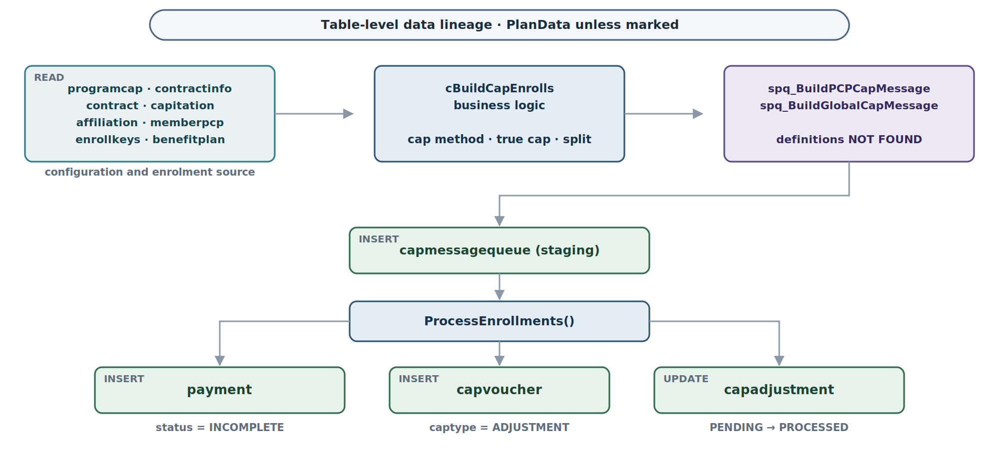
Figure 4 — Source tables, the staging hop through capmessagequeue, and the three written outcomes.

12. Configuration and runtime dependencies
Behaviour depends on settings held outside the source: two in session options, one in a global dictionary, one in the QEnterprise database, and three connection aliases.
Setting |  | Source | Read by | Effect
PlanData alias |  | Session / application configuration | cBuildCapEnrolls.New() | Primary connection for all plan-data queries
qenterprise alias |  | Session / application configuration | cBuildCapEnrolls.New() | QEnterprise database, held for cross-database reference
planintegration alias |  | Session / application configuration | cBuildCapEnrolls.New() | Process-state and process-log queries
optCAPBatchSize |  | Session.HasOption(qmxGlobals.QCSOptions.optCAPBatchSize) | BuildCapEnrolls() L211 | Enables enrollment batch splitting
qmxGlobals.dictCAPBatch |  | Global dictionary | BuildCapEnrolls() L213 | Maps the option value to the actual batch size, and therefore decides synchronous versus asynchronous dispatch
QCS_ID_MISC |  | ID generation constant | CNextId.GetStringID() | Queue ID generation type
QCS_ID_PAYABLE |  | ID generation constant | CreatePayment() | Payment ID generation type
Agent registration |  | QEnterprise database | Agent dispatcher | Maps CapProviderRequestMessageType to CapitationCreateAgent
loginfo flag |  | XML message attribute | ProcessMessage() L130 | Controls verbose process-log writing
capitationType |  | XML message — "CAP" or "MGT" | Multiple methods | Selects management versus standard capitation throughout
Batch size is a behavioural switch, not a tuning knob
optCAPBatchSize decides whether the enrollment work executes inside this process or is handed to the queue. The two routes differ in failure isolation, in restart behaviour and in where errors are recorded. A change to this option changes the execution model of the stage. [VERIFIED]

13. Transaction, error and restart behaviour

13.1 Error handling strategy
- Pattern. Try/Catch at every method level, with a rethrow (Throw or Throw ex). Errors propagate to ProcessMessage() and then to CapitationService, which wraps them as ActivityServiceComponentException.
- Logging. Errors are written to the process log through lProcessLog.CreatePLDetailState() with StateStageEnum.ERROR.
- Fallback. WriteAppEvent() writes to the Windows event log when the process log is itself unavailable, so a failure to log does not silently discard the error.
Throw ex rather than Throw appears at several levels. Where it does, the original stack trace is reset at that frame, so the deepest frame visible in a logged exception may be the rethrow site rather than the origin. [VERIFIED]

13.2 Error paths
Scenario |  | Location | Behaviour
Invalid or empty XML message |  | ProcessMessage() L155 | Logs ERROR, returns False
No global payto affiliation, or more than one |  | Build_Global_Enrollments() L608 / L612 | Throws; logged; run fails
No capitated contracts for the global payto |  | Build_Global_Enrollments() L618 | Throws; logged; run fails
No enrollments found |  | ProcessEnrollments() L860 | Logs INFORMATION — not treated as an error. The run completes having done nothing
Cannot query for enrollments |  | ProcessEnrollments() L868 | Logs ERROR
Payment creation failure |  | CreatePayment() | Returns an empty string and throws
Adjustment query or insert failure |  | CalcCapAdjustments() | Throws; the whole run fails, potentially mid-loop
Invalid capfactor fund configuration |  | ValidateCapFactorProgramFunds…() | Logs WARNING only; processing continues to completion
Provider on pay hold |  | CheckPayHolds() | Logs WARNING only; the provider is still built into the enrollment set
An empty result and a successful run are indistinguishable at the boundary
A run that finds no enrollments logs INFORMATION and finishes COMPLETED, exactly as a run that processed thousands. The distinction is recoverable only from the process-log detail, not from the completion status. [VERIFIED — ProcessEnrollments() L860]

13.3 Transaction behaviour
- No explicit transaction scope is present anywhere in cBuildCapEnrolls. Each query class manages its own connection and commits independently.
- The payment INSERT is a single statement. If it fails, processing stops for that batch and the exception propagates.
- Adjustment settlement performs an INSERT into capvoucher followed by an UPDATE of capadjustment, per adjustment, with nothing wrapping the pair. A failure between them leaves a voucher row whose originating adjustment is still PENDING.
- The stored procedures very likely contain internal transactions, but their bodies are not available, so this is [INFERRED] from the volume of work they perform rather than read.
The adjustment loop is the exposure
Because the loop iterates adjustments and commits each statement independently, a failure part way through leaves the set partially settled: some adjustments PROCESSED with vouchers, one with a voucher but still PENDING, and the remainder untouched. The PENDING row is eligible to be selected again by §10.12 on the next run, which would produce a second voucher for the same adjustment. Nothing in the code detects the duplicate. [VERIFIED — cBuildCapEnrolls.vb:2038, :2055]

13.4 Restart and retry
RestartFailedCapRun() at cBuildCapEnrolls.vb:1604 is entered when the inbound message carries restarting = "Y". It does not rebuild the enrollment set. Instead it:
- Queries cSelectRemainingCapmessagesByMessagequeueid (QUERYID 10574) for the count and ID range of messages still sitting in capmessagequeue under the original queue ID.
- If messages remain, re-dispatches them — synchronously through cBatchProcessEnrolls.ProcessMessage() or asynchronously through CapitationBatchProcessProxy, on the same batch-size logic as the normal path.
- If no messages remain, calls cCapPayment.ProcessMessage() to finalise the payment that the failed run had already opened.
CapitationRestartAgent provides an independent agent entry point for the same operation, so a restart can be triggered without replaying the original create message.
Restart resumes the queue, it does not re-derive it
The enrollment set is whatever the original run staged. If the failure was caused by the staged set itself — a stored procedure that selected the wrong members, a cap date that moved unexpectedly under rule 2 — restarting reprocesses the same wrong set. Restart is a recovery mechanism for downstream failures, not for build failures. [INFERRED from RestartFailedCapRun() reading only capmessagequeue]

13.5 Final status
The Finally block of ProcessMessage() always runs, on both the success and failure paths:
- Query cSelectProcessstateFailureCountByDetailId (QUERYID 65223, planintegration) for the count of processstate rows with a non-zero failure count against this detail ID.
- If the count is greater than zero, call UpdatePLDetailNoXml with DetailStageEnum.ERROR.
- Otherwise call UpdatePLDetailNoXml with DetailStageEnum.COMPLETED.
The status is therefore derived from state written by other components — including the asynchronous batch agents — rather than from this method’s own outcome. A run whose own code completed normally is still marked ERROR if a batch it dispatched recorded a failure against the same detail ID. [VERIFIED — cBuildCapEnrolls.vb:183]

14. Cross-repository dependency map
The component is assembled from ten referenced assemblies and reaches two runtime counterparties. Every dependency is an assembly reference except the last two, which are message-queue hops.
Source | Destination | Mechanism | What crosses
QCSI ASC Capitation | Q.QFrame.Extensibility | Assembly reference | QFrameAgent base class
QCSI ASC Capitation | Q.QFrame.Messages | Assembly reference | CapProviderRequestMessageType, CapitationBatchProcessRequestMessageType
QCSI ASC Capitation | Q.QFrame.Utilities | Assembly reference | CUtility.GetObject(), CUtility.GetXml()
QCSI ASC Capitation | Q.Global | Assembly reference | IQcsiSession, Globals, ConnectionManager
QCSI ASC Capitation | Q.DataServices.Payment.DataAccess | Assembly reference | The bulk of the Queries.* classes in §8
QCSI ASC Capitation | Q.DataServices.Provider.DataAccess | Assembly reference | cSelectAffiliationByAffiliationid
QCSI ASC Capitation | Q.DataServices.ProcessLog.DataAccess | Assembly reference | cSelectProcessstateFailureCountByDetailId
QCSI ASC Capitation | Q.ProcessLogWrapper | Assembly reference | cProcessLog
QCSI ASC Capitation | Q.Proxy | Assembly reference | CapitationBatchProcessProxy
QCSI ASC Capitation | Q.Core.Shared | Assembly reference | CNextId, CService
ProcessEnrollments() | CapitationBatchProcessProxy | QFrame proxy to message queue | Serialised cap enrollment batch XML
CapitationBatchProcessAgent | CapitationService.BatchProcessEnrollments() | QFrame agent | Batch processing message — the downstream half of the pipeline

15. Interaction view
Figure 5 shows the same run as Figures 2 and 3, ordered by participant rather than by control flow. It makes visible how much of the work crosses a tier boundary: of the sixteen numbered messages, eleven leave the component.
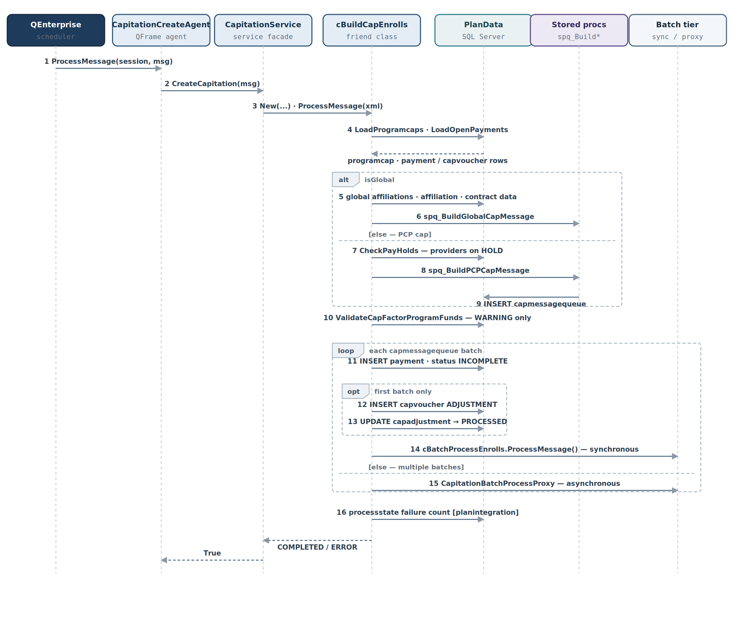
Figure 5 — Interaction sequence from scheduler dispatch to process-log finalisation. Dashed arrows are returns.
Three features of the interaction are worth stating explicitly.
- The stored procedures write to the database, not back to the caller. Message 9 goes from the procedure to PlanData, not back to cBuildCapEnrolls. The component learns what was staged by querying capmessagequeue afterwards, not from a return value.
- The adjustment settlement sits inside the batch loop but executes once. The opt frame is guarded by m_adjustCap, which the method clears on first execution.
- The final status read crosses to a different database. Message 16 runs against planintegration, the only query in the process that does.

16. Evidence matrix
Each material finding, with the evidence that supports it and the confidence attaching to it.
Finding | File | Class / method | Lines | Evidence | Confidence
cBuildCapEnrolls is a Friend class | cBuildCapEnrolls.vb | cBuildCapEnrolls | 32 | Friend Class cBuildCapEnrolls | VERIFIED
Entry is via CapitationCreateAgent | aCapitationAgents.vb | CapitationCreateAgent | 23–55 | Extends QFrameAgent; constructs CapitationService | VERIFIED
CapitationService delegates to cBuildCapEnrolls | CapitationService.vb | CreateCapitation | 62–95 | New cBuildCapEnrolls(...) followed by .ProcessMessage() | VERIFIED
Two implementation paths exist | BuildCapEnrolls.cs, BuildCapEnrolls.vb | BuildCapEnrolls, cBuildCapEnrolls | various | C# agent with VB wrapper; VB agent with direct class | VERIFIED
The active path is the VB agent chain | aCapitationAgents.vb | CapitationCreateAgent | 23 | The VB path is the only one containing data access and business logic | INFERRED — registration is database-held
spq_BuildPCPCapMessage is called | cBuildCapEnrolls.vb | Build_PCP_Enrollments | 465–487 | Query class wrapping the SP execution | VERIFIED
spq_BuildGlobalCapMessage is called | cBuildCapEnrolls.vb | Build_Global_Enrollments | 657–665 | Query class wrapping the SP execution | VERIFIED
Payment INSERT via query class | cBuildCapEnrolls.vb | CreatePayment | 1290–1296 | cInsertPaymentWithPaymentidProgramidProvidPaytypeEtc.ExecuteQuery() | VERIFIED
Adjustments create capvoucher rows | cBuildCapEnrolls.vb | CalcCapAdjustments | 2038–2046 | cCreatecapvoucherRecord.ExecuteQuery() | VERIFIED
Adjustment INSERT and UPDATE are unguarded | cBuildCapEnrolls.vb | CalcCapAdjustments | 2038, 2055 | Two ExecuteQuery() calls in sequence with no transaction scope | VERIFIED
Three database aliases are used | cBuildCapEnrolls.vb | New() | 98–105 | PlanData, qenterprise, planintegration | VERIFIED
Batch dispatch via proxy | cBuildCapEnrolls.vb | ProcessEnrollments | 835–850 | CapitationBatchProcessProxy.ProcessMessage() | VERIFIED
Inline SQL is concatenated | cBuildCapEnrolls.vb | DistinctRateIDSQL, DistinctEligibleorgIDSQL | 1763–1948 | String concatenation of message values into statement text | VERIFIED
Final status derives from processstate | cBuildCapEnrolls.vb | ProcessMessage finally | 183 | cSelectProcessstateFailureCountByDetailId then UpdatePLDetailNoXml | VERIFIED

17. Unresolved items and repository gaps
Nine items could not be resolved from the available workspace. Each is recorded with what was searched for and what the absence means for the trace.
# | Item | Detail and consequence
1 | Stored-procedure definitions | spq_BuildPCPCapMessage and spq_BuildGlobalCapMessage, with their advance-recon variants, are not present. These procedures populate capmessagequeue and therefore own the enrollment eligibility rule. Likely held in a database project or deployment artefact outside this workspace. This is the largest gap in the trace.
2 | Query class implementations | All Queries.* classes — for example cRetrieveProgramCapsByProgidCapTypeEffdateTermdate — are referenced through compiled assemblies. Their SQL is compiled into Q.DataServices.Payment.DataAccess.dll and relatives, and is not visible as source. The SQL in §10 is taken from the generated query-class definitions.
3 | QFrame agent registration | The mapping that binds CapitationCreateAgent to CapProviderRequestMessageType is database-driven and not in the repository. This is why §2.2 marks the active path INFERRED rather than VERIFIED.
4 | CapitationBatchProcessProxy | The proxy class lives in the Q.Proxy assembly and is not available as source. It dispatches to the QFrame message queue for asynchronous processing; the dispatch semantics — ordering, retry, poison handling — cannot be confirmed.
5 | Database project | components/QNXT/Processes/Capitation/ contains only Doco and Designs/. No SQL project or stored-procedure source was found anywhere in the tree.
6 | cCapPayment class | Referenced by RestartFailedCapRun() to finalise a payment when no messages remain. Located at cCapPayment.vb but not analysed in detail, so the finalisation semantics of the restart path are not fully traced.
7 | CapDataWrapper class | Used by the newer BuildCapEnrolls.vb wrapper as oCapMessage. Not analysed. Relevant only to the legacy path.
8 | Connection string resolution | The aliases PlanData, qenterprise and planintegration resolve to server and database names through QFrame session configuration held outside the repository. Which physical databases a given environment binds them to cannot be confirmed here.
9 | Dynamic SQL construction | DistinctRateIDSQL() and DistinctEligibleorgIDSQL() build SQL by string concatenation with message values. The values originate in internally generated messages rather than from user input, so no injection path is demonstrated; the construction itself is recorded as an observation. See §10.18.

18. Closing narrative
cBuildCapEnrolls is the capitation enrollment builder within the QNXT healthcare claims management system, and the first substantive stage of the advanced capitation pipeline.

18.1 Trigger
The QEnterprise scheduler dispatches a CapProviderRequestMessageType XML message to CapitationCreateAgent, a QFrame message-queue consumer registered in the QEnterprise database. There is no other way in.

18.2 Initialisation
The agent creates a CapitationService, which clones the session, deserialises the message and instantiates cBuildCapEnrolls. The constructor establishes three database sessions: PlanData for plan data, qenterprise for queue and integration data, and planintegration for process-state tracking.

18.3 Processing
ProcessMessage() decides whether this is a new run or a restart of a failed one. For a new run, BuildCapEnrolls() orchestrates the following.
- Program cap configuration is loaded from programcap to establish the cap method, the split-month settings, and whether true cap — full-month enrollment capture — is enabled. Where it is, the cap date moves to the end of the month.
- Existing open payments are loaded for reconciliation.
- The process branches on global versus PCP capitation. A global run finds the single global payto affiliation, validates its contracts and capitation configuration, and executes spq_BuildGlobalCapMessage to populate capmessagequeue. A PCP run checks for providers on pay hold — warning but continuing — generates a queue ID, and executes spq_BuildPCPCapMessage against the same staging table.
- Fund validation looks for capfactors pointing at funds the program does not hold, and logs warnings.
- Enrollment processing iterates the batched enrollment records. Each batch opens a payment row at status INCOMPLETE. The first batch additionally settles pending monetary adjustments by creating capvoucher rows and marking the capadjustment rows PROCESSED. Small batches are processed synchronously by cBatchProcessEnrolls; larger sets are dispatched sub-batch by sub-batch through CapitationBatchProcessProxy onto the QFrame queue.

18.4 Completion
The Finally block queries processstate for a failure count and marks the process-log detail COMPLETED or ERROR. Because the count is written by other components, including the asynchronous batch agents, the status reflects the wider run rather than this method alone.

18.5 What the process leaves behind
Table | Operation | State written
payment | INSERT | One row per batch at status = INCOMPLETE, carrying the originating XML message in capmessage
capvoucher | INSERT | One row per settled adjustment at captype = ADJUSTMENT, method = CAPTERMS
capadjustment | UPDATE | PENDING to PROCESSED, stamped with the process date and the new payment ID
capmessagequeue | INSERT | Staged enrollment messages, written inside the stored procedures

18.6 Downstream
The dispatched batch messages are consumed by CapitationBatchProcessAgent, which drives the remaining capitation steps: selecting affiliations, allocating amounts, allocating funds, adjusting funds and storing cap vouchers against the payment this process opened. The payment row created here at INCOMPLETE is the row that subsequently moves through the payment lifecycle traced in CEF-CAP-VOID-002.

End of document. CEF-CAP-ENRL-001 rev 0.1 — DRAFT. MSS / Gainwell Confidential.

