Jeremy Elder

Tommy Murphy

David Diaz

Fatimah Alowa

Groovy Music

Original ER Diagram

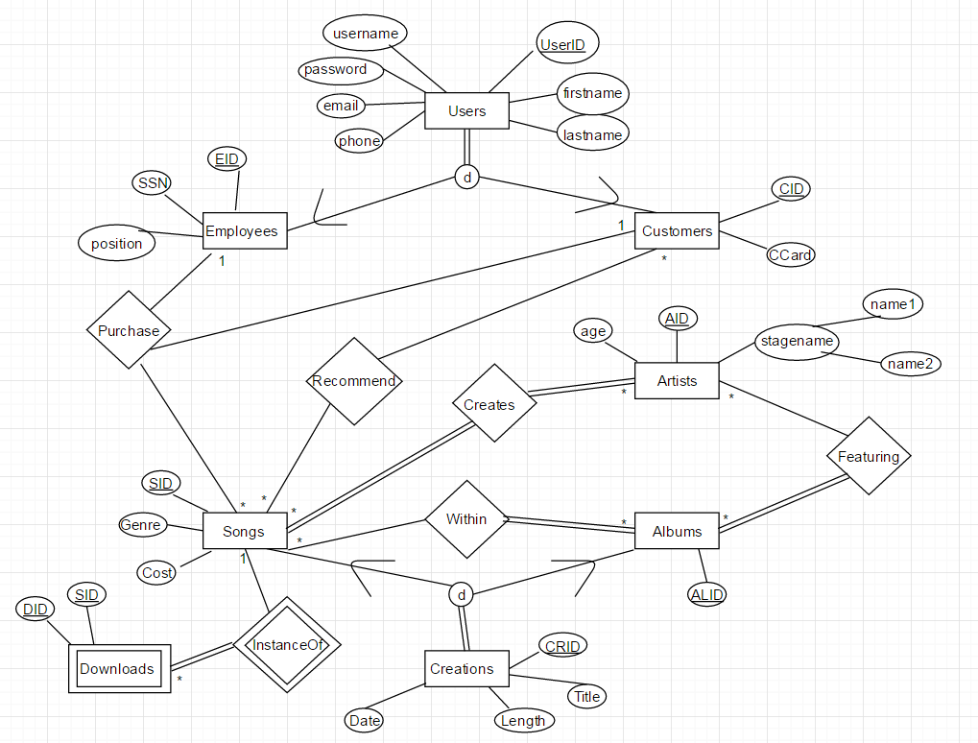

Changes Reasoning

* Ultimately we changed the concept from purchasing songs and holding robust song-related information to playing songs in a playlist and buying merchandise
* None of our members had significant web/PHP experience; the original ER would have added complexity that may not be feasible at this time
* Through normalization processes as well as integrating our newer concept, we concluded that many relationships and entities were unneeded
  + Examples: No employees need to oversee the site (all automated); artists and albums could just be attributes of songs for the purpose of our website

Updated ER Diagram

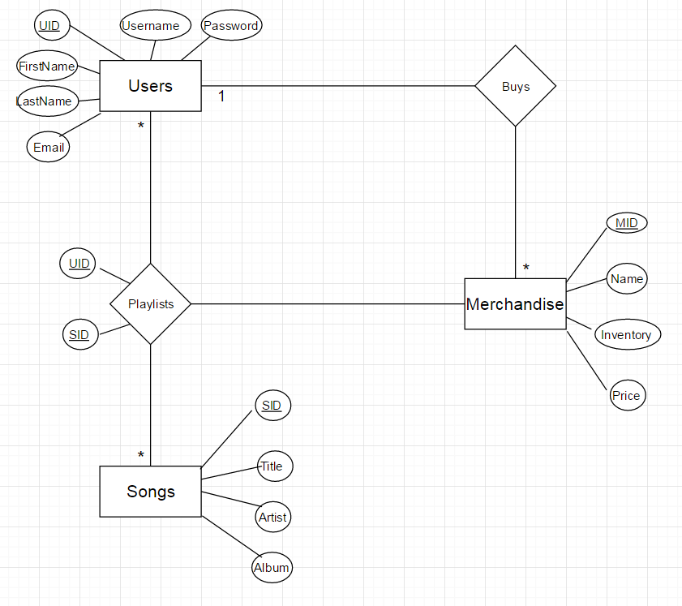

Team Members Contributions

* Jeremy: Brainstorming, ER Diagram (Before/After), Normalization, Topic Presentation, Demo Powerpoint
* David: Brainstorming, Coding (PHP/SQL via XAMPP), Topic Presentation
* Tommy: Brainstorming, Front-end design (Bootstrap/HTML), back-end coding (PHP), Coding (PHP/SQL via XAMPP), Normalization, Topic Presentation, readme, GitHub set-up, SQL Queries
  + Coded front-end and back-end of web application
  + Designed and coded the following pages in conjunction with Bootstrap framework and PHP:
    - Connection.php, editUser.php, home.php, index.php, login.php, loginprocess.php, removeSong.php, signup.php, songlist.php, songlistProcess.php, userPlaylist.php, users.php
  + Wrote vast majority of SQL queries and initialized/set-up mySQL database with the use of XAMPP
* Fatimah: Brainstorming, Topic Presentation

Teamwork Contributions:

* Communicated via Slack and mobile group chat
* Utilized GitHub to collaborate on web application design and coding
* Met when project began to get a feel for the architecture of the project and the ER diagram (Tommy, Fatimah, Jeremy, David)
* Group meeting to research Topic Presentation and complete presentation (Tommy, Fatimah)
* Met again to complete Topic Presentation (Tommy, Fatimah, David, Jeremy)
* Met to rehearse the Topic Presentation (Tommy, Fatimah, David, Jeremy)
* Met to rehearse Demo and Demo presentation (Tommy, Fatimah, David, Jeremy)

GitHub/Coding Contributions

GitHub link: <https://github.com/temurph1/ser322-FinalProject-Music>

Commits: <https://github.com/temurph1/ser322-FinalProject-Music/commits/master>

Contributions: <https://github.com/temurph1/ser322-FinalProject-Music/graphs/contributors>