# 1.5 Motion System

Duty of this system is maintaining mechanical rigidity of the driving system. Construction of this system contain two subsystems which are, wheels Subsystem and motor subsystem.

1. Wheels Subsystem which is responsible for transferring power from motor shaft to road.

2. Motors Subsystem which is responsible for converting electrical power to mechanical power.

## 1.5.1 Wheels Subsystem

As the previous suggestion in CDR, 2+1 combination (2 wheel with power and 1 caster ball) is preferred due to easier implementation and control. Although this placement weaker in balance and obstacle handling, importance of easier implementation and control are considered more beneficial.

While choosing wheels, high friction property is considered. Because of this reason, super soft and slick tire are chosen with lighten aluminum rim. Besides, larger width is preferred to increase hanging on the lane.

## 1.5.2 Motors Subsystem

As the previous suggestion in CDR, DC motor selection did not change. The reason of this brushed gearhead DC motors are designed to this usage. Even though 3kg-cm is proposed, because the size and weight of the motors in this specs are not appropriate under 600 RPM condition, besides of this reason, there is no product in the market available to get, and eliminate the over engineering, this calculation turns into 1 kg-cm= torque at the shaft of the motor. RPM condition is set in CDR with equation (1). According to this equation 95.5 RPM is the minimum condition, but to be a strong competitor, 5 times of this value is idealized to goal speed. To handle with this value 100 RPM margin is set, to health of the motors during competition.

After testing the new motors by using basic pulley structure, 1 kg-cm total torque is verified.

# Power Analysis

|  |  |  |  |  |
| --- | --- | --- | --- | --- |
|  | **Current (Avg) A** | **Watt (Avg) W** | **Current (Max) A** | **Watt (Max) W** |
| **Raspberry Pi** | 0.85 | 4.25 | 2.5 | 12.5 |
| **Arduino** | 80 m | 0.4 | 0.2 | 1 |
| **Driver and DC Motors** | 0.4 | 4.8 | 1.1 | 12.12 |
| **ToF sensors** | 19 m | 62.7 m | 40 m | 132 m |
| **Total power consumption** | 1.52 | 9.513 | 3.84 | 25.75 |

The table x shows the consumption under regular case and extreme case. If extreme scenario is considered, full power consumption of Pİ is supplied from powerbank while motors are supplied by Li-Po battery. Also, sensors and Arduino are supplied from Pi because they do not have high demand. Powerbank has two output could supply 2.5A for 5V output, so Pi could supply in the worst case.

Li-Po battery has these specs: 1750 mAh 11.1V 3S 25C, so it can supply 43 ampere constants during discharge although the motors demand 1.1 ampere at stall condition.

All in all, sources are completely enough for consumption even in the worst case conditions.

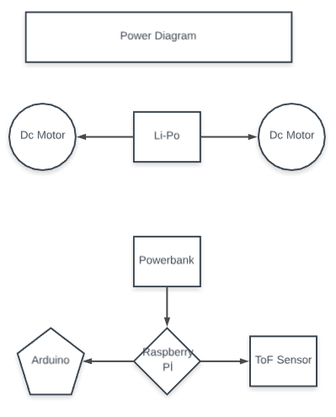

# Cost Analysis

|  |  |
| --- | --- |
| **Component** | **Price ($)** |
| Raspberry Pi | 48 |
| Arduino | 4 |
| Driver and DC Motors | 24.5 |
| ToF sensors | 18 |
| Wheels | 8 |
| Powerbank | 12 |
| Li-Po Battery | 24 |
| Chassis | 15 |
| Camera | 23 |
| LED headlight/LED | 0.2 |
| Total Project | 176.7 |

As seen in this table, budget is optimized with some changes such as Arduino Uno is replaced with its nano version, and upper layer of the chassis is designed thinner plexi glass. However, critical components, such as motors, ToF sensors and wheels, are selected for their performance. Powerbank selection is based on its size. The chosen one is the smallest powerbank which can give enough output to supply Raspberry Pi under full load. Camera and Raspberry pi have no other option in this project. Li-Po battery selection is based on duration and output voltage. 12V output is required during motor drive, and long term is required for demonstrations. Therefore, 1750 mAh 11.1V 3S battery is selected.