İclal SATICI-2094407 EE407 Halil TEMURTAŞ-2094522 22/10/2018

HW 1

1. b)

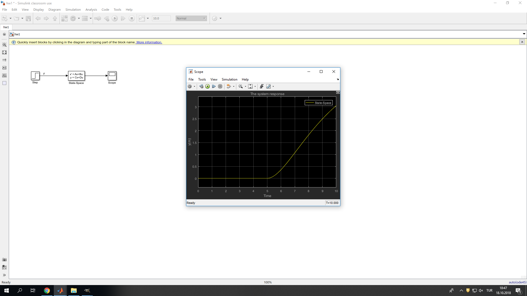

c) i)



Figure 1: The system response for MSD when m = 1kg, b = 0.2Ns/m, k = 1N/m

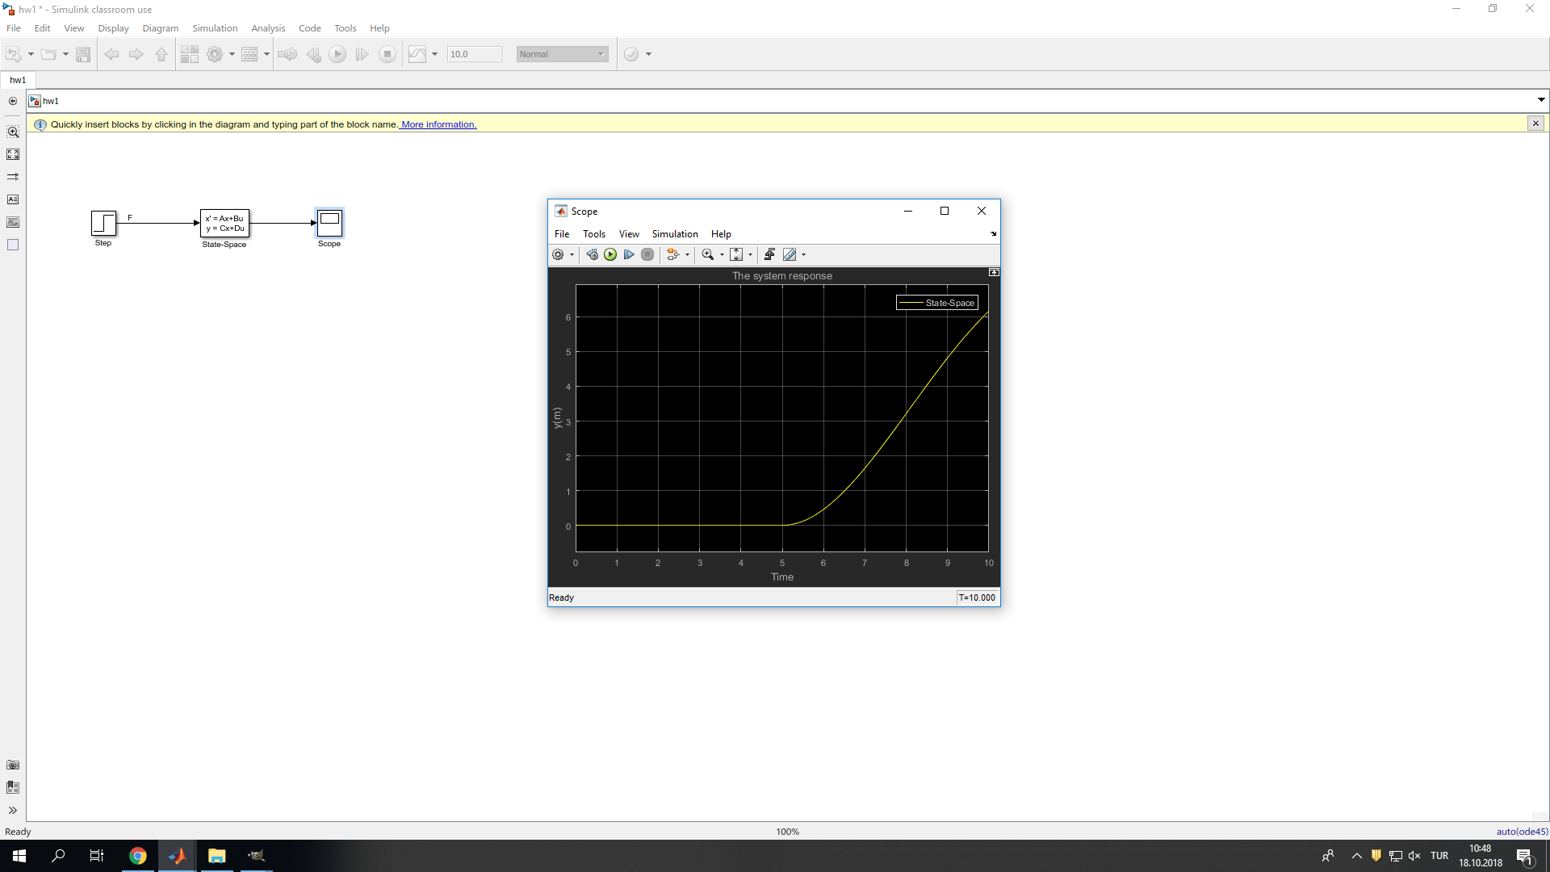

Figure 2: The system response for MSD when m = 1kg, b = 0.2Ns/m, k = 0.2N/m

The spring force is proportional to the displacement of the mass,x with the direction of opposite to the F. Therefore, when the spring constant increased, the displacement of x is decreased. The figures are consistent with these, Figure 2 has small k value and it reaches far than Figure 1.

ii)



Figure 3: The system response for MSD when m = 1kg, b = 0.2Ns/m, k = 1N/m

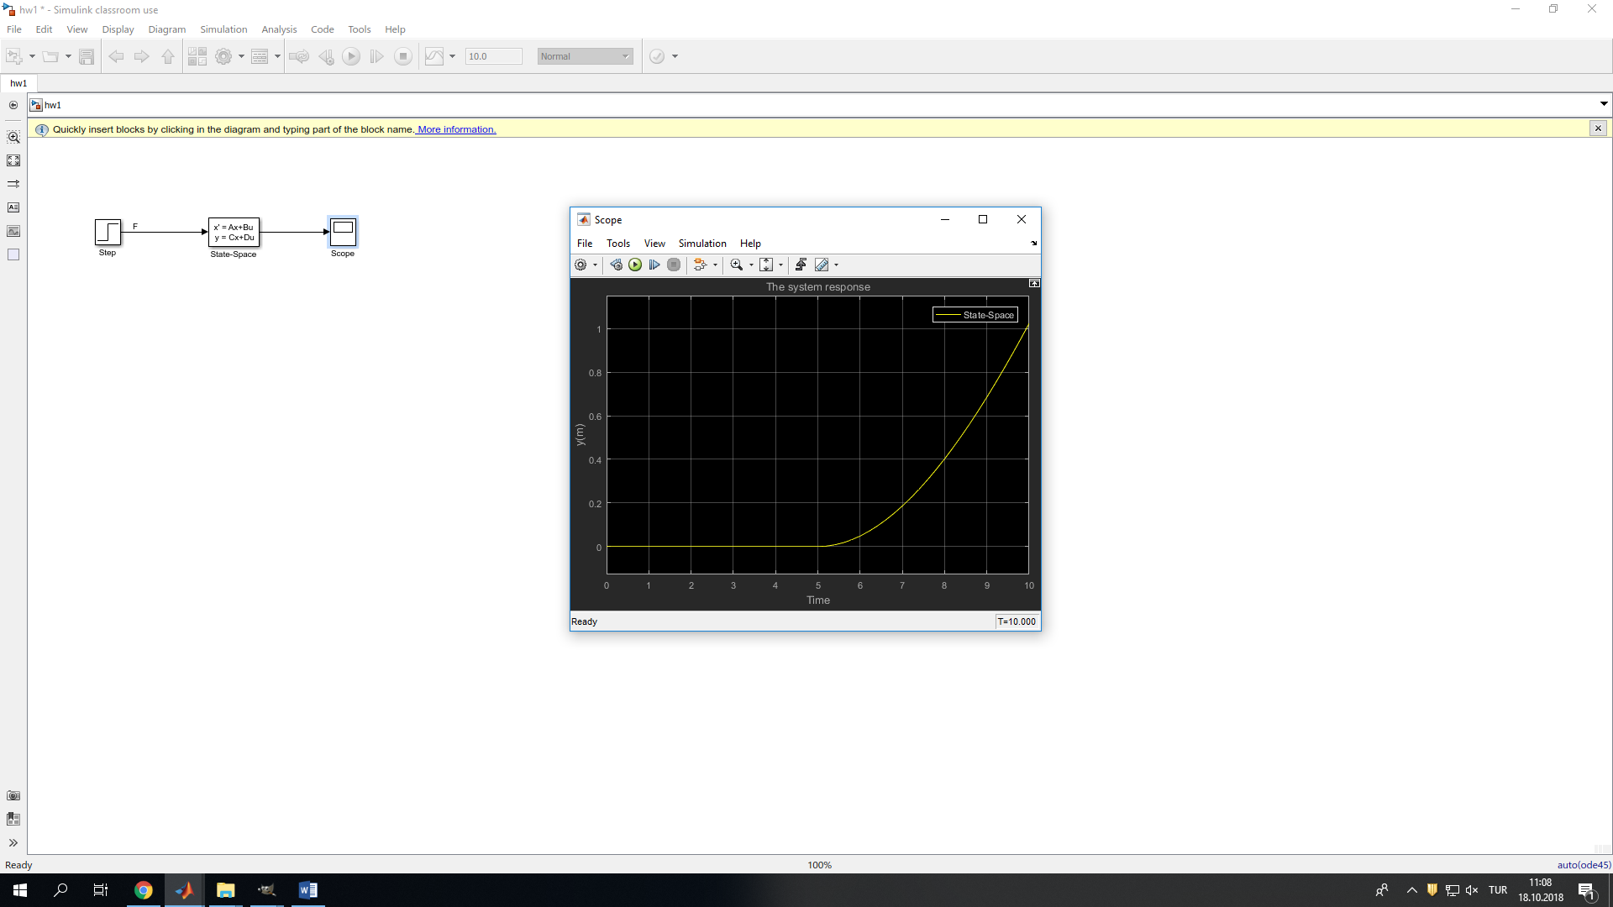

Figure 4: The system response for MSD when m = 10kg, b = 0.2Ns/m, k = 1N/m

It is known that $F_{net}=ma=m\ddot{x}$, then mass and acceleration that is related to position are oppositely proportional, so when mass increased, the output will be decreased. The Figure 3 and 4 are expected.

iii)



Figure 5: The system response for MSD when m = 1kg, b = 0.2Ns/m, k = 1N/m

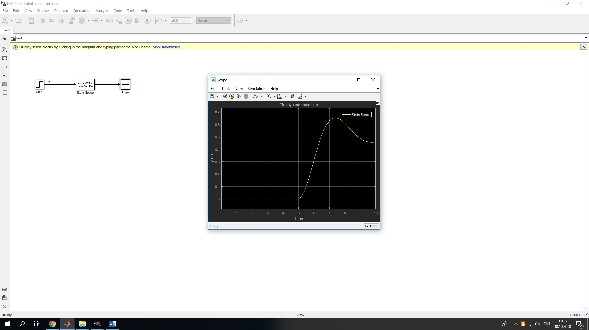

Figure 6: The system response for MSD when m = 1kg, b = 2Ns/m, k = 1N/m

The viscous damping force is proportional to the velocity of the mass, v = $\hat{x}$ with the direction of opposite to the F. In this case, firstly this opposite direction is not so much because of the velocity is small and after some point this velocity value increases and effect the system with more opposite force. Therefore, Figure 5 and 6 are expected.