1. Pad´e Approximation
2. m=2 , n=2 , m+n+1=5

e-s=1-s+2s22!-3s33!+4s44!a0+a1s+a2s21+b1s+b2s2

(1+b1s+b2s2)(1-s+2s22!-3s33!+4s44!)+HOT(greater than s2)a0+a1s+a2s2

a0=1, a1=b1-, a2=b2-b1+22!, 0=-b2 +b122!-33!, 0=b222!-b133!-44!

By solving them:

a0=1, a1=-2, a2=212, b1=2,  b2=212

     b) m=0 , n=1 , m+n+1=2

e-s=1es=11+sa01+b1s

a0=1, b1=

m=0 , n=2 , m+n+1=3

e-s=1es=11+s+2s22!a01+b1s+b2s2

a0=1, b1= b2=22

    c)

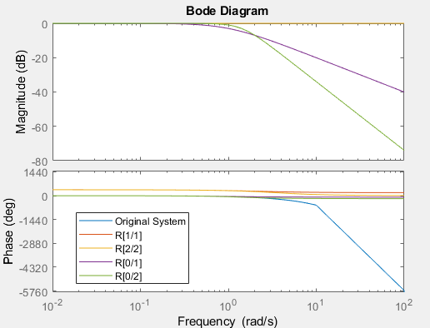

Figure 1: The magnitude and phase responses of e-s and corresponding R[0/1], R[0/2], R[1/1] and R[2/2]

The magnitude response of .e-s is always 1,R[1/1] and R[2/2] magnitude response are also exactly 1 and fit the original system. When m=n, the all pass system do not change.  The result is expected since smaller m and n values represent more approximation. R[1/1] and R[2/2] have more closer phase response to the original system than  R[0/1] and R[0/2].

From the figure 1, we understood that for small frequency, the approximation is valid. However, it became invalid for high frequency.

d)

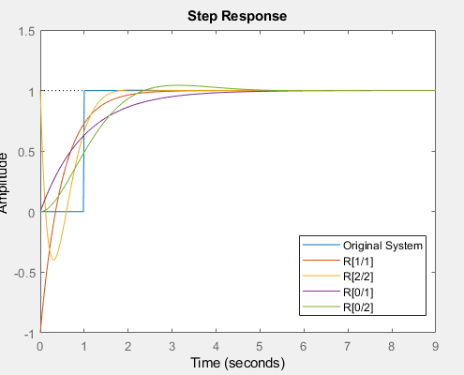

Figure 2: The step responses of e-s and corresponding R[0/1], R[0/2], R[1/1] and R[2/2]

The justification hold from the previous step. The systems with non-minimum phase zeros which are R[1/1] and R[2/2] behave oscillatory behaviour around t = 0, then fit the corresponding data. The start point for non-minimum phase zeros do not fit with the original system.

2. Model-Based Design Methods

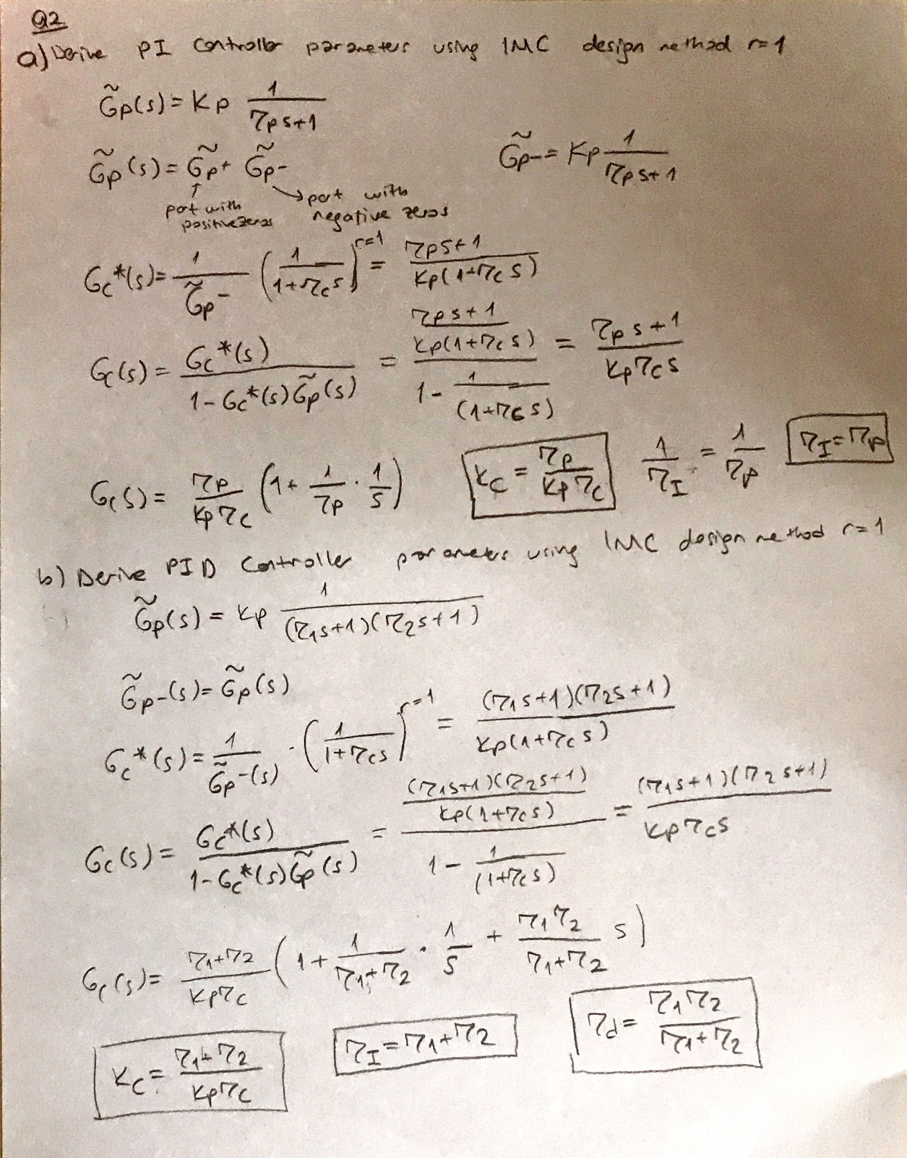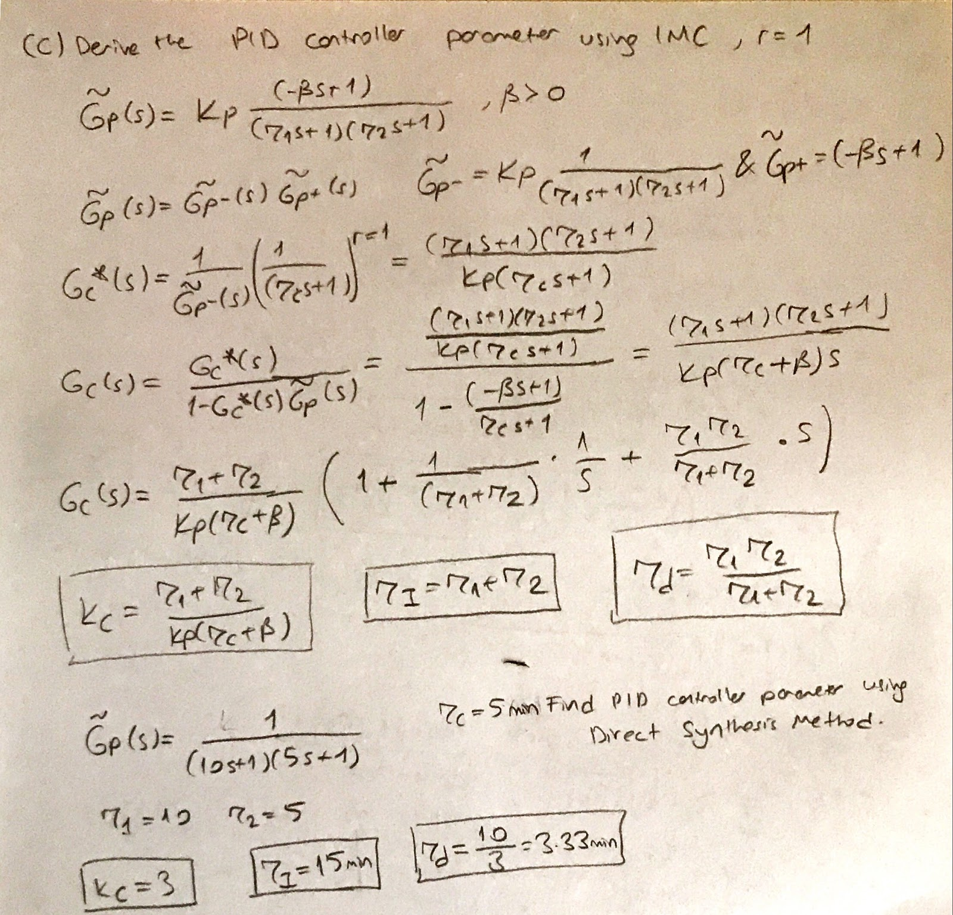

d)

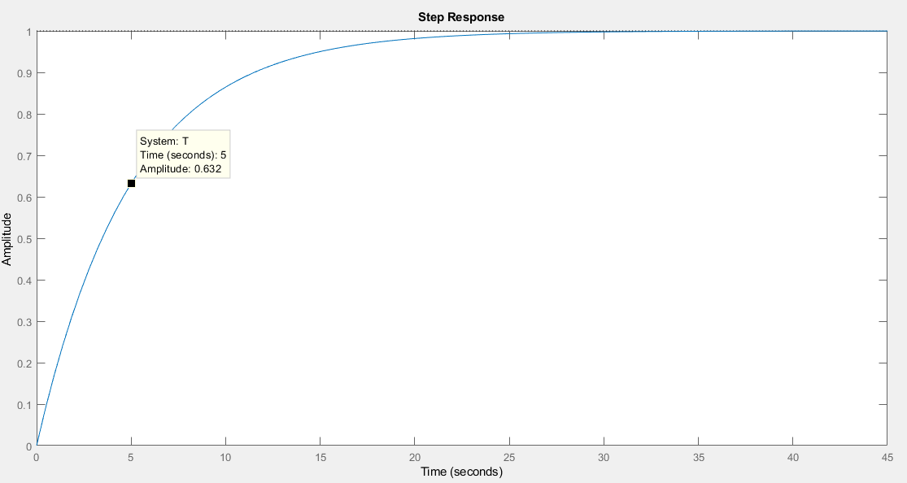

Figure 3: The step response of  the system in Part c

The time is in minute , not in second. I write the coefficient according to minute.

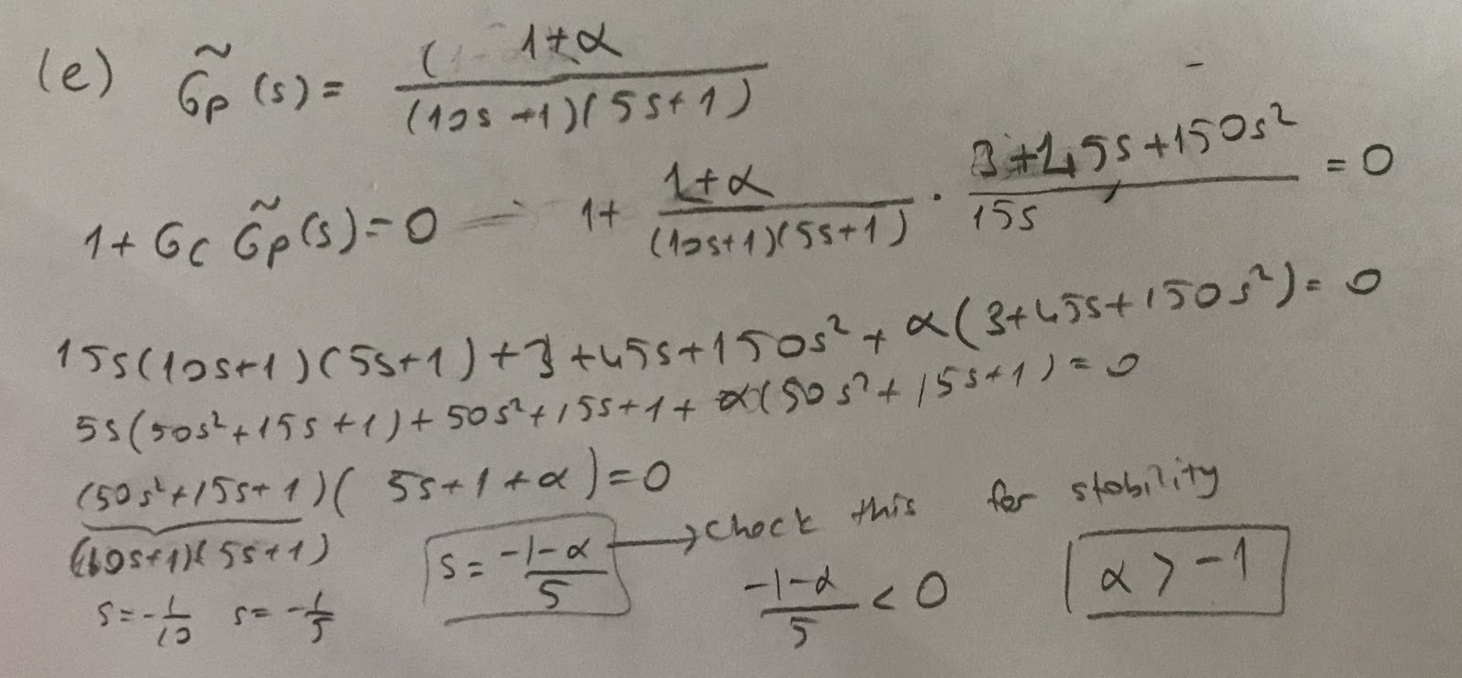

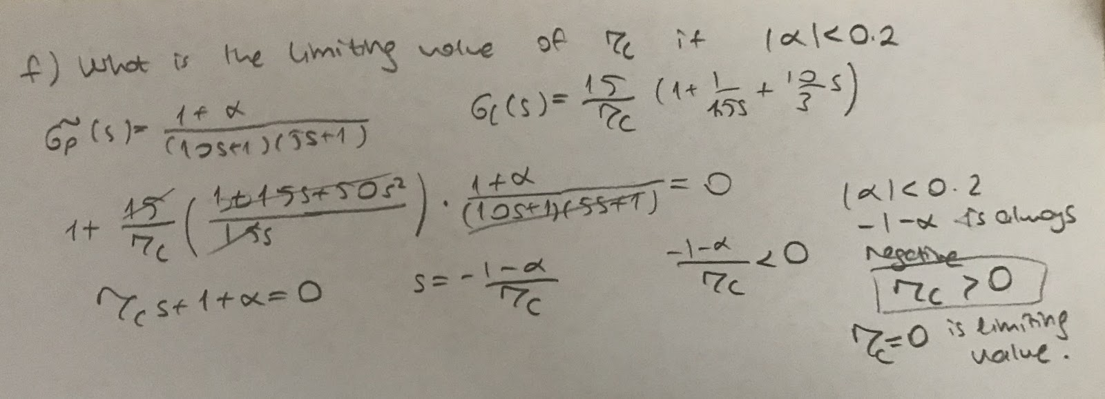

3. Distributed Parameter Systems

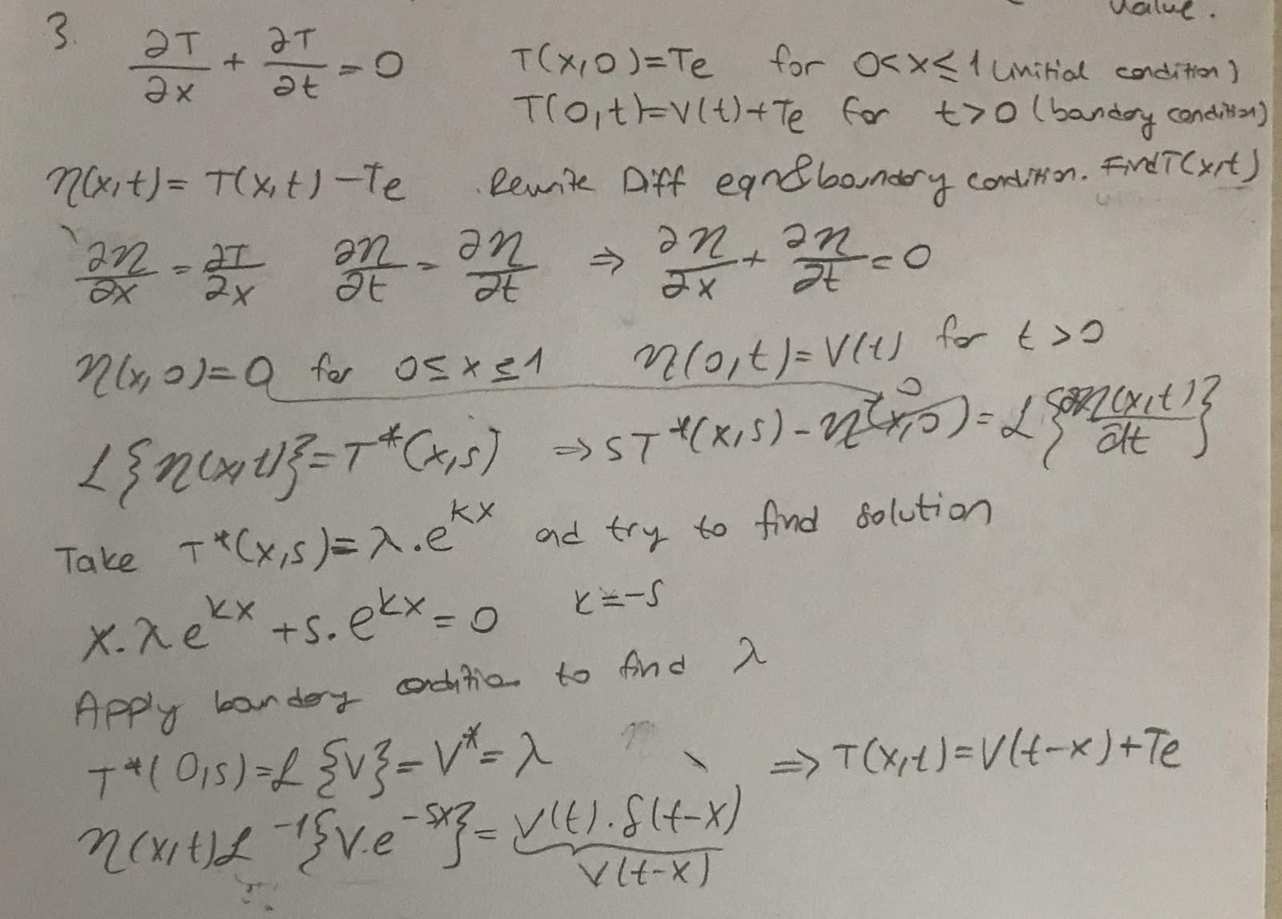

4. Feedforward Control

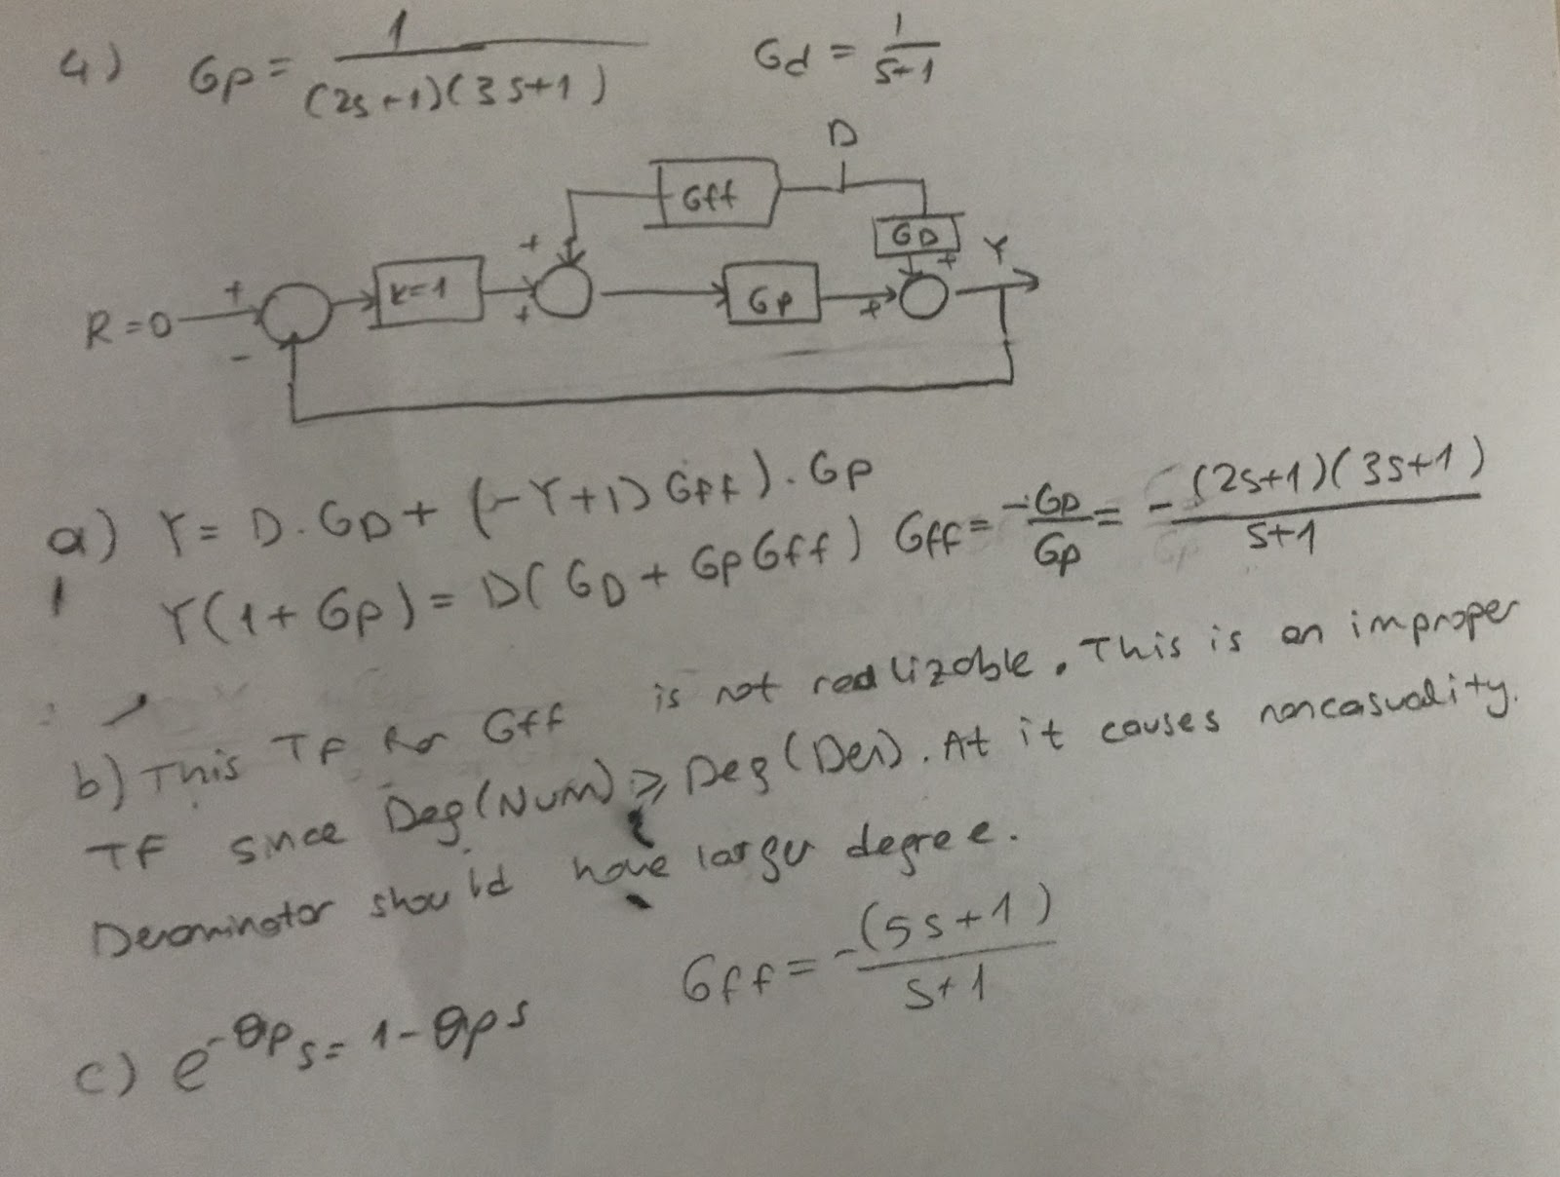

d)  bu partta biraktim.