# EIS & Motor Indicators

The display options in the Figure 1 were decided to be used as a main display and replacement for the indicators.

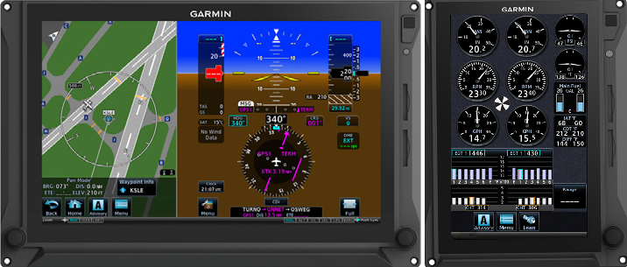

Figure 1 GDU 1060 and GDU 700P

The wanted indicators from TAI at the begging of the project can be seen below.

|  |  |  |  |
| --- | --- | --- | --- |
| **Göstergeler** |  |  | **#** |
| Motor & Yakıt Göstergeleri | EIS | Fuel Qty (Main, Aux) | 1 |
| Trim Göstergesi |  |  | 1 |
| Flap Göstergesi |  |  | 1 |
| Yakıt Seviyesi Göstergesi | EIS | Fuel Flow | 1 |
| Yağ Basınç Göstergesi | EIS | Oil Pressure | 1 |
| Yağ Sıcaklık Göstergesi | EIS | Oil Temperature | 1 |
| Yakıt Basınç Göstergesi | EIS | Fuel Pressure | 1 |
| Manifold Basınç Göstergesi (EGT) | EIS | (CHT, EGT) | 1 |
| Cylinder Head Temperature (CHT) Göstergesi | EIS | (CHT, EGT) | 1 |
| Elektrik Göstergesi | EIS | Amps/Volts | 1 |
| Durum Göstergesi |  |  | 1 |
| Yedek Hız İrtifa Göstergesi | PFD? | Display Backup | 1 |
| Takometre | EIS | RPM/Tach | 1 |
| Uyarı/İkaz Paneli |  |  | 1 |
| A coolant temperature Göstergesi | EIS | Intercooler | 1 |

The second column of above table represent what display option of G500 TXI replace the corresponding indicator and the third column specify the job.

The table below specifies the system functions of three display options of G500 TXI.

|  |  |  |
| --- | --- | --- |
| **PFD** | **MFD** | **EIS** |
| * Attitude * Airspeed * Altitude * Vertical Speed * Turn Coordinator * HSI * HSI Map * Clock * Lateral and Vertical * Deviation Indicators * Datalink Weather * Display * Radar Altimeter * Autopilot * Annunciations * Flight Director * Synthetic Vision * Flight Path Marker * System Advisories * Safety Monitors * GPS NAV Status * Display Backup * Terrain Avoidance | * Navigation Map * Traffic * Terrain * Charts * Flight Plan * Weather * Waypoint Information * Music Services * Terrain Avoidance * Engine Data * System Advisories * Video | * Fuel Qty (Main, Aux) * RPM/Tach * Propeller Sync Display * Manifold Pressure * Oil Pressure * Oil Temperature * Fuel Flow * Fuel Pressure * Fuel Calculations * Cylinder Operating * Temperatures * (CHT, EGT) * TIT * Lean Assist Mode * Carburetor Air * Temperature * Intercooler * Temperatures * (IAT, CDT, Difference) * Amps/Volts * User Selectable Fields * User Adjustable * Advisories |

The following are mentioned in the manuals of ROTAX 912is as internal sensors. However, it is not certain that these sensors can be used for EIS purposes.

1. Fuel Pressure Sensor // A fuel pressure sensor is required to monitor the operating limits of the engine.
2. Low Fuel Sensor
3. Temperature Sensor // For cooling Unit
4. Engine control unit (ECU) Sensors
5. Ambient air, pressure, temperature sensor (AAPTS)

The table below specifies the components for EIS. While the GEA 110 is directly a subsystem of TXI, other components are basically sensors to be connected to the engine.

|  |  |  |
| --- | --- | --- |
| **Components for EIS** |  | **Description** |
| GEA 110 Engine Interface |  | The GEA 110 is a remote mount engine interfacing and monitoring module used for gathering sensor input  parameters from the engine and processing the signals for the G500/G600 TXi system.  **The GEA 110 communicates with the G500/G600 TXi using an RS-485 digital**  **interface.** |
| Engine Annunciator |  | An engine annunciator will only be installed if the EIS display is not installed within 8 inches of the center  of the pilot’s field-of-view. |
| Carburetor Temperature Probe |  | The carburetor temperature probe is a Type-K thermocouple (Chromel and Alumel) probe. |
| Oil Temperature Probe |  | The oil temperature probe is a Type-K thermocouple (Chromel and Alumel) probe. |
| Fuel Flow Sensors |  | The fuel flow sensor is incorporated in an aluminum housing that is installed in-line to the engine fuel  supply. |
| Brass Pressure Sensors |  | The brass pressure sensors are small sensors that are supplied with a compatible plug. |
| Stainless Steel Pressure Sensors |  | The stainless pressure sensors are unamplified, high-reliability sensors for harsh installation environments.  There are four sensors available to measure oil, fuel, and manifold pressure. |
| P-Lead RPM Pickup |  | A wire with two parallel resistors in-line connects from each P-lead, at the Magneto or the ignition switch,  to the GEA 110 to sense RPM. |