

ODTÜ Very Light Aircraft Project

Preliminary Design Report

ABSTRACT: This report covers the conceptual and preliminary design and trade-off studies of VLA project.

AUTHOR(s): ODTÜ VLA TEAM

APPROVER(s): [Manager]

AUTHORIZER(s): [Status]

PUBLISH DATE: [Publish Date]

**This page intentionally left blank.**

# **APPROVAL & AUTHORIZATION of CHAPTER 1**

|  |  |  |  |
| --- | --- | --- | --- |
| **Responsible** | **Name-Title** | **Date** | **Sign** |
| Author | ODTÜ VLA TEAM |  |  |
| Contributor | Ömer Tunahan Liman |  |  |
| Contributor | Veysel Burhan |  |  |
| Contributor | Rüştü Görkem Yılmaz |  |  |
| Contributor | Mustafa Özdemir |  |  |
| Contributor | Kaan Yenipazar |  |  |
| Contributor | Berk Sarıkaya |  |  |
| Contributor | Murat Alper Sayıcı |  |  |
| Contributor | Fatma Çağla Dağ |  |  |
| Contributor | Mert Ali Andırın |  |  |
| Contributor | Özgür Zafer |  |  |
| Contributor | Nilay Kırcı |  |  |
| Contributor | Sima Demir |  |  |
| Contributor | Eren Dönertaş |  |  |
| Contributor | Alaaddin Furkan Uzunkaya |  |  |
| Contributor | Murat Yıldırım |  |  |
| Contributor | Hüseyin Coskun |  |  |
| Contributor | Onur Ali Batmaz |  |  |
| Contributor | Eren Çalış |  |  |
| Contributor | Selçuk Güzel |  |  |
| Contributor | Alper Faruk Yiğit |  |  |
| Contributor | Güngör Yurttav |  |  |
| Contributor | Sefa Tak |  |  |
| Contributor | Metehan Akinci |  |  |
| Contributor | Uğur Polat |  |  |
| Contributor | Hakan Doğan |  |  |
| Contributor | Utku Zengin |  |  |
| Contributor | Furkan Kaynar |  |  |
| Contributor | Cem Semerci |  |  |
| Contributor | Mehmet Şahin |  |  |
| Contributor | Mert Ozan Taş |  |  |
| Contributor | Haktan Bozkurt |  |  |
| Contributor | Salih Toker |  |  |
| Contributor | Ata Urun |  |  |
| Contributor | Çağlar Sevinç |  |  |
| Contributor | Batur Zafer |  |  |
| Contributor | Hasan Gençarslan |  |  |
| Contributor | Mehmet Kepenekçi |  |  |
| Contributor | Mehmet Canpolat |  |  |
| Contributor | Can Erdoğan |  |  |
| Approver | [Manager] |  |  |
| Authorizer | [Status] |  |  |

Table 1.1‑1 Approval & Authorization

**DOCUMENT ID**

|  |  |
| --- | --- |
| Document No | XXXXXXXXXX |
| Document Title | Preliminary Design Report |
| Project Name | ODTÜ Very Light Aircraft Project |
| Document Type | PP |
| Issue | 1 |
| Version | 1 |
| Keywords | An index term, subject term, subject heading, or descriptor, in information retrieval, is a term that captures the essence of the topic of a document. |
| Baseline | N/A. |
| CDRL/SVİL NO (if have) | N/A. |
| Publish Date | [Publish Date] |
| Abstract | This report covers the conceptual and preliminary design and trade-off studies of VLA project. |
| Applicability | Applicability describes the Model(s) or the Type Version(s) this document is applicable or can/shall/must be applied to. |

Table 1.1‑2 Document Id

# **DOCUMENT ID (PROJECT)**

|  |  |
| --- | --- |
| ATA | N/A. |
| SUB ATA | N/A. |
| System | N/A. |
| Other System (impacted) | N/A. |
| Target Milestone | N/A. |

Table 1.1‑1 Document Id (Project)

ODTÜ – TAI VLA Avionics Selection Proposal

# Required Component by the Project Description

|  |  |  |
| --- | --- | --- |
| 1.2 | AVİYONİK/ELEKTRİK SİSTEMLER |  |
| 1.2.1 | Seyrüsefer Ekipmanı | 1 |
| 1.2.2 | Transponder | 1 |
| 1.2.3 | Hız/İrtifa Göstergesi | 1 |
| 1.2.4 | Motor & Yakıt Kontrol Paneli | 1 |
| 1.2.8 | Magnetic Compass | 1 |
| 1.2.9 | Statik Port | 1 |
| 1.2.10 | Pitot Tube | 1 |
| 1.2.11 | Stall Uyarısı | 1 |
| 1.2.12 | Haberleşme Sistemi |  |
| 1.2.15 | Göstergeler |  |
| 1.2.15.1 | Motor & Yakıt Göstergeleri | 1 |
| 1.2.15.2 | Trim Göstergesi | 1 |
| 1.2.15.3 | Flap Göstergesi | 1 |
| 1.2.15.12 | Yedek Hız İrtifa Göstergesi | 1 |

Table 1 Required Component List from the Project Requirements

# Avionic Equipment Requirements

|  |  |  |  |  |  |  |  |
| --- | --- | --- | --- | --- | --- | --- | --- |
| ODTU-VLA-SRD-575 | Veri gösterim fonksiyonu etkin görev yönetimi için gündüz koşullarında gerekli bilgiyi pilota sağlayacaktır. | TİD 5.4.3 | A | Avionics System | Electrical System | MoC 5 | Avionics System Test Report |
| ODTU-VLA-SRD-577 | Gösterge ve Kontrol sistemi CS-VLA ve SHGM Talimatnamesi’ni sağlayacak sistemlerden oluşacaktır: | TİD 5.4.4.1 | A | Avionics System | Electrical System | MoC 5 | Avionics System Test Report |
| ODTU-VLA-SRD-578 | Seyrüsefer sistemi Prototip Uçak’ın pozisyonu, hızı, yatışı, yunuslaması, irtifası, mutlak irtifası, baş açısı ve benzeri ilgili verileri; işlemek, belirleyebilmek, ilgili sistemlere sağlamak ve göstermek için gerekli fonksiyonları yerine getirecektir. | TİD 5.4.5.1 | A | Avionics System | Electrical System | Moc4 | Avionics System Test Report |
| ODTU-VLA-SRD-579 | Seyrüsefer sistemi CS-VLA ve SHGM Talimatnamesi’ni sağlayacak sistemlerden oluşacaktır. | TİD 5.4.5.2 | A | Avionics System | Electrical System | MoC 5 | Avionics System Test Report |
| ODTU-VLA-SRD-580 | Haberleşme/Tanıma Sistemi Ses Dağıtım, VHF radyo haberleşme, Mode-S Transponder kabiliyetlerine sahip olacak ve bu sistemlerin kontrolünü sağlayacaktır | TİD 5.4.6.1 | A | Avionics System | Electrical System | MoC 5 | Avionics System Test Report |
| ODTU-VLA-SRD-581 | Sesli ikaz üretimi fonksiyonu pilotların her uçuş koşulunda sesli ikazlarını duymasını sağlayacaktır. | TİD 5.4.6.2.1 | A | Avionics System | Electrical System | MoC 5 | Avionics System Test Report |
| ODTU-VLA-SRD-582 | Her pilot dâhili ve harici haberleşme için kulaklık ve mikrofona sahip olacaktır. | TİD 5.4.6.2.2 | A | Avionics System | Electrical System | MoC 5 | Avionics System Test Report |
| ODTU-VLA-SRD-583 | Dâhili Haberleşme Sistemi, Haberleşme ve Radyo Seyrüsefer Sistemi sesleri ve insan sesi iletimi ve kontrolünü sağlayacaktır. | TİD 5.4.6.2.4 | A | Avionics System | Electrical System | MoC 5 | Avionics System Test Report |
| ODTU-VLA-SRD-584 | Dahili haberleşme fonksiyonu ile pilotlar arasında çift yönlü eş-zamanlı haberleşme mümkün olacaktır. | TİD 5.4.6.2.5 | A | Avionics System | Electrical System | MoC 5 | Avionics System Test Report |
| ODTU-VLA-SRD-585 | Hava-hava, hava-yer haberleşmesi bir adet VHF radyo ile sağlanacaktır. | TİD 5.4.6.3.1 | A | Avionics System | Electrical System | MoC 5 | Avionics System Test Report |
| ODTU-VLA-SRD-586 | Uçakta SHGM talimatnamesine göre otomaktik çalışan ve uçağa sabit monte adilmiş (AF tip) 121,5 / 243,0 / 406 Mhz frekanslarında yayın yapabilen bir adet ELT olabilecektir. | TİD 5.4.6.3.2 | A | Avionics System | Electrical System | MoC 5 | Avionics System Test Report |
| ODTU-VLA-SRD-587 | Tanıma Sistemi : Uçakta tanıma sistemi olacaktır. | TİD 5.4.6.4 | A | Avionics System | Electrical System | MoC 5 | Avionics System Test Report |
| ODTU-VLA-SRD-588 | Yedek Uçuş Göstergesi irtifa, hava hızı ve uçağın yatış, yunuslama ve baş pozisyon bilgilerini gösterecektir. | TİD 5.4.7.1.1 | A | Avionics System | Electrical System | MoC 5 | Avionics System Test Report |
| ODTU-VLA-SRD-589 | Yedek Uçuş Göstergesi her bir pilot tarafından kolayca farkedilebilecek ve kullanılabilecek şekilde yerleştirilecektir. | TİD 5.4.7.1.2 | A | Avionics System | Cockpit Design | MoC 5 | Avionics System Test Report |
| ODTU-VLA-SRD-590 | Uçak içerisinde bir adet manyetik pusula bulunacaktır. | TİD 5.4.7.2.1 | A | Avionics System | Cockpit Design | MoC 5 | Avionics System Test Report |

Table 2 Avionic Equipment Requirements

# Selected Avionics,

As choosing the necessary avionic devices for the aircraft, the requirements specified and required components by TAI are considered. The required components can be seen at Table 2 requirements considered in this process can be seen at Table 2.

|  |  |  |  |  |
| --- | --- | --- | --- | --- |
| Avionic | Physical Dimensions | Functionality | On Component  Table | Satisfied Requirement |
| G500 TXI | 10.6” | Primary flight display/multi-function display | 1.2.3, 1.2.8, 1.2.9, 1.2.10, 1.2.11 | ODTU-VLA-SRD-575, 578 |
| EIS TXI (G500) | 7” | EIS | 1.2.4, 1.2.11 | ODTU-VLA-SRD- 577 |
| GTN 750 | 6.9" | GPS/NAV/COMM/MFD | 1.2.1 | ODTU-VLA-SRD-575, 578, 579, 580, 585 |
| GTX 345 | 6.30” | ADB-S & Transponder | 1.2.2 | ODTU-VLA-SRD-580, 587 |
| GMA 345 | 8.09" | Audio Panel | 1.2.12 | ODTU-VLA-SRD-580, 581, 582, 583, 584 |
| G5 | 3.0" | BFI | 1.2.15.12 | ODTU-VLA-SRD-588, 589 |

Table 3 Selected Avionics

## Size/Weight/Power Consumption of the Avionics

|  |  |  |  |  |  |
| --- | --- | --- | --- | --- | --- |
| Avionic | Physical Dimensions | Functionality | Width | Height | Dept |
| G500 TXI | 10.6” | Display | 11.4” | 7.25” | 3” |
| EIS TXI (G500) | 7” | EIS | 5.5” | 7.25” | 3” |
| GTN 750 | 6.9" | GPS/NAV/COMM/MFD | 6.25"  (159 mm) | 6.00"  (152 mm) | 11.25  (286 mm) |
| GTX 345 | 6.30” | ADS-B & Transponder | 6.30”  (160 mm) | 1.65”  (42 m) | 10.07”  (256 mm) |
| GMA 345 | 8.09" | Audio Panel | 6.30"  (160 mm) | 1.33"  (34 mm) | 8.09"  (205 mm) |
| G5 | 3.0" | BFI | 3.4”  (86.4 mm) | 3.6"  (91.4 mm) | 3.0”  (76.2 mm) |

Table 4 Dimensional Properties of the Selected Avionics

|  |  |  |  |  |
| --- | --- | --- | --- | --- |
| Avionic | Physical Dimensions | Functionality | Weight | Weight with Additions |
| G500 TXI | 10.6” | Display | 6.49 lbs. | 7.25 lbs. (with integral ADAHRS) |
| EIS TXI (G500) | 7” | EIS | 3.99 lbs. | 4.45 lbs. (with integral ADAHRS) |
| GTN 750 | 6.9" | GPS/NAV/COMM/MFD | 9.3 lbs.  (4.24 kg) |  |
| GTX 345 | 6.30” | ADS-B & Transponder | 3.1 lbs. (1.41 kg) |  |
| GMA 345 | 8.09" | Audio Panel | 1.78 lbs. (807.4 g) |  |
| G5 | 3.0" | BFI | 13.3 oz (377.0 g) |  |

Table 5 Weight Properties of the Selected Avionics

|  |  |  |  |  |
| --- | --- | --- | --- | --- |
| Avionic | Physical Dimensions | Functionality | Typical Current (12 V) | Max Current (12 V) |
| G500 TXI | 10.6” | Display | 7.29 A | 12.45 A |
| EIS TXI (G500) | 7” | EIS | 3 A | 6 A |
| GTN 750 | 6.9" | GPS/NAV/COMM/MFD | 3.45 A | 8.58 A |
| GTX 345 | 6.30” | ADS-B & Transponder | 0.72 A | 1.30 A |
| GMA 345 | 8.09" | Audio Panel | 0.83 A | 2.39 A |
| G5 | 3.0" | BFI | 0.2 A | 0.25 A |
| TOTAL |  | - | 15.49 A | 30.97 A |

Table 6 Power Consumption of the Selected Avionics

## Garmin G500 TXI and EIS TXI

The G500 TXi is a display and sensor system available in three display options:

* GDU 1060 – 10” display
* GDU 700P – 7” portrait display
* GDU 700L – 7” landscape display

Display options can be seen at Figure 1. Depending on system specifics one or more of the following functions may apply:

1. **Primary Flight Display (PFD)** – provides attitude, heading, air data, and navigation information to the pilot
2. **Multi-Function Display (MFD)** – provides pilot awareness of factors that may affect the overall conduct of a flight
3. **Engine Indicating System (EIS)** – provides engine and airframe operating parameters to the pilot

Due to its natural support to EIS, we decided to use G500 TXI over G500. With an integrated EIS support, G500 TXI can simply display any vital engine information on its screen. Considering the display configurations for the 1060 and 700P at Figures 1 and 2 respectively, we decided to use 10” configuration and 7” configuration of the G500 TXI instead of dual 7” option. Using MFD/PFD configuration of 10” configuration and EIS only mode of 7” configuration, pilots can be informed about the plane from two screen.

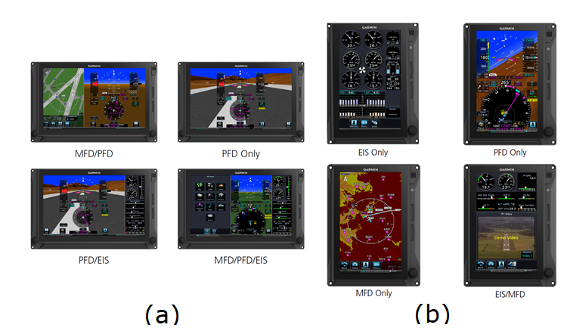

Figure 1 Display Configuration for GDU 1060 (a) and GDU 700P (b)

## Garmin GTN750

GTN 750 from Garmin is a GPS/NAV/COMM multifunction display system which can feature things such as graphical flight planning, terrain mapping, air traffic viewing, detailed geo-referenced charting, satellite weather reporting. With it is 6” tall touchscreen display that allows for easy access menu options and high detailed graphics; it is very preferable over other navigation solutions. Garmin GTN 750 can be seen from Figure 2.

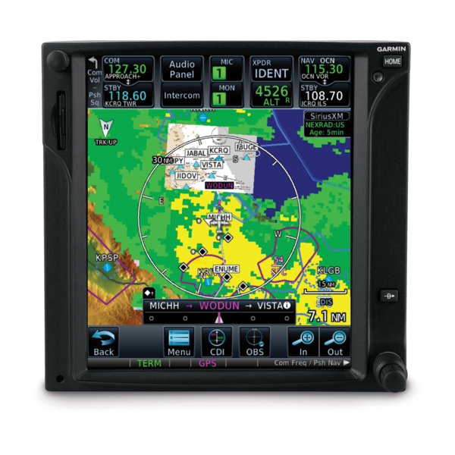

Figure 2 Garmin GTN750

## Garmin GMA345

The GMA 345 Audio Panel provides the traditional audio selector functions of microphone and receiver audio selection. The Audio Panel includes an intercom system (ICS), a marker beacon receiver, a COM clearance recorder, USB power jack, and Bluetooth® audio. Ambient noise from the aircraft radios is reduced by Avionics Squelch (ASQ). When no audio is detected, ASQ processing further reduces the amount of background noise. Intercom squelch threshold adjustments are handled automatically by the system. Garmin GMA 345 can be seen at Figure 3.

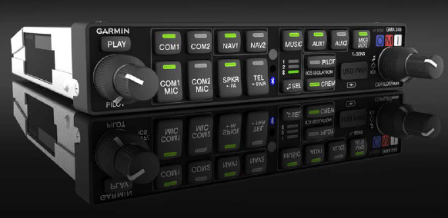

Figure 3 Garmin GMA 345

## Garmin GTX345

GTX 345 from Garmin is a very popular compact panel mount ADB-S transponder solution in aircraft market which is capable of 1090 MHz ADB-S out transmission capability as well as ADB-S in capability. For added situational awareness, the GTX 345 further incorporates a built-in audio output for audible traffic and altitude alerts which can be integrated into existing audio panels. And for even more flexibility, optional remote mount GTX 345 are available for compatibility with the GTN 750 series of touchscreen GPS/Comm/Nav systems. Garmin GTX 345 can be seen at Figure 4.

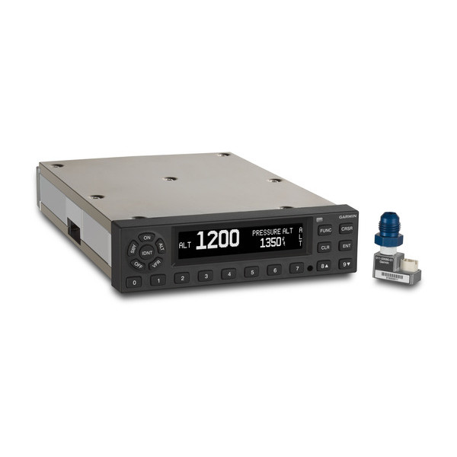

Figure 4 Garmin GTX 335/345

## Garmin G5

Garmin G5 is a cost-effective primary or back-up attitude indicator or turn coordinator is a good alternative for older, vacuum-driven equipment with a modern “glass” solution. G5 is also certificated as a replacement heading indicator/directional gyro or horizontal situation indicator.  Additionally, when paired with select VHF Nav/Comms or GPS navigators (such as GTN 750), G5 can also provide course guidance, as well as distance and groundspeed indications.