## Size/Weight/Power Consumption of the Avionics

|  |  |  |  |  |  |
| --- | --- | --- | --- | --- | --- |
| Avionic | Configuration | Functionality | Width | Height | Dept |
| G500 TXI | 10.6” | Display | 11.4” | 7.25” | 3” |
| EIS TXI (G500) | 7” | EIS | 5.5” | 7.25” | 3” |
| GTN 750 | - | GPS/NAV/COMM/MFD | 6.25"  (159 mm) | 6.00"  (152 mm) | 11.25  (286 mm) |
| GTX 345 | - | ADS-B & Transponder | 6.30”  (160 mm) | 1.65”  (42 m) | 10.07”  (256 mm) |
| GMA 345 | - | Audio Panel | 6.30"  (160 mm) | 1.33"  (34 mm) | 8.09"  (205 mm) |
| G5 | - | BFI | 3.4”  (86.4 mm) | 3.6"  (91.4 mm) | 3.0”  (76.2 mm) |

Table 1 Dimensional Properties of the Avionics

|  |  |  |  |  |
| --- | --- | --- | --- | --- |
| Avionic | Configuration | Functionality | Weight | Weight with Additions |
| G500 TXI | 10.6” | Display | 6.49 lbs. | 7.25 lbs. (with integral ADAHRS) |
| EIS TXI (G500) | 7” | EIS | 3.99 lbs. | 4.45 lbs. (with integral ADAHRS) |
| GTN 750 | - | GPS/NAV/COMM/MFD | 9.3 lbs.  (4.24 kg) |  |
| GTX 345 | - | ADS-B & Transponder | 3.1 lbs. (1.41 kg) |  |
| GMA 345 | - | Audio Panel | 1.78 lbs. (807.4 g) |  |
| G5 | - | BFI | 13.3 oz (377.0 g) |  |

Table 2 Weight Properties of the Avionics

|  |  |  |  |  |
| --- | --- | --- | --- | --- |
| Avionic | Configuration | Functionality | Typical Current (12 V) | Max Current (12 V) |
| G500 TXI | 10.6” | Display | 7.29 A | 12.45 A |
| EIS TXI (G500) | 7” | EIS | 3 A | 6 A |
| GTN 750 | - | GPS/NAV/COMM/MFD | 3.45 A | 8.58 A |
| GTX 345 | - | ADS-B & Transponder | 0.72 A | 1.30 A |
| GMA 345 | - | Audio Panel | 0.83 A | 2.39 A |
| G5 | - | BFI | 0.2 A | 0.25 A |
| TOTAL |  | - | 15.49 A | 30.97 A |

Table 3 Power Consumption of the Avionics

## Power Outputs on the Aircraft

|  |  |  |  |
| --- | --- | --- | --- |
| Power Output | Voltage (Volts) | Current Output (Amperes) | Nominal Capacity at 20°C/68 °F |
| Motor Generator A | 14.2 | 16 | 220 W |
| Motor Generator B | 14.2 | 30 | 420 W |
| Possible Battery Option | 12 | 22 |  |

Table 4 Power Supply Capabilities of the Supply’s

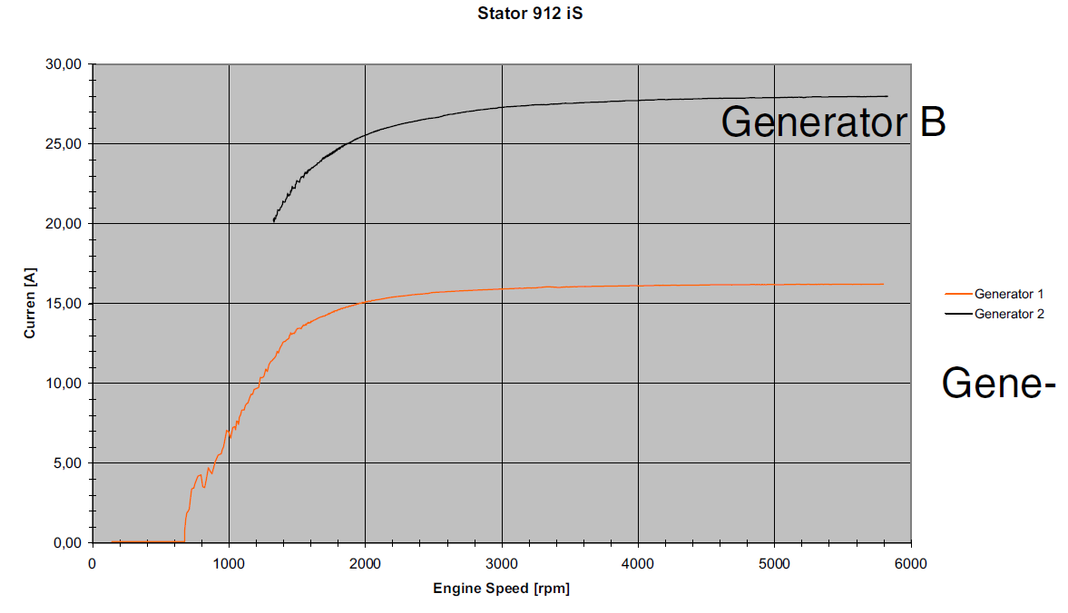

Figure 1 Performance diagram showing engine speed against amps

The internal generator has two isolated coils integrated (individual generators).

During the starting operation, the EMS system is powered by the

battery. With enough speed generator B takes over this function. After

the EMS system check, generator A takes over the supply of the EMS

system (engine), if the switching threshold is exceeded. Generator B is

then used to supply the aircraft instruments and for charging the battery.

While the engine is running, generator B can be used for the board instrumentation.

**If generator A fails,** generator B takes over its functions. The onboard computer and the instruments will be supplied by the battery. The battery will no longer be charged!

**If generator B fails,** the battery will no longer be charged. The engine still runs on generator A and the instruments will be supplied by the battery. The function of the instruments depends on the state of charge of the battery.

The charging of the battery from generator B is not monitored by the

EMS. A possibly necessary load control has to be provided by the aircraft

manufacturer according to the latest requirements.

Generator A can supply the avionic components at their typical current values, and the generator B can supply the avionic components at their maximum current values.

The current requirements of other components are another important concern.

## Battery Usage & Selection

The battery is responsible of the operation of the vital components of the aircraft in case of an emergency. At the times of emergencies, only a fraction of the electrical components will bi supplies with a power. The supplied avionics can be seen at the Table 5 below.

|  |  |  |  |  |
| --- | --- | --- | --- | --- |
| Avionic | Configuration | Functionality | Typical Current (12 V) | Max Current (12 V) |
| EIS TXI (G500) | 7” | EIS | 3 A | 6 A |
| GTX 345 | - | ADS-B & Transponder | 0.72 A | 1.30 A |
| GMA 345 | - | Audio Panel | 0.83 A | 2.39 A |
| G5 | - | BFI | 0.2 A | 0.25 A |
| TOTAL |  | - | 4.75 A | 9.94 A |

Table 5 Power Consumption of Essential Avionics

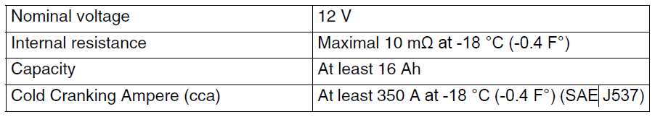

Figure 2 Battery Specification required by the Motor

Considering the minimum capacity requirement from the motor and current consumption of the avionics, a typical 22Ah can be a good choice for safe operation. **This kind of batteries weigh around 10-12 kilograms.**