[Belge başlığı]

[Belge alt konu başlığı]

Halil Temurtaş

[Yıl]

İçindekiler

1. Introduction 2

1.1. General 2

1.2. Applicability 2

1.3. Equipment Covered by This Specification 2

2. Glossary 2

2.1. List of Abbreviations 2

3. Applicability 2

3.1. Reference Documents 2

3.2. Reference Standards 2

4. System Design Information 2

5. System Definition 2

5.1. System Architecture 2

5.2. Allocation of Requirements 2

5.3. General Characteristics of Equipment 2

5.4. Operation/Control and Indicating 2

5.5. Provisions 2

5.6. Installation Concepts 2

5.7. Interface Requirements for the Other Systems and Structures 2

5.8. Additional Definition Information 2

6. System Behavior Definition 2

# Introduction

# General

GTN 750 intro

# Applicability

-

# Equipment Covered by This Specification

This document covers the details of Garmin GTN750.

# Glossary

# List of Abbreviations

-

# Applicability

# Reference Documents

Garmin GTN 750 Pilot’s Guide

Garmin GTN 750 System Maintenance Document

# Reference Standards

CS VLA

TİD

# System Design Information

-

# System Definition

# System Architecture

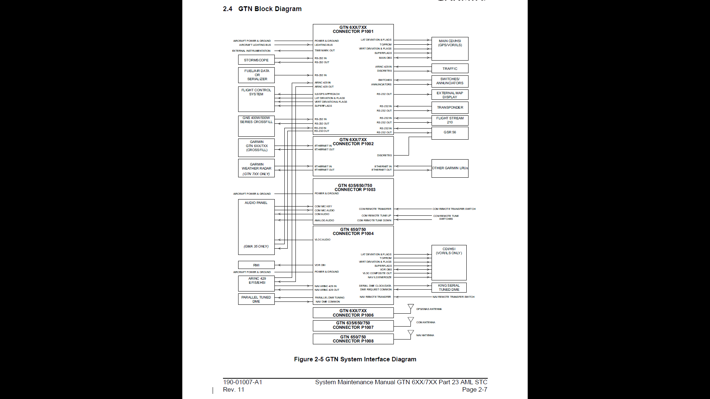

Figure 1 System Interface Diagram

# Allocation of Requirements

# General Characteristics of Equipment

# Operation/Control and Indicating

# Provisions

# Installation Concepts

* See installation manual

# Interface Requirements for the Other Systems and Structures

# Additional Definition Information

# System Behavior Definition