

Avionic and Electrical Architecture Proposal Report

Our intention in this report is to present our ideas for the electrical and avionic architecture of our VLA. This is a draft document and therefore should not be regarded as the final proposal.

On Figure 1, you can observe the crude electrical architecture. Two busses – main and essential- are used on the architecture, typical for such aircraft. The generator relies on the engine to provide power while battery is used to provide a steady and safe source of energy in the case of a discrepancy.

**GMFD** stands for the control panels.

**CVR** is the black box.

The rest is given below.

Figure 2 shows our design for the avionic architecture. The avionic architecture relies mainly on ARINC-429 standard, which is well known to be wide spread in non-military avionic applications. However, the system also employs discrete and Ethernet connections. To denote briefly the individual components on the architecture:

**CV / FDR** stands for “Cockpit Voice / Flight Data Recorder”, is the black box of the aircraft.

**G500** represents Garmin G500 dual screen electronic display.

**BFI** or more commonly BFS is the “Backup Flight System”.

**ADC** is the air data computer.

**INS / GPS** stands for the Inertial Navigation System and the Global Positioning System.

**ELT** is the Emergency Locator Transmitter.

**ICS** is the Intercom equipment.

**V/UHF** is the Very High and Ultra High Frequency Radio.

**Mode-S** is the Mode-S Transponder.

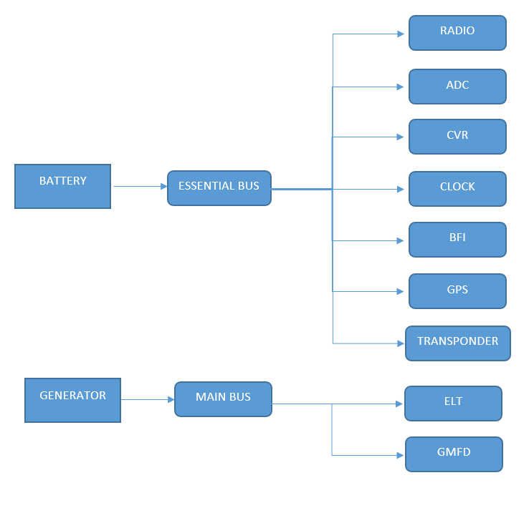

Figure : The crude electrical architecture

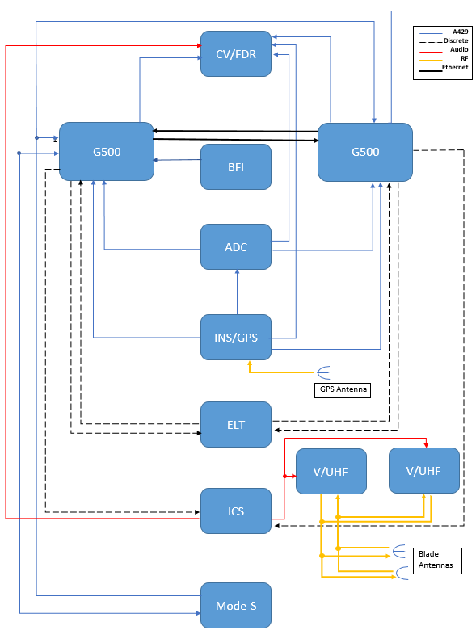

Figure : The proposed avinoic architecture. Notice the legend.