

ODTÜ Very Light Aircraft Project

Preliminary Design Report

ABSTRACT: This report covers the conceptual and preliminary design and trade-off studies of VLA project.

AUTHOR(s): ODTÜ VLA TEAM

APPROVER(s): [Manager]

AUTHORIZER(s): [Status]

PUBLISH DATE: [Publish Date]

**This page intentionally left blank.**

# **APPROVAL & AUTHORIZATION of CHAPTER 1**

|  |  |  |  |
| --- | --- | --- | --- |
| **Responsible** | **Name-Title** | **Date** | **Sign** |
| Author | ODTÜ VLA TEAM |  |  |
| Contributor | Ömer Tunahan Liman |  |  |
| Contributor | Veysel Burhan |  |  |
| Contributor | Rüştü Görkem Yılmaz |  |  |
| Contributor | Mustafa Özdemir |  |  |
| Contributor | Kaan Yenipazar |  |  |
| Contributor | Berk Sarıkaya |  |  |
| Contributor | Murat Alper Sayıcı |  |  |
| Contributor | Fatma Çağla Dağ |  |  |
| Contributor | Mert Ali Andırın |  |  |
| Contributor | Özgür Zafer |  |  |
| Contributor | Nilay Kırcı |  |  |
| Contributor | Sima Demir |  |  |
| Contributor | Eren Dönertaş |  |  |
| Contributor | Alaaddin Furkan Uzunkaya |  |  |
| Contributor | Murat Yıldırım |  |  |
| Contributor | Hüseyin Coskun |  |  |
| Contributor | Onur Ali Batmaz |  |  |
| Contributor | Eren Çalış |  |  |
| Contributor | Selçuk Güzel |  |  |
| Contributor | Alper Faruk Yiğit |  |  |
| Contributor | Güngör Yurttav |  |  |
| Contributor | Sefa Tak |  |  |
| Contributor | Metehan Akinci |  |  |
| Contributor | Uğur Polat |  |  |
| Contributor | Hakan Doğan |  |  |
| Contributor | Utku Zengin |  |  |
| Contributor | Furkan Kaynar |  |  |
| Contributor | Cem Semerci |  |  |
| Contributor | Mehmet Şahin |  |  |
| Contributor | Mert Ozan Taş |  |  |
| Contributor | Haktan Bozkurt |  |  |
| Contributor | Salih Toker |  |  |
| Contributor | Ata Urun |  |  |
| Contributor | Çağlar Sevinç |  |  |
| Contributor | Batur Zafer |  |  |
| Contributor | Hasan Gençarslan |  |  |
| Contributor | Mehmet Kepenekçi |  |  |
| Contributor | Mehmet Canpolat |  |  |
| Contributor | Can Erdoğan |  |  |
| Approver | [Manager] |  |  |
| Authorizer | [Status] |  |  |

Table 1.1‑1 Approval & Authorization

**DOCUMENT ID**

|  |  |
| --- | --- |
| Document No | XXXXXXXXXX |
| Document Title | Preliminary Design Report |
| Project Name | ODTÜ Very Light Aircraft Project |
| Document Type | PP |
| Issue | 1 |
| Version | 1 |
| Keywords | An index term, subject term, subject heading, or descriptor, in information retrieval, is a term that captures the essence of the topic of a document. |
| Baseline | N/A. |
| CDRL/SVİL NO (if have) | N/A. |
| Publish Date | [Publish Date] |
| Abstract | This report covers the conceptual and preliminary design and trade-off studies of VLA project. |
| Applicability | Applicability describes the Model(s) or the Type Version(s) this document is applicable or can/shall/must be applied to. |

Table 1.1‑2 Document Id

# **DOCUMENT ID (PROJECT)**

|  |  |
| --- | --- |
| ATA | N/A. |
| SUB ATA | N/A. |
| System | N/A. |
| Other System (impacted) | N/A. |
| Target Milestone | N/A. |

Table 1.1‑1 Document Id (Project)

# **CONTENTS**

## Avionics, Missions & Electrical System

Our intention in this report is to present our ideas for the electrical and avionic architecture of our VLA

### Avionics and BFI

#### Choosing the Avionics

As choosing the necessary avionic devices for the aircraft, the requirements specified by the TAI is considered. Corresponding requirements considered in this process can be seen at Table 3.5 1. ,

|  |  |  |
| --- | --- | --- |
| ****Requirement**** | ****Definition**** | ****Chosen Avionic**** |
| ODTÜ-VLA-SRD-017 | Gösterge ve Kontrol Sistemi, Haberleşme/Tanıma Sistemi, Seyrüsefer Sistemi, diğer elektronik arayüzü olan uçak sistemlerinin ve bu sistemlerin destek/bakım fonksiyonlarının kontrol edilmesini (pilota ve/veya bakım personeline yönelik), gerekli veri gösterimini ve veri girişini sağlayacaktır. | Garmin G500 TXI-Garmin GTN 750 |
| ODTÜ-VLA-SRD-018 | Veri gösterim fonksiyonu etkin görev yönetimi için gündüz koşullarında gerekli bilgiyi pilota sağlayacaktır. | Garmin G500 TXI-Garmin GTN 750 |
| ODTÜ-VLA-SRD-019 | Kontrol fonksiyonları, muhtemel tüm uçuş koşullarında pilotların uçuş ve görevlerini etkin bir şekilde icra edebilmesi amacıyla, aviyonik sistemleri kontrol edebilmesini sağlayacaktır. | Garmin G500 TXI-Garmin GTN 750 |
| ODTÜ-VLA-SRD-020 | Gösterge ve Kontrol sistemi CS-VLA ve SHGM Talimatnamesi’ni sağlayacak sistemlerden oluşacaktır: | Garmin G500 TXI-Garmin GTN 750 |
| ODTÜ-VLA-SRD-021 | Seyrüsefer sistemi Prototip Uçak’ın pozisyonu, hızı, yatışı, yunuslaması, irtifası, mutlak irtifası, baş açısı ve benzeri ilgili verileri; işlemek, belirleyebilmek, ilgili sistemlere sağlamak ve göstermek için gerekli fonksiyonları yerine getirecektir. | Garmin G500 TXI-Garmin GTN 750 |
| ODTÜ-VLA-SRD-022 | Seyrüsefer sistemi CS-VLA ve SHGM Talimatnamesi’ni sağlayacak sistemlerden oluşacaktır. | Garmin GTN 750 |
| ODTÜ-VLA-SRD-023 | Haberleşme/Tanıma Sistemi Ses Dağıtım, VHF radyo haberleşme, Mode-S Transponder kabiliyetlerine sahip olacak ve bu sistemlerin kontrolünü sağlayacaktır | Garmin GTN 750-Garmin GTX 335 |
| ODTÜ-VLA-SRD-024 | Sesli ikaz üretimi fonksiyonu pilotların her uçuş koşulunda sesli ikazlarını duymasını sağlayacaktır. | Garmin GMA 345 |
| ODTÜ-VLA-SRD-026 | Dâhili Haberleşme Sistemi, Haberleşme ve Radyo Seyrüsefer Sistemi sesleri ve insan sesi iletimi ve kontrolünü sağlayacaktır. | Garmin GMA 345 |
| ODTÜ-VLA-SRD-027 | Dahili haberleşme fonksiyonu ile pilotlar arasında çift yönlü eş-zamanlı haberleşme mümkün olacaktır. | Garmin GMA 345 |
| ODTÜ-VLA-SRD-028 | Hava-hava, hava-yer haberleşmesi bir adet VHF radyo ile sağlanacaktır. | Garmin GMA 345 |
| ODTÜ-VLA-SRD-029 | Uçakta SHGM talimatnamesine göre otomaktik çalışan ve uçağa sabit monte adilmiş (AF tip) 121,5 / 243,0 / 406 Mhz frekanslarında yayın yapabilen bir adet ELT olabilecektir. | Artex ME406 ELT |
| ODTÜ-VLA-SRD-030 | Tanıma Sistemi : Uçakta tanıma sistemi olacaktır. | Garmin GTX 345 |

Table 3.5 1 Table

|  |  |
| --- | --- |
| ****Required Equipment**** | ****Chosen Avionic**** |
| Seyrüsefer Ekipmanı | Garmin GTN 750 |
| Transponder | Garmin GTX 345 |
| Hız/İrtifa Göstergesi | Garmin G5 |
| Motor&Yakıt Kontrol Paneli | Garmin G500 TXI |
| Elektrik Kontrol Paneli | Garmin G500 TXI |
| Saat | Garmin G500 TXI |
| ELT (Emergency Locator Transmitter) | Artex ME 406 ELT |
| Magnetic Compass |  |
| Statik Port | Garmin G500 TXI |
| Pitot Tube |  |
| Stall Uyarısı | Garmin G500 TXI |
| Haberleşme Sistemi | Garmin GMA 345 |

Table 3.5 2 Table

#### Avionics

|  |  |  |  |  |  |
| --- | --- | --- | --- | --- | --- |
| Avionic | Configuration | Functionality | Width | Height | Dept |
| G500 TXI | 10.6” | Display | 11.4” | 7.25” | 3” |
| G500 TXI | 7” | EIS | 5.5” | 7.25” | 3” |
| GTN 750 | - | GPS/NAV/COMM/MFD | 6.25"  (159 mm) | 6.00"  (152 mm) | 11.25  (286 mm) |
| GTX 345 | - | ADS-B & Transponder | 6.30”  (160 mm) | 1.65”  (42 m) | 10.07”  (256 mm) |
| GMA 345 | - | Audio Panel | 6.30"  (160 mm) | 1.33"  (34 mm) | 8.09"  (205 mm) |
| G5 | - | Attitude Indicator | 3.4”  (86.4 mm) | 3.6"  (91.4 mm) | 3.0”  (76.2 mm) |

Table 3.5 3

|  |  |  |  |  |
| --- | --- | --- | --- | --- |
| Avionic | Configuration | Functionality | Weight | Weight with Additions |
| G500 TXI | 10.6” | Display | 6.49 lbs. | 7.25 lbs. (with integral ADAHRS) |
| G500 TXI | 7” | EIS | 3.99 lbs. | 4.45 lbs. (with integral ADAHRS) |
| GTN 750 | - | GPS/NAV/COMM/MFD | 9.3 lbs.  (4.24 kg) |  |
| GTX 345 | - | ADS-B & Transponder | 3.1 lbs. (1.41 kg) |  |
| GMA 345 | - | Audio Panel | 1.78 lbs. (807.4 g) |  |
| G5 | - | Attitude Indicator | 13.3 oz (377.0 g) |  |

Table 3.5 4

##### Garmin G500 TXI

The G500 TXi is a display and sensor system available in three display options:

* GDU 1060 – 10”display
* GDU 700P – 7”portrait display
* GDU 700L – 7”landscape display

Display options can be seen at Figure 8. Depending on system specifics one or more of the following functions may apply:

1. **Primary Flight Display (PFD)** – provides attitude, heading, air data, and navigation information to the pilot
2. **Multi-Function Display (MFD)** – provides pilot awareness of factors that may affect the overall conduct of a flight
3. **Engine Indicating System (EIS)** – provides engine and airframe operating parameters to the pilot

Due to its natural support to EIS, we decided to use G500 TXI over G500. With an integrated EIS at Figure 9, G500 TXI can simply display any vital engine information on its screen. Considering the display configurations for the 1060 and 700P at Figures 176 and 177 respectively, we decided to use 10” configuration and 7” configuration of the G500 TXI instead of dual 7” option. Using MFD/PFD configuration of 10” configuration and EIS only mode of 7” configuration, pilots can be informed about the plane from two screen.

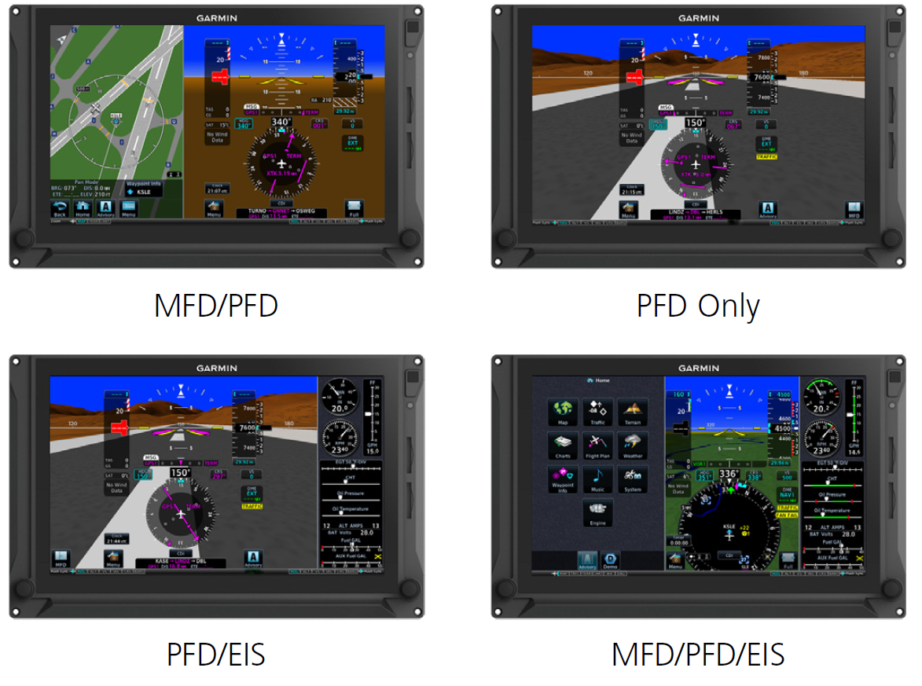

Figure 1 GDU 1060 Display Configuration

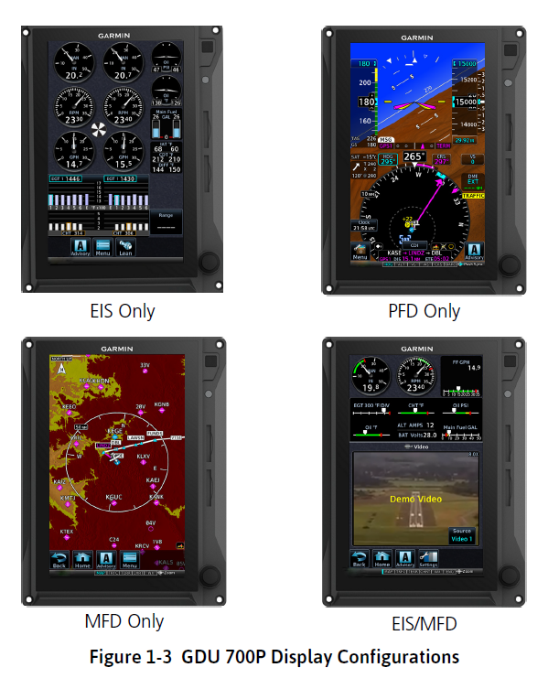

Figure 2 GDU 700P Display Configuration

Electrical loads of subsystems of G500 TXI can be seen at Figure 179.

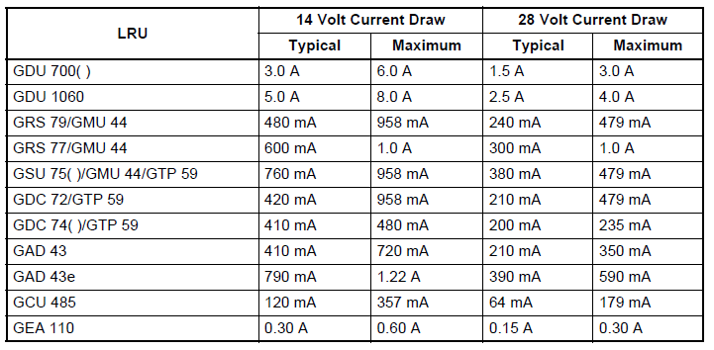

Figure 3 Electrical Load of Subsystems of G500 TXI

##### Garmin GTN750

GTN 750 from Garmin is a GPS/NAV/COMM multifunction display system which can feature things such as graphical flight planning, terrain mapping, air traffic viewing, detailed geo-referenced charting, satellite weather reporting. With it is 6” tall touchscreen display that allows for easy access menu options and high detailed graphics, it is very preferable over other navigation solutions. Garmin GTN 750 can be seen from Figure 4.

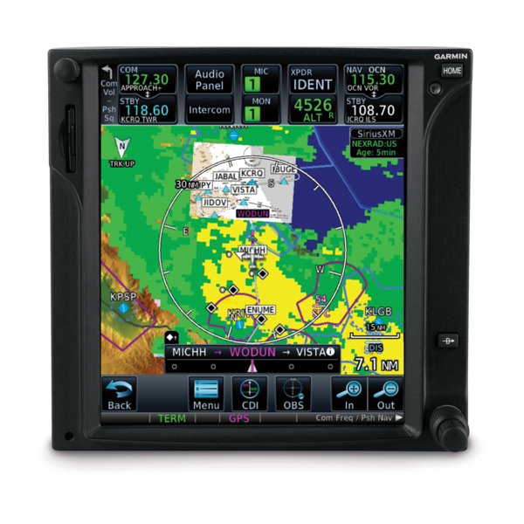

Figure 4 Garmin GTN750

##### Garmin GMA345

The GMA 345 Audio Panel provides the traditional audio selector functions of microphone and receiver audio selection. The Audio Panel includes an intercom system (ICS), a marker beacon receiver, a COM clearance recorder, USB power jack, and Bluetooth® audio. Ambient noise from the aircraft radios is reduced by Avionics Squelch (ASQ). When no audio is detected, ASQ processing further reduces the amount of background noise. Intercom squelch threshold adjustments are handled automatically by the system. Garmin GMA 345 can be seen at Figure 5.

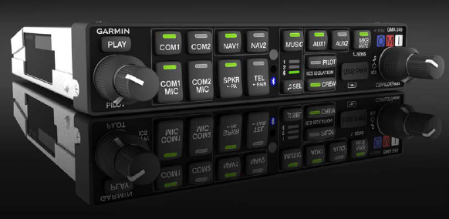

Figure 5 Garmin GMA 345

##### Garmin GTX345

GTX 345 from Garmin is a very popular compact panel mount ADB-S transponder solution in aircraft market which is capable of 1090 MHz ADB-S out transmission capability as well as ADB-S in capability. For added situational awareness, the GTX 345 further incorporates a built-in audio output for audible traffic and altitude alerts which can be integrated into existing audio panels. And for even more flexibility, optional remote mount GTX 345 are available for compatibility with the GTN 750 series of touchscreen GPS/Comm/Nav systems. Garmin GTX 345 can be seen at Figure 6.

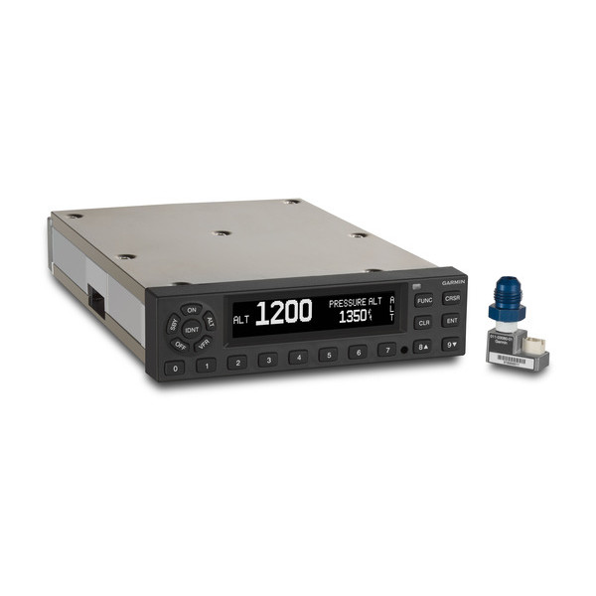

Figure 6 Garmin GTX 335/345

##### Garmin G5

Garmin G5 is a cost-effective primary or back-up attitude indicator or turn coordinator is a good alternative for older, vacuum-driven equipment with a modern “glass” solution. G5 is also certificated as a replacement heading indicator/directional gyro or horizontal situation indicator.  Additionally, when paired with select VHF Nav/Comms or GPS navigators (such as GTN 750), G5 can also provide course guidance, as well as distance and groundspeed indications. Garmin G5 can be seen at Figure 7.

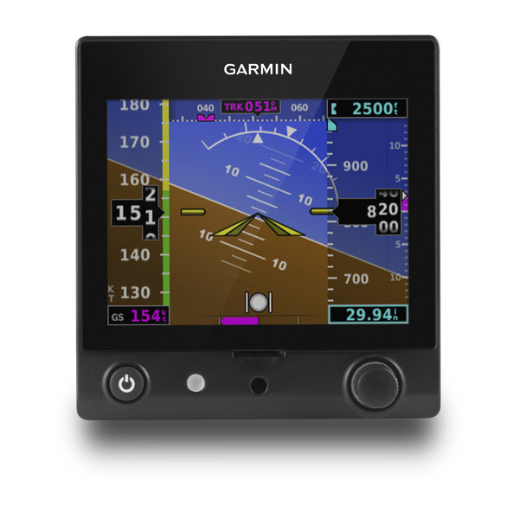

Figure 7 Garmin G5

#### Proposed Avionic Architecture

Figure 184 shows our design for the avionic architecture. The avionic architecture relies mainly on ARINC-429 standard, which is well known to be wide spread in non-military avionic applications. However, the system also employs discrete and Ethernet connections. To denote briefly the individual components on the architecture:

* **CV / FDR** stands for “Cockpit Voice / Flight Data Recorder”, is the black box of the aircraft.
* **G500** represents Garmin G500 dual screen electronic display.
* **BFI** or more commonly BFS is the “Backup Flight System”.
* **ADC** is the air data computer.
* **INS / GPS** stands for the Inertial Navigation System and the Global Positioning System.
* **ELT** is the Emergency Locator Transmitter.
* **ICS** is the Intercom equipment.
* **V/UHF** is the Very High and Ultra High Frequency Radio.
* **Mode-S** is the Mode-S Transponder.

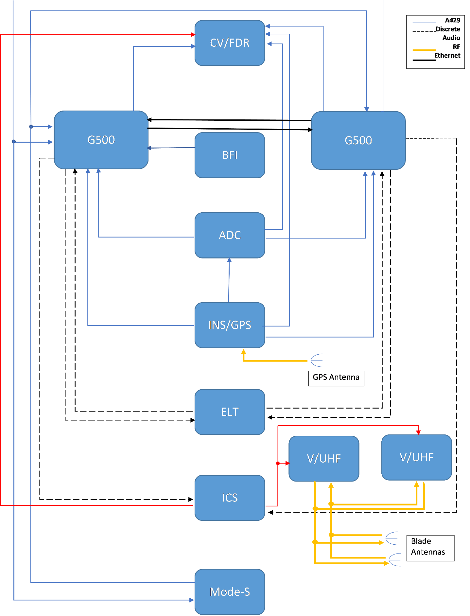

**Figure 8 : The proposed avinoic architecture. Notice the legend.**

### Choosing the Necessary Lighting Equipments

According to CS-VLA 1384, external lights must be installed with regard to CS-23 23.2530. These sub-paragraphs mention that any position lights must include a red light on the left wing, a green light on the right wing and a white light facing aft. Also any position or anti-collision lights must have proper features to provide sufficient time for another aircraft to avoid a collision. Therefore, we deduced that we should have 3 position lights, as red, green and white, and 2 anti-collision lights.

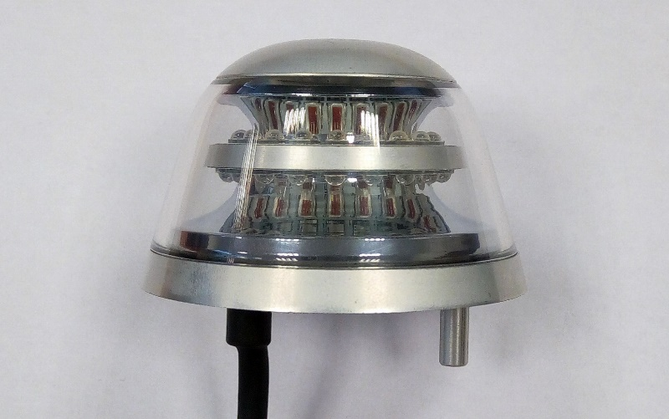

Figure 9 Anti-collision LED light – Red or White

Since those lighting systems are very common, companies like AVEO Engineering are building compact systems. AVEO’s Ultra DayLite and Andromeda DayLite products are two examples of that. They both have navigation (red and green lights), position (white light) and strobe (anti-collision light) systems built in. When compared in terms of weight and power usage, they do not have an important difference. Main reason to choose one to other can be the design. Their prices are same, $769.00. However, these products are not TSO certified. If a TSO certified product is necessary, TSO certified Ultra Galactica can be used, priced at $1099.00. An example for Anti-collision LED light from AVEO can be seen from Figure 185 while an example for Navigation / Position / Strobe LED light can be seen at Figure 186.

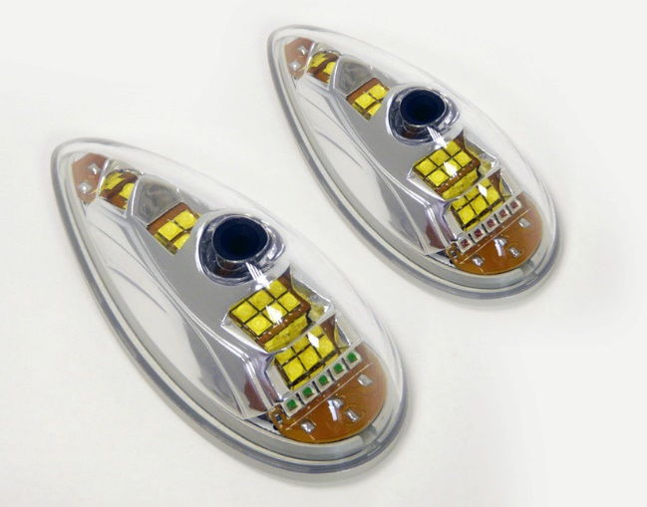

Figure 186 Navigation / Position / Strobe LED light

### Preliminary Electrical Architecture

On Figure 187, you can observe the preliminary electrical architecture. Two busses – main and essential- are used on the architecture, typical for such aircraft. The generator relies on the engine to provide power while battery is used to provide a steady and safe source of energy in the case of a discrepancy.

* **GMFD** stands for the control panels.
* **CVR** is the black box.
* The rest is given below.

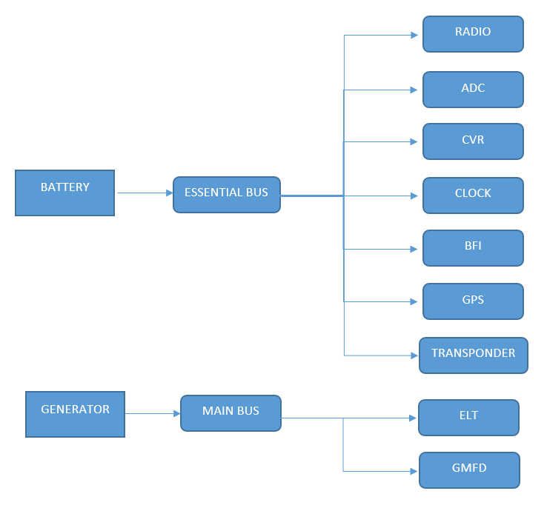

**Figure 10 : Preliminary Electrical Architecture**