

Avionic and Electrical Architecture Proposal Report

Our intention in this report is to present our ideas for the electrical and avionic architecture of our VLA. This is a draft document and therefore should not be regarded as the final proposal.

On Figure 1, you can observe the crude electrical architecture. Two busses – main and essential- are used on the architecture, typical for such aircraft. The generator relies on the engine to provide power while battery is used to provide a steady and safe source of energy in the case of a discrepancy.

**GMFD** stands for the control panels.

**CVR** is the black box.

The rest is given below.

Figure 2 shows our design for the avionic architecture. The avionic architecture relies mainly on ARINC-429 standard, which is well known to be wide spread in non-military avionic applications. However, the system also employs discrete and Ethernet connections. To denote briefly the individual components on the architecture:

**CV / FDR** stands for “Cockpit Voice / Flight Data Recorder”, is the black box of the aircraft.

**G500** represents Garmin G500 dual screen electronic display.

**BFI** or more commonly BFS is the “Backup Flight System”.

**ADC** is the air data computer.

**INS / GPS** stands for the Inertial Navigation System and the Global Positioning System.

**ELT** is the Emergency Locator Transmitter.

**ICS** is the Intercom equipment.

**V/UHF** is the Very High and Ultra High Frequency Radio.

**Mode-S** is the Mode-S Transponder.

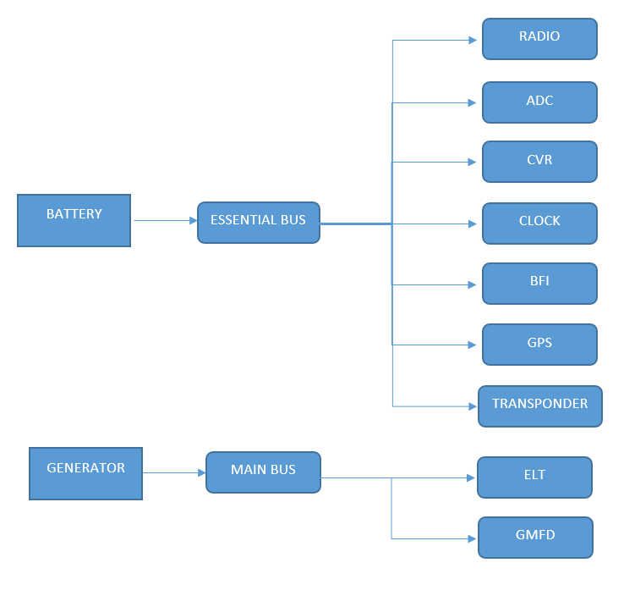

Figure 1 : The crude electrical architecture

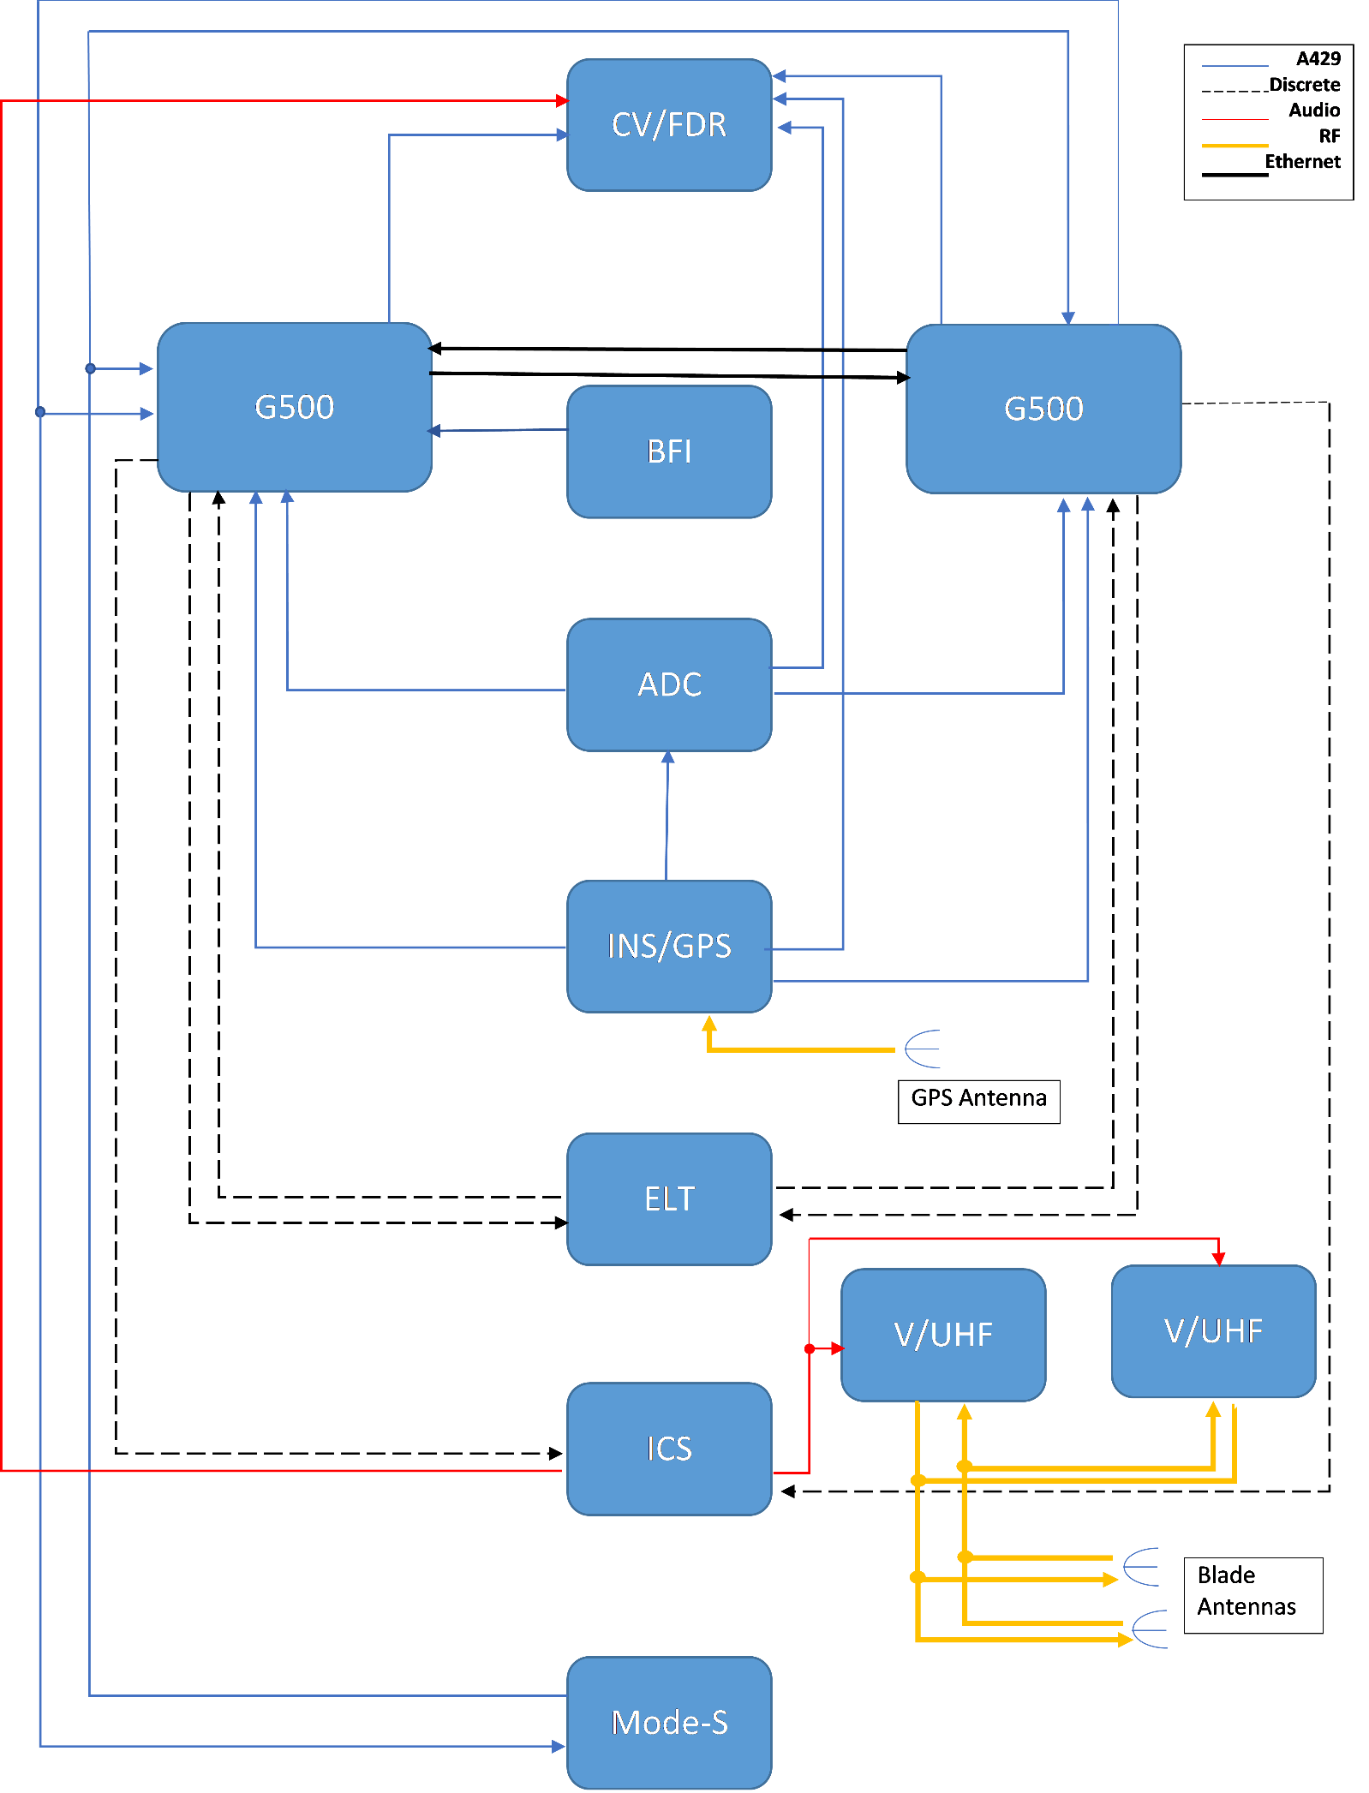

Figure 2 : The proposed avinoic architecture. Notice the legend.

Choosing the Necessary Lighting Equipments

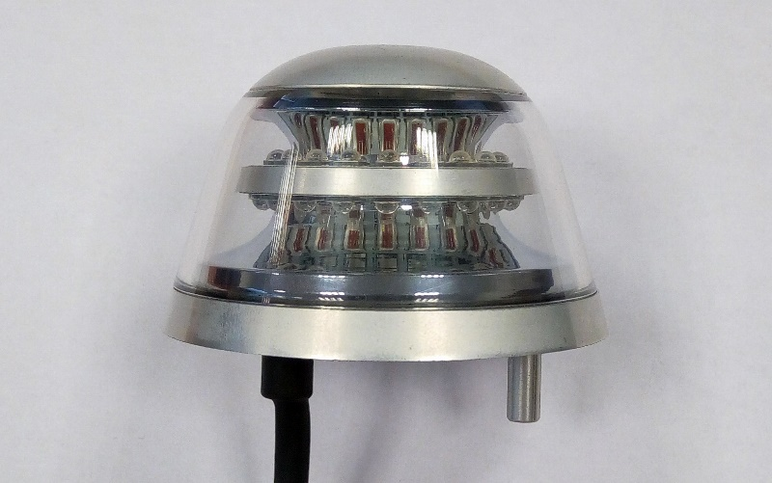 According to CS-VLA 1384, external lights must be installed with regard to CS-23 23.2530. These sub-paragraphs mention that any position lights must include a red light on the left wing, a green light on the right wing and a white light facing aft. Also any position or anti-collision lights must have proper features to provide sufficient time for another aircraft to avoid a collision. Therefore, we deduced that we should have 3 position lights, as red, green and white, and 2 anti-collision lights.

Figure 3 Anti-collision LED light – Red or White

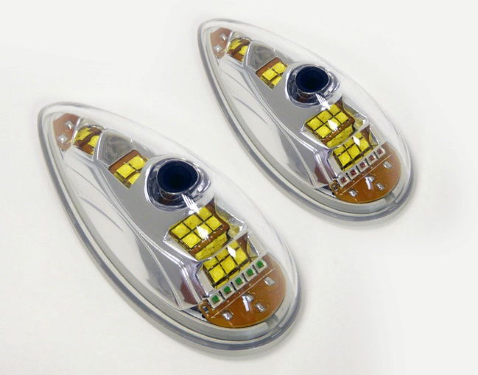 Since those lighting systems are very common, companies like AVEO Engineering are building compact systems. AVEO’s [Ultra DayLite](http://www.aveoengineering.com/lsa-experimental-ul-kits-and-gliders/ultra-daylite/) and [Andromeda DayLite](http://www.aveoengineering.com/lsa-experimental-ul-kits-and-gliders/andromeda-daylite/) products are two examples of that. They both have navigation (red and green lights), position (white light) and strobe (anti-collision light) systems built in. When compared in terms of weight and power usage, they do not have an important difference. Main reason to choose one to other can be the design. Their prices are same, $769.00. However, these products are not TSO certified. If a TSO certified product is necessary, TSO certified [Ultra Galactica](http://www.aveoengineering.com/ultra-galactica-2/) can be used, priced at $1099.00. An example for Anti-collision LED light from AVEO can be seen from Figure 3 while an example for Navigation / Position / Strobe LED light can be seen at Figure 4.

Figure 4 Navigation / Position / Strobe LED light

Choosing the Avionics

As choosing the necesary avionic devices for the aircraft, the requirements spesified by the TAI is considered. Corresponding requirements considered in this process can be seen at Table 1.

|  |  |  |
| --- | --- | --- |
| Requirement | Chosen Avionics |  |
| ODTÜ-VLA-SRD-017 | Garmin GTN 750-Garmin G500 |  |
| ODTÜ-VLA-SRD-018 | Garmin G500-Garmin GTN 750 |  |
| ODTÜ-VLA-SRD-019 | Garmin G500-Garmin GTN 750 |  |
| ODTÜ-VLA-SRD-020 | Garmin G500-Garmin GTN 750 |  |
| ODTÜ-VLA-SRD-021 | Garmin G500-Garmin GTN 750 |  |
| ODTÜ-VLA-SRD-022 | Garmin GTN 750 |  |
| ODTÜ-VLA-SRD-023 | Garmin GTN 750-Garmin GTX 335 |  |
| ODTÜ-VLA-SRD-024 | Garmin GMA 340 |  |
| ODTÜ-VLA-SRD-026 | Garmin GTN 750 |  |
| ODTÜ-VLA-SRD-027 | Garmin GTN 750 |  |
| ODTÜ-VLA-SRD-028 | Garmin GTN 750 |  |
| ODTÜ-VLA-SRD-029 | Artex ME406 ELT |  |
| ODTÜ-VLA-SRD-030 | Garmin GTX 335 |  |
| ODTÜ-VLA-SRD-025 | Garmin GMA 340 |  |

**Table 1 Corresponding Requirements for Avionics**