freETarget
FreeEtarget an Electronic Scoring System made by shooters for shooters.

Features
- Open source – build it yourself.  - Available assembled and tested.  - Includes a wide range of targets, 10m rifle to 1000-meter large bore.  - Rapid fire pistol.  - Built-in training features.  - WiFi network for multiple viewers – athlete, coach, and spectators  Scan to find out more: Free-e-target.com | 

Build
- DIY – buy the circuit and build the rest yourself. Drawings and 3D printed parts available.
- Club – entry level ESS for clubs and beginners.
- Competition – full-featured target that you assemble yourself.
- 25/50 meter pistol or rifle target

Get Started
Visit free-e-target.com to find out more. Shipping is not included.
Circuit | Basic circuit, build the rest | $230
Witness Paper Drive | Used to improve accuracy | $105
Club Target - Kit | Low-cost ESS – simple target holder and circuit | $345
Competition Target - Kit | Circuit, witness paper drive, choice of target plates  Not included: LED lights, glue, pellet trap | $549
Competition Target - Assembled | Assembled competition target | $749
25/50 Meter Pistol | Large target for pistol shooting at 25 or 50 meters | $595

How to use the target
Follow these instructions to use the target with your laptop.
- Download the PC Client onto your pc from https://free-e-target.com/downloads/#PCClient
- Install the client onto your PC
- Open the client and go to the setup tab.

- Make the following settings
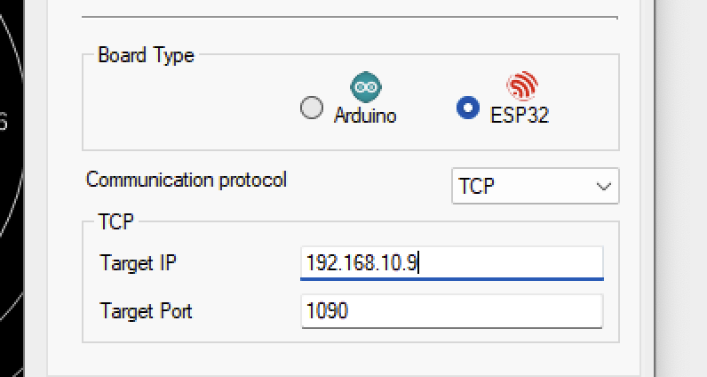
  - Select ESP32
  - Enter the target IP address, 192.168.10.9
  - Press OK to continue

- Change your laptop WiFi SSID to FET-TARGET
- Connect to the target by pressing the CONNECT button
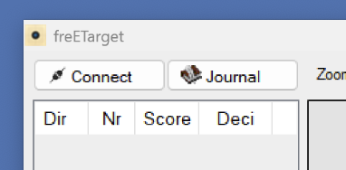
- Select any of the Pistol events
- Follow all the safety procedures you would use for any shooting event.
- Have Fun
Note
The target and PC Client may show slightly different results. This is to be expected since the PC and target are not adjusted for your setup.

