NBA

Table of Contents

* Let’s investigate some of the per game statistics of NBA teams during the 2021-2022 season!

## Off/Def Rebounds XY Plot

df %>%  
 ggplot(aes(x = orb, y = drb)) +  
 geom_point(size = 3) +  
 geom_vline(aes(xintercept = mean(orb)),  
 linetype = "dashed",  
 size = 1.2) +  
 geom_hline(aes(yintercept = mean(drb)),  
 linetype = "dashed",  
 size = 1.2) +  
 ggrepel::geom_text_repel(aes(label = team))

## Warning: ggrepel: 2 unlabeled data points (too many overlaps). Consider  
## increasing max.overlaps

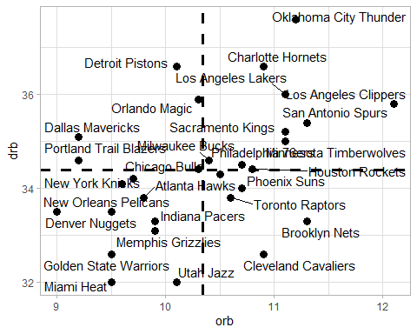

Offensive and Defensive Rebounds for each Team

## Team 3-Point Scoring

three_pt <- df %>%  
 mutate(  
 three_z = z_score(x3p_percent),  
 three_pt_pct = scales::percent(x3p_percent, accuracy = 0.1)  
 ) %>%  
 ggplot(  
 aes(  
 x = three_z,  
 y = reorder(team, three_z),  
 label = three_pt_pct  
 )  
 ) +  
 geom_col(width = 0.2) +  
 geom_point(  
 aes(  
 size = x3pa  
 ),  
 color = "green") +  
 geom_vline(  
 xintercept = 0,  
 size = 1.2) +  
 scale_x_continuous(  
 breaks = seq(-3, 3, 1),  
 labels = seq(20, 80, 10)  
 ) +  
 theme(  
 legend.position = "none"  
 ) +  
 labs(  
 x = "Three Point% t-score",  
 y = NULL,  
 title = "2021-2022 Three Point%",  
 subtitle = "Dot Size = 3 Point Attempts"  
 )  
  
ggplotly(three_pt)

