# Integrate with Prisma

## Setup Prisma

1. npm I prisma

2. npx prisma init – generate prisma schema file

3. open prisma schema file and setup the database and connection url. Prisma support multi type of database, for this case we use mongo db

4. Update database while model update(migration) with command npx prisma db push

## Prisma data model

1. Data type allow nullable, exp: String?

2. List of data type:

- String

- DateTime

-Int

3. api attribute

-@id

-@default(auto())

-@default(autoincrement())

- @unique

- @updatedAt

- @default(now())

- @db.ObjectId

- @relation

- @map

## Prisma data model relations

Example relationship between Tweet and User model

# Create Nuxt 3 App

1. npx nuxi init ___

2. npm i

# Nuxt 3 server (api endpoint)

1. Basic structure

**/api/auth/login – post method**

2. index and param

3. Deep url – /api/user/tweets – post method

# Auth Process

## Register with bcrypt package

1. npm I bcrypt

2. encrypt password



3. Verify password



## Login with jwt

1. npm I jsonwebtoken

2. Generate access token or refresh token

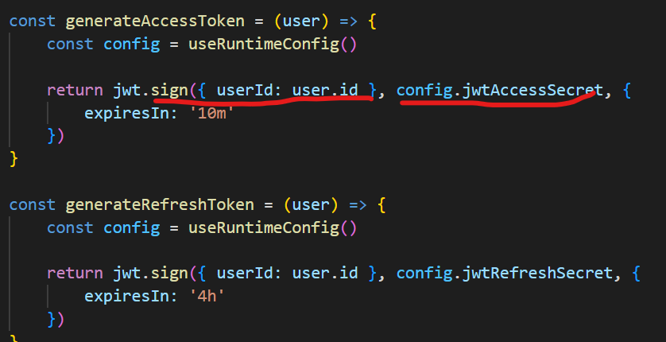

* Combine value to jwt token which can decoding to get data to the onward process.
* Config was setup on nuxt.config.js.

3. Decode token – 2 ways

First method

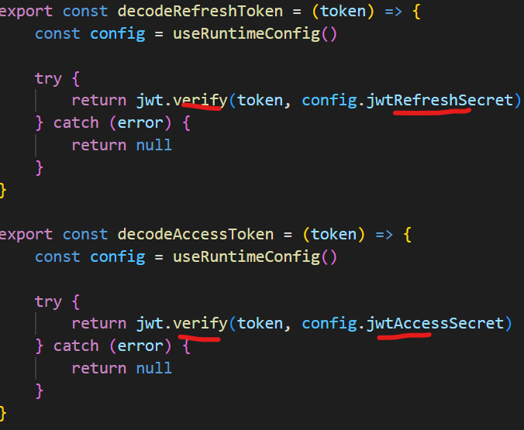

-verify function will validate token and return decode value, exp decoded.userId

4. set cookie

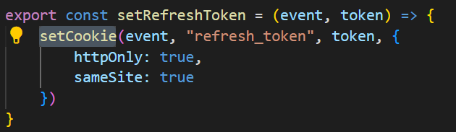

5. get cookie

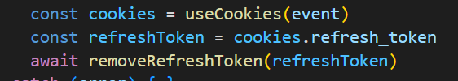

Second method

1. npm I jwt-decode, then



# Tailwindcss

## Setup

1. npm install @nuxtjs/tailndcss

2. add register tailwindcss in nuxt.config file

3. npx tailwindcss init – generate tailwind.config file

## Tailwind Input class stylish

1. npm I @tailwindcss/forms

2. Register it to tailwind.config.js

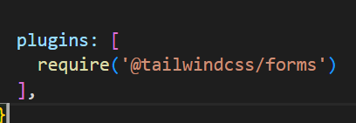

# Others

## url-pattern package - Middleware for api endpoint

1. Pass authorization to request

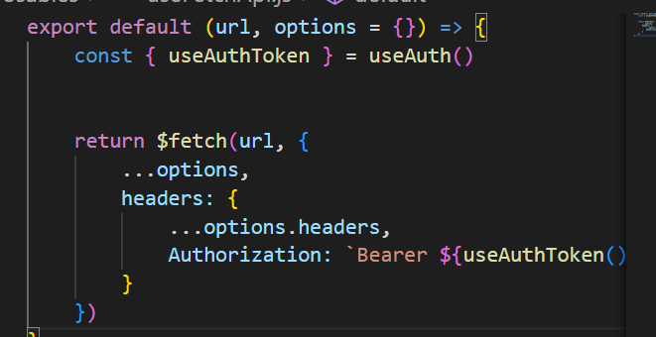

2. Hit the middleware

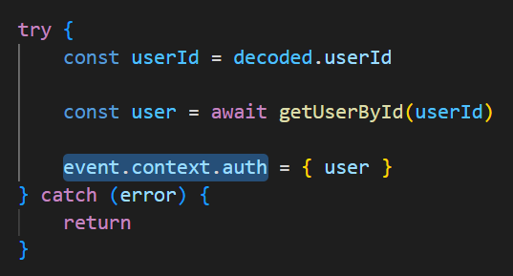

-assign user data to context, then we can get user data globally, exp:

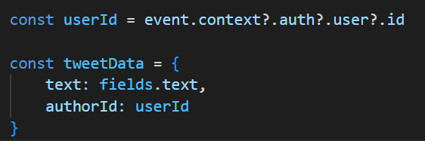

3. Execute authorize endpoint



## Cloudinary – Free cloud for image storage(limit)

## mitt – listerning event package

1. add file at composable folder

2. listening

3. fire event

## Heroicons – Ease to use, provide solid and outline version icon

1. npm I @heroicons/vue

## Human-time



1. npm I human-time

2. pass datetime value

## Formidable - A Node.js module for parsing form data, especially file uploads.

1. npm I formidable

2. Parsing fields and files

