Jeanette Pranin

HW#5

11/20/14

**Example of Original Image**

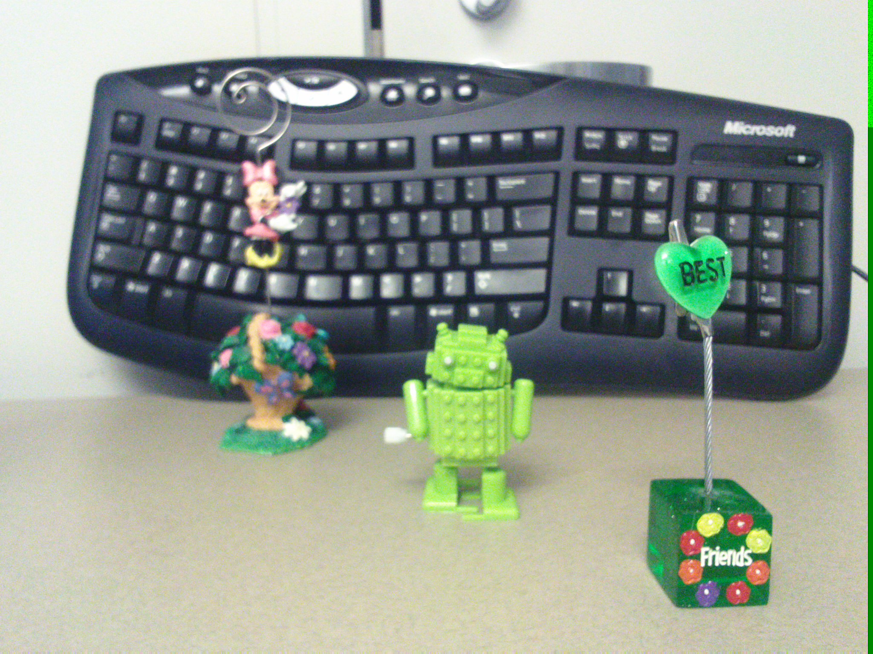

**Depth Map**

**K = 1**

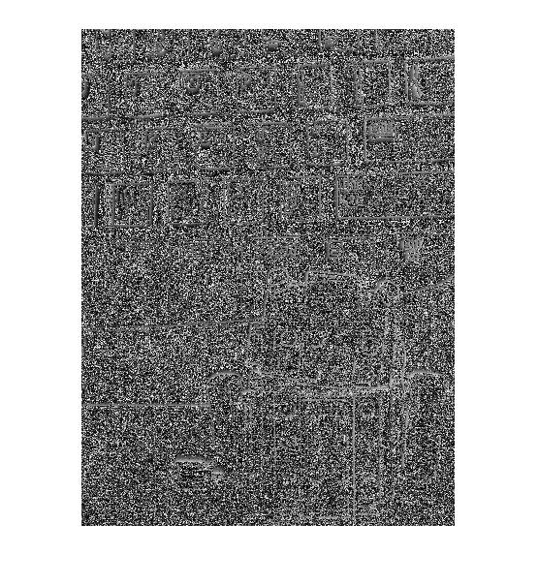

**K = 3**

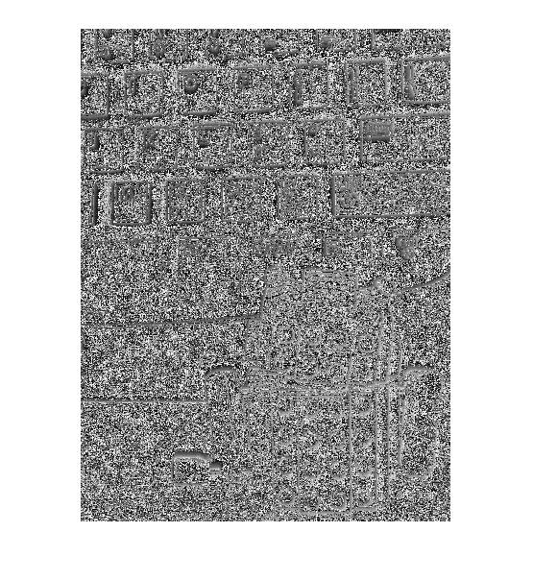

**K = 10**

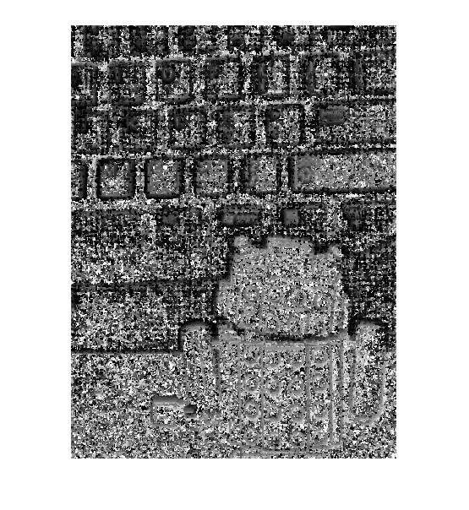

**Changing values of K = All focus images**

**K = 1**

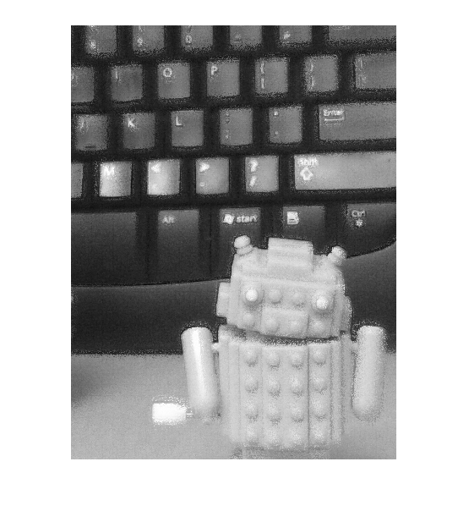

**K = 3**

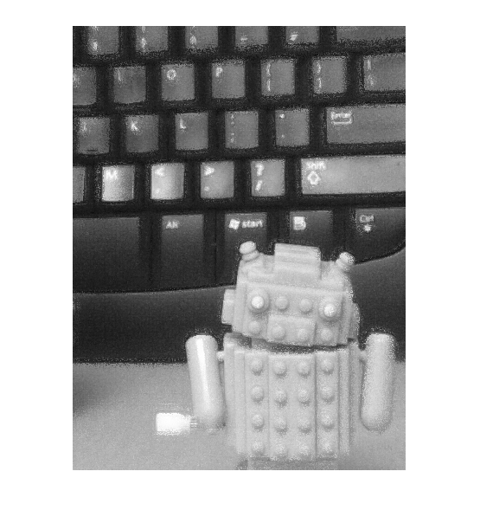

**K = 10**

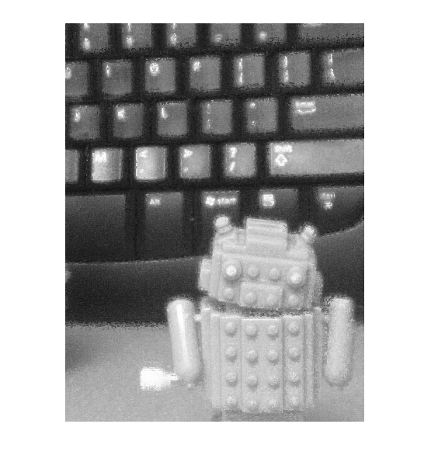

**Varying K values**

As we increase the value of K, the image becomes smoother but blurrier. This option is good with the photo does not have a lot of texture. As we decrease the value of K, the image becomes sharper but noisier. This option is better when the scene is filled with texture.

**Problems we encountered**

At first, when we wrote the convolution code, we attempted to run a five-nested for-loop. In the loops, we were performing a convolution on every pixel on every picture, where our pictures were 1536x2048 each. This made our code run for 30+ minutes and was horribly inefficient. However, we learned that by performing imfilter twice, we could do perform the convolution on every picture in a fraction of the time. (We have left our old for loop code commented out so you can see the evolution of our code).

We also had trouble implementing our android code without a full package, but using our old Homework 3 skeleton code fixed the issue.

If we were to do this assignment again, I would lower the image resolution to make our code run faster.