Jeanette Pranin

HW#6

Special K Box in focus

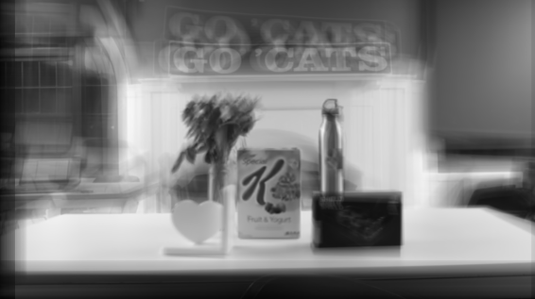

Special K Pixel Shift

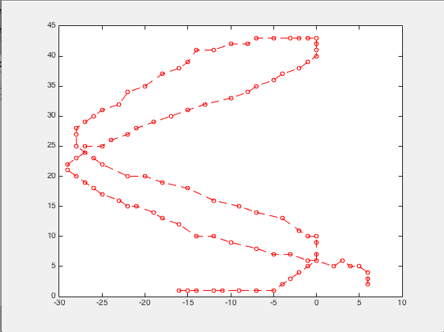

Shield Tablet Case in focus

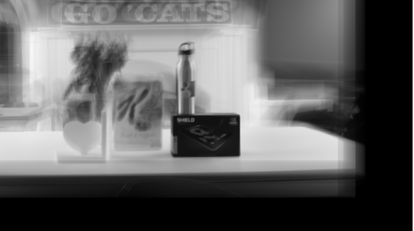

Shield Tablet Case Pixel Shift

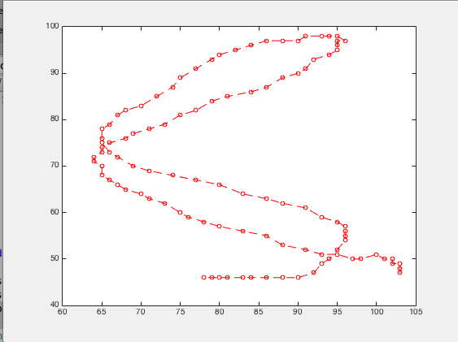

Google Water Bottle in focus

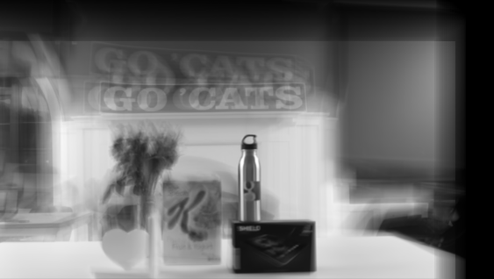

Google Water Bottle Pixel Shift

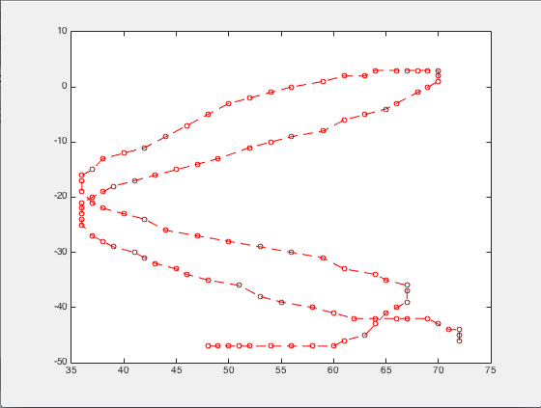

**Problems we encountered:**

We found that holding the camera steady without tilting was an extremely difficult task, and our final video is one we shot with the least amount of obvious tilting.

We also found that if we focused on objects that were relatively close to center, our pixel shift plot would behave normally. However, if we chose an object that was close to the frame’s edges, e.g. the ‘Go Cats!’ banner in the background, the pixel shift plot would become a strange mass of straight lines and shapes. We believe this happens because our code places whatever object we are focusing on in the center of our frame, meaning that the lower half of our frame was cut out when the ‘Go Cats!’ banner was selected as the object of focus. The upper half of the screen would be black, and the pixel plot would take this into account. However, our code would refocus the image just fine. Only the pixel plot code suffered.

We learned that more symmetric objects like boxes were easier to focus on than asymmetric objects like our flower vase.