1. What do you observe about the PDF of the noise? What is its approximate shape?
   * 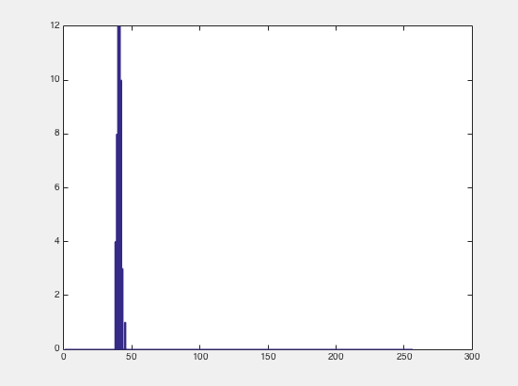
   * 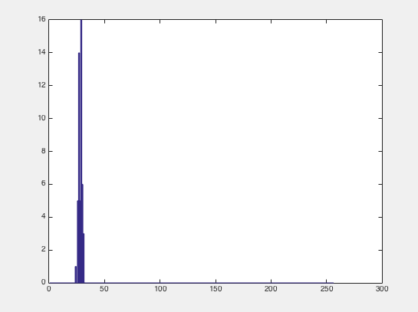
   * 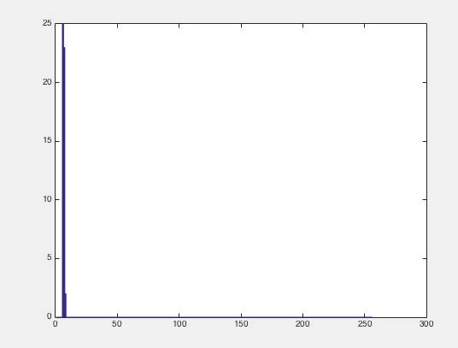
   * for Gain: 1000 and Exposure: 100
   * 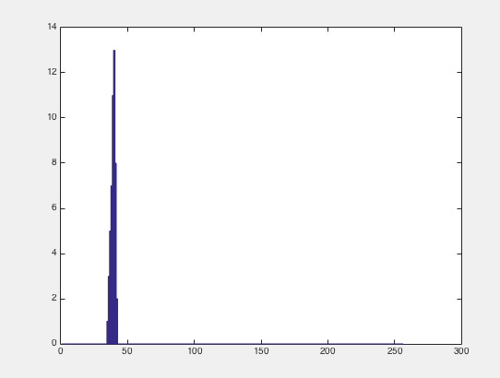
   * 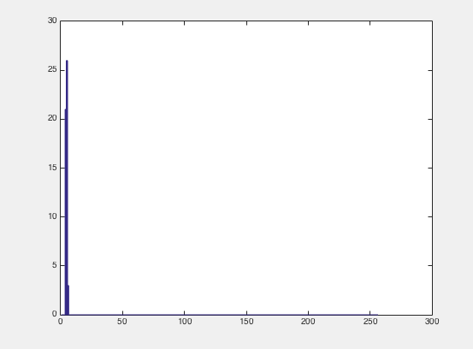
   * 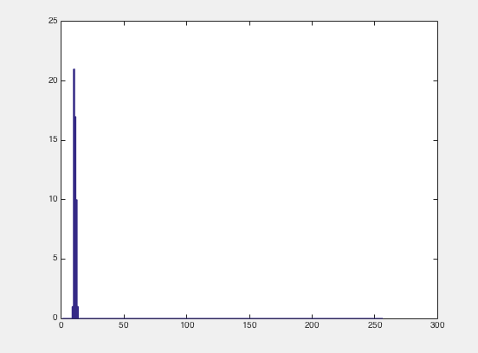
   * for Gain: 500 and Exposure: 18000
   * The shape for both graphs looks like a steep Gaussian function. Brighter pixels are more to the right, so we can tell by the plot of each pixel how much brightness it has/where it might be in the image.
   * For many of the graphs, the pixels have high brightness levels.
2. The main problem we encountered in Part I was making the camera app run consistently. Our jni code did not work on Greg’s PC and it only worked under very specific conditions under my Mac. We had to plug it into Greg’s PC, run it, then unplug it and run it on mine. By doing this, my Mac overwrote the signature made by Greg’s PC and uninstalled and reinstalled the app, making it work on my computer.

Mean image of Low Gain (500), High Exposure (18000)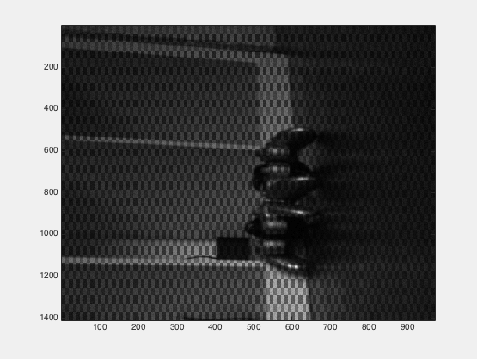

Variance image of Low Gain (500), High Exposure (18000)

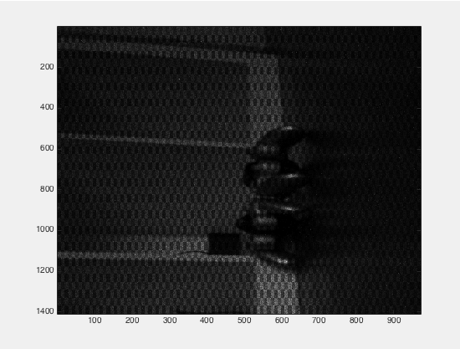

Original image of Low Gain (500), High Exposure (18000)

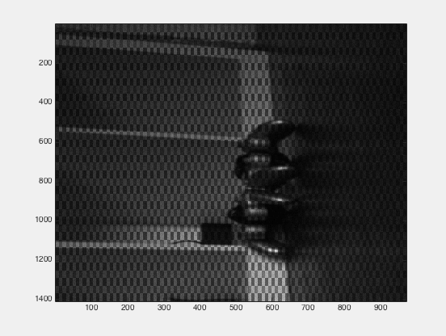

Mean image of High Gain (1000), Low Exposure (100)

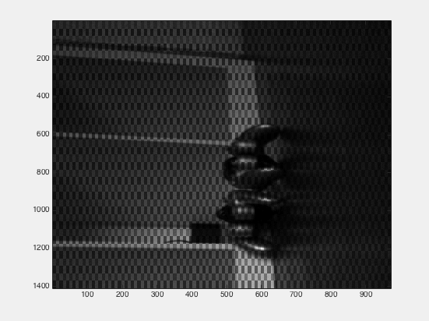

Variance image of High Gain (1000), Low Exposure (100)

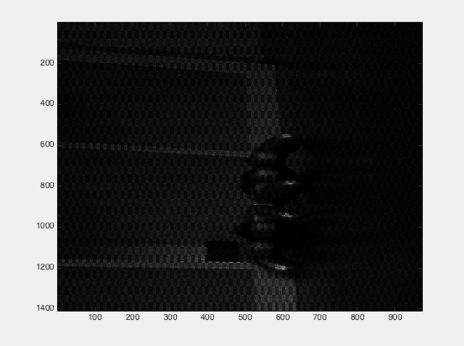

Original image of High Gain (1000), Low Exposure (100)

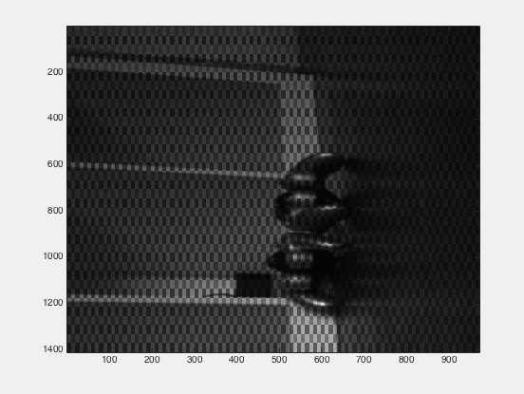

1. Plot the variance as a function of the mean (for low Gain, high Exposure)

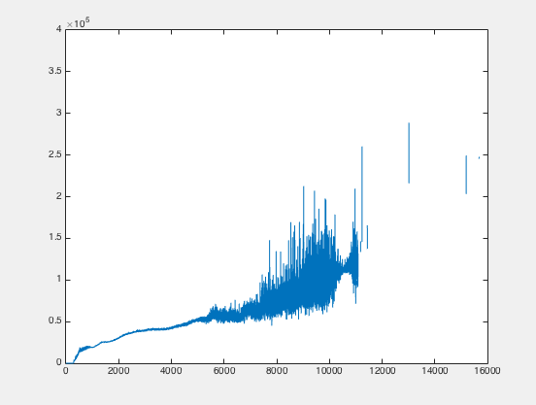

1. Plot the variance as a function of the mean (for high Gain, low Exposure)

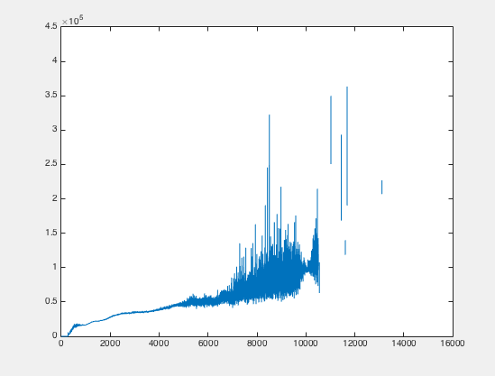

1. For each experiment, fit a line to the plotted data.

For high gain, low exposure: g $≈$ 12.8144

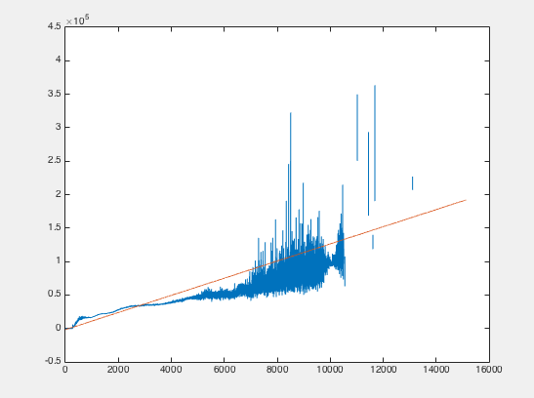

For low gain, high exposure: g $≈$ 13.4951

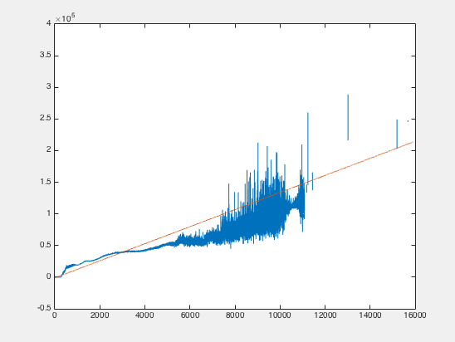

1. Plot the SNR as a function of mean pixel value. What is your interpretation of this plot? How does it relate to the three types of noise from equations (4) and (5)? What is the maximum SNR that can be achieved by the Tegra camera?

SNR for low gain, high exposure

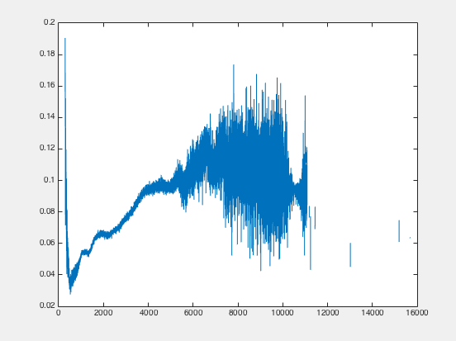

SNR for high gain, low exposure

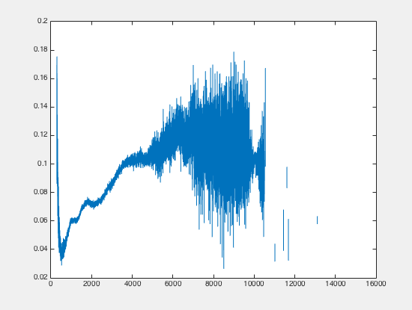

* The SNR plot looks like a more chaotic version of our average variance plots. The leftmost parts of these graphs have a relatively low SNR, but as we see as we travel to the left, the SNR increases dramatically, especially near the 6,000 mark, which thus resulted in a lot of noise. Therefore, as the brightness values increased in the images, the noise varied greatly in comparison to the signals received. Any type of the three noises we discussed, read, ADC, or dark noise, could have influenced these results.
* Through our calculations, we concluded that the read noise $≈$ 38.5 while our ADC noise $≈$-271,045.6.
* The maximum SNR of the Tegra Camera is roughly a 25:1 ratio, as our SNR plots begin to level off around 0.1 on the vertical axis, which we multiply by 256 to get $≈$ 25.
* In Part II, we had trouble with the nuances of the MatLab because neither Greg nor I have coded in MatLab before this class. Nathan did an amazing job in teaching us the syntax and the subtleties that come with matrix division and polyfit in MatLab, along with other built in functions. In the coming weeks we hope to rely less on the TA hours and more on our knowledge so we can complete the homeworks quickly and gain a better understanding of the material.