African Conflict Analysis Report

Generated on: November 22, 2024

# Executive Summary

**Multi-Model Approach:**1. Binary Classification: Predicting occurrence of fatalities  
2. Split Population Regression: Separate models for different fatality ranges

# 1. Fatality Occurrence Prediction

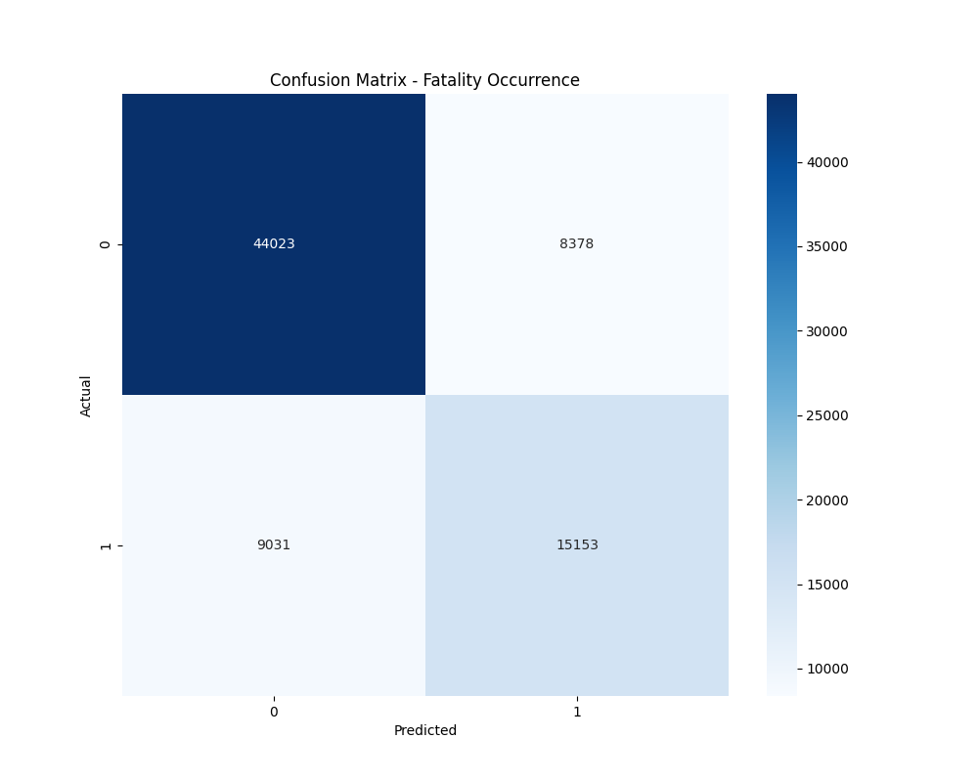

Figure 1: Confusion Matrix for Fatality Occurrence

**Classification Performance:**Accuracy: 0.7727  
  
Detailed Classification Report:  
 precision recall f1-score support  
  
 0 0.83 0.84 0.83 52401  
 1 0.64 0.63 0.64 24184  
  
 accuracy 0.77 76585  
 macro avg 0.74 0.73 0.74 76585  
weighted avg 0.77 0.77 0.77 76585

# 2. Split Population Regression Results

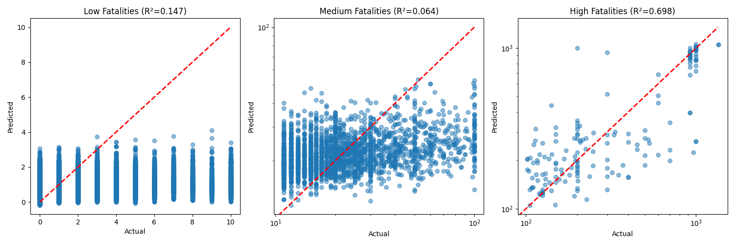

Figure 2: Predictions for Different Fatality Ranges

**Model Performance by Fatality Range:**  
Low Fatalities:  
R² Score: 0.1470  
RMSE: 1.6918  
Sample Size: 73842  
  
Medium Fatalities:  
R² Score: 0.0645  
RMSE: 18.8976  
Sample Size: 2581  
  
High Fatalities:  
R² Score: 0.6980  
RMSE: 191.7501  
Sample Size: 162

# 3. Key Findings and Implications

**Classification Insights:**• Can predict fatality occurrence with 77.3% accuracy  
• Provides early warning capability for potentially fatal events  
  
**Regression Insights:**• Low fatality events (n=73842):  
 - R² Score: 0.1470  
 - RMSE: 1.69  
• Medium fatality events (n=2581):  
 - R² Score: 0.0645  
 - RMSE: 18.90  
• High fatality events (n=162):  
 - R² Score: 0.6980  
 - RMSE: 191.75

**Practical Implications:**• High classification accuracy enables reliable early warning systems  
• Separate models for different fatality ranges provide more accurate predictions  
• Results can inform resource allocation and intervention strategies