African Conflict Analysis Report

Generated on: November 24, 2024

# Executive Summary

**Multi-Model Approach:**1. Binary Classification: Predicting occurrence of fatalities  
2. Event Classification: Classifying event types using Random Forest  
3. Random Forest Ensemble: Advanced event type classification  
4. ZINB Regression: Separate models for different fatality ranges

# 1. Fatality Occurrence Prediction

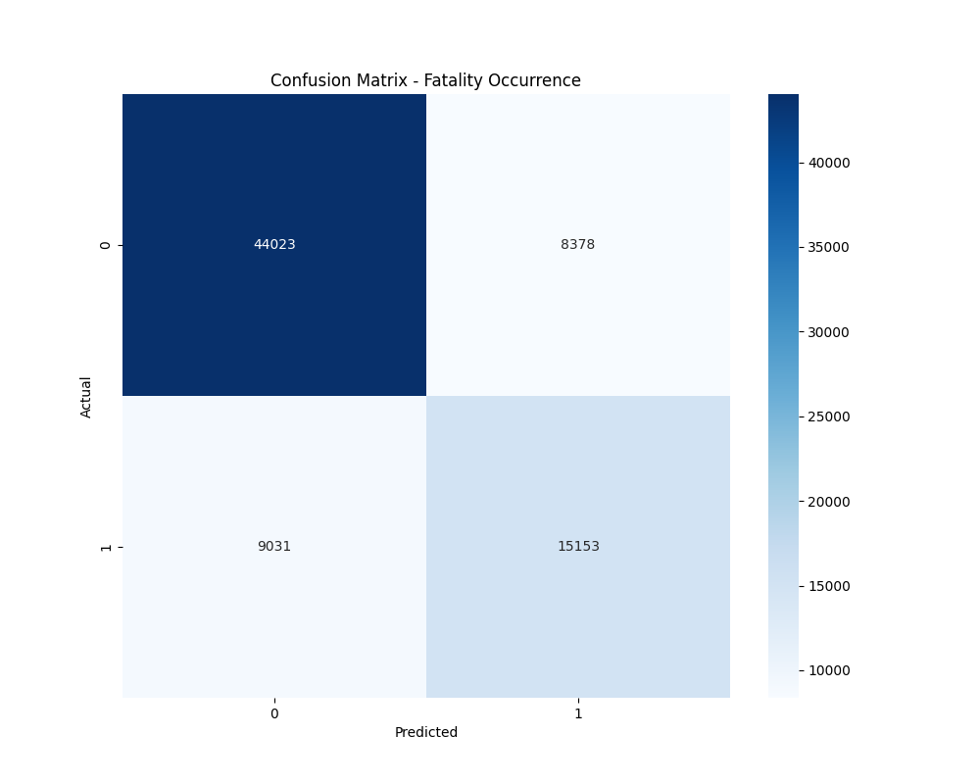

Figure 1: Confusion Matrix for Fatality Occurrence

**Classification Performance:**Accuracy: 0.7727  
  
Detailed Classification Report:  
 precision recall f1-score support  
  
 0 0.83 0.84 0.83 52401  
 1 0.64 0.63 0.64 24184  
  
 accuracy 0.77 76585  
 macro avg 0.74 0.73 0.74 76585  
weighted avg 0.77 0.77 0.77 76585

# 2. Event Classification Results

**Random Forest Classifier Performance:**Mean Accuracy: 0.7297  
Number of Classes: 6  
Total Samples: 76585  
  
Detailed Classification Report:  
{'Battles': {'precision': 0.6278937381404175, 'recall': 0.6763067804404476, 'f1-score': 0.6512016924552901, 'support': 19571.0}, 'Explosions/Remote violence': {'precision': 0.4891167852658016, 'recall': 0.4007888869833648, 'f1-score': 0.4405693279291168, 'support': 5831.0}, 'Protests': {'precision': 0.992838060592281, 'recall': 0.9899682611652686, 'f1-score': 0.9914010840877486, 'support': 17644.0}, 'Riots': {'precision': 0.9818876293740759, 'recall': 0.9833415597235933, 'f1-score': 0.9826140567200986, 'support': 8104.0}, 'Strategic developments': {'precision': 0.47571157495256167, 'recall': 0.36534538035558145, 'f1-score': 0.41328717441477086, 'support': 6862.0}, 'Violence against civilians': {'precision': 0.6261393558841402, 'recall': 0.6657513595003499, 'f1-score': 0.6453380652905717, 'support': 18573.0}, 'accuracy': 0.7296598550630019, 'macro avg': {'precision': 0.6989311907015464, 'recall': 0.6802503713614342, 'f1-score': 0.6874019001495996, 'support': 76585.0}, 'weighted avg': {'precision': 0.7248027616077474, 'recall': 0.7296598550630019, 'f1-score': 0.7258713011030493, 'support': 76585.0}}

# 3. Random Forest Ensemble Analysis

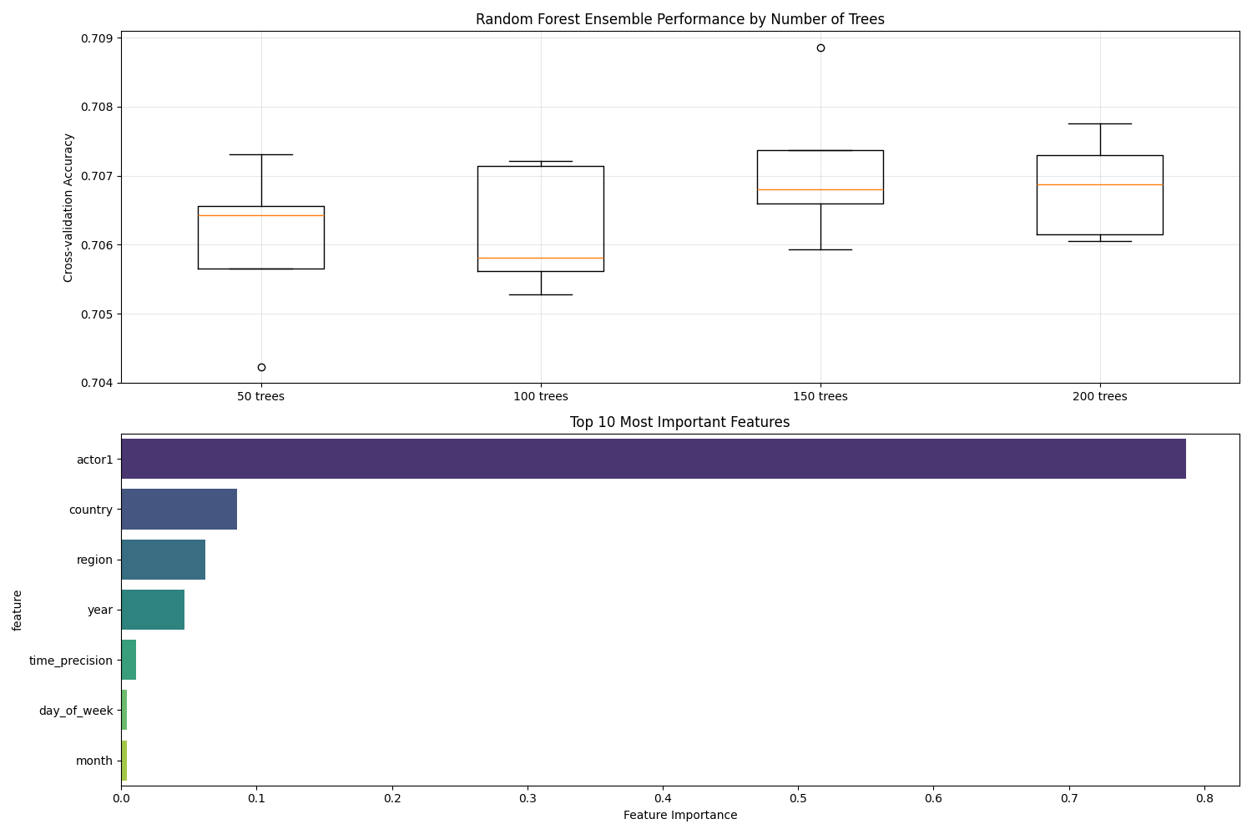

Figure 2: Random Forest Ensemble Performance and Feature Importance

**Ensemble Model Performance:**Best Model Accuracy: 0.7081  
Optimal Number of Trees: 150  
  
**Top 5 Most Important Features:**• actor1: 0.7867  
• country: 0.0853  
• region: 0.0621  
• year: 0.0465  
• time_precision: 0.0107  
 **Cross-validation Performance:**Mean CV Score: 0.7065  
Standard Deviation: 0.0004

# 4. ZINB Regression Results

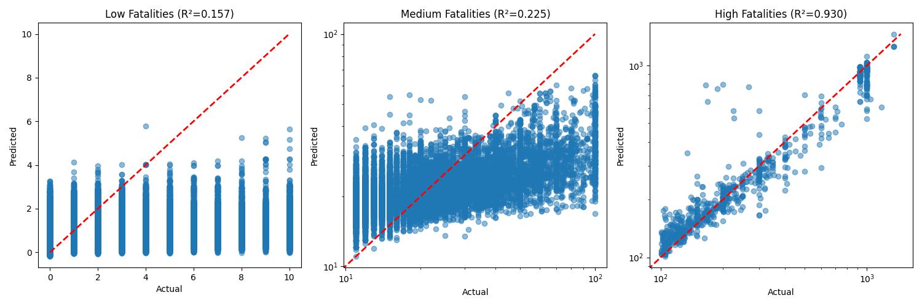

Figure 3: Predictions for Different Fatality Ranges

**Model Performance by Fatality Range:**  
Low Fatalities:  
R² Score: 0.1575  
RMSE: 1.6761  
Sample Size: 369024  
  
Medium Fatalities:  
R² Score: 0.2251  
RMSE: 16.7791  
Sample Size: 13068  
  
High Fatalities:  
R² Score: 0.9304  
RMSE: 89.7118  
Sample Size: 829

# 5. Key Findings and Implications

**Classification Insights:**• Can predict fatality occurrence with 77.3% accuracy  
• Provides early warning capability for potentially fatal events  
  
**Event Classification Insights:**• Basic Random Forest achieves 73.0% accuracy  
• Ensemble approach improves accuracy to 70.8%  
• Identified 7 relevant features  
  
**ZINB Regression Insights:**• Low fatality events (n=369024):  
 - R² Score: 0.1575  
 - RMSE: 1.68  
• Medium fatality events (n=13068):  
 - R² Score: 0.2251  
 - RMSE: 16.78  
• High fatality events (n=829):  
 - R² Score: 0.9304  
 - RMSE: 89.71

**Enhanced Model Implications:**• Random Forest ensemble provides more robust event classification  
• Feature importance analysis reveals key conflict predictors  
• Cross-validation ensures model reliability  
• Combined approach enables comprehensive conflict analysis  
• Results can inform targeted intervention strategies