African Conflict Analysis Report

Generated on: November 24, 2024

# Executive Summary

**Multi-Model Approach:**1. Binary Classification: Predicting occurrence of fatalities  
2. Random Forest Ensemble: Advanced event type classification  
3. ZINB Regression: Separate models for different fatality ranges

# 1. Fatality Occurrence Prediction

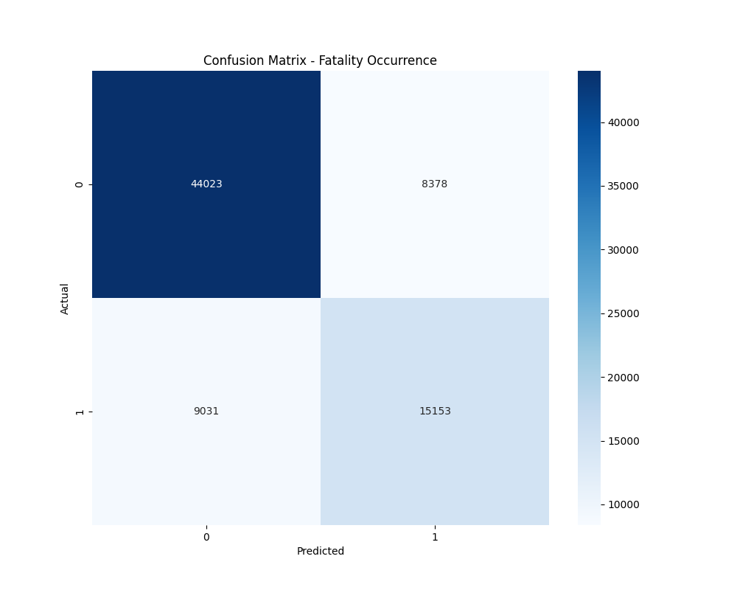

Figure 1: Confusion Matrix for Fatality Occurrence

**Classification Performance:**Accuracy: 0.7727  
  
Detailed Classification Report:  
 precision recall f1-score support  
  
 0 0.83 0.84 0.83 52401  
 1 0.64 0.63 0.64 24184  
  
 accuracy 0.77 76585  
 macro avg 0.74 0.73 0.74 76585  
weighted avg 0.77 0.77 0.77 76585

# 2. Random Forest Ensemble Analysis

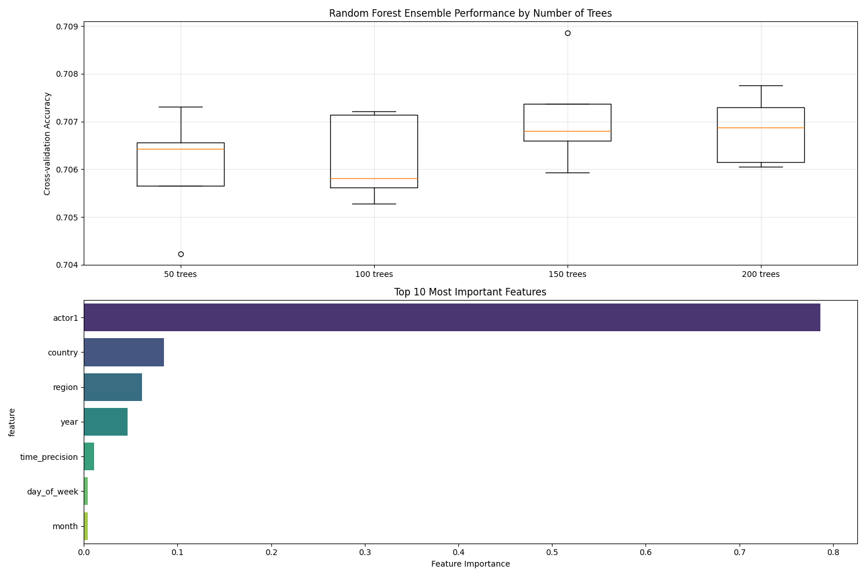

Figure 2: Random Forest Ensemble Performance and Feature Importance

**Ensemble Model Performance:**Best Model Accuracy: 0.7081  
Optimal Number of Trees: 150  
  
**Top 5 Most Important Features:**• actor1: 0.7867  
• country: 0.0853  
• region: 0.0621  
• year: 0.0465  
• time_precision: 0.0107

# 3. ZINB Regression Results

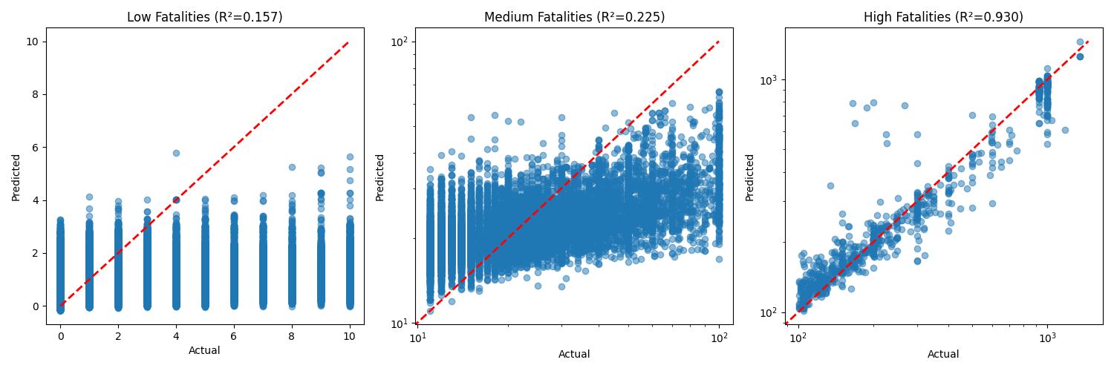

Figure 3: Predictions for Different Fatality Ranges

**Model Performance by Fatality Range:**  
Low Fatalities:  
R² Score: 0.1575  
RMSE: 1.6761  
Sample Size: 369024  
  
Medium Fatalities:  
R² Score: 0.2251  
RMSE: 16.7791  
Sample Size: 13068  
  
High Fatalities:  
R² Score: 0.9304  
RMSE: 89.7118  
Sample Size: 829

# 4. Key Findings and Implications

**Binary Classification Insights:**• Can predict fatality occurrence with 77.3% accuracy  
• Provides early warning capability for potentially fatal events  
  
**Random Forest Ensemble Insights:**• Achieves 70.8% accuracy in event type prediction  
• Optimal performance with 150 trees  
• Cross-validation ensures model reliability  
  
**ZINB Model Insights:**• Low fatality events (n=369024):  
 - R² Score: 0.1575  
 - RMSE: 1.68  
• Medium fatality events (n=13068):  
 - R² Score: 0.2251  
 - RMSE: 16.78  
• High fatality events (n=829):  
 - R² Score: 0.9304  
 - RMSE: 89.71

**Practical Implications:**• Model ensemble provides robust event type prediction  
• Feature importance analysis reveals key conflict drivers  
• Separate fatality models capture different conflict dynamics  
• Results can inform intervention strategies and resource allocation