African Conflict Analysis Report

Generated on: November 22, 2024

# Executive Summary

**Dual Modeling Approach:**1. Binary Classification: Predicting occurrence of fatalities  
2. Hierarchical Quantile Regression: Estimating fatality ranges with uncertainty

# 1. Fatality Occurrence Prediction

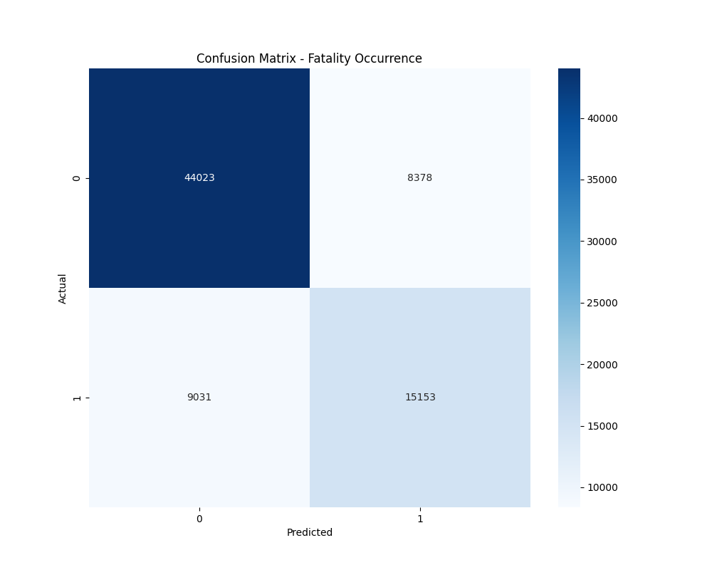

Figure 1: Confusion Matrix for Fatality Occurrence

**Classification Performance:**Accuracy: 0.7727  
  
Detailed Classification Report:  
 precision recall f1-score support  
  
 0 0.83 0.84 0.83 52401  
 1 0.64 0.63 0.64 24184  
  
 accuracy 0.77 76585  
 macro avg 0.74 0.73 0.74 76585  
weighted avg 0.77 0.77 0.77 76585

# 2. Hierarchical Quantile Regression Results

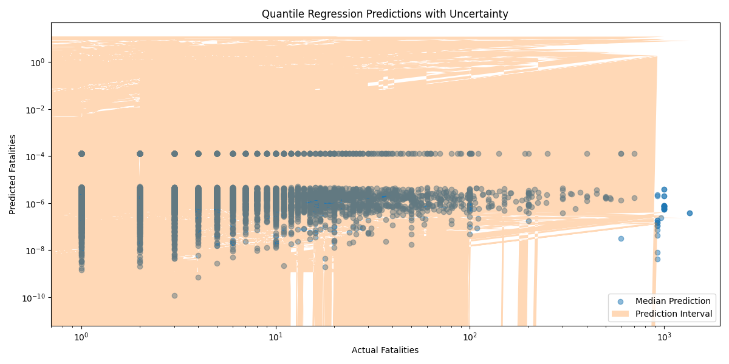

Figure 2: Fatality Predictions with Uncertainty Intervals

**Model Performance:**R² Score: -0.0098  
RMSE: 25.8750

# 3. Key Findings and Implications

**Classification Insights:**• Can predict fatality occurrence with 77.3% accuracy  
• Provides early warning capability for potentially fatal events  
  
**Quantile Regression Insights:**• Explains -1.0% of fatality count variation  
• Provides prediction intervals for better risk assessment  
• Accounts for hierarchical structure in conflict patterns