African Conflict Analysis Report

Generated on: November 22, 2024

# Executive Summary

**Dual Model Analysis:**1. Binary Classification Model: Predicting likelihood of fatalities  
2. Zero-Inflated Negative Binomial Model: Estimating fatality counts

# 1. Fatality Occurrence Prediction

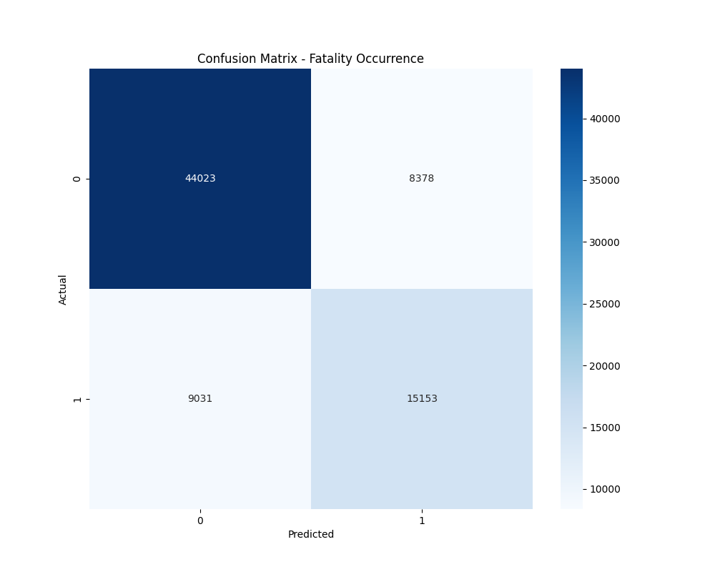

Figure 1: Confusion Matrix for Fatality Occurrence

**Classification Performance:**Accuracy: 0.7727  
  
Detailed Classification Report:  
 precision recall f1-score support  
  
 0 0.83 0.84 0.83 52401  
 1 0.64 0.63 0.64 24184  
  
 accuracy 0.77 76585  
 macro avg 0.74 0.73 0.74 76585  
weighted avg 0.77 0.77 0.77 76585

# 2. Zero-Inflated Negative Binomial Model Results

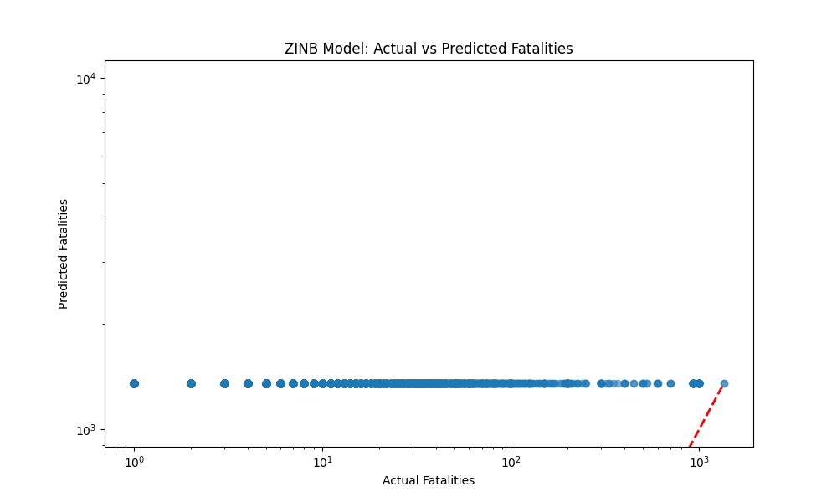

Figure 2: ZINB Model Predictions

**ZINB Model Performance:**R² Score: -2738.4814  
RMSE: 1347.6942  
  
Model Summary:  
 ZeroInflatedNegativeBinomialP Regression Results   
=========================================================================================  
Dep. Variable: fatalities No. Observations: 306336  
Model: ZeroInflatedNegativeBinomialP Df Residuals: 306327  
Method: MLE Df Model: 8  
Date: Fri, 22 Nov 2024 Pseudo R-squ.: nan  
Time: 13:48:45 Log-Likelihood: nan  
converged: False LL-Null: -4.3641e+05  
Covariance Type: nonrobust LLR p-value: nan  
==================================================================================  
 coef std err z P>|z| [0.025 0.975]  
----------------------------------------------------------------------------------  
inflate_const -0.4705 nan nan nan nan nan  
const 2.1922 nan nan nan nan nan  
event_type 0.6514 nan nan nan nan nan  
actor1 1034.1932 nan nan nan nan nan  
country 9.7288 nan nan nan nan nan  
region 0.5626 nan nan nan nan nan  
time_precision 0.2942 nan nan nan nan nan  
month -0.0804 nan nan nan nan nan  
day_of_week 0.0523 nan nan nan nan nan  
year -0.5760 nan nan nan nan nan  
alpha 10.0308 nan nan nan nan nan  
==================================================================================

# 3. Key Findings and Implications

**Classification Model:**• Achieves 77.3% accuracy  
• Effective for early warning system  
• Reliable identification of potentially fatal events  
  
**ZINB Model:**• Explains -273848.1% of variation  
• Accounts for excess zeros in fatality counts  
• Provides more nuanced count predictions