Implementation and Methodology

A code was developed in Python. The .tsv files were read and put inside matrices, graphs and connected components were computed using networkx, metrics were computed using pandas and networkx and graphics were plotted using matplotlib.

For Gephi visualizations, .gexf files were generated using networkx and exported and formatted on Gephi.

Bipartite Network

Visualization

The graph could be view with Gephi by opening bipartite_graph.gephi file.

Degree Distribution
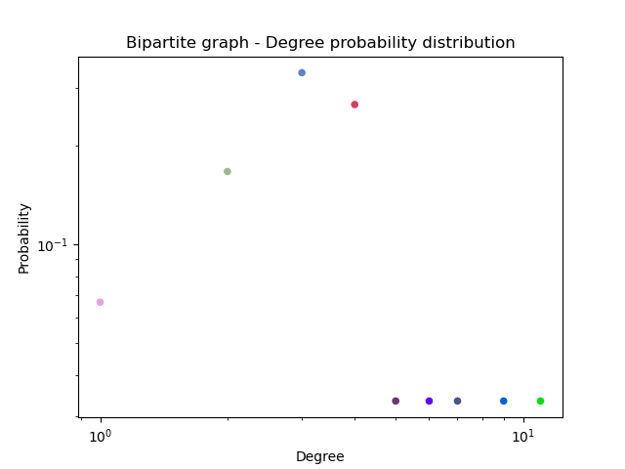
Degree | Probability
1 | 0.066667
2 | 0.166667
3 | 0.333333
4 | 0.266667
5 | 0.033333
6 | 0.033333
7 | 0.033333
9 | 0.033333
11 | 0.033333

The graph does not fit a power law, or known degree distribution. The graph is too small to follow them.

Connected Components

There is only one connected component in the bipartite class network ([{'P9', 'P1', 'P15', 'H11', 'H2', 'P2', 'P4', 'P13', 'H8', 'H9', 'P3', 'H3', 'P5', 'H7', 'P7', 'P17', 'P18', 'P11', 'P14', 'P8', 'P12', 'P10', 'H6', 'H12', 'H10', 'P6', 'P16', 'H1', 'H5', 'H4'}]), meaning that this graph is a connected graph.

Clustering Coefficients

Node | Value
H1 | 0
H2 | 0
H3 | 0
H4 | 0
H5 | 0
H6 | 0
H7 | 0
H8 | 0
H9 | 0
H10 | 0
H11 | 0
H12 | 0
P1 | 0
P2 | 0
P3 | 0
P4 | 0
P5 | 0
P6 | 0
P7 | 0
P8 | 0
P9 | 0
P10 | 0
P11 | 0
P12 | 0
P13 | 0
P14 | 0
P15 | 0
P16 | 0
P17 | 0
P18 | 0

Average Cluster Coefficient: 0

Other Metrics

Average Degree: 3.7333333333333334
Degree Standard Deviation: 2.14850923992032
Average Distance: 2.6160919540229886

Projection 1 (Hobbies)

Visualization

The graph could be view with Gephi by opening projection_graph_1.gephi file.

Degree Distribution

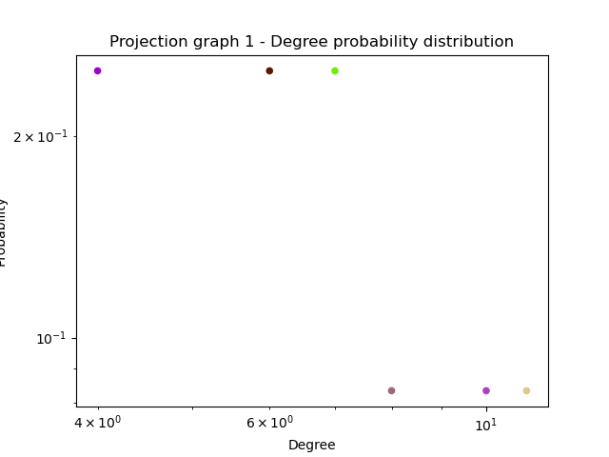
Degree | Probability
4 | 0.25
6 | 0.25
7 | 0.25
8 | 0.083333
10 | 0.083333
11 | 0.083333

The graph does not fit a power law, or known degree distribution. The graph is too small to follow them.

Connected Components

There is only one connected component in the hobbies projected class network ([{'H6', 'H12', 'H10', 'H4', 'H8', 'H11', 'H9', 'H3', 'H1', 'H5', 'H7', 'H2'}]), meaning that this graph is a connected graph.

Clustering Coefficients

Node | Value
H1 | 0.73333333333
H2 | 0.71428571428
H3 | 1
H4 | 1
H5 | 0.76190476190
H6 | 0.8
H7 | 0.52727272727
H8 | 0.57777777777
H9 | 1
H10 | 0.71428571428
H11 | 0.73333333333
H12 | 0.64285714285

Average Cluster Coefficient: 0.767087542087542

Other Metrics

Average Degree: 6.666666666666667
Degree Standard Deviation: 2.229281716090851
Average Distance: 1.393939393939394

Projection 2 (Persons)

Visualization

The graph could be view with Gephi by opening projection_graph_2.gephi file.

Degree Distribution
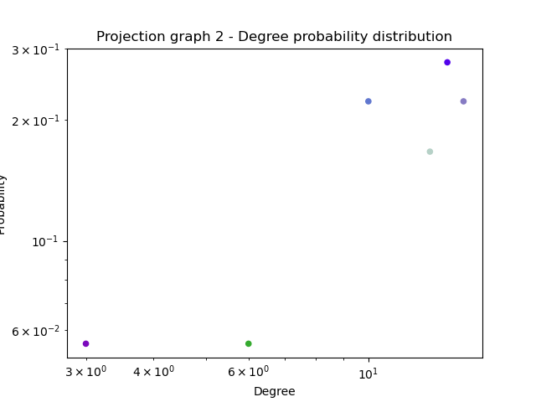
Degree | Probability
3 | 0.055556
6 | 0.055556
10 | 0.222222
13 | 0.166667
14 | 0.277778
15 | 0.222222

The graph does not fit a power law, or known degree distribution. The graph is too small to follow them.

Connected Components

There is only one connected component in the hobbies projected class network ([{'P4', 'P13', 'P17', 'P9', 'P18', 'P1', 'P10', 'P15', 'P6', 'P3', 'P5', 'P16', 'P14', 'P11', 'P2', 'P8', 'P12', 'P7'}]), meaning that this graph is a connected graph.

Clustering Coefficients

Node | Value
P1 | 0.73333333333
P2 | 0.89743589743
P3 | 1
P4 | 0.77142857142
P5 | 0.8571428571428571
P6 | 1
P7 | 0.64444444444
P8 | 0.69230769230
P9 | 0.80952380952
P10 | 0.73626373626
P11 | 0.88888888888
P12 | 0.78095238095
P13 | 0.85714285714
P14 | 0.76923076923
P15 | 0.80952380952
P16 | 0.89743589743
P17 | 0.86666666666
P18 | 0.84615384615

Average Cluster Coefficient: 0.8254375254375257

Other Metrics

Average Degree: 12.11111111111111
Degree Standard Deviation: 3.3587268051501282
Average Distance: 1.2875816993464053

