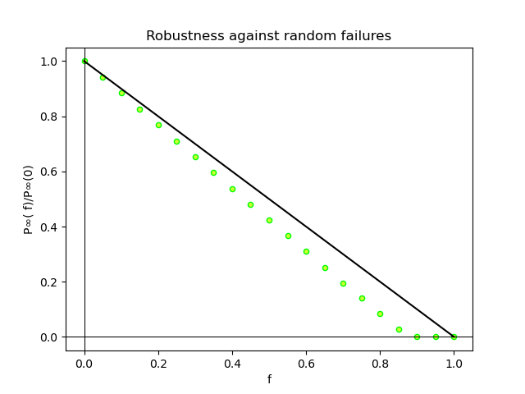

Graph degree mean: 9.126082771896053
Network Degree Exponent (Approx.): 2.01792384
Critical threshold: 0.8769394764893995

Value of f when P∞( f)/P∞(0) = 50%: 0.4329868593614672

In my opinion the network is robust against random failures, because as a scale-free network with 2 < γ < 3 the critical threshold is near to 1 when we plot P∞( f)/P∞(0) ratios, and the value of is big enough to reinforce this fact.

